Wichita State University
Budget Manual

Last Update: January 10, 2024

Budgeting Basics

Where to Find Budget Office Forms 2
What is a Budget 2
How are University Budget Decisions Made 2
Annual Budget Timelines and Deadlines 3
Responsibilities of a Budget Officer and Budget Review Officer 6

Budget Stages

Stage 1 – Developing a Business Plan 7
Stage 2 – Requesting Additional GU Funding: GU Funding Proposal 8
Stage 3 – Requesting an Increase to Existing Student Fees or Creation of a New Fee 9
SGA Student Support Services Fee 9
College and Department Fees Less than $250,000 9
College and Department Fees in Excess of $250,000 10
Stage 4 – Submitting the Annual Budget Request 10
Accessing the University Budgeting System and Training 10
General Use (GU) Base Budget Targets 11
Budgeting Positions and Personnel Costs 13
Budgeting OOE – Other Operating Expenditures 14
Budgeting by Account 14
Budgeting Restricted Use (RU) Revenue 15
Budgeting Cash Balances 15
Budgeting Cash Transfers Between Restricted Use (RU) Funds 16
Budgeting for Research Related Organizations and Funds 16
FAQs – Frequent Causes of Confusion in Formulating the Budget Request 17
How do I Know my Budget is Finished – Budget Submission Checklist 18
Stage 5 – Budget Maintenance: Common Actions, Monitoring, and Reporting 20
Faculty of Distinction 20
Requests to Create a New Organization or Fund 21
Requests for a Budget Transfer or Budget Adjustment 22
Restricted Use (RU) Cash Transfers 25
Position and Personnel Changes 26
General Use (GU) Shrinkage (Salary Savings) 27
Monitoring the Budget and Reports 30

General Information

Who to Contact with Questions 33
Other Key Information 34
Fringe Benefit Rates 34

All Budget Office forms referenced in this document can be found on the Budget Office’s website, or at this link: Forms (wichita.edu).

- What is a Budget

A budget is frequently thought of as nothing more than a plan for how revenues will be spent. But, instead a budget should be viewed as a map depicting how a college or department will financially navigate its business plan to achieve its organizational purpose. To do this, a Budget Officer and Review Officer must understand and estimate a host of different variables within their business plan and choose how to best maximize available resources. Some of these variables include:

- Performance – Objectives and Action Items: frame what is to be achieved during the budget year which should generally be in alignment with the college or department’s organizational purpose.
- Estimate Resources: determine what resources will be available and estimate the amount to be collected in support of the planned performance included in the business plan. For RU budgets, this will often require knowledge regarding what elements influence the amount of revenue collected. This might include student headcount or credit hours in a program or course, fee rates and
- Use of Resources: develop an effective plan of how the resources will be used for personnel, supplies, equipment, etc. to achieve the planned objectives and action items.

Please review the section discussing the development of a business plan for additional detail.

- How are University Budget Decisions Made

The majority of budget and operating decisions at Wichita State are made directly by Budget Officers and Review Officers. Decisions of a strategic, campus-wide nature are formulated through discussions in the Presidents Executive Team (PET), with final decisions often made by the Vice President for Finance and Administration, Executive Vice President and Provost, and the President. These decisions often concentrate on campus-wide faculty and staff pay adjustments, capital projects, how to use or address fluctuations in state or tuition revenue, and how to fund new campus initiatives.

Throughout the budget process, the university embraces an inclusive and collaborative budget development process that draws on faculty, staff, and student involvement through multiple engagement opportunities. The university President reviews and discusses the current legislative status concerning appropriations and potential tuition increases with the President’s Executive Team and during campus townhalls to obtain campus input. In addition, the University’s Budget Advisory Committee (BAC) includes diverse representation across campus of faculty, staff, and students. The BAC is co-chaired by the Vice President for Finance and Administration and the Executive Vice President and Provost, and includes the Sr. Associate Vice President for Finance and Administration, Executive Director of Budgets, Deans from the academic colleges, Presidents from the Faculty and Staff Senates, and Student Government. Members of the Faculty and Staff Senate, as well as others from the campus community, can observe committee meetings.

The BAC is charged with developing a lasting framework to identify, assess, and implement ideas that can positively impact the budget and its alignment with the university’s strategic plan. Throughout the development process, the committee is advised of tuition and State General Fund revenue estimates, with the committee providing guidance regarding expenditure planning around those parameters. Budget considerations by the committee are weighed based on their impact on the goals of the university’s strategic plan and the following key criteria:

- Suggest strategic budget priorities consistent with the strategic plan.
- Evaluate and recommend options regarding specific campus budgetary concerns as assigned by the committee chairs.
- Communicate committee discussions and information with the areas of the university that they represent.

BAC discussions are then combined with those of other campus-wide committees, such as Strategic Enrollment Management and Strategic Planning. University Budget Officers are asked in early May to submit, through an online budgeting system, their budget request for the upcoming budget year based on guidelines developed from the past discussions with the Budget Advisory Committee and the President’s Executive Team.

Throughout the budget process, the President, Vice Presidents, and Division of Finance and Administration hold discussions and presentations with deans, faculty, university senates, and the student body. Within these settings, students, faculty, and staff have the opportunity to ask questions and seek additional information at different stages of the budgeting process.

- Annual Budget Timelines and Deadlines

For Budget Officers and Review Officers, key dates in the budget process are outlined below:

GU Funding Proposals
- February 2nd – GU Funding Proposals due. Make sure that your Divisional VP has signed the form. Late requests, absent an emergency, will not be considered for funding.

Student Fees
- February 7th – SGA Student Services Support Fee
- March 29th – Submission for consideration of rate changes for KBOR Approved Student Fees in Excess of $250,000 due.

Annual Budget Submission
- April 22 – Budget system opens for Budget and Review Officers to begin entering budget requests.
- Open In-Person Training Labs
  - At least three training labs will be announced on WSUToday, with registeration through myTraining. The open training lab is normally held in Jabara Hall, Room 124.
- May 13 - Last day to submit HR forms. Submissions after this date will not be incorporated into your FY ’25 adopted budget.
- May 17 – Final day for Budget and Review Officers to complete budget requests within TM1 prior to VP review.
- May 24 – Final day for vice presidents to review requests and enter changes in TM1.

Development of the university’s budget and submission to the state is a year-long process. Key milestones of the budget process by month include:

July
- State budgeting system opened to kick-off next budget cycle (revised current fiscal year and next fiscal year initial estimate)
- University Budget Office prepares budget submission
- State Finance Council may meet
- Kansas Board of Regents Budget Workshop held

September
- State budget completed and submitted in IBARS (Sept. 15)
- KBOR State General Fund budget request submitted

October
- Fall 20th day census data
- Preparation for upcoming budget cycle

November
- Initial State consensus revenue estimates released
- Division of the Budget recommendations go to the Governor
- Governor’s Budget Appeal Letter

December
- University Budget Advisory Committee convenes
- Call for General Use New Funding Proposals

January
- Governor’s Recommended Budget released
- Call for SGA student support services fee funding requests
- Legislative session begins
- Evaluation of proposed changes to College/Department student fees begins (any fee generating more than $250K must be adopted by KBOR)
- Review of draft state appropriations bill from KDOB

February
- General Use Funding Proposals and SGA student support services fee requests due (early Feb.)
- Development of General Use base budget targets for Divisions/Colleges/Departments
- Review of strategic General Use New Funding Proposals with the Budget Advisory Committee
- Tuition revenue estimating team convenes following spring census (late Feb.)

March
- Senate Ways and Means and House Appropriations Committee - legislative support of Gov. budget recommendations and legislative recommendations start to emerge
- SGA student support services fee hearings and budget adoption
- Initial General Use base budget targets reviewed with Divisions/Colleges/Departments, feedback regarding needs
- Preparation of KBOR Tuition and Fee Proposal kicks off
- Tuition revenue estimating team finalizes recommendations

April
- Video and in-person budget training begins
- Budgeting System (TM1) opens, Divisions/Colleges/Departments submit their budget requests based on their developed business plans for the upcoming fiscal year (late April)
- Evaluation of credit hour estimates and tuition rate recommendations finalized
- Review with SGA Student Fees Committee the KBOR Tuition and Fee Proposal
- Proposed fee and tuition rate changes finalized, preparation of KBOR Tuition and Fee Proposal finished
- Update to State consensus revenue estimates released (guides appropriation bill adoption)
- Legislature adopts appropriation bills, but may delay some or all decisions to omnibus

May
- KBOR Tuition and Fee Proposal due (early May)
- Legislative omnibus session and Legislature adjourns (mid-May)
- KBOR Tuition and Fee Proposal first read (mid-May)
- Divisions/Colleges/Departments complete budget submissions (late May)

June
- Budget Office completes adopted budget (first week June)
- Budget loaded to Banner (second week June)
- First payroll of new fiscal year starts (third week June)
- KBOR Tuition and Fee Proposal adopted (mid-June)
- Adopted budget book published and posted to web

- Responsibilities of a Budget Officer and Budget Review Officer
When developing the annual budget request, key responsibilities of a Budget Officer and Budget Review Officer include:
- Developing the budgets assigned to them based on a business plan for the upcoming fiscal year.
- Estimate Restricted Use (RU) revenue collections for the fiscal year to be included in the budget.
- Budgeting realistically for both resources and expenses by org., fund, and account that will be used to achieve the operating goals included in the business plan. The State of Kansas requires state agencies to budget appropriately by account for both expenses and revenue.
- Develop a balanced RU budget where planned operating expenses are offset by available resources (new revenue plus existing cash).
- Review position salaries and funding assignments to ensure they are being accurately budgeted.
- Coordinate with college or departmental leadership to ensure General Use (GU) base budget targets aren’t exceeded.
- Review officers must coordinate with their budget officers to give them guidance and expectations regarding the upcoming budget cycle. Colleges and departments often have their own internally established budget development procedures, so if in doubt on the expectations of your college or department, first visit with your leadership and/or business manager.
Please note that the Budget Office does not budget orgs. or funds on behalf of the Budget and Review Officers, budget development responsibilities rest with the budget officers.
Following budget adoption (post adoption), Budget Officers and Budget Review Officers have the following key responsibilities:

- Monitor the budget to ensure it is progressing as originally planned. Any concerns should be shared with your college or departmental leadership.
- If your business plan changes during the fiscal year due to unexpected revenue, expenses, or position changes, process budgetary updates to reflect those changes.

- Stage – 1 Developing a Business Plan

Budget Officers and Budget Review Officers are responsible for development of the business plan that their annual budget request is founded on. Prior to developing the budget, a well thought out business plan should be prepared, even if it does not take the form of a formal document. Regardless of what form your business plan takes, there are some fundamental elements that should be included. Once your plan is in place, then you’re ready to develop your annual budget.
Common Elements of a Business Plan
Purpose | The plan should be based on a solid understanding of how the services delivered fit within the university’s strategic plan and overall goals. This may take the form of a mission statement.
Resources | Understanding the level of resources (revenue) available is an essential component of developing both the business plan and later the budget. This should include recurring and one-time revenue collections, as well as cash balances. Only by having realistic estimates of the resources available during the upcoming fiscal year, can effective goals and objectives be created.
Goals | The plan should define your key goals and be directly related to the purpose of why your services are delivered at the university.
Objectives/Action Items | After developing your goals, the plan should outline your objectives in relation to achieving each goal. Objectives define the key outcomes desired and should be important, actionable, measurable, and achievable with the resources available. Next, the plan should list the actions, funded by your resources, that will deliver the listed objectives.
Determining Success | How will you know if you’ve been successful? Every plan should include a set of Key Performance Indicators related to the plan’s objectives. These metrics will help the Budget/Review Officer assess the achievements of the plan throughout the fiscal year and consider revisions when appropriate.
Opportunities/Environmental Scan | The plan should reflect on realistic opportunities that haven’t yet been pursued, but if they were, could have significant impact on delivered services. It should also reflect any external/internal concerns that may impact how existing services are delivered. This could include (but not limited to) new legal requirements, changing accreditation standards, or changes in funding practices.

- Stage – 2 Requesting Additional GU Funding: GU Funding Proposal

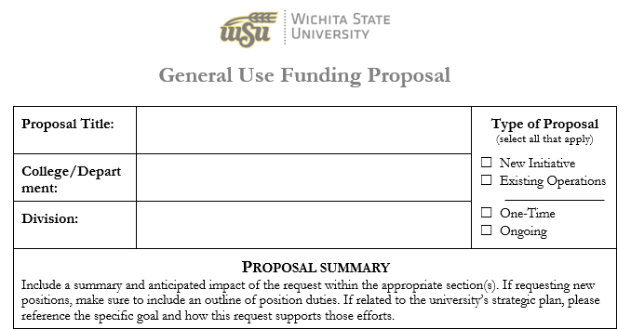When funding is available, the university has a formal process for colleges and departments to request additional GU funding allocations, which is known as a GU Funding Proposal. If requesting funding as part of the annual budget development cycle, a call for proposals is normally made in late November and requests are normally due in late December to early January. Requests submitted post budget adoption will only be considered by executive administration under special circumstances.

As part of the submission process, there are some general expectations that must be followed:

- Ensure your submitted requests are refined to reflect your highest priority needs. As you consider those priority needs, make sure to evaluate your Restricted Use (RU) funds to determine how valuable proposals can be moved forward with non-GU resources.
- Prior to completing the form, you must coordinate with your Divisional Vice President (Shirley Lefever, Werner Golling, John Tomblin, President Muma) and discuss the request to gauge Divisional VP support. Your Divisional VP must sign-off on the submitted form. Submitted forms without the appropriate signatures will not be considered.
- Regardless of the dollar amount, if you are seeking an increase to your existing GU budget, you must submit the form (this also includes increases to routine contractual costs anticipated to increase because of inflationary factors, such as utility costs, leases, IT contracts, student recruiting contracts, etc.). If a form is not submitted, the Budget Office will assume you have evaluated your RU resources and plan to utilize those as the funding source.
- Previous proposals must be re-submitted in the new form each year.
- For proposals involving new positions, make sure to include in the summary an outline of job duties and include key performance/outcome measures that demonstrate the need for the position(s).
- If data is not available to complete a section, it is essential to make a best estimate and reference it as an estimate, rather than not complete the plan. Incomplete plans will not be considered for funding.

GU Funding Proposals are reviewed with the Budget Advisory Committee to solicit feedback and help frame campus priorities. Colleges and departments are traditionally advised in late May to early June if their proposal will be included in the annual operating budget.

- Stage – 3 Requesting an Increase to Existing Student Fees or Creation of a New Fee

When requesting a change to an existing student fee, or implementation of a new fee, you’ll need to follow one of three different procedures, depending on the type of fee.

SGA Student Support Services Fee

The Student Government Association (SGA) adopts a Student Support Services Fee each year that funds a variety of different campus services in direct support of students. Campus programs that receive funding are reviewed every three years in accordance with SGA’s bylaws. In December of each year those agencies up for review who would like to continue to receive funding will be asked to submit a new funding request. At the same time, a call for any new funding requests for SGA consideration is made on campus. In early March a SGA Student Fees Committee holds hearings to hear presentations from those submitting request, which is then followed by deliberations to formulate the Committee’s fee budget, which is then adopted by the SGA Senate in late March/April. After SGA Senate adoption, the budget is then approved by the President, and finally must be adopted by the Kansas Board of Regents (KBOR) as part of the annual tuition proposal. The tuition proposal is presented for first read during the May meeting, followed by adoption during the June meeting.

College and Department Fees Less than $250,000

If revenue collections for a student fee generates less than $250,000 annually, then the university is able to make changes in the fee or the fee rate without KBOR approval. The process for these changes is managed by the Provost’s Office through a call for requests shared with colleges and departments in early spring.

College and Department Fees in Excess of $250,000

If revenue collections for a student fee generates revenue in excess of $250,000 annually, then KBOR approval is required. In early March a call for requests is made with all university deans, with funding requests due back by the end of the month. As part of the request process, KBOR does require that an information/feedback engagement is held with the impacted student body.

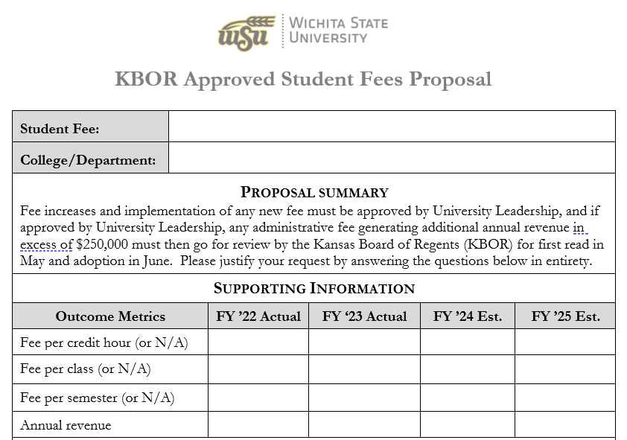

- Stage 4 – Submitting the Annual Budget Request

Accessing the University Budgeting System and Training

The IBM COGNOS/TM1 budgeting system can be accessed through a link on MyWSU in the Employee Toolbox section under University Budget or by visiting the University Budget Office’s website at Budget Software (TM1) Training (wichita.edu). If you are a Budget Officer or Budget Review Officer and encounter issues logging into the system using your university credentials, please contact your assigned budget analyst to assist.

On the Budget Office’s website both video and printable training materials are available. These include:

- TM1 Training Video – how to navigate and enter your budget request
- TM1 Reports Video – how to use the available financial and position reports in the budgeting system
- TM1 Training & Navigation Guide – summarized written outline of how to navigate and use the budgeting system

Prior to entering your budget request, it is recommended that all Budget and Review Officers watch both TM1 training videos.

The Budget Office will also hold two in-person open lab training sessions once the system is opened for budget submission. Keep an eye out for the announcements in WSU Today and register through myTraining.

If you are an experienced budget or review officer, you are likely to find the video training sufficient as a reminder of how the budgeting system works. For faculty and staff new to the process and depending on how your college or department traditionally handles the process of entering your budget requests, the open training lab will be beneficial. The open training labs are designed to work in conjunction with the training videos, as a result your attendance will be more effective if you’ve watched the training videos prior to attending the training lab.

In addition to the training options outlined, one-on-one training is available with your assigned budget analyst. But, due to high demand and limited availability, please schedule these with your analyst as soon as possible once the budgeting system is open. The Budget Office may not be able to accommodate late requests.

General Use (GU) Base Budget Targets

Wichita State uses incremental budgeting which is a traditional budgeting method whereby the budget is prepared by taking the current period’s budget, with incremental amounts then being added or subtracted for the new budget period as a base. For example, say a department had budgeted salaries totaled $1,000,000 in the current period. Next year, employee salaries will increase by 2% and they will hire one new employee, who will receive a base salary of $50,000. The formula for the new budget period base will be: Current year salary + % of increment on current salary + Salary of new employee = New Period’s Budget. ($1,000,000 + $20,000 +$50,000 = $1,070,000). The incremental budgeting approach is widely used by educational institutions, governments, and large organizations that allocate funds to departments due to its ease of use, consistency and operational stability, and funding stability.

In the Spring semester of each year, the Wichita State Budget Office distributes to each Division or College/Department, depending on the structure of the Division, a General Use (GU) Base Budget Target. The GU Base Budget Target is intended to reconcile the budgetary changes throughout the year in which you may have received additional budget authority, shifted budget authority/positions to another College/Department, or funding for one-time projects. GU funds are derived from two separate funding sources: State General Fund and General Fees. New GU resources (state funding, tuition rate, student mix, etc.) and new required GU expenses (contractual increases, prior year budgetary shortfalls, strategic investments, etc.) play an important role for determining any increase or decrease to a Colleges/Departments GU Base Budget Target.
Colleges/Departments are required to ensure their total budget entered into the TM1 Budget System (TM1) match the amount on the GU Base Budget Target provided. A check can be done through the “General Use (GU) Base Budget Targets” link under the Budget Request Input Forms section on the TM1 landing page. In the instances where a College/Department has multiple units responsible for their individual budgets, they must communicate with each other to ensure their overall target is met. No Division or College/Department is allowed to go over their budget. Changes in employee benefit costs do not impact GU Base Budget Targets from one year to the next. Instead, benefits are budgeted in the Central Fringe Benefits Pool. This is done to not penalize a department for when an employee changes benefit selection or if they hire new employees who have higher benefit costs than their predecessors. While benefits are shown on the GU Base Budget Target, they are removed at the end of the calculation.

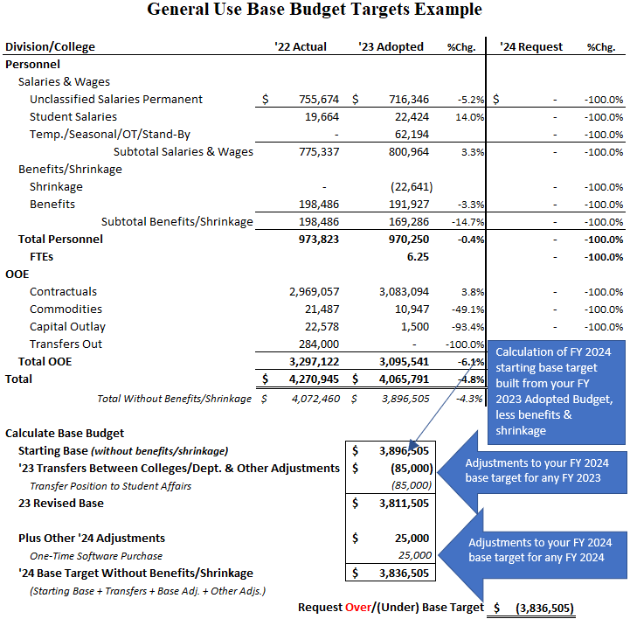

Budgeting Positions and Personnel Costs

For most university budgets, the largest and most important expense to plan for is positions and other personnel costs. The method of budgeting for personnel costs is different depending on the type of position and the type of related cost.

- Benefits eligible positions are budgeted by specific position. The budget placed on these positions are then assigned to one of three accounts, depending on the type of position:
  - 1000 – USS Salaries Permanent
  - 1100 – Unclassified Salaries Permanent
  - 1105 – Unclassified Salaries Stipend (compensation related to a specific job duty that is permanent in nature, but the faculty/staff assigned to full fill those duties may change from one fiscal year to the next – for example, a dept. chair often has a stipend related to fulfilling those responsibilities)

- All other personnel costs are budgeted in aggregate by account, and not by position. These costs often fluctuate and would be difficult to accurately estimate if budgeted by position/employee. Examples include:
  - 1110 – Unclassified Salaries – Seasonal and Temporary
  - 1010 – USS Salaries – Temporary
  - 1020 – USS Salaries – Overtime
  - 1030 – USS Salaries – Stand-by-Pay
  - 1110 – Unclassified Salaries – Seasonal and Temporary
  - 1115 – Unclassified Salaries - Additional Compensation
  - 1120/1130/1140/1150 – Grad Assistants
  - 1160 – Unclassified Salaries – Overtime
  - 1170 – Unclassified Salaries – Summer Lecturer
  - 1180 – Unclassified Salaries – Lecturer
  - 1200 – Student Salaries Regular

When preparing the personnel budget within the budgeting system, there are some very important considerations to keep in mind:

- You can change the budget on vacant positions at the salary level it is anticipated to be filled at, as long as the budgeted salary is at or above the position minimum. Changes should be in accordance with existing HR policies (if in doubt, contact your HR Business Partner). Vacant positions can be re-assigned to different fund(s) and organization(s) within the budgeting system, but please see the bullet below regarding changes to “home org.” assignments.
- For filled, benefits eligible positions, any changes must be done through the appropriate HR forms (ex. PAR or HR200), which can be accessed on the HR website. Deadlines for form submission as part of the budget process will fluctuate each year, but it is normally around mid May. Forms received after that date will not be included in the budget and the college/department will have to reconcile the changes when the fiscal year begins.
  - HR200: Used to change a current employee’s status regarding a funding change (org./fund split adjustment), name change, position reclassification, etc.
  - Position Action Review (PAR): Used for promotions/demotions/transfers, off-cycle pay changes, employee searches, etc.
- To create a new position, contact HR.ServiceCenter@wichita.edu to start the PAR process and have the position added to Banner.
- To change the “home org.” assigned to a position while developing your annual budget request, contact your budget analyst if the intent is for it to be effective the beginning of the upcoming budget/fiscal year. If effective immediately, submit the proper HR form. The home org. represents the organization responsible for managing the position, not necessarily the organization funding the position.
- Fringe benefit costs are calculated automatically within the budgeting system.
Budgeting OOE – Other Operating Expenditures

OOE, or Other Operating Expenditures, includes all expenditures that are non-personnel related. These primarily include contractual, commodity, and capital outlay expenses, as well as interfund “cash” transfers.
As a state agency, many of our financial practices must follow the standards established by the state. One of these standards is to budget by account. Although a Budget/Review Officer may feel compelled to budget all of their OOE expenses in a single account, like 2990 – other contractual services, this is not an acceptable practice. Instead, the Budget/Review Officer must budget by account in relation to their business plan and the correct accounts that properly reflect how you will use your resources to accomplish your business plan.
As you develop your budget, please remember that:

- The budgeting system will reflect only the accounts you’ve recently used. But, you can add new accounts within the system.
- There is never a reason to budget a negative amount on any revenue or expense accounts.
Budgeting by Account

The State of Kansas requires that state agencies, including the university, budget by account. When our annual budget is submitted to the state in the Fall, both the Governor’s Budget Office, as well as Legislative Research review the budget, which can influence their recommendations to the Governor and the Legislature. As shown in the graphic below, common issues that we see include:

- Not budgeting by account, missing budget entries
- The budget entered by account isn’t consistent with historical patterns (this could be appropriate if a significant change in your business plan)
- Placing all of the budget authority on a single or a handful of accounts, ingnoring the other accounts that are used
- Incorrectly entering transfers between funds (see the “Budgeting Cash Transfers Between Restricted Use (RU) Funds” section

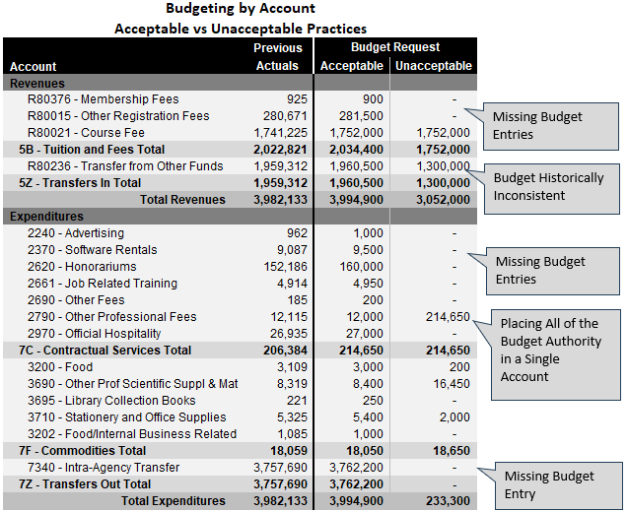

Budgeting Restricted Use (RU) Revenue

Just like budgeting for OOE, a Budget/Review Officer must budget for revenue collections by account as well. As part of developing both the business plan and the annual budget request, the Officer must estimate the amount of RU revenue anticipated to be collected for the upcoming budget year and budget it by account. As a state agency, the revenue estimates must be reasonable based on historical collection patterns, and current or anticipated changes in the variables that drive the revenue collections must be taken into account. For example, if a college is proposing a fee increase or a new fee, then the new revenue to be generated from the increase must be included in the budget submission. Other important elements include:

- The budgeting system will reflect only the accounts you’ve recently used. But, you can add new accounts within the system.
- Budgeted revenue collections must be consistent with the business plan for the next fiscal year based on realistic financial means available to achieve your overarching goals.
- Don’t inflate budgeted revenues to make your RU budget balance. Instead, consider budgeting cash if you have it available, or re-align your expenditure budget to realistic levels.
- Each budget by organization and RU fund must be balanced, meaning that resources (revenue + cash) are exactly equal to expenses.
Budgeting Cash Balances

Your business plan may call to use a portion of a Restricted Use (RU) fund’s existing cash balance to fund one-time expenditures like software, equipment, furniture, or a capital improvement to existing facilities. When budgeting to use your cash balance, it is important to understand levels of recurring revenue collections, as well as the timing during the fiscal year of when expenditures traditionally occur and when revenues are collected (also known as cash flow) to ensure adequate cash is available at any given time, especially when considering one-time purchases.

It is not recommended that a RU fund’s cash balance be used in support of recurring operational expenditures, unless it is part of a carefully developed and deliberate business plan that calls for such action to either address operational anomalies or to act as a financial bridge until known increases in revenue collections occur.

If your business plan calls for a draw on existing cash balances to fund one-time expenses or support general operations for a short period of time, you can budget the cash draw on account R70002 – Prior Year Carried Forward.

When budgeting to use cash post-budget adoption, this budget authority often already exists and does not require any budgetary action to fund a new expense. When the adopted budget is loaded to Banner, the university’s standard practice has historically been to automatically budget the cash balance carried-forward from the previous fiscal year. This allows you to utilize the cash balance for OOE expenses that may not have been included in your adopted budget, without submitting a budget adjustment form. These transactions are posted on the revenue side in account R70002 – Prior Year Carried Forward and on the expense side in OOE account BALFWD – Balance Forward-Budget Only (please note, actual expenses should never be posted to this account).

Budgeting Cash Transfers Between Restricted Use (RU) Funds

Cash transfers between RU funds must be balanced, meaning the budgeted transfer-out of one fund exactly matches to the transfer-in from another fund. Cash transfers are often used when revenue is deposited in a single fund, but the expenses supported by that revenue occurs in multiple funds. Another common scenario is when two or more colleges or departments have a partnership project, and one partner needs to reimburse the other for the budgeted expenses.

If you are transferring or receiving RU funds from another college/department, you must coordinate with them to ensure that you are both budgeting for the exact same amount. The Governor’s Budget Office and Legislative Research, who we submit our budget to, expects these to balance without fail.
Common accounts used for fund transfers include:
- Revenue for the fund receiving the transfer: R80236: Transfer From Other Funds
- Expense for the fund transferring the funding: 7340: Intra-Agency Transfer (there are additional accounts used in specific situations, particularly within Research)
Budgeting for Research Related Organizations and Funds

The university’s budgeting practice for research organizations (orgs. that begin with a 7*) is unique from the standards for all other organizations beginning with 10*. The reason for the difference is that research orgs. often have grant funding awarded with timelines that are different from our own fiscal year (July 1st to June 30th). As a result of these timing differences, the university has found it easier to have the Office of Research and the Division of Industry and Defense to estimate their overall anticipated revenue, OOE expenses, and personnel expenses that are not position specific (ex. overtime, seasonal and temp. assistance, student salaries) for entry into the budget by state fund. Research assigned benefits eligible positions do remain assigned to their 7* org. in the developed budget and any changes to those positions should be pursued through the standard HR processes.
As a result of how research organizations are budgeted, Budget and Review Officers do not need to take any actions within the TM1 budgeting system during the budget development cycle.

FAQs - Frequent Causes of Confusion in Formulating the Budget Request

Who is responsible for submitting the budget request?

Budget and Review Officers are responsible for the budgets that they are assigned to, following the guidance provided by their college deans or departmental directors. The University Budget Office does not complete budget requests on behalf of Budget and Review Officers.

RU funds were originally balanced, but no longer are. I no longer match to the GU Base Budget Target.

As positions are filled or other compensation changes occur, these actions do change your total budget request as the budgeting system updates overnight based on personnel changes entered into Banner. If the budget request is finished before the deadline, and the budget has vacant positions that are later filled, it is likely that that RU fund will no longer be balanced (resources no longer equal expenses). For Colleges and Departments with a GU Base Budget Target, recently filled positions may also cause you to no longer match to your GU target.

Even if finished, Budget and Review Officers must use the reports available in the system to ensure they still meet expectations as the final days of the process approach.

How do I Budget for Faculty of Distinction funding?

Faculty should be GU budgeted, with the FOD position funding re-assignments occurring after the budget is adopted. This is for two key reasons:

  - creates GU discretionary funding for the college after the FOD position re-assignments are processed post budget adoption,
  - actual funding allocations from both the State and Foundation can fluctuate significantly from one year to the next and aren’t known until the fiscal year starts.
See the Faculty of Distinction section for additional information.

FOD funding is received from two sources:

  - Foundation - often deposited in a fund starting with a “D”. Expenses from these funds must be used in alignment with the donors guidance. If questions, please reach out to the Foundation.
  - State of Kansas - a state match that is traditionally a smaller contribution than the Foundation, with the funding levels dependent on state investment returns from the previous fiscal year. These funds are often deposited in a fund starting with a “R” and can be used in support of the faculty member, OOE support, or staff supporting the faculty member. Because the revenue is dependent on investment returns, the funding can have significant fluctuations between fiscal years.

How do I budget for Workstudy students?
Workstudy budgets for student employment assistance (fund R40041) have already been entered for you based on the funding distributions developed by the Office of Financial Aid, Financial Operations, and Career Development. The R40041 fund is unique in that it will not balance by org.

How Do I Know My Budget is Finished

First, use the “Budget Request Variance” report to identify any orgs., funds, and accounts that have not been properly budgeted.

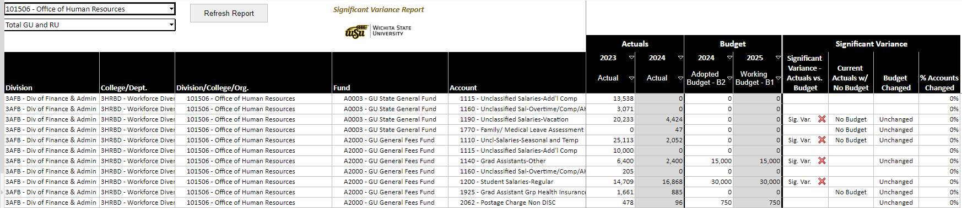

After reviewing the “Budget Request Variance” report, you can then use the Budget Submission Checklist to verify that all steps of the submission process have been completed. Within that checklist, here are some of the most important considerations:

- Verify that the budget is consistent with the business plan for the next fiscal year based on the financial means available.
- Review budgeted compensation levels of benefits eligible positions to verify they are correct in the budget submission.
- For GU funding, make sure that you have followed the guidance and funding targets provided by your division, college, or department. VP’s, Deans, and Department Heads, you must verify that the “General Use (GU) Base Targets” form shows that your “Total Request” is equal to your Base Budget Target (target input).
- For RU funding, the bottom of the “Revenue and Expenses” form shows that revenues and expenditures by fund are balanced (unless the exception of intentionally planning to increase your cash balance as previously mentioned or workstudy as referenced below).
  - You can also use the “Simple Budget Summary” report (or other reports) to check the balance of individual funds. Select the appropriate org. (or division/college/department selections if you have access to all orgs. within your division/college/department) and then select “Restricted Use (RU)” in the fund section.
  - Workstudy budgets for student employment assistance (fund R40041) have already been entered for you based on the funding distributions developed by the Office of Financial Aid, Financial Operations, and Career Development. The R40041 fund is unique in that it will not balance by org. due to the revenue being deposited in a single org. only, while the expenses occur in multiple orgs.
  - Validate that all of your individual RU cash balances will remain positive at the end of the budgeted fiscal year.
This checklist can be used by a Budget Officer or Review Officer to verify that they have appropriately completed the budget submission process.

Budget Submission Checklist
Training: Reviewed the budget manual, watched the budget training videos (TM1 Training and TM1 Reports), and attended an Open Lab training session (if needed).
RU Revenue: Estimated all RU revenue collections by appropriate account and entered them in the budgeting system in the “Revenue and Expenses” input form.
Position and Salary Review: Reviewed all budgeted, benefits eligible positions, validating salary and org./fund assignments. Appropriate adjustments on vacant positions have been entered in the system (remember you can’t budget a vacant position below the minimum salary range).
HR Forms – Filled Positions: Submitted PAR and/or HR200 forms by the deadline in relation to any changes for filled, benefits eligible positions.
HR Forms – Creating New Positions: Contacted HR at HR.ServiceCenter@wichita.edu to have any new benefits eligible positions created.
Expenditures: Entered all GU and RU budgeted expenditures by the appropriate account, in accordance with the business plan. Use the “Budget Request Variance Report” to validate proper entry by account.
RU Fund Transfers: All RU transfers between funds are balanced (transfer out of one fund is exactly equal to the budgeted transfer in to another fund).
GU Base Budget Target: Verified that the entered GU base budget matches to the GU base budget target using the “General Use (GU) Base Targets” input form (applies primarily to colleges and depts., individual orgs. are not given targets by the Budget Office).
RU Funds Balanced: Verified that all RU funds are balanced with budgeted resources = budgeted expenditures (unless planning to increase cash balances). If planning to draw down existing cash balances to fund a one-time project or in temporary support of ongoing operations, this will be budgeted on account R70002 – Prior Year Carried Forward.

- Stage – 5 Budget Maintenance: Common Actions, Monitoring, and Reporting

While developing your annual budget, or while monitoring and maintaining your adopted budget, there are a variety of key actions that a Budget Office and Review Officer will have to take. These common actions include requesting the creation of new organizations and funds; requesting budget transfers and adjustments; processing cash transfers; position and personnel changes; monitoring GU shrinkage (salary savings) balances; and monitoring the overall budget through financial reports.

Faculty of Distinction

The Kansas Partnership for Faculty of Distinction Program was enacted by the Kansas legislature in 2000 to assist eligible educational institutions (see KSA 76-773) to attract and retain highly qualified faculty. Through a partnership among the institutions, private donors, and the State of Kansas, qualified gifts to an endowment association are matched by the State at an interest earnings equivalent rate. The institutions are required to use the earnings in coordination with endowed funds to support the professorships established through the Program. For Wichita State University, qualifying gifts of at least $350,000 to establish professorships for participating in the Faculty of Distinction Program. Within the university’s financial system, the state match is deposited in a “R” fund within the college, while foundation endowments are deposited in a “D” fund.
Faculty of Distinction Process Steps
- State funding match allocations are received from KBOR and deposited in state match holding org/fund 101519/R10620.
- Foundation prepares summary tables outlining endowment funding available per each individual endowment award.
- In the fall of each year, the Budget Office prepares initial tables to facilitate the calculation of position reassignments for use of the available funding, for consideration of the college. The college will review, make appropriate changes based on discussions with the FOD faculty, and then resubmit the form to the Budget Office for processing of the position re-assignments through ePAF’s. Any OOE adjustments in comparison to the current budget are processed by the college either directly in the university’s financial system or by submission of a Budget Adjustment Form.
- Budget Office and Financial Operations prepares and processes cash transfers from the state match holding org/fund to the appropriate college “R” fund. Colleges verify that the correct org/fund is reflected in the table.
- Colleges request from the Foundation transfers of endowment earnings to their appropriate “D” fund based on their plans for use and in accordance with the provisions of the endowment award.
- Budget Office prepares and submits funding change ePAF’s through the normal process to adjust position splits in accordance with the college’s plan for use of available funding for the current fiscal year.
- Colleges monitor budget and variance to budget for all accounts supporting Faculty of Distinction and take action as necessary to maintain financial stability.

Request to Create a New Organization or Fund

To properly manage financial activities, creation of a new organization or fund may be required. The Chart of Accounts (COA) structure in Banner is made up of what is called a FOAPAL string comprised of six elements to categorize each financial transaction posted to Banner.

 | F | O | A | P | A | L
 | Fund | Organization | Account | Program | Activity | Location
Example | A2000 | 102144 | 3690 | 20440 | (limited use) | (limited use)
Fund | Identifies the source of funding and segregates cash and other resources designated for specific purposes.
Organization | Identifies a unit of budgetary responsibility. It is normally used to define “who” spends the money.
Account | Identifies natural classification of a finance activity or “what” the funding is being spent on.
Program | Identifies the organization objective that is being accomplished or “why” the money is being spent.

A new organization or fund can be requested by completing the request form, and submitting it as instructed in the form. Requests to establish a new fund are processed by Financial Operations.

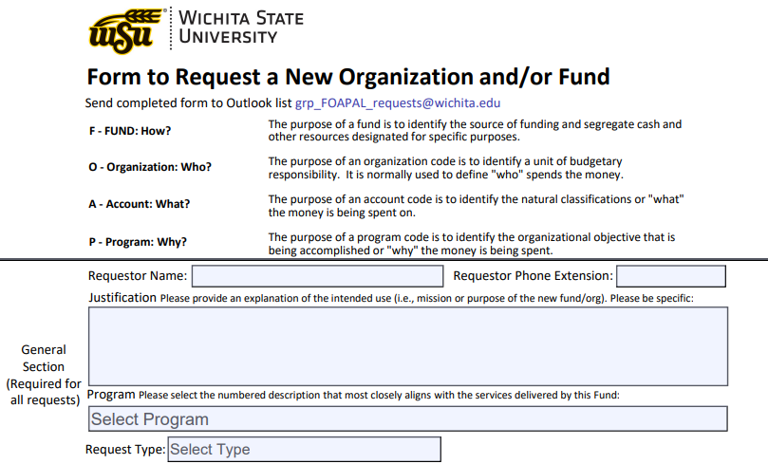
Request for a Budget Transfer or Budget Adjustment

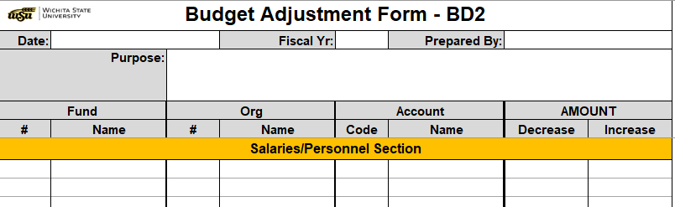

The Budget Adjustment Form can be used to request Budget Transfers or the Creation of New Budget Authority. These changes only impact the “planning” of how financial resources are intended to accomplish goals/responsibilities through your budget and business plan. Requested changes to your budget will not impact actual expenditures or revenue collections.

Budget Transfers

A budget transfer is an action to re-align your budget by transferring existing budget authority from one org./fund/account and placing it in a different org./fund/account. The transfer then provides the required budget authority to pursue procurement of OOE (Other Operating Expenses) or personnel expenses.
Budget transfers are often processed for a few common reasons:

- Existing budget authority is in the wrong account
  - Even the best business plans change over time. For example, you may have planned to have a contractual vendor deliver a service, but then later choose to not pursue the service from a third party, but instead paid overtime to existing staff to deliver the same service. In this case, the Budget/Review Officer will need to process a budget transfer from the OOE contractual account to the classified and/or unclassified overtime accounts of 1020 and 1160.
- Responsibilities have shifted from one College/Department/Org. to another
  - Occasionally, the area responsible for delivering a service on campus changes. When this occurs, the existing budget authority funding those services must be transferred to the new area of the university now delivering the service.
- A new service is funded
  - After the budget is adopted, campus administration may choose to fund an activity or service that wasn’t originally part of the adopted budget. If that new activity is to be funded with General Use (GU) funding, then this will often result in a budget transfer to the College/Department/Org. that will implementing the new service.

Important things to know when making the request:

- Transfers must include an increase and a decrease in the budget in equal amounts and can only occur on existing, unexpended budget authority.
- General Use (GU) Budget Transfers:
  - Budgetary changes regarding GU funding are always addressed through a budget transfer. You should never need to create new budget authority.
  - Transfers must be within the same GU fund (e.g., A0003 to A0003 or A2000 to A2000). Transfers cannot cross GU funds.
- Restricted Use (RU) Budget Transfers:
  - Budgetary changes regarding RU funding may need to be a transfer, or you may need to create new budget authority, depending on the circumstances.
  - RU budget transfers are traditionally processed only within the same RU fund. Budget transfers between RU funds are rare because each fund is its own unique representation of financial activity and operational purpose. Perhaps an easier way to think of it is as if each fund is a separate “checkbook”. As a result, if an actual expense is to occur in a different fund from where the actual revenue was collected, then those resources must be placed in the other fund to offset the expense. This is accomplished through a “cash transfer” processed through Financial Operations and submission of budget adjustments to the Budget Office in support of the new financial activity occurring within both of the funds.

Budget Adjustments - Creating New Budget Authority/Reducing Existing Budget Authority for Restricted Use (RU) Funding Only

New budget authority or reductions to existing budget authority should be requested by a Budget/Review Officer in the following key instances:

- A new service or expansion of an existing service is occurring.
- Restricted Use (RU) revenues are now expected to exceed the original estimates included in your adopted budget and you plan to use all or a portion of the new resources. The opposite is also true, if RU revenues are expected to be less than budgeted, a Budget/Review Officer must re-align their budget by reducing anticipated revenue collections and reducing budgeted expenses by an equal amount. If the org./fund has adequate positive RU cash balances, a Budget/Review Officer may choose to utilize the existing cash balance as a temporary option to address the reduction in revenue collections.
- RU revenue projections have been revised down, and the Budget/Review Officer is now preparing to re-align budget expectations for the year.
- A previously unbudgeted cash transfer between RU funds is occurring.

Important things to know when making the request:

- Fringe Benefit Calculations
  - Most changes to fringe benefits are automatically calculated in the Budget Adjustment form, with exception of health benefit costs. These must be manually entered.
- Revenue and Expenses must be balanced
  - When creating new budget authority, the request by the Budget/Review Officer must be balanced. This means that if you add new expenses, you must also add new budgeted revenue to fund the new expense.
- Use of cash balances to fund a new expense
  - Often, this budget authority already exists and does not require any budgetary action to fund a new expense. When the adopted budget is loaded to Banner, the university’s standard practice has historically been to automatically budget the cash balance carried-forward from the previous fiscal year. This allows you to utilize the cash balance for OOE expenses that may not have been included in your adopted budget, without submitting a budget adjustment form. These transactions are posted on the revenue side in account R70002 – Prior Year Carried Forward and on the expense side in OOE account BALFWD – Balance Forward-Budget Only (please note, actual expenses should never be posted to this account).
Submitting the Request

After completing the form, the Budget Office or Budget Review Officer for the impacted organization should email the form to their assigned Budget Analyst.

Using the Form

The form is designed so that when a user enters a fund/organization/account code, the name will populate automatically. In the instance that the name does not populate correctly, a user can unprotect the form by going to “Review”, and then selecting “Unprotect Sheet” to then be able to manually enter the correct name.
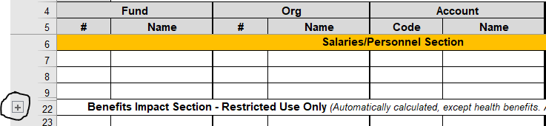
If the request requires additional rows, the form includes expansion buttons to the left of the worksheet to expand the number of rows available within each section. Prior to selecting the expansion button a user must unprotect the form by going to “Review”, and then selecting “Unprotect Sheet”.

For Restricted Use (RU) requests involving personnel, the form will calculate the impact on fringe benefit accounts based on the rates included in the “Benefit Rates” tab. Keep the following exceptions in mind:
- Health Benefits: Because health benefit costs vary based on the type of benefit selection chosen by each employee, as well as the timing of when the budget change is effective, this entry must be manually entered.
  - A safe methodology for estimating these costs is to assume the employee(s) has selected the most expense benefit option of Family (single + dependent) and then to estimate the remaining costs based on the number of months remaining in the fiscal year. Another methodology is to use the average cost per FTE from the adopted budget.
- Retirement: This is estimated based on the Regents retirement rate. The real retirement rate can vary depending on the type of employee or their chosen selection.

All fields at the top of the form must be completed, including a brief outline of the purpose/reason for the request.

The excel workbook includes a “Common Account Search” tool. If you’re not certain of the correct account to use in your request, this tool can make it easier to identify the correct selection(s).

Below is a simple example of a completed form transferring budget authority between OOE accounts within the same org. and fund combination.
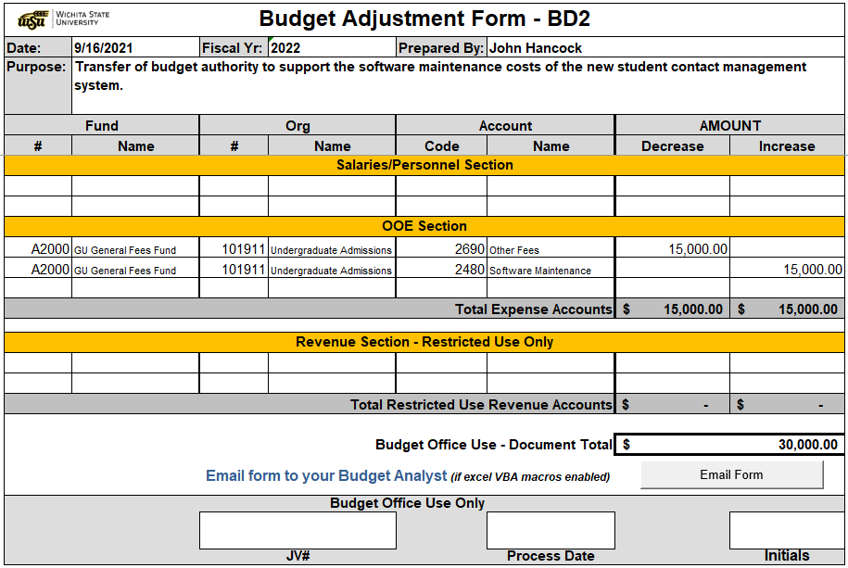

Restricted Use (RU) Cash Transfers

A cash transfer is the reallocation of collected Restricted Use (RU) revenue from one Org/Fund to another. Cash transfers occur primarily due to revenue collections being deposited in a single Fund and Org, while the operational expenses related to the collection of the revenue are occurring in multiple Orgs/Funds. Another common reason for a cash transfer includes when one area of the university agrees to help fund the operations of another area thru their RU revenue collections.

Cash transfers are processed by Financial Services and the form can be found on their Form Page here: https://www.wichita.edu/services/controller/fobt_forms.php

Note: General Use fund numbers must never be used on this form. The Budget Adjustment form is to be used for the transfer of General Use funds. This form should also not be used to pay for services or to transfer safekeeping funds. For additional information, please contact Financial Services.

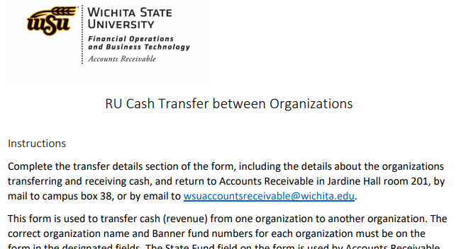

Position and Personnel Changes

Personnel Changes must be requested differently depending on what is changing and if the position is filled or vacant. Below is an outline of which form might be required based on the personnel action, please reach out to your HR Business Partner, Budget Analyst, hr.servicecenter@wichita.edu or epaf@wichita.edu if you have any questions.

All Forms can be found on the Human Resources Forms Index, with more detailed instructions as well: https://www.wichita.edu/services/humanresources/Forms/Index.php

Non-Benefits Eligible Employee (Temp or Student Position)
Vacant Position
- Request to hire: Non-Benefit Eligible Hire Form
- Request to change funding: Funding Change ePAF or reach out to hr.servicecenter@wichita.edu if a new position number is needed.
Filled Position
- Request to change hours or pay rate: Change of Status ePAF
- Request to change funding: Funding Change ePAF or reach out to hr.servicecenter@wichita.edu if a new position number is needed.
Needing to submit a termination: Termination ePAF

Benefits Eligible Employee
Vacant Position
- Request to hire: PAR Form
- Request to change funding: OHR 200 Form (Or OHR 220 Form if Research Funded)
Filled Position
- Request to change hours/FTE only: OHR 200 Form (Or OHR 220 Form if Research Funded)
- Request to change pay rate or position title: PAR Form
- Request to change funding distribution only: OHR 200 Form (Or OHR 220 Form is Research Funded)
- Request to create a new position: contact HR.ServiceCenter@wichita.edu to start the PAR process and have the position added to Banner.
- Needing to submit a termination: Termination ePAF

*Positions in the Division of Industry and Defense Programs do not follow these processes; please reach out to your Human Resources Team if you have questions at: hr-niar@niar.wichita.edu .

General Use (GU) Shrinkage (Salary Savings)
Shrinkage is a reduction to the University budget for salaries and wages as a result of vacancies that occur throughout the fiscal year. It is a reduction imposed by the state on general use funded budgets. As result, the total budget required for salaries and benefits is reduced by a percentage factor as determined through the appropriation process. The shrinkage rate for Wichita State University is 2.28%. Absent the shrinkage reduction, University departmental budgets are funded fully for salary and fringe benefit requirements.
The current process assigns authority to central administration to appropriate any “salary savings” generated during the fiscal year, focusing on one-time projects of a strategic nature. At the beginning of each fiscal year, the total budgeted GU shrinkage cost at the state mandated 2.28% rate is transferred from adopted operating budgets and assigned to the Campus-Wide GU Shrinkage Pool. As positions become vacant throughout the fiscal year, at the end of each payroll period, the Budget Office processes a capture of the budgetary savings generated for that single payroll period from operating budgets. The budgetary monies captured are split in the following manner:
- 90% transferred to the Campus-Wide GU Central Shrinkage Pool.
- 10% transferred to a designated shrinkage org. for each division. The transfer is intended to serve as a funding source to:
  - offset compensation changes for new employees that exceed that of the previous position holder. These costs are reflected in the “Filled Shrinkage Org.” discussed below.
  - support miscellaneous and smaller scale personnel related expenditures.
- Each division/college possesses a Filled Shrinkage Org. that captures salary changes on filled positions. This could include the hiring of a position at a higher or lower salary than budgeted, an offcycle pay-raise, or funding assignment changes on a filled position through an HR200. It is the responsibility of the Division/College to monitor the balance, and if necessary supplement the balance, in order to make sure it does not go negative.
- In the case of a faculty member placed on Research Release, the College retains the position’s generated savings to support a teaching overload, hiring of a graduate student or lecturer, and to incentivize research efforts. These savings are placed in the Colleges Research Release Shrinkage Org.

In addition to processing the shrinkage actions referenced above, the Budget Office also processes the following related actions.
- Vacation payout: for GU employees leaving WSU, but not retiring, their vacation payout is paid by the Campus-Wide GU Shrinkage Pool. No action is required from the College/Dept.
- Military/FMLA Leave: if a GU funded employee is on leave, the College/Dept. may request the position be backfilled with a temporary employee or encounter additional overtime expenses. To fund the additional cost, the College/Dept. can submit a form outlining the position on leave, anticipated cost, and supporting documents to the Budget Office. The Budget Office will then process the transfer from the Campus-Wide GU Shrinkage Pool to their operating budget.
- Campus-Wide GU Shrinkage Pool Requests: approved central shrinkage requests will be processed to the Organization and GU Fund indicated on the request form. Acceptable central shrinkage requests include: one-time purchases, start-up costs for new programs or initiatives, additional compensation or other controllable salary expenses due to employee absences or turnover.

Colleges and departments that contribute to the GU shrinkage balance are allowed to request use of the balance to cover expenses specifically related to the vacancy of a GU funded position. These would generally include:
- Overtime
- Lecturer expense
- Additional compensation
- Temporary staff

Additional types of requests are possible, but please visit with your assigned budget analyst prior to submitting the request. Requests are approved by a Central Shrinkage Review Committee, which includes the VP for Finance and Administration, Executive VP and Provost, Associate VP for Financial Services, and University Budget Director.
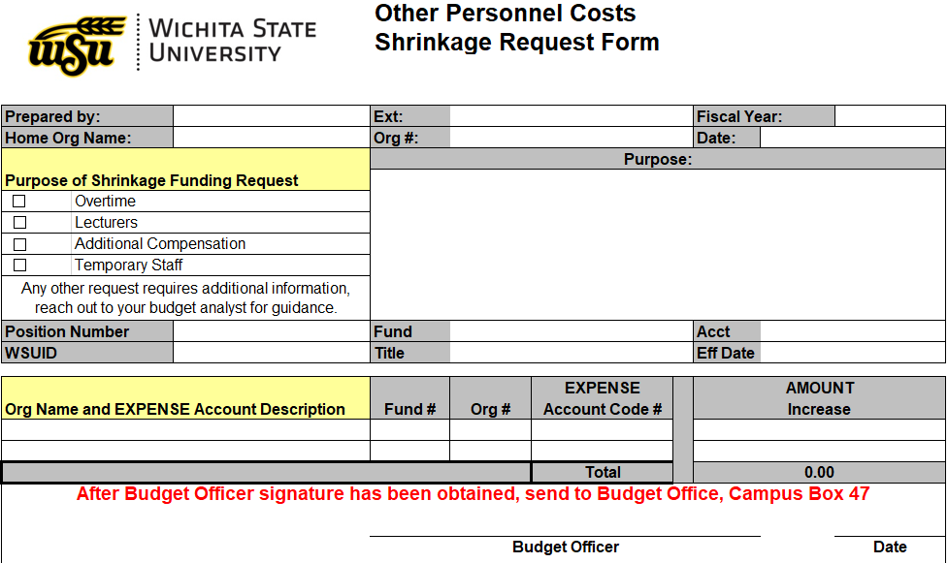
Division/College Shrinkage Organizations List

Division Filled Position Shrinkage Orgs
101551 President - Shrinkage Filled
101552 Academic Affairs - Shrinkage Filled
101554 Admin & Finance - Shrinkage Filled
101573 NIAR - Shrinkage Filled
101577 RTT - Shrinkage Filled
101555 Student Affairs - Shrinkage Filled

College Filled Position Shrinkage Orgs
101570 Shrinkage - Barton School
101558 Shrinkage - Applied Studies
101528 Shrinkage - Engineering
101571 Shrinkage - Fine Arts
101572 Shrinkage - Health Professions
101574 Shrinkage - Library
101567 Shrinkage - Liberal Arts

Division Vacant Position Shrinkage Orgs
101593 President - Shrinkage Vacant
101591 Academic Affairs - Shrinkage Vacant
101592 Admin & Finance - Shrinkage Vacant
101596 NIAR - Shrinkage Vacant
101594 RTT - Shrinkage Vacant
101598 Student Affairs - Shrinkage Vacant

Research Release Shrinkage Orgs
101560 Acad Affairs - Shrinkage Res Rel
101562 Barton School - Shrinkage Res Rel
101565 App Studies - Shrinkage Res Rel
101564 Engineering - Shrinkage Res Rel
101563 Fine Arts - Shrinkage Res Rel
101566 Health Prof - Shrinkage Res Rel
101561 Liberal Arts - Shrinkage Res Rel
101568 Library - Shrinkage Res Rel

Monitoring the Budget and Reporting

The budgeting system includes a variety of reports designed to assist in both the development, as well as the monitoring of your annual budget. For the best overview of available reports and how to run them, please watch the TM1 Reports Training Video. When monitoring your budget during the fiscal year, there are a few key items a Budget Officer and Review Officers should concentrate on.

Monitor Actual Revenue and Expenditure Trends in Comparison to the Budget

Monitor your revenue and expenditure collections in comparison to the budget and understand how they have changed over time. A recommended report for this purpose is the “Budget Monitoring Report”. It provides both historical comparisons, as well as a comparison of budget to actuals to quickly gauge how your current trends compare to previous years (often referred to as a burn rate).

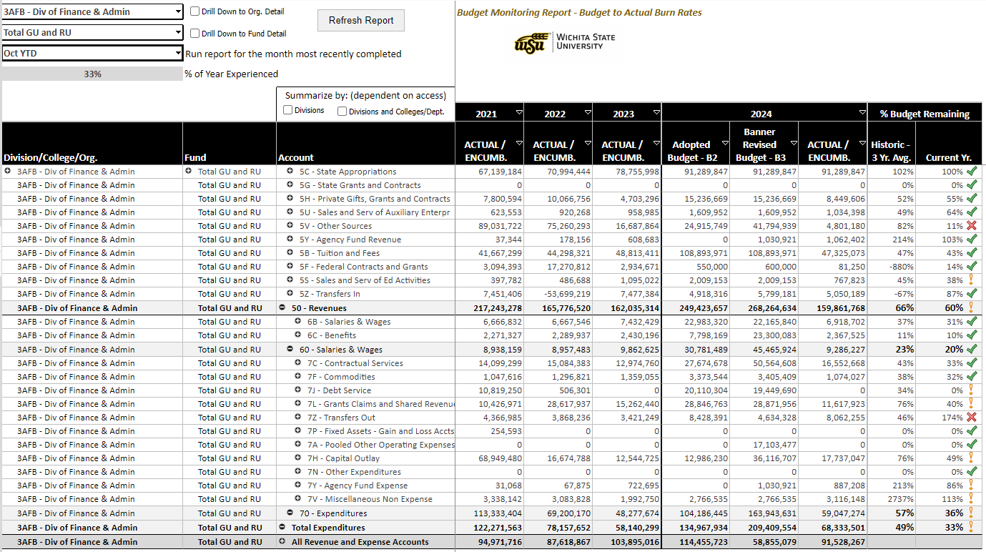

Monitoring Personnel Expenses

As an organization that relies heavily on human resources to deliver educational services and research, monitoring of budgeted to actual personnel expenses is a vital aspect of financial management at the university. The budgeting system includes several reports that are useful for this purpose.

The “Compensation Excluding Benefits” report provides an excellent outline of budgeted compensation by position and employee by account, actual compensation levels, and summarized data for the other compensation accounts that include additional compensation, overtime, seasonal and temporary assistance, and student salaries.
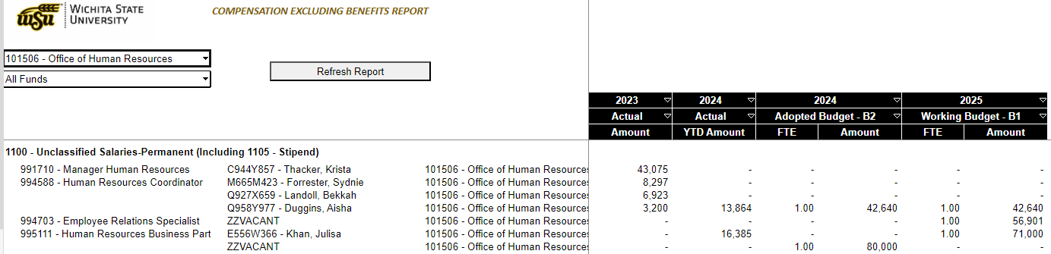

For more advanced analysis, the ‘Multi Year Position Summary” report provides the ability to isolate and analyze personnel information by division, college, department, organization, fund, account, employee, position, eclass, and pclass over multiple years.

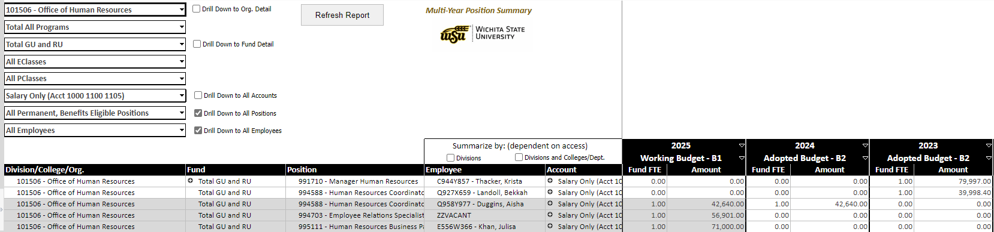

For areas managing RU funds who have to monitor benefit costs, the “Compensation and Benefits” report provides a helpful breakdown of compensation and benefit costs by position.

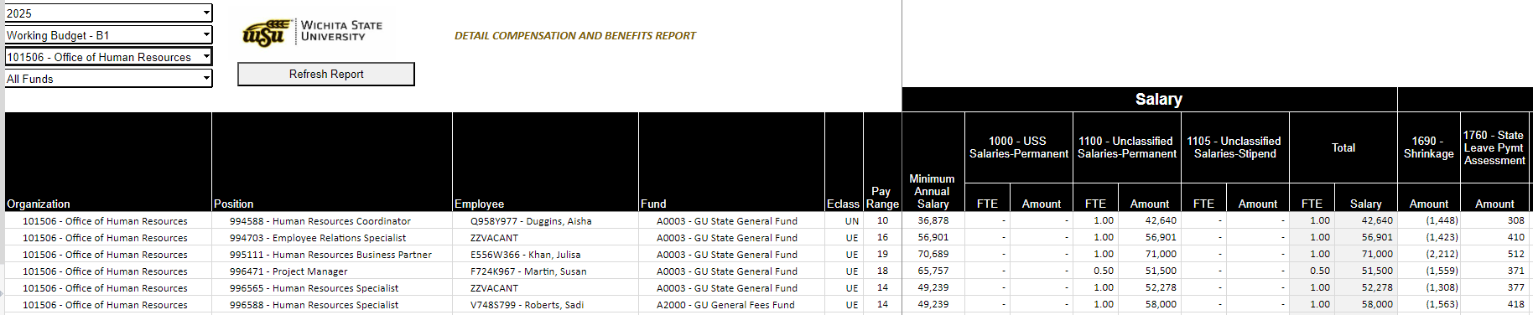

Monitoring RU Cash Balances

The monitoring of cash balances and cash flow is one of the most important actions that a Budget Officer or Review Officer can perform to fulfill their financial responsibilities. The budgeting system includes two reports to assist in this effort. The “Monthly Cash Flow” report provides a break down by month of how RU fund balances have changed throughout the fiscal year, while the “Multi Year Cash Summary” provides the ability to see how balances have changed over time, including a by quarter comparison.

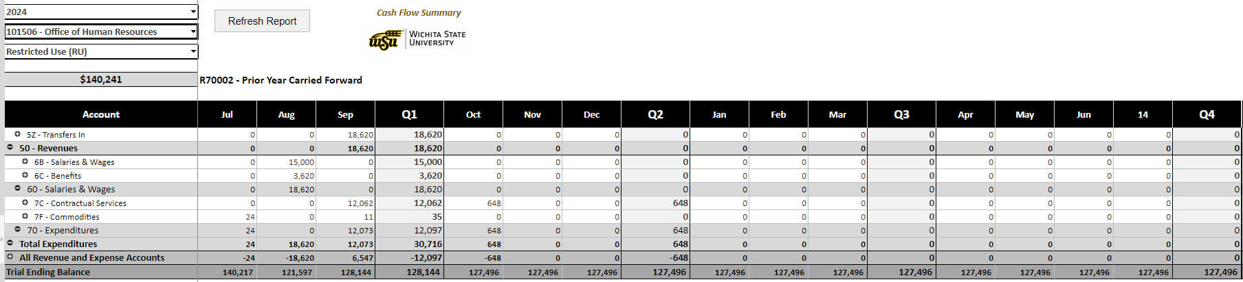

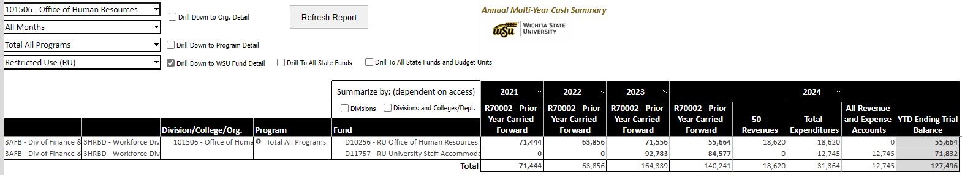

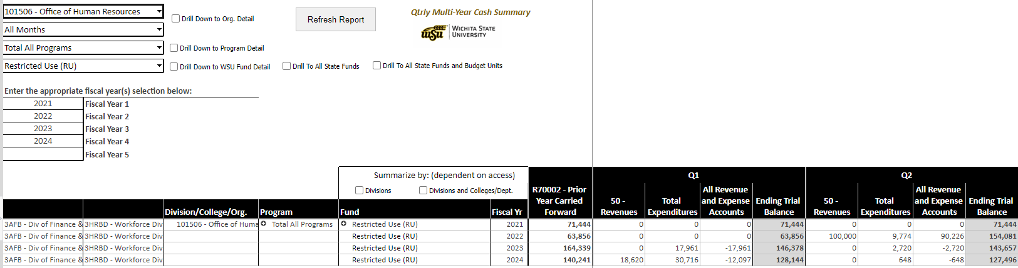

GU End of Year (EOY)

As part of the year-end process GU controllable salaries and wages, and other operating expenses (OOE) that were overspent during the fiscal year in comparison to the budget must be reconciled. The “EOY Budget Variance” report can be used to quickly identify the overspent budgets that must be corrected prior to year-end.

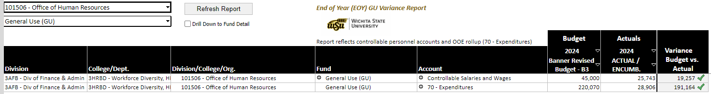
- Who to Contact with Questions

All colleges, and most departments, have a formal business manager, or a position(s) with similar duties assigned to assist with the financial operations of their campus area. Because colleges have their own internal practices for developing and monitoring the annual budget, as established by the dean, it is often best to reach out to them first. For more significant financial challenges, please see the Budget Office’s Staff Assignments below.

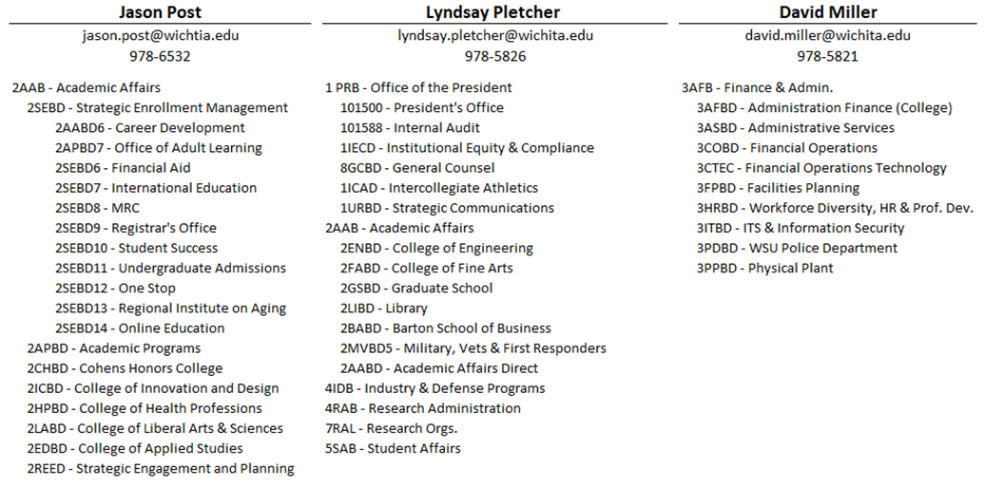

- Other Key Information

The University Budget Office’s website includes a variety of important information that may be helpful in developing your budget request. These include a payroll schedule (including detail for nine and ten month appointments), program code definitions, chart of accounts, and fringe benefit rates broken down by employee type.

Comparison of Fringe Benefit Rates Between FY 2023 through FY 2025
 | Fringe Benefits |  |  |  | FY 2023 Rate |  | FY 2024 Rate |  | FY 2025 Rate
 | KPERS Retirement Rate |  |  |  | 13.11% |  | 12.57% |  | 11.42%
 | Regents Police Officer Retirement |  |  |  | 22.99% |  | 22.86% |  | 23.10%
 | Regents Retirement |  |  |  | 8.50% |  | 8.50% |  | 8.50%
 | Death and Disability Insurance Benefit |  |  |  | 1.00% |  | 1.00% |  | 1.00%
 | Workers Compensation Assessment |  |  |  | 0.287% |  | 0.284% |  | 0.273%
 | Unemployment Compensation |  |  |  | 0.00% |  | 0.00% |  | 0.06%
 | State Leave Payment Assessment |  |  |  | 0.72% |  | 0.72% |  | 0.72%
 | FICA Rate |  |  |  | 7.65% |  | 7.65% |  | 7.65%
 | FICA Maximum Salary for OASDI
 | Paychecks Issued July1-December 31 |  |  |  | $147,000 |  | $160,200 |  | $167,700
 | Paychecks Issued January 1-June 30 |  |  |  | $160,200 |  | $167,700 |  | $174,900
Health Insurance - Employer Paid (Annual)_

Single Member Health Insurance Premium
 | Full-Time Employees |  |  |  | $8,223.36 |  | $8,994.00 |  | $9,399.84
 | Part-Time Employees |  |  |  | $6,517.68 |  | $7,298.88 |  | $7,655.76
 | Dependent Health Insurance Premium
 | Full-Time Employees |  |  |  | $12,109.92 |  | $13,163.76 |  | $13,774.56
 | Part-Time Employees |  |  |  | $9,589.44 |  | $10,594.08 |  | $11,112.72
 | Healthy Kids Health Insurance Premium
 | Full-Time Employees |  |  |  | $12,842.88 |  | $13,951.68 |  | $14,637.84
 | Part-Time Employees |  |  |  | $10,198.08 |  | $11,247.12 |  | $11,799.60

