Diversity, Equity and Inclusion (DE&I) Report
Academic Year 2022-23
June 14, 2023

College Mission Statement
To be an essential educational and economic driver for Kansas and the greater public good

Faculty Hiring Initiative

Goal
Recruit, develop and retain faculty and staff who are committed to recruiting, developing and retaining a diverse and inclusive student.

Rationale
Research shows that student recruitment and retention are influenced by the representation of faculty and staff. For example, WSU is an emerging Hispanic Serving Institution (HIS), and engineering students are 13% Hispanic, yet we have no Hispanic faculty born in the U.S. in the college. Moreover, the way that faculty and staff conduct their classrooms, meetings and interactions with students affects the learning climate.

Initiative
Tenure-track faculty recruitment for Fall 2023

Responsibility
- Dean
- Associate Dean for faculty development
- Department chairs
- Department and college search committees

Approach
- We ensured a broad and diverse pool of applicants by training search committees on building diverse pools of applicants, writing a broad job description, advertising in a wide range of outlets including those focused on specific demographic groups, and adding to the candidate evaluation criteria.
- The dean and associate dean for faculty development led the department chairs and search committee in a series of training and discussions on recruiting diverse faculty.
- The deans and department chairs collaborated on a job description template that was inclusive of a wide range of candidate backgrounds.
- Two department chairs attended national conferences and recruited applicants.
- Candidates were required to submit research, teaching and DE&I statements and were evaluated on four criteria weighted equally: research accomplishments, research potential, teaching accomplishments and DE&I accomplishments.

Impact
Candidates were rejected without further consideration if all three required statements were not submitted. There were one Black and 13 Hispanic applicants in the entire candidate pool based on the voluntary demographic information provided. The six department searches yielded 21 finalists of whom nine were female and 12 were male. There were no Black or Hispanic candidates who made it to the finalist stage. We made 17 job offers and two were accepted: one female and one male. There is one outstanding offer.

Next Steps
The deans and chairs will analyze the tenure-track faculty process to identify strengths and areas for improvement. We will work with minority-serving institutions, such as Historically Black Colleges and Universities (HBCUs) and HSIs. The objective is to identify people early who are interested in a faculty career and in WSU’s mission so that we can help them become more competitive tenure-track candidates.

Featured Student Programs and Events

Shocker Engineering Academy (SEA)

Overview
Shocker Engineering Academy (SEA) is a summer bridge program to help new underrepresented students transition into WSU and increase their academic success. Students can jump-start their education through a week engaged in academic enrichment sessions, hands-on activities and fun social events. For the hands-on activities, the SEA students collaborate with GoBabyGo to modify ride-on cars for young children with mobility issues from the Wichita community. SEA is funded by the National Science Foundation (NSF) Kansas Louis Stokes Alliances for Minority Participation (KS-LSAMP).

Summer 2022–Spring 2023
In August 2022, 23 students participated in SEA. All except for one student returned to the College of Engineering in Spring 2023; that is 96% fall-to-spring persistence. The demographics of the participants are as follows:
- 48% women
- 74% first generation
- 60% Hispanic
- 22% Black
- 17% Native American

Introduce a Girl to Engineering Day (IGED)

Overview
Introduce a Girl to Engineering Day (IGED) is a national outreach event that takes place during National Engineers Week. The purpose of IGED is to foster a positive connection between young women and STEM. Professional and collegiate volunteers mentor high school students and participate in motivational presentations, STEM hands-on activities and a career fair. IGED inspires and empowers young women to believe engineering is a possible career path.

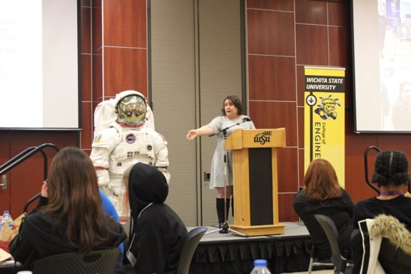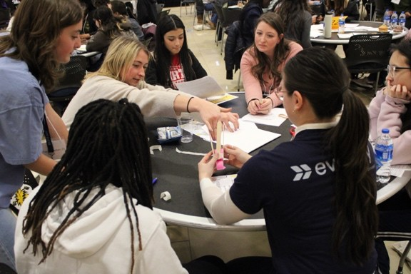
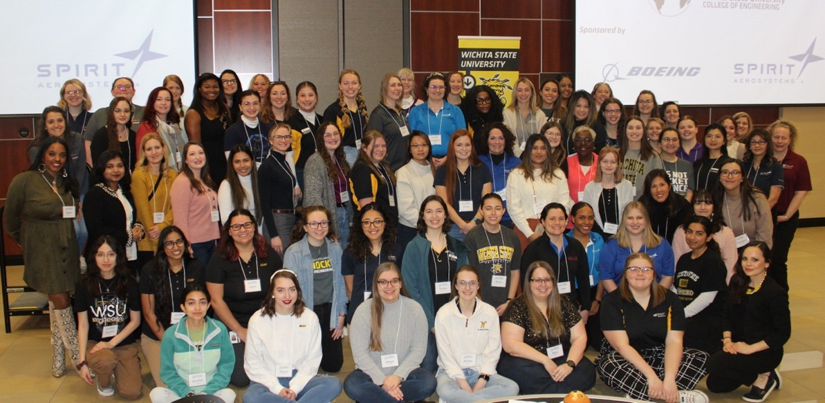

2023 Event
For the inaugural 2023 year, the College of Engineering collaborated with Wichita Public High Schools and about 110 high school students attended the day-long event. The students were mentored by 75 professional and collegiate women in different engineering and computing fields who volunteered their time. The demographics of the students who registered are:
- 39% Hispanic
- 24% White
- 21% Black
- 12% Asian
- 3% Native American
- 1% Not reported
From the post-event surveys, 88% of students agreed or strongly agreed that they will pursue a degree in engineering or computing. The students indicated that the most impactful elements of IGED were mentorship, hands-on activities and alumni

motivational presentations. Overall, 97% of all attendees reported having benefited from attending the inaugural WSU IGED 2023.

Spirit Strong Scholars Program

Overview
The Spirit Strong First-Generation Scholar Program is a first-year success program for incoming first-time College of Engineering freshmen who are first-generation college students with financial need. The program lasts for a full academic year and includes peer and professional mentorship, academic and professional development workshops, tutoring, social engagement and financial assistance. Students who complete the program are guaranteed an internship interview with Spirit AeroSystems in the fall of their sophomore year and are also encouraged to become peer mentors in the program.
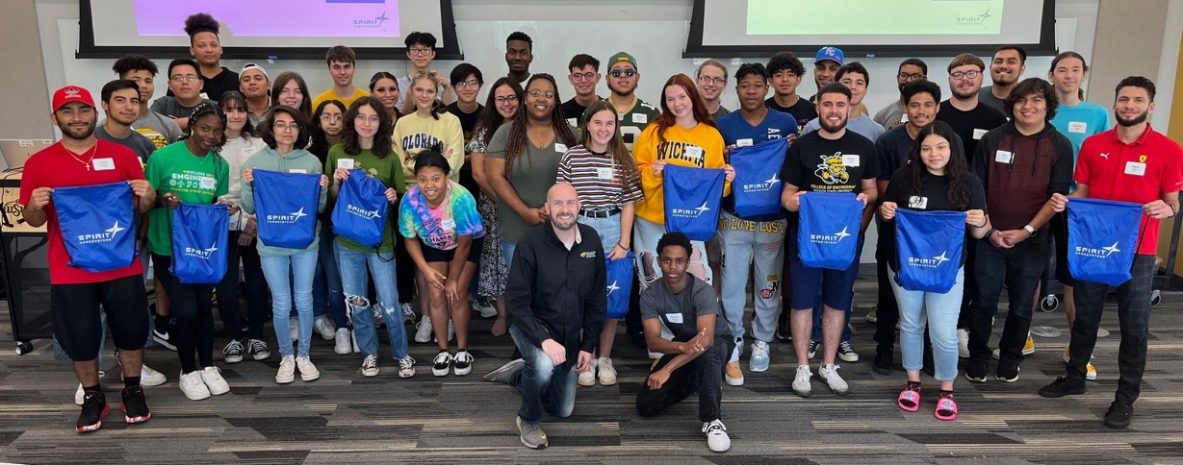

Program Goals
- Assist students with making the transition from high school to college and adjusting to college life and academic expectations.
- Provide a network of support through connections with peers, mentors and College of Engineering staff.
- Assist students in developing habits for success in college.
- Provide resources and guidance to aid students in successful persistence from the first to the second year of college.

2022-2023 Program Participants

For the academic year 2023, 47 fall 2022 incoming freshmen applied for the program. Of those, 29 were selected to be in the program. Below is demographic data on the 29 scholars for the academic year 2023.

Demographic | Count | Percent
Woman | 12 | 41%
Man | 17 | 59%
Asian | 2 | 7%
American Indian/Alaska Native | 1 | 3%
Black/African American | 5 | 17%
Hispanic | 17 | 59%
White | 4 | 14%

Impact
For the academic year 2023 cohort, there was an 86% fall to spring retention rate in the College of Engineering. Since it is too early to measure freshman to sophomore retention for the academic year 2023 cohort, below is retention data for the academic year 2022 program cohort, which had similar demographics.

Fall 2021 Incoming College of Engineering Freshmen | # Enrolled Fall 2021 | # Returned 2nd Year | % Retained Year 1 to Year 2
Spirit Strong Scholars | 30 | 21 | 76.7%
CoE Under-served Students | 209 | 132 | 53.1%

Wallace Invitational for Scholarships in Engineering/Wallace Scholars

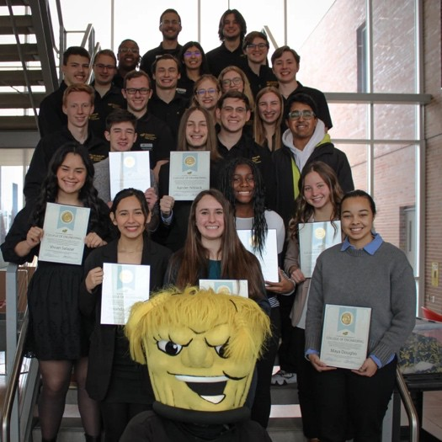
Overview
Each fall in November, the College of Engineering hosts the Wallace Invitational for Scholarships in Engineering, a scholarship competition for eligible high school seniors that is used to select our next incoming freshman class of Wallace Scholars. The Wallace Scholars program is the longest- standing and most prestigious scholar program in the College of Engineering. Wallace Scholars receive a $28,500 Wallace Scholarship package to attend WSU. Winners are announced in February each year.

Fall 2022
This year, the Engineering Student Success Center (ESSC) made intentional efforts to select an incoming class of scholars that both met the high standards for the Wallace program and represent the diversity of the College of Engineering student body. Based on these purposeful efforts to support diversity and equity, the college named the most diverse incoming freshman class in the program’s 47-year history. Of the 10 students selected, there were seven women, three Black, three Hispanic, two American Indian/Alaska Native, and three first-generation college students.

Inclusive Student Organizations
In the academic year 2022-23, the College of Engineering supported SHPE: Leading Hispanics in STEM, the National Society of Black Engineering (NSBE), the Society of Women Engineers (SWE), the American Indian Science and Engineering Society (AISES) and Out in STEM (oSTEM) for the LGBTQ+ STEM community. (AISES was established at WSU in fall 2022, and oSTEM was established at WSU in spring 2022.)
The college provided financial and staff support to help students travel to national and regional conferences and to execute the groups’ signature or joint events, including Hispanic Heritage Month, Black History Month, Native American History Month, Women’s History Month, Friendsgiving, Valentine’s Social and Inclusive Graduation Celebration. The groups received the 2022-2023 Commitment to Connectedness Award from the Office of Student Engagement, Advocacy and Leadership (SEAL) for their Friendsgiving event.

The inclusive engineering student organizations are advised by EESC staff who dedicate time helping the groups to fundraise, develop programs, transition officers, travel to conferences, connect with resources, recruit, establish personal connections, etc.

Featured:

SHPE: Leading Hispanics in STEM (Formerly: Society of Hispanic Professional Engineers)

Overview
SHPE: Leading Hispanics in STEM is a national professional society whose mission is to empower the Hispanic community in STEM.
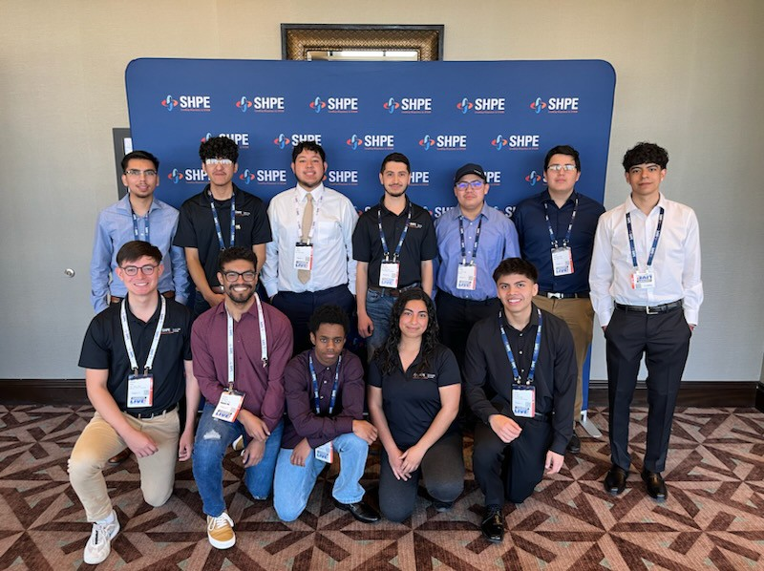

Academic Year 2022-23
The WSU SHPE collegiate chapter achieved major accomplishments during the academic year 2022-23.

Featured:
- They increased their membership from a consistent 30+ members per year to 50+ members.
- They also sent a record number of representatives to the National Convention
(20) and Regional Conference (12). One of SHPE’s members was a finalist for the Nissan Design Challenge at the 2022 National Convention, and several students obtained internship and full-time job offers through its career fair.
- SHPE established the chapter’s first SHPEtinas group to empower the women of WSU SHPE.
- They hosted many outreach, recruitment, professional and social events throughout the year including their signature community event, Noche de Ciencias, at Wichita North High School.
- A WSU SHPE sophomore was recently elected as the SHPE Region 3 student representative for the academic year 2023-2024. He will become the first student to ever represent WSU at the regional level. Lastly, SHPE was named the 2023 WSU Outstanding Large Organization of the Year.

National Society of Black Engineering (NSBE)

Overview
The National Society of Black Engineers’ mission is to increase the number of culturally responsible Black engineers who excel academically, succeed professionally and positively impact the community. The WSU Chapter of the National Society of Black Engineers has made major strides toward chapter growth, participation and activity for this past academic year.

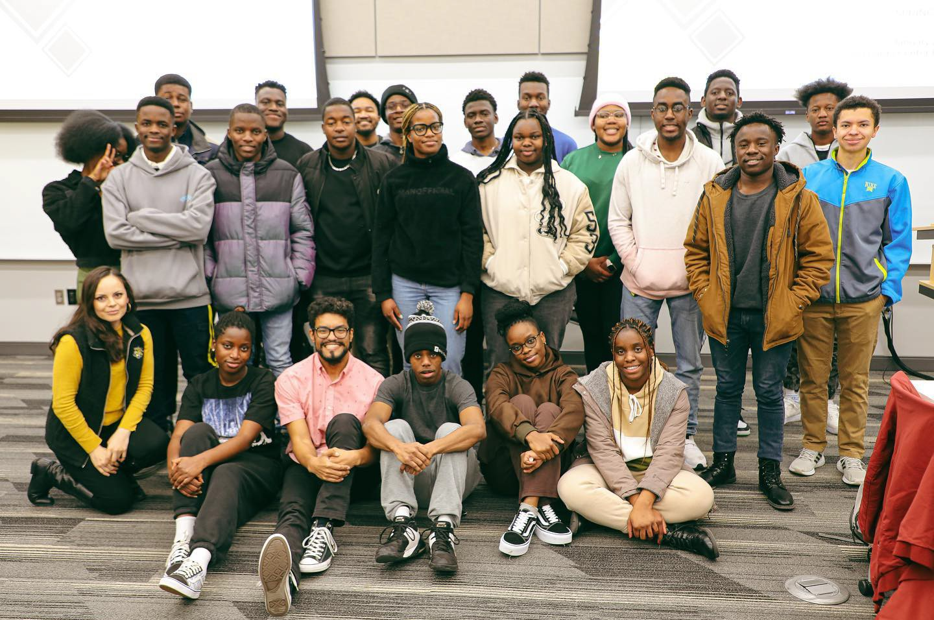

Academic Year 2022-23
  - NSBE increased its membership to 60+ members and participated in several community events, including Wu’s Event, Exploration Place and Open Streets Shocker Neighborhood.
  - NSBE established connections with three local schools: Buckner Elementary, Mueller Magnet Elementary and Brooks Middle School to begin the Pre- Collegiate Initiative (PCI) program in the upcoming academic year.
  - Through PCI, NSBE members along with College of Engineering Ambassadors will host hands-on activities to spark an interest in students to pursue STEM careers.
  - Lastly, NSBE sent a record number of 30 students to the 2023 National Convention in Kansas City, MO, where five students received summer internship offers.

