2023 DEI REPORT
ABOUT US
The College of Innovation & Design is the connector where academics and industry converge for discovery and innovation to
develop students into innovators and leaders who will change the world. Specifically, we
focus on identifying and developing digital
and leadership skills students need to thrive in the digital economy.

We are committed to investing in initiatives, systems, and infrastructure that promote
belonging, community and transparency as it relates to our discipline and vision.

At the core of CID is a learning community where students, faculty, and staff can get
to know each other and come together in a safe and empowering culture. The
foundation of successful innovation stems from inclusiveness, open-mindedness, and being able to lean on one another. The CID blends place, programs, and mindset that attracts a mix of people, beliefs, values,
and identities. We continue to seek ways to make our college an even more welcoming environment for all.

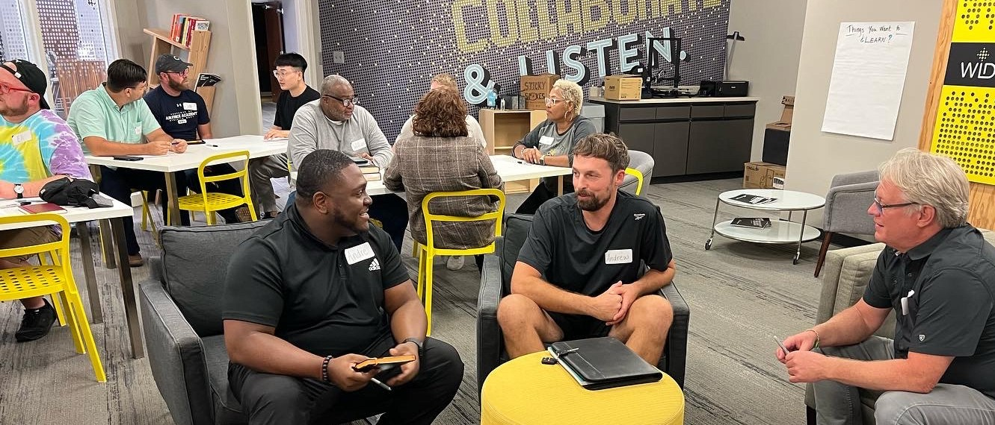

OUR VISION
To become a widely recognized as a productive innovation engine, generating strong inter- connections, and forging
valuable partnerships towards successful and viable establishments across all spectrums of society.
- Serendipity created f rom bottom up; student focused.
  - Intersection between academics and industry.

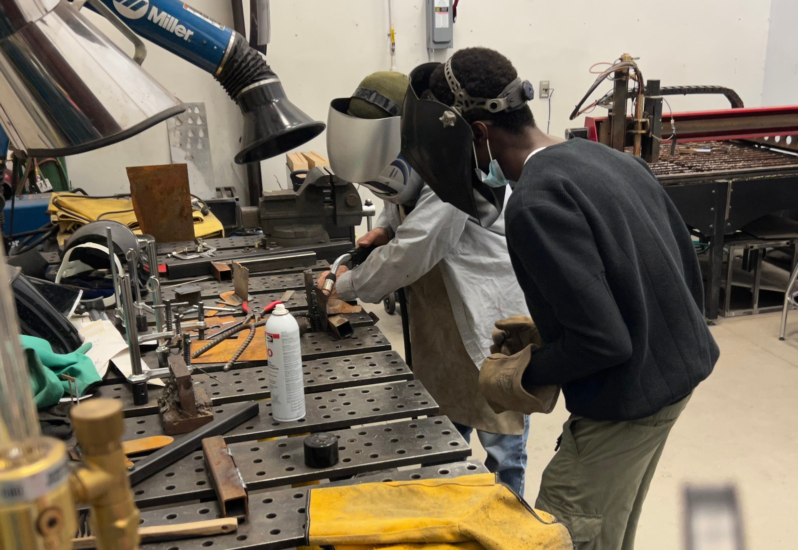
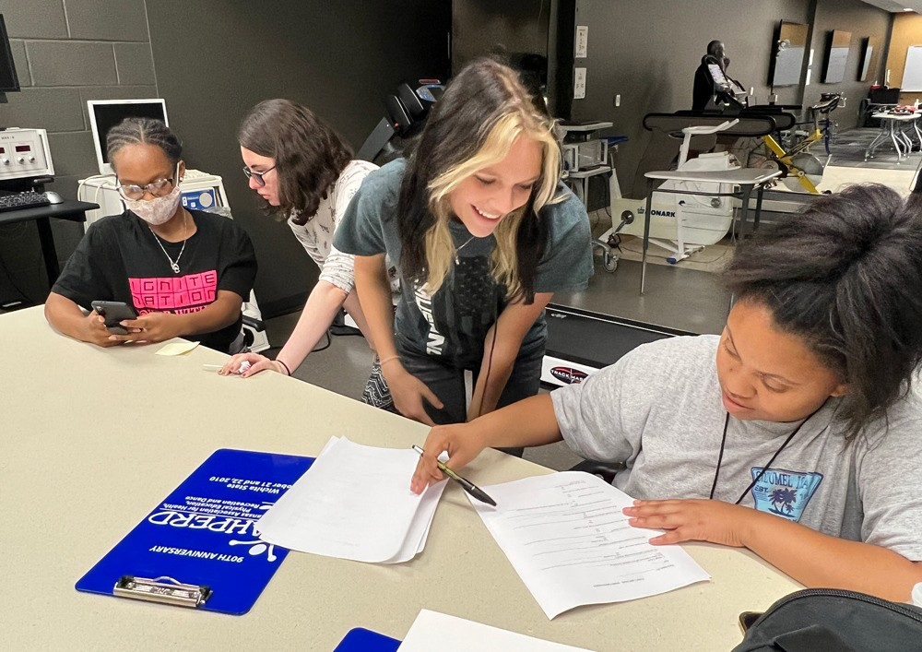
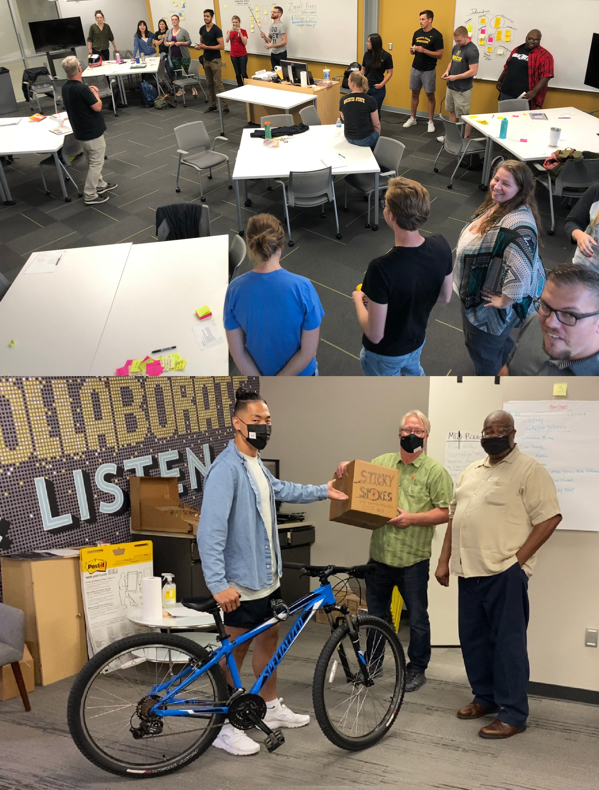
COLLEGE OF INNOVATION & DESIGN DEI REPORT

DISCUSSIONS & EVENTS
DEI Strategic Plan outlined
Completed evaluation session with WSU VP and Chief Diversity Officer regrading college
website and promotional materials to identify
ways to enhance inclusive language and visuals. Focused marketing of ignitor, a Startup Program to underserved communities
Collaboration with companies/organizations with strong DEI initiatives
Co-Facilitated 2022 Summer Research Institute for underserved freshman at WSU
Hosted Honors College Oculus Experience In 2022 we were the recipient of a City of Wichita ARPA Award to support local small
businesses impacted by the pandemic. By the end of 2022, two cohorts of business owners completed the program with 33% reportedly
from Equity Zip Codes

IN-PROGRESS
We are launching a speaker series that
prioritizes engagement and action to recognize and tackle systemic equity gaps within our
local entrepreneurial ecosystem. This could entail inviting DEI speakers to discuss
diversifying startup founders or empowering diverse founders
NASA EPSCoR Partnership Development grant
focuses on providing research opportunities for graduate and undergraduate students. This
grant will support 2-4 underrepresented
students for a week-long product development workshop in summer 2023, and a trip to
Johnson Space Center to present in front of NASA scientists in spring 2024
Every year, CID faculty advise a student team to participate in the NASA SUITS (Spacesuit User
Interface Technologies for Students) Challenge. Since 2019, 45% of participating WSU students were women, and 55% were non-white. 2022
Team diversity focus was recognized and highlighted by NASA Admin

OUR DEI LEADERSHIP & IMPLEMENTATION COMMITTEE
The purpose of the committee is to plan and oversee the implementation
and tracking of programs and
activities of the college DEI strategic plan, including the development of
this report. The committee comprises leaders responsible for all areas of
CID operations.

Jeremy Patterson
Dean of CID

Doug Stucky
Graduate Education

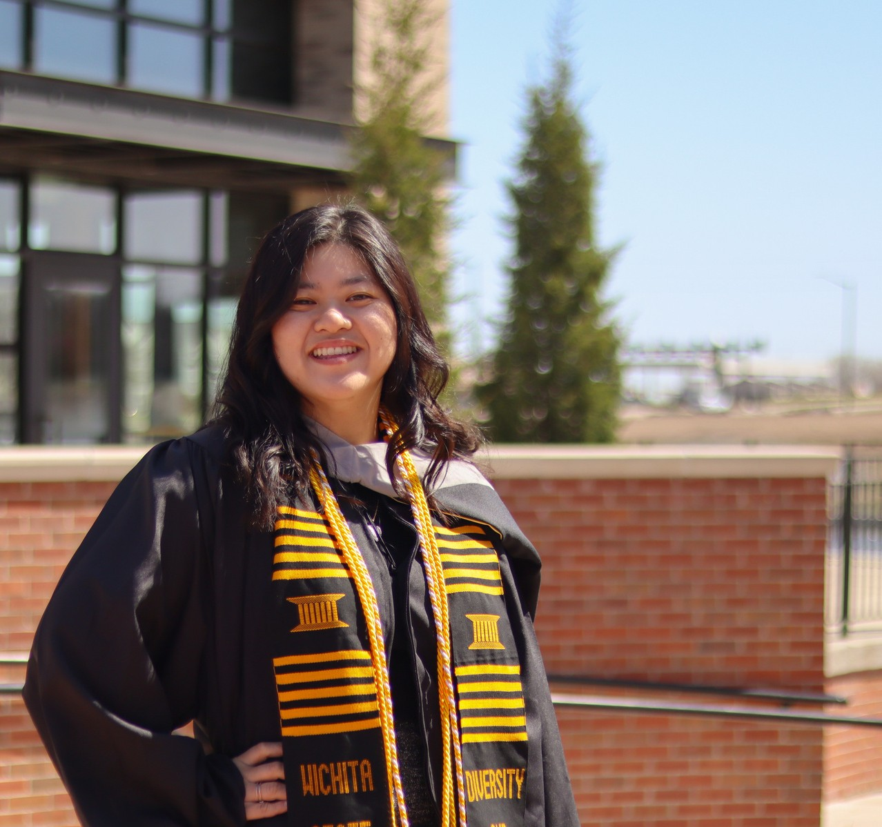
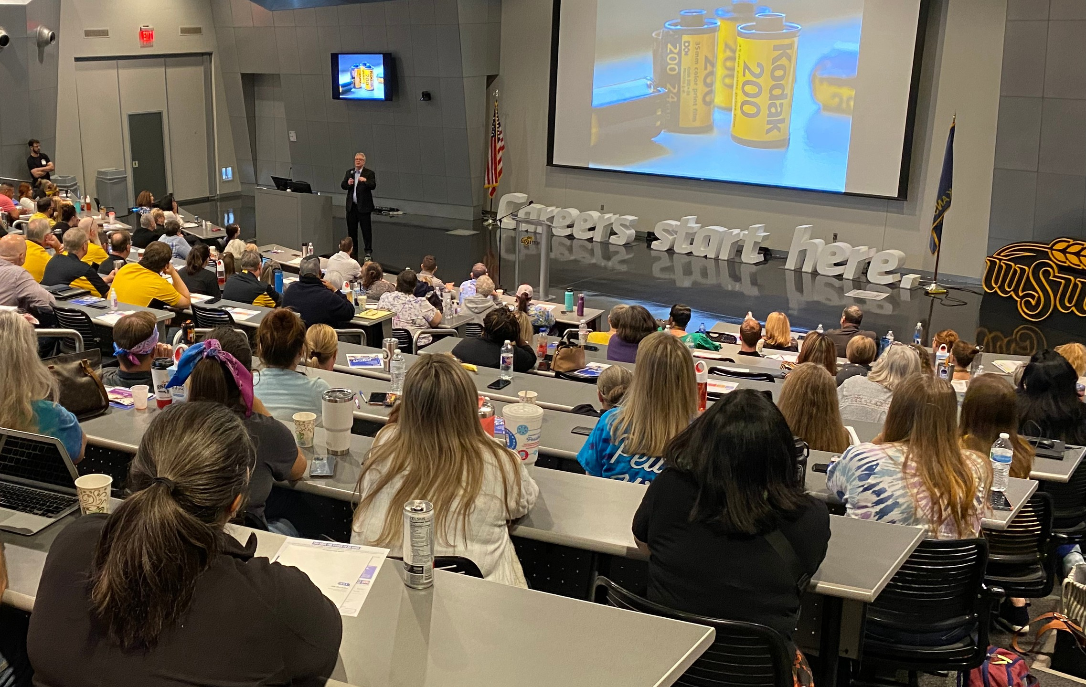
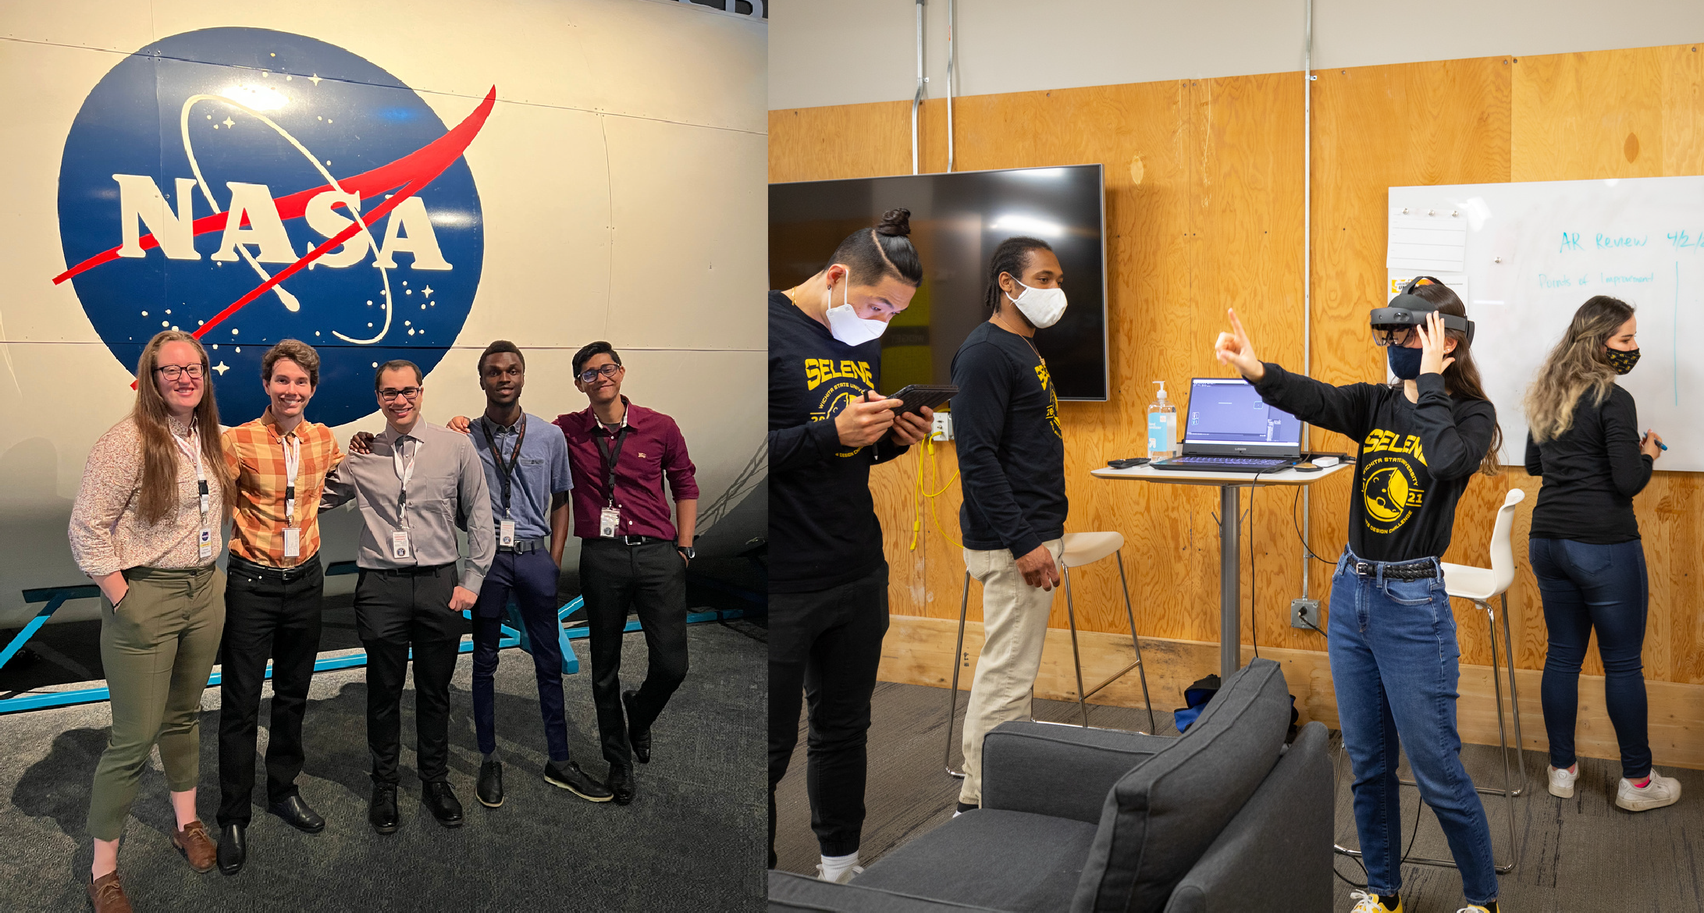
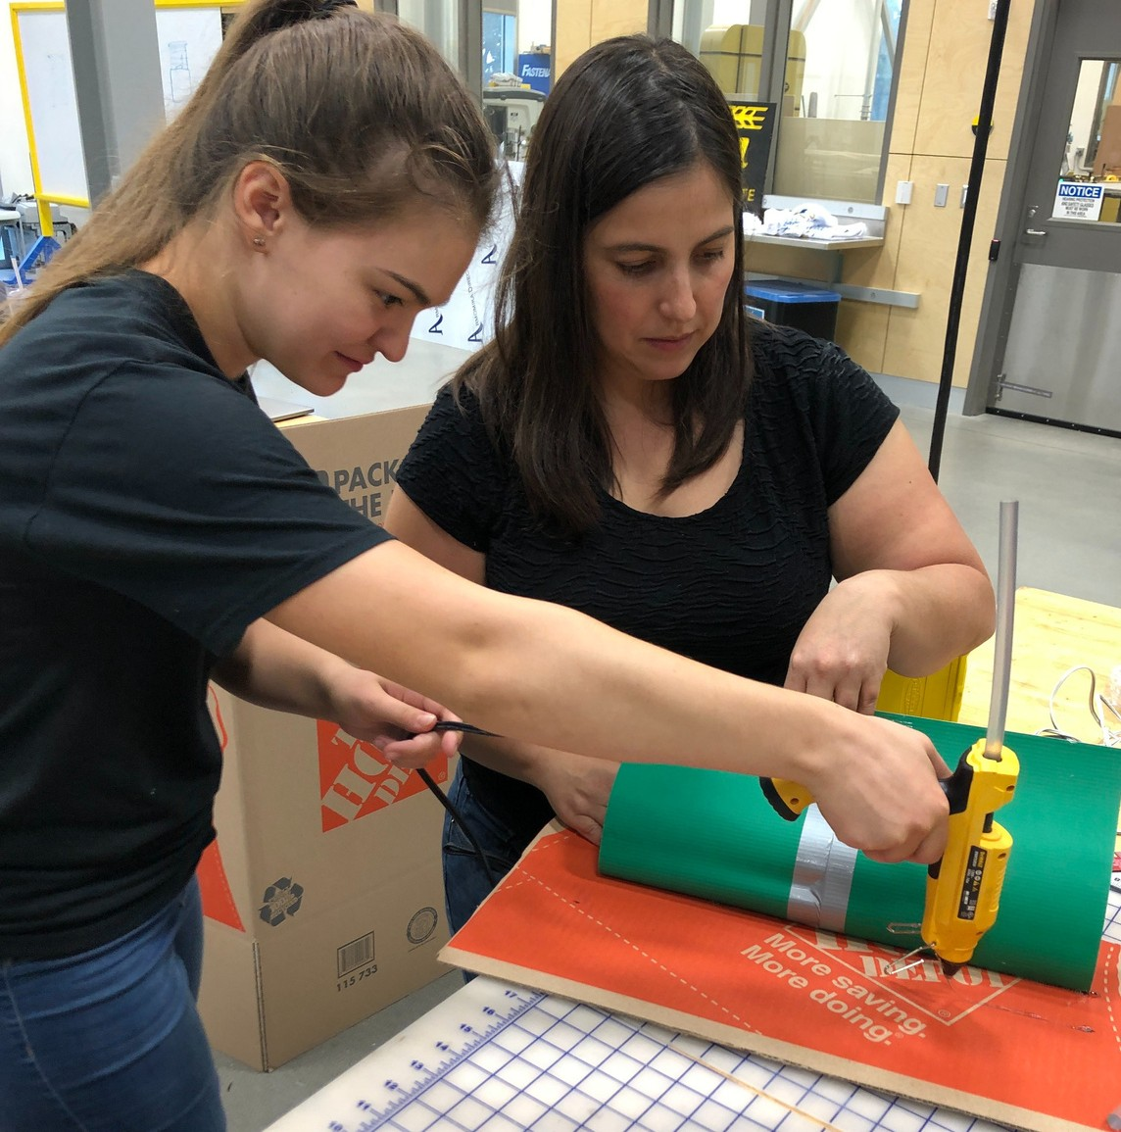

FUTURE PLANS
New First Year Seminar course with mode of
instruction that is inclusive, and student centered to deliver content for undergrad success.
Promote interdisciplinary as a learning construct to increase diversity of thoughts, ideas and solutions. We will develop the framework to track the metrics listed in our college.
DEI strategic plan that was developed over the past year. These metrics will be shared with college
leadership and other stakeholders.
Organize a college workshop to further evaluate our culture and invest further into building an inclusive
climate that allows all members of our university unit, associated stakeholders, and community members to contribute while feeling safe and included in the
College family.
New cllaborations with companies/organizations with strong DEI initiatives.

JaNeshia Wilson
Outreach; Community Engagement

Maggie Schoonover
Research

Kristyn Waits
Marketing; Advising

Troy Tabor
Director; Center for Entrepreneurship

Nancy Kersenbrock
Entrepreneurial Ecosystem Outreach

Lance Minor
Director; Kansas Family Business Forum

Carrie Venezia
Resource Management; Operations

