Creating an Invoice

Scenario:
Invoice Payment to Greater Wichita Partnership 10/20/2019 $5,000.00

Step | What to Do | Notes
1. | Log into Chrome River Test  - Information provided in classroom | 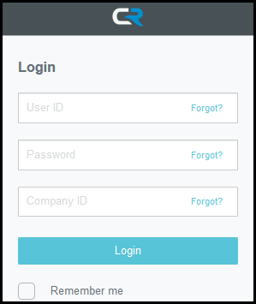
2. | Click the +New icon and select New Invoice | 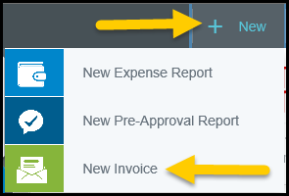
3. | The Invoice Header page will be displayed on the right side of the screen. | 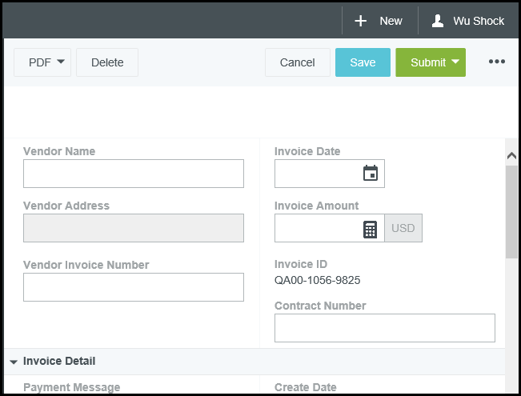
4. | Enter the Vendor Name:  - Greater Wichita Partnership
5. | Select the Vendor:  - X10873128 | 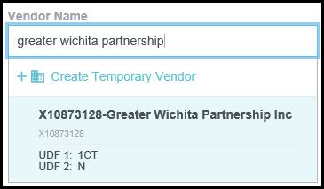
6. | Select the Vendor Address:  - Will auto-populate if there is only one address in the system | 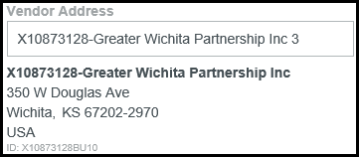
7. | Enter Vendor Invoice Number  - If there is not one, leave this field blank | 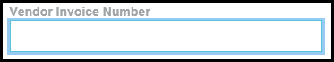
8. | Enter the Invoice Date  - If typing the date instead of using the calendar, make sure to use the following format: MM/DD/YYYY; otherwise the system will revert to the current date. | 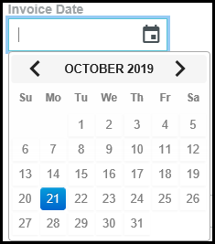
9. | Enter the total amount of the Invoice  - Split funding will be completed in the Add Expense Section.  - Note: If the Invoice is not in USD currency, you can utilize the dropdown on the USD field to change the currency to the actual currency listed on the invoice. | 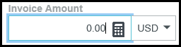
10. | Invoice ID is a system generated ID from Chrome River | 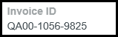
11. | Enter the Contract Number (if applicable)
12. | Invoice Detail Information  - This section will provide more detailed invoice information | 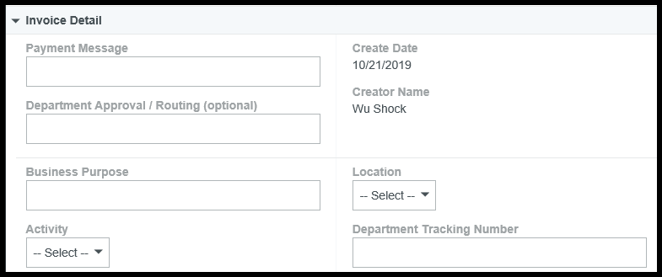
13. | Payment Message  - This will be printed on the Check sent to the vendor minus the characters typed in the Vendor Invoice Number  - Total maximum number of characters allowed is 70 | The Payment Message should include  - Customer number listed on the invoice,  - Account number listed on the invoice,  - Any other information that will assist the vendor in applying the payment correctly
14. | Department Approval / Routing (optional)  - This feature will send the invoice to the WSU Employee you select, and they will have to approve the Invoice in addition to the required approvers.  - When in this field start typing the person’s name or myWSU ID that you would like to select.  - For this scenario, select Wu Shock | 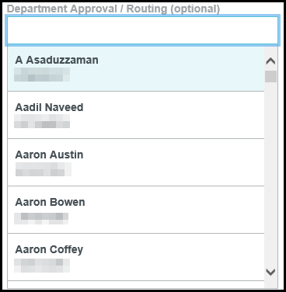
15. | Business Purpose  - Explain why the item was purchased  - For this scenario, Sponsorship to reach the community members and teach them more about the program’s offered at the University. | The business purpose should explain:  - what purpose the expenditure served,  - why the expense was necessary,  - how it furthered the University’s goals
16. | Activity  - If your department uses the Banner Activity field, click the dropdown  - If your department does not use the Banner Activity field, leave the value -- Select -- in the field  - For this scenario, leave the value -- Select -- in the field | 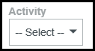
17. | Location  - If your department uses the Banner Location field, click the dropdown  - If your department does not use the Banner Location field, leave the value -- Select -- in the field  - For this scenario, leave the value -- Select -- in the field. | 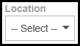
18. | Department Tracking Number  - This is an optional field  - Populate when your department utilizes a separate numbering system to keep track of payments.  - For this scenario, leave the box blank | 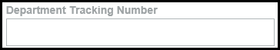
19. | Special Handling Information  - This section will provide check details | 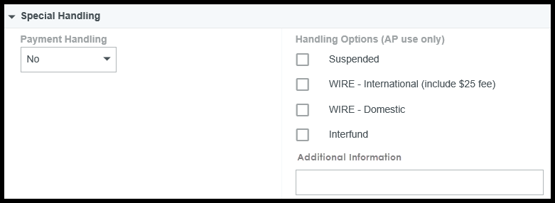
20. | Payment Handling  - Should only be used when the vendor is to receive a paper check and check is to be hand delivered or sent with additional documentation | 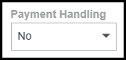
21. | Payment Handling Options  - No – payment will be made using the default payment method. If the default payment method is check, the check will be sent to the address selected in the Header section.  - Yes – check will be mailed back to WSU and Financial Operations will mail the check to the vendor along with additional documentation. When selecting Yes, leave the employee name “Select” field blank.  - Yes, Pickup by – check will be mailed back to WSU and the Employee selected below will be called to pick up the check from Financial Operations  - Yes, Send to – check will be mailed back to WSU and sent to the Employee selected below via campus mail.  - For this scenario, select No | 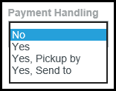  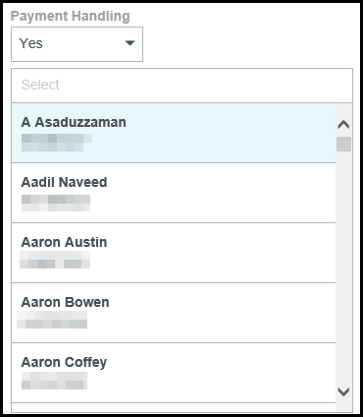
22. | Handling Option (AP use only)  - This section will be completed by the Accounts Payable staff. | 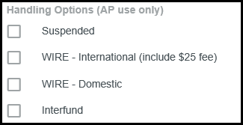
23. | Additional Information  - If there is any additional Information about the payment, enter it in this field.  - For this Scenario, leave the field blank
24. | Comments  - Enter any additional comments about the invoice here.  - Once the comment has been added it cannot be deleted
25. | Attachments  - Drag and Drop the PDF or Browse to the appropriate location to select the PDF file.  - Most expenses require an itemized receipt or adequate supporting documentation to be attached.  - Attachments can be added in Chrome River in various ways. Visit wichita.edu/cr to locate additional information.  - Click the Browse File Button  - Search for the correct invoice and click Open | 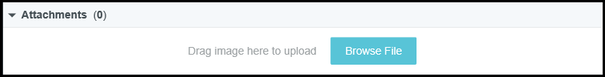  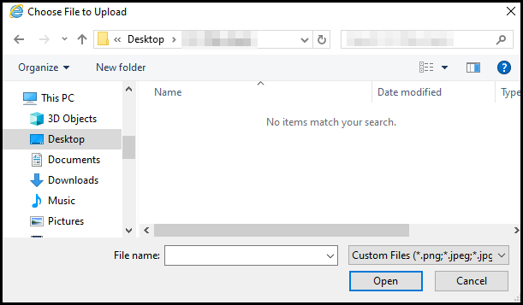
26. | Extract Data  - This is the OCR Vision that will read the invoice and enter the Header details for you.  - For this scenario, select skip | 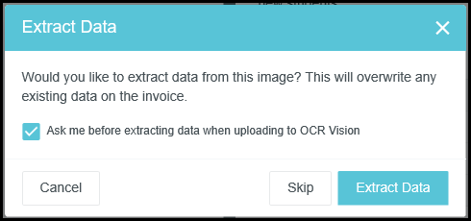  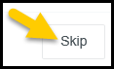
27. | Note: By moving the slider bar up or down, you can show more of the Invoice Header Information or Allocation sections
28. | +Add Expense  - This will enable you to select the appropriate funding source and account code for the invoice  - Multiple expense lines can be added to the invoice to accommodate split funding, multiple funding sources, or multiple account codes  - Note: This button is not active until the invoice date has been entered. | 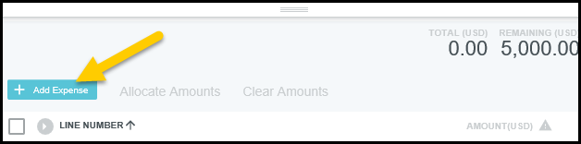
29. | Select an item type  - There are two options to choose from  - For this scenario, we will select the All other Account Codes tile | 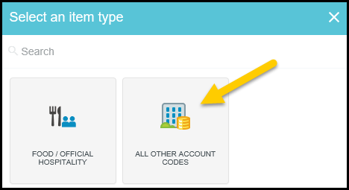
30. | - You will be returned to the main invoice page.  - The system will default the total amount of the invoice  - For this scenario, change the amount to $4,500.00 | 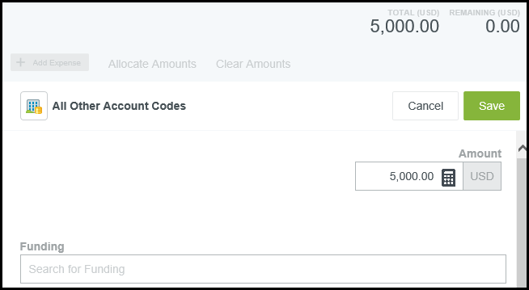
31. | Funding section | 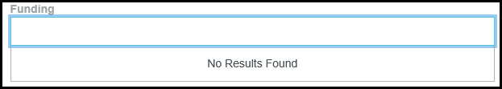
32. | Begin typing in the Search for Funding box to locate and select the appropriate funding for the Expense Type.  - As you begin typing, the system will display results that contain the value entered.  - For this scenario, enter your Fund, Org or Department Name and click on the appropriate value from the displayed results | 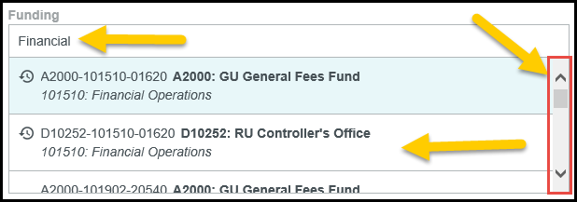  **Use the scroll bar to see additional matches
33. | -- Select –  - Once a funding value has been selected, the – Select – field will display.  - Click in the field to view the drop down list of available values  - Select the appropriate value  - For this scenario, select 2240-Advertising / Marketing | 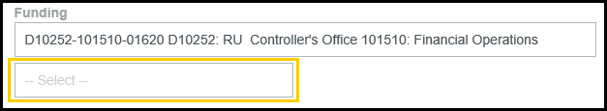  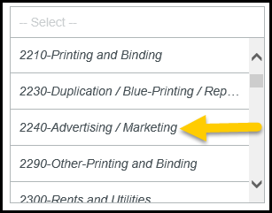
34. | Click Save | 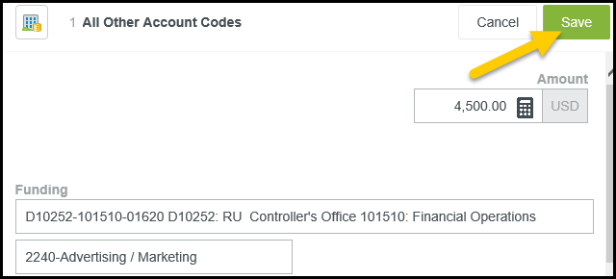
35. | The line has now been saved and you can continue to add expenses to fully allocate the invoice.  - Select the Add Expense button  - Select the All other Account Codes tile | 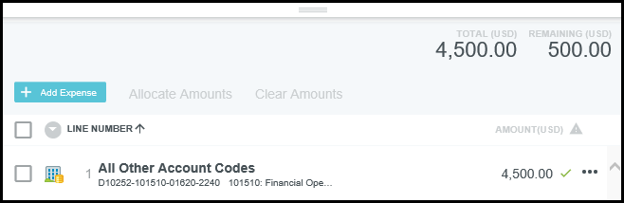
36. | Notice the system populated the Amount field with the full remaining dollar amount that must be allocated  - In the Search for Funding box, enter your Fund, Org or Department Name and click on the appropriate value from the displayed results  - Once a funding value has been selected, the – Select – field will display.  - Click in the field to view the drop down list of available values  - Select the appropriate value  - For this scenario, select 2320-Booth Rental | 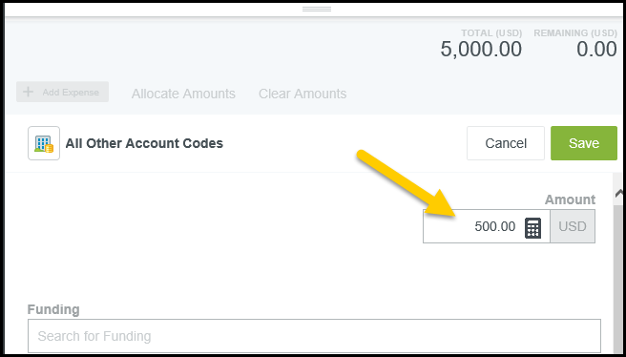  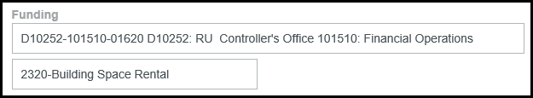
37. | Click Save in the upper right hand corner of the form.
38. | This is what the final product should look like from the Add Expense section. | 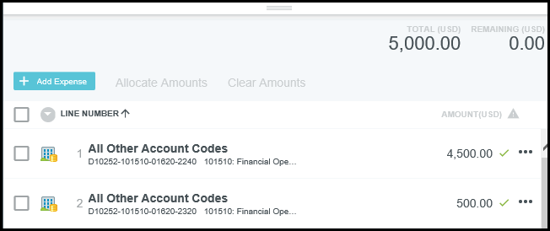
39. | - Click the Submit button located in the upper right corner of the form  - Select Approve from the displayed options. | 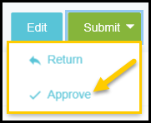
40. | An Approval Confirmation page will display  - If any Additional Reviewers are needed you can enter their name or myWSU ID in the Select Additional Reviewer box, a comment is required if you select a name.  - The Optional Comment field is independent of the Additional Reviewer assignment.  - Any comment added in this section will display on the main invoice page.  - For this scenario, leave blank and click Approve | 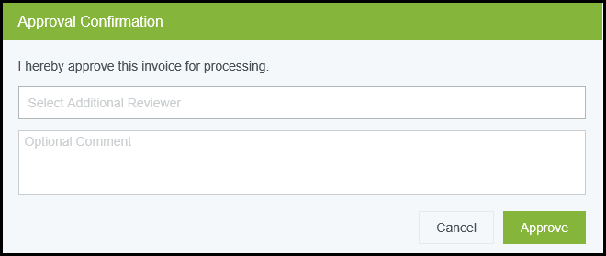
41. | The confirmation message will display.
42. | Click the “ChromeRiver” icon to return to the home page.
43. | To view the submitted report, click on the number listed in the “Submitted Last 90 days” section of the Invoice swim lane. | 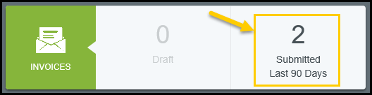
44. | Locate the report in the Submitted Expense Reports list and click once to display the report details.  - Note: The report status is displayed below the amount field.  - Statuses include:  - Pending  - Approved  - Paid | 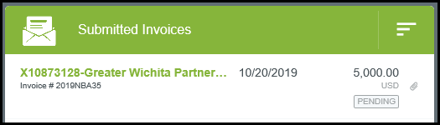
45. | The report details will be displayed on the right side of the screen. Four options will be displayed along the top of the report:  - Images  - Tracking  - PDF  - Recall | 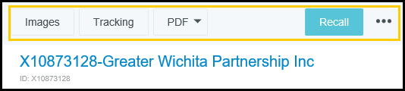
46. | Selecting the Tracking button will display where each line of the report is in the approval process. | 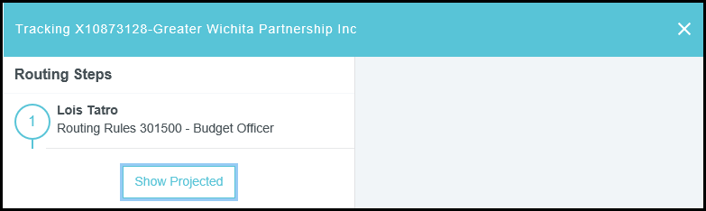
47. | Select a person on the left to display more information on the right. | 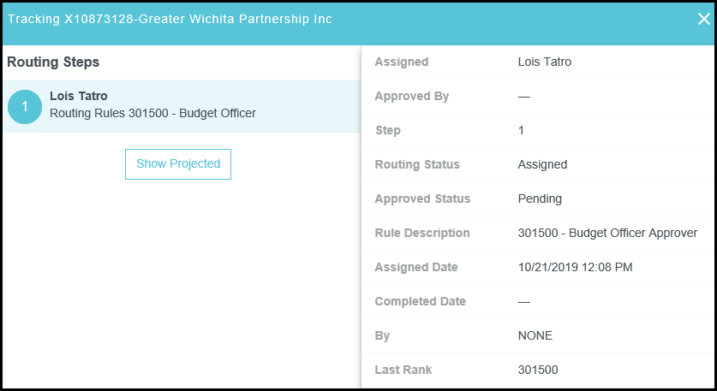
48. | To see additional tracking information, click on Show Projected.  - Clicking on the numbered circles will display information about the selected approval step.  - When an approval step has been completed, the number will be replaced with a green check mark.  - When finished reviewing the tracking information, click the “X” in the upper right-hand corner of the screen. | 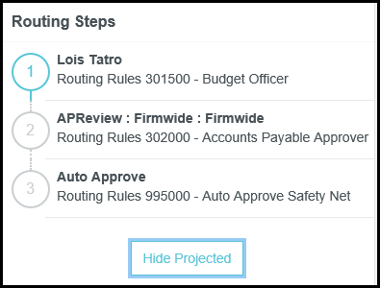
49. | Selecting PDF will display two options to select from:  - Full Report will create a PDF of the full report minus any attachments  - Full Report with Image will create a PDF of the full report and receipts.  After selecting an option, a new browser window will open. Once closed you will be taken back to the summary page of the report. | 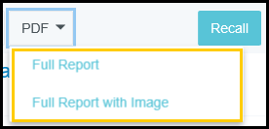
50. | Selecting the Recall button will remove the report from workflow and return it to the creator’s Approvals Queue section.  - Invoices can only be recalled prior to obtaining final approval  - Once in the Approval Queue the Invoice can be modified  - The invoice cannot be deleted once submitted  Submitting the Invoice will restart the workflow approval process. | 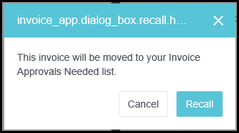
51. | Click the “ChromeRiver” icon to return to the home page.  Click the Invoices option from the Approvals swim lane. | 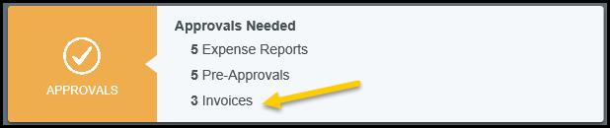
52. | Click once on the Invoice on the left side of the screen to open it on the right  - Click Edit and make any changes necessary  - For this scenario, change the Department Tracking number to IX200358 from within the Invoice Detail Section. Repeat steps XX to submit the Invoice for approvals again. | 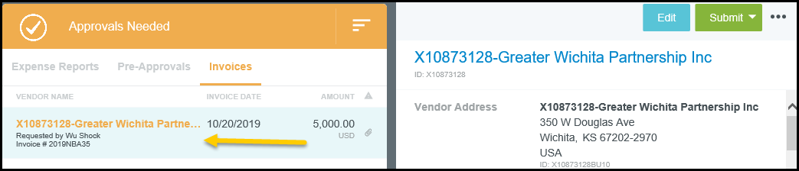
53. | The three dots will display the option to Audit the Invoice.
54. | Log out by clicking the user icon in the upper right hand corner of the screen and selecting Logout | 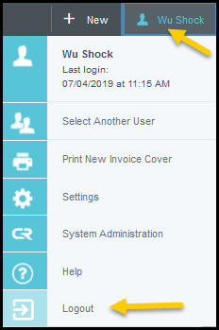
55. | Complete

