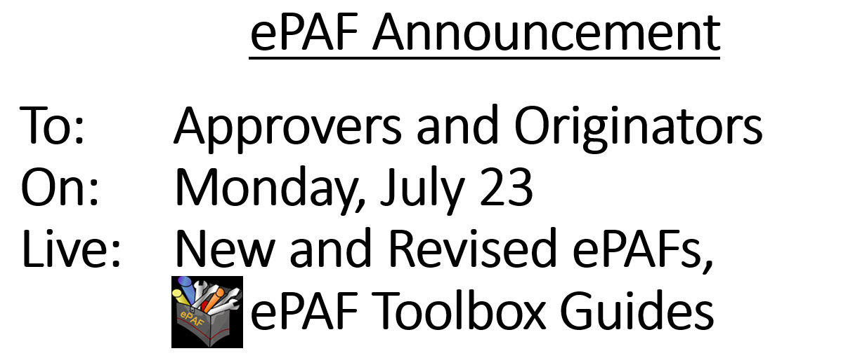

Please review the following information regarding changes to Banner Self Service Electronic Personnel Action Forms (ePAFs).

4 New ePAFs
NOTE: OHR200 continues to be used for Change of Status information but is no longer used for Terminations
New Types of ePAFs | When the ePAF is used
Position ONLY Termination | Termination ePAF used to terminate an employee’s position(s)
Position AND Employee Termination | Termination ePAF is used to terminate a benefit eligible employee’s position(s) AND terminate the employee from the university This ePAF must be used with care!  When the ePAF is approved and completed, it will trigger a series of events including termination of benefits and network access
Additional Compensation | Replaces the hardcopy forms OHR210, OHR300 and OHR330  Used to add an Overload position to a benefit eligible, exempt employee  The employee’s primary position is benefit eligible, the additional compensation position is not
Campus Box Address Changes | Originators may create or revise employee’s WSU Campus Box Address and Telephone Numbers within their department  The information displays on the various online WSU Campus Directories

Revisions to Current ePAFs

Data Label Names
The names of four ePAF data labels were updated to reflect more familiar, WSU wording:

New Name | Former Name
Salary | Annual Salary
Number of Pays (P)  Number of Pays (F) | Pays  Factors
Hours per Pay Period | Hours per Pay
Hourly Pay Rate | Regular Rate

Location of Enterable and Non-Enterable Data Entry Items
To improve the flow of data entry, data enterable items are now located at the top of each Section within the ePAF. For example:
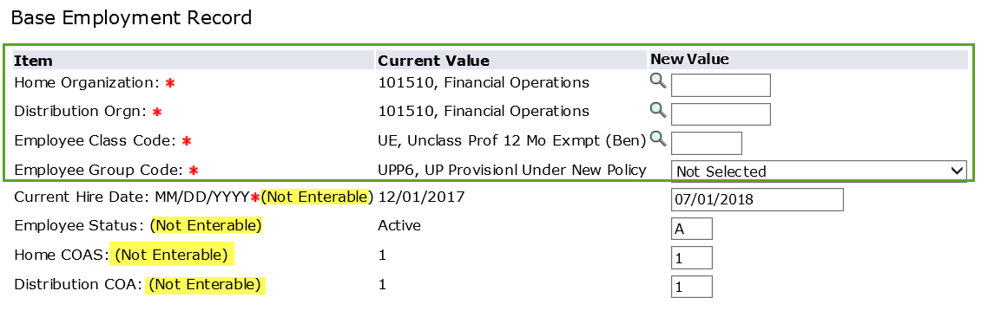

ePAF Toolbox
The ePAF Toolbox on myWSU, EmpHelp, houses information guides for ePAF Originators and Approvers. To easily access the information, log on to myWSU, Faculty/Staff tab. Look for this link when accessing ePAFs in Banner Self Service: ePAF Toolbox – Help Guides.

ePAF Training and Support

All ePAF Originators are asked to contact their College/Department Business Manager for training information
Banner ePAF Open Lab and Training is held most Thursdays starting at 2:00. Registration is strongly encouraged on myWSU, myTraining. The session is attended by both new and experienced ePAF Originators and Approvers (primary and proxy).
Prior to attending training, Budget Officers are asked to request ePAF security access for their employee. Instructions are in the ePAF Toolbox, 1.01 How to Request ePAF Access.

Questions?
New ePAF or ePAF processing questions may be directed to the following areas:

Area | Contact Information
ITS Applications Training and Support | 978-5800 or training@wichita.edu
Human Resources (Position Numbers, etc.) | 978-3065 or ePAF@wichita.edu
Payroll (Payment Calculations, etc.) | 978-3074 or payroll@wichita.edu
Research Technology & Transfer Payroll | 978-6847 or researchpayroll@wichita.edu
Graduate School (Graduate Appointment Notices) | 978-6241 or constance.owens@wichita.edu

