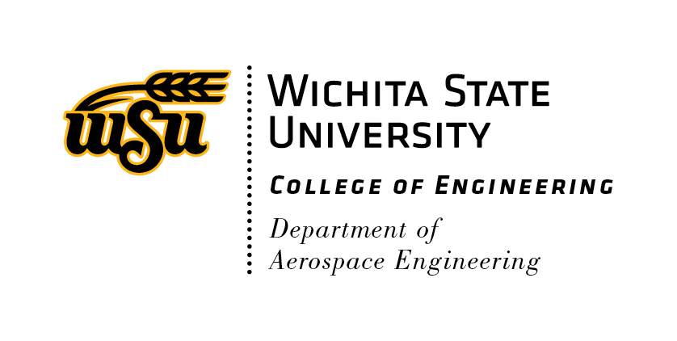
WSU Department of Aerospace Engineering
Palazola & Benmoussa Scholarship (P&B Scholarship) Application

Applications should be electronically completed and submitted to the AE Department Chair, Dr. Raju (suresh.keshavanarayana@wichita.edu). The following materials are required for a complete application package and must be submitted as a single compiled PDF format document.
- A completed P&B Scholarship application form (i.e., this document).
- A current resume (two pages or less).
- A one-page essay demonstrating your motivation, maturity, and potential to meet scholarship goals.
- An endorsement letter, from an AE faculty member, outlining specific collaborative work and/or research outcomes.
- A one-page, or less, financial need essay. (See related document on AE website)

Date:
Name (last, first):
MyWSU ID #:
Phone #:
WSU E-mail address:
Are you an AE Major?
Are you in good academic standing?
What is your WSU GPA?
Are you a full-time senior in your last semester?
What was your final grade in AE 324?
If selected, will you commit to 10-20 hours per week of work with an AE faculty member?
Do you understand, that if selected, working elsewhere (including on-campus, off-campus, NIAR, Coop/Internships, etc.) is not acceptable?
Has an AE faculty member endorsed collaborations with you (if yes, with whom)?
Are you from rural Kansas (if yes, from where)?
Are you eligible to be employed in the United States?
Have you submitted financial needs information?

