Ad Astra Per Aspera

Section 1: Assembly Prep

- From a 4’ X 8’ sheet of luan panel (5.2mm thick= ¼”), cut a 4’ x 4’ square
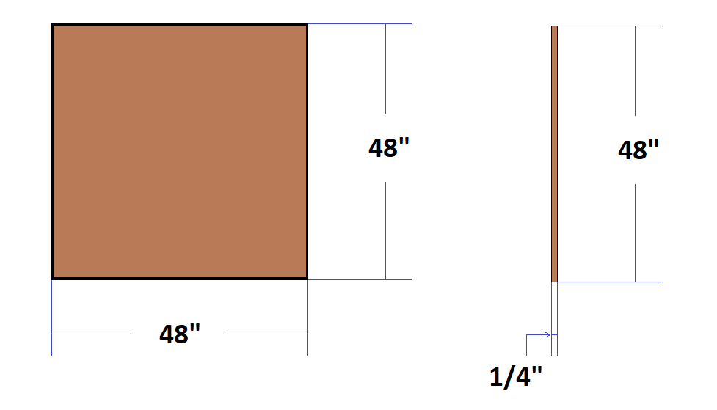
- From two 10’ lengths of 1” x 2”, cut
  - Two 4’ boards
  - Four 20 ½” boards
- From an 8’ length of 1” x 4”, cut a 4’ board
- From two 8’ lengths of 2” x 4”, cut three 4’ boards
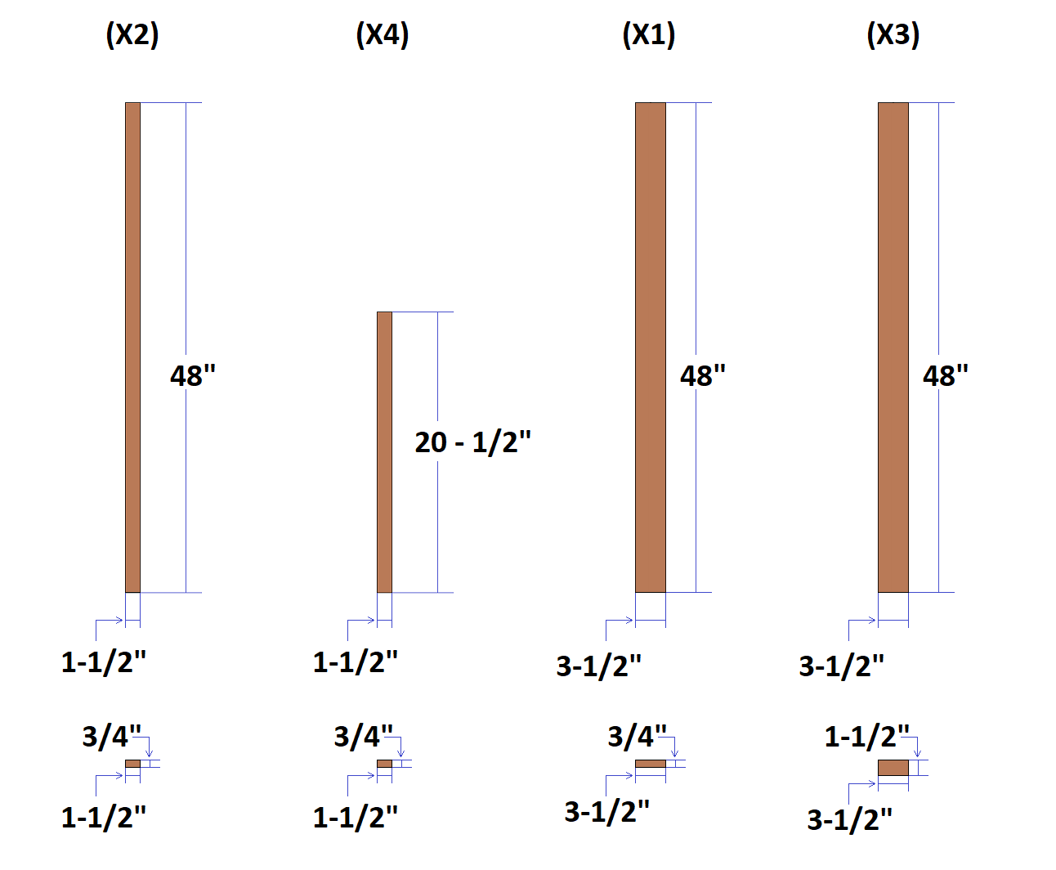

- From a length of ⅜” dowel rod, cut a section of each these lengths
  - 3”
  - 4”
  - 5”
  - 6”
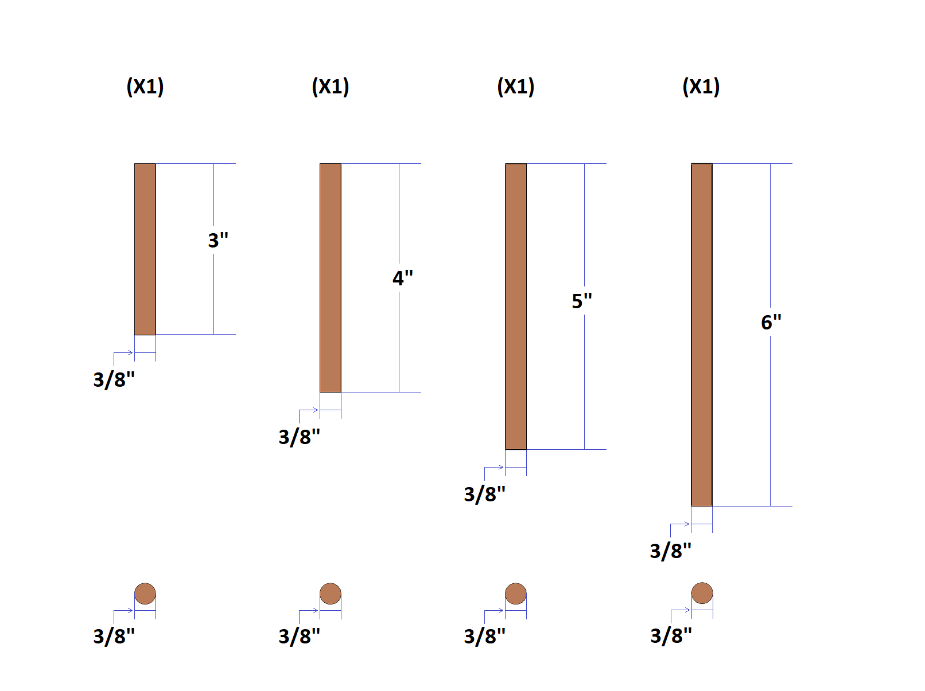
- Cut the hooks off of a 1” ratchet strap and melt the frayed ends

Section 1.1: Top Board Prep

- On one of the 4’ lengths of 2” x 4”, make a mark at these distances along the 4” side (all the way across)
  - 14”
  - 19”
  - 24”
  - 29”
  - 34”
- At the 14” and 19” marks, make a mark 1 ¾” from the edge
- At the 29” and 34” marks, make a mark 1” from the edge ( measure from opposite edges so that they form a diagonal line on the board)

- At the 14”, 19”, 29”, and 34” marks, use a ½” spade bit to bore approximately 3/16” deep recesses at each of their mark intersections ( These will hold your magnets. It would be better for them to be slightly shallow than deep.)
  - Using super glue secure a ½” x 3/16” magnet in each of your ½” wide recesses (make sure the poles of all the magnets face the same way)

14” and 19”
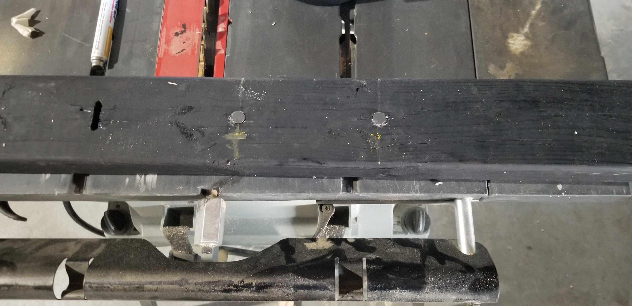

29” and 34”
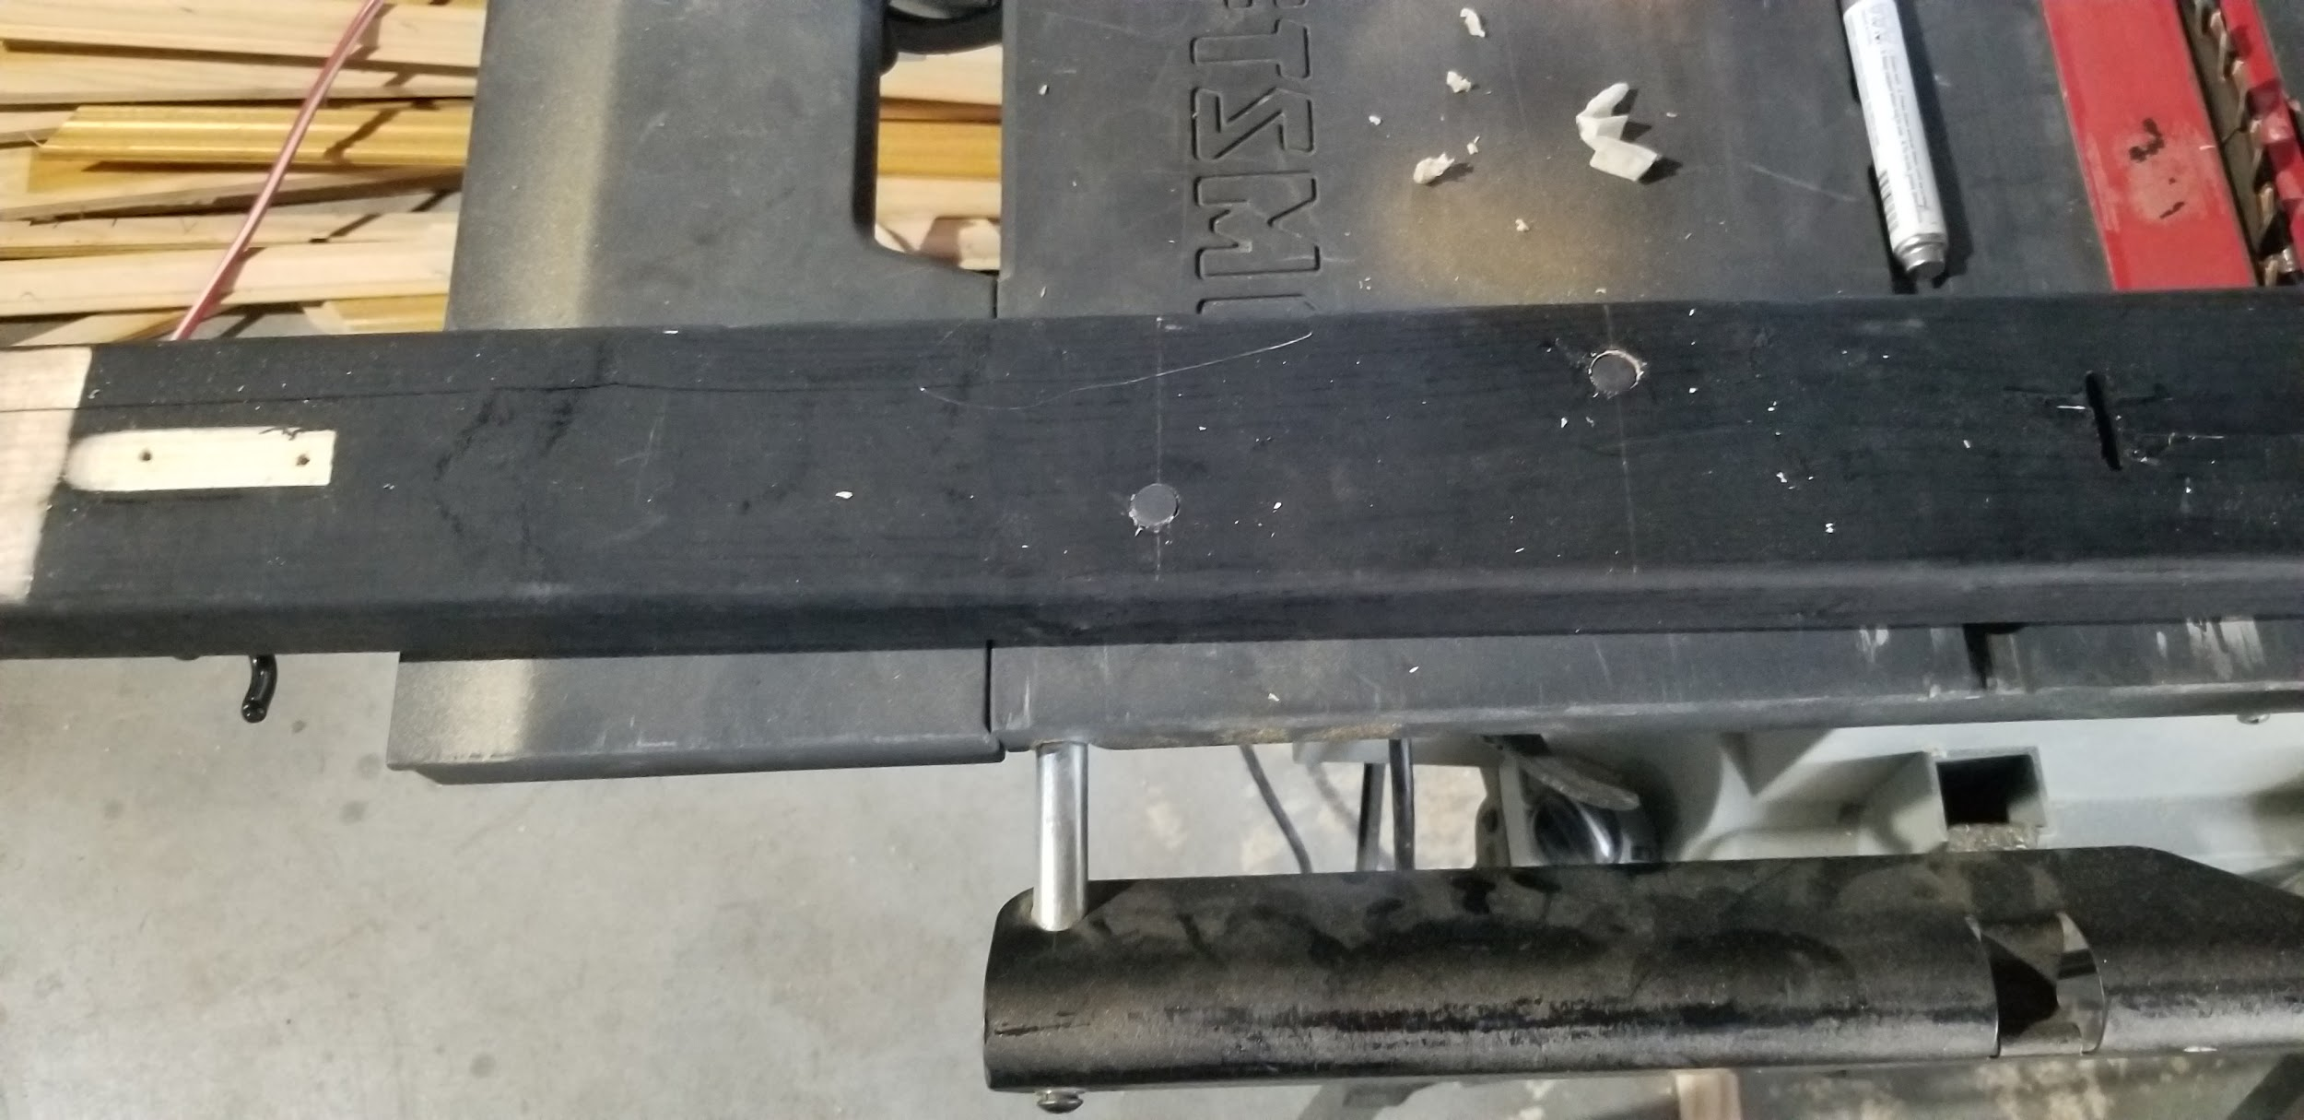

- At the 24” mark, make marks at these distances from the edge
  - 1 ⅜”
  - 1 ⅝”
  - 1 ⅞”
  - 2 ⅛”
- At the 24” mark drill a ⅛” hole through the board at each of the mark intersections
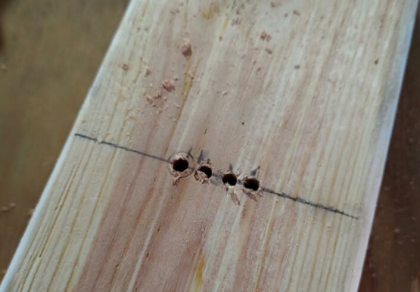
- Use a ¼” drill bit to ream each ⅛” hole to ¼”
  - After reaming use the ¼” bit to wallow the holes together into a 1” wide slot in the middle of the board
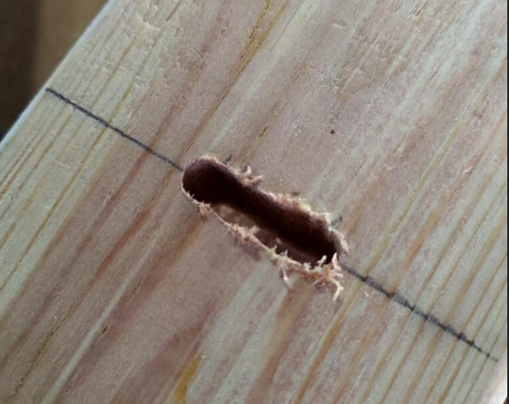

Section 1.2: Baseboard Tension Support Prep

- On the 4’ length of 1” x 4”, make a mark at 24” along the 4” side (all the way across)
- At the 24” mark, make marks at these distances from the edge
  - 1 ⅜”
  - 1 ⅝”
  - 1 ⅞”
  - 2 ⅛”
- At the 24” mark drill a ⅛” hole through the board at each of the mark intersections
- Use a ¼” drill bit to ream each ⅛” hole to ¼”
  - After reaming use the ¼” bit to wallow the holes together into a 1” wide slot in the middle of the board

Section 2: Baseboard Assembly

(Warning: use caution while driving screws into the luan panel.
Fasteners can easily be over driven, and will rip through the panel.)

(Note: all framework for the baseboard assembly will be secured with the widest side of the board against the luan panel.)
(Note: for best results, pre-drill screw holes with a small diameter drill bit in order to prevent splitting)

- Secure a 4’ length of 1” x 2” flush with the edge of the panel.
- Secure a 20½” length of 1” x 2” along the sides at the end of the 4’ length also flush with the edges
- Secure the slotted 1” x 4” against the ends of the 20½” boards
- Secure the remaining two 20½” lengths of 1” x 2” along the sides against the 1” x 4” flush with the edges
- Secure the last 4’ section of 1” x 2” flush with the remaining edges

- Use a ¼” drill bit to backdrill the slot from the 1” x 4” into the luan panel
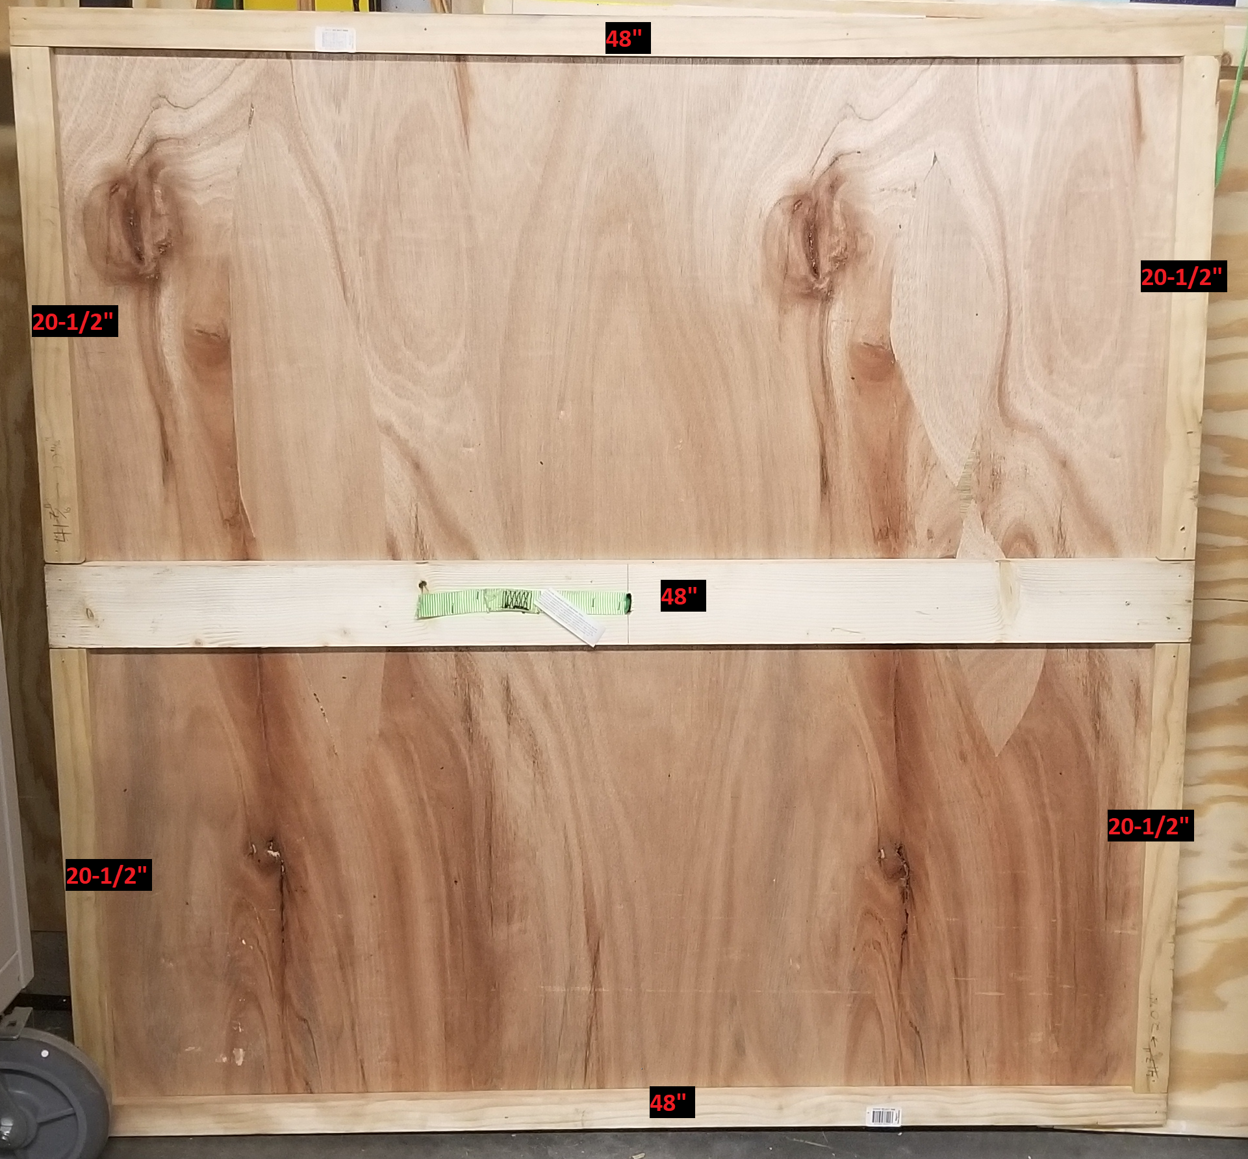

Section 3: Major parts painting

- Using the leftover luan panel as a mask, paint 4 equal quadrants of blue, green, red, and yellow
  - The orientation of the 1” x 4” will determine the orientation of the board and therefore the color each quadrant should be
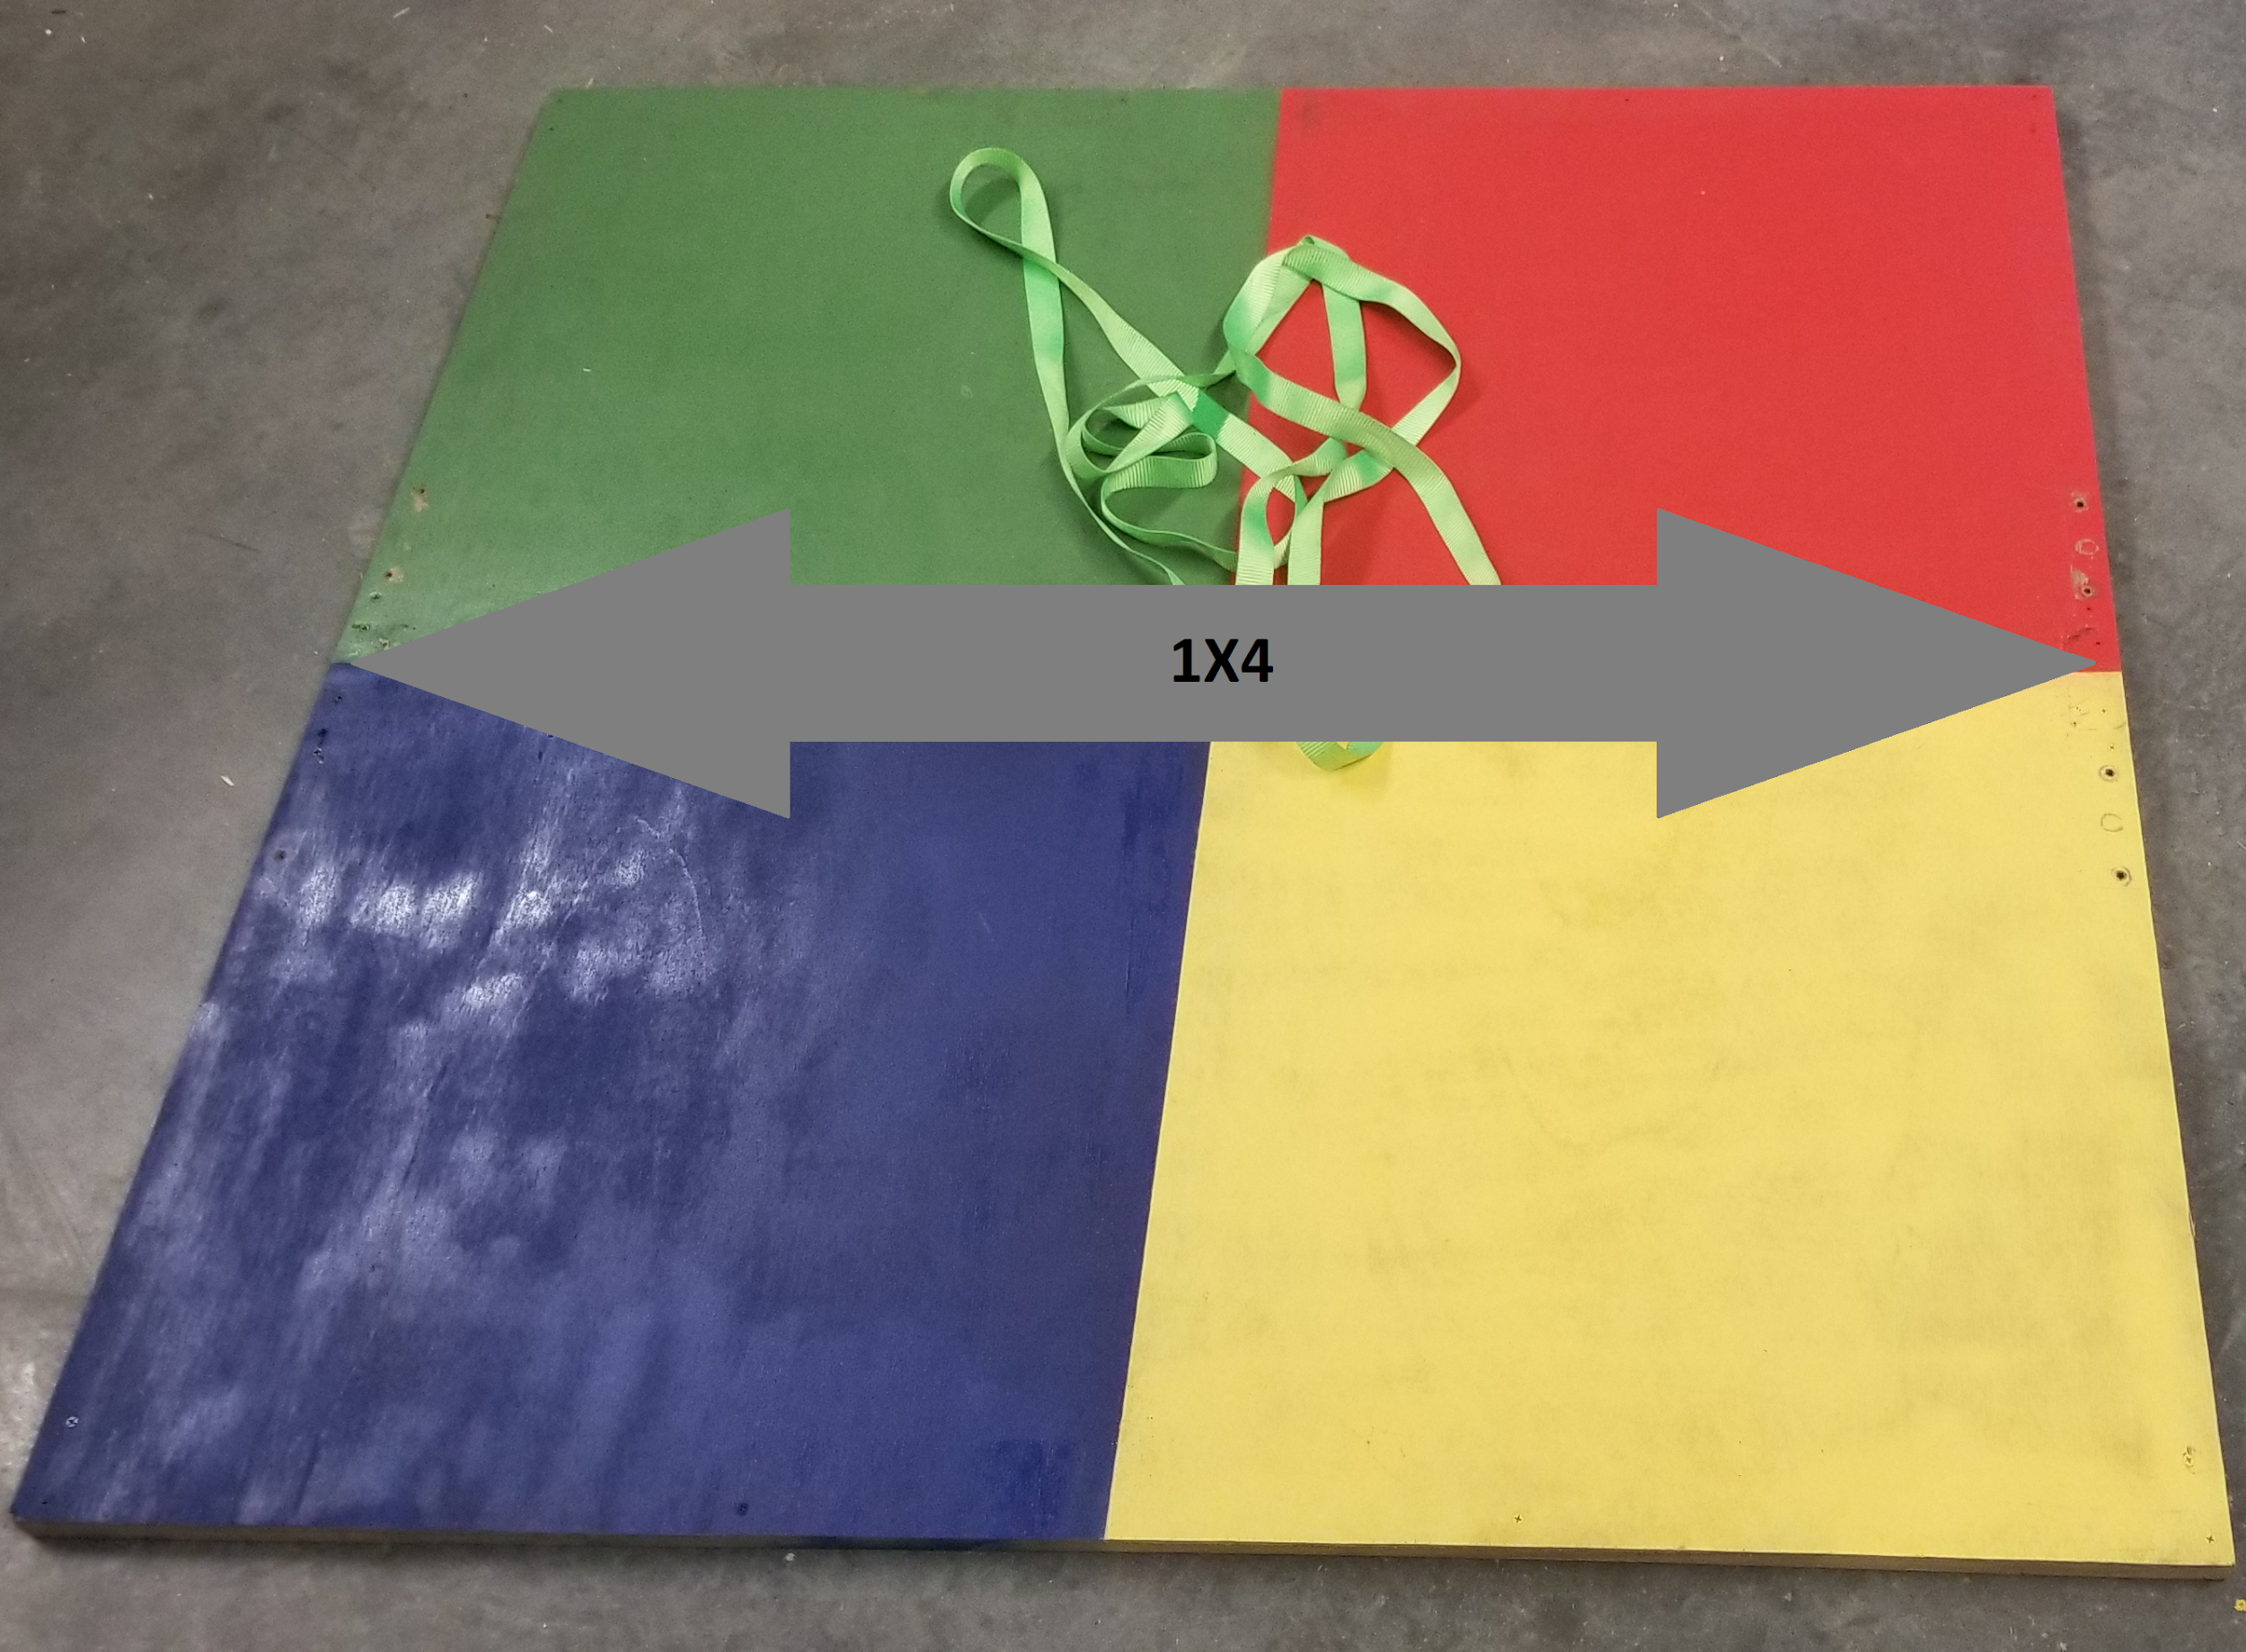
- Paint these things black
  - Top board
  - Two 3” x ¾” corner braces
  - Eight 5” x 1” corner braces
  - Two 4’ lengths of 2” x 4”
- Let paint cure for at least 1 hour before assembly

Section 4: Top Frame Initial Assembly

- Use a 3” x ¾” support bracket to fasten a 4’ section of 2” x 4” on each end of the slotted top board
  - The side boards should rest under the top board, not underneath making the total width 4’
  - The top board should be oriented with the magnet side down
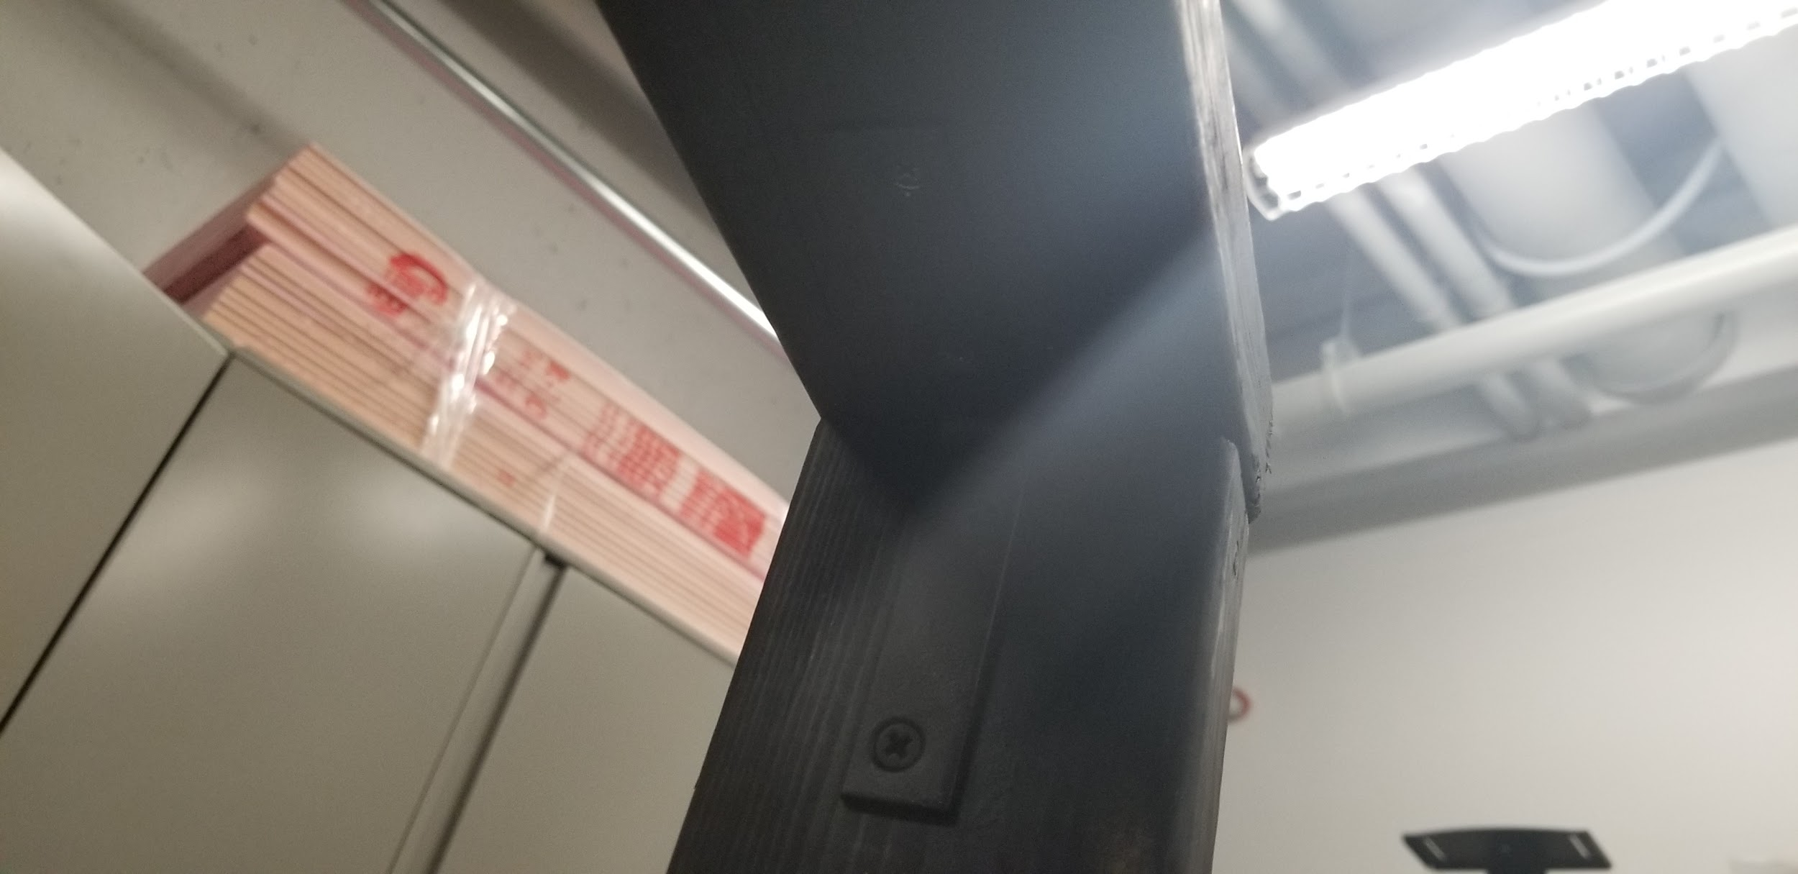

Section 5: Major Assembly
(Note: the 5” x 1” corner braces require ¾” long lag screws with a ⅜” head)

- Set the top frame assembly upright on top of the baseboard assembly
- Align the width of the side boards directly above the slotted 1” x 4” on the baseboard assembly.
  - The edges of the side boards should be flush with the edges of the base board assembly
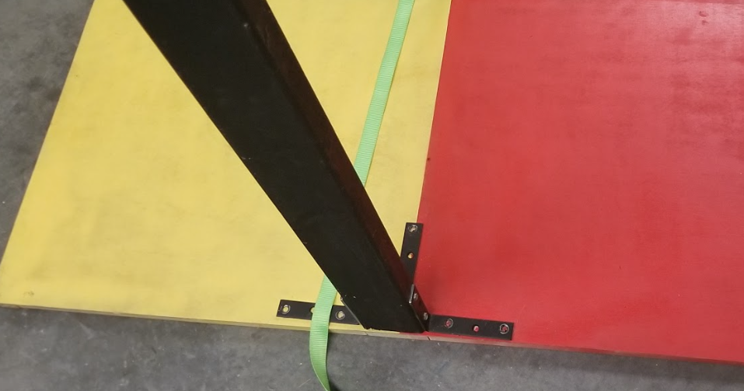

- Secure the top frame assembly to the base board assembly using a 5” x 1” corner brace on each 1-1/2” side of the side boards as well as one in the middle of the inner 3-1/2” side
- Use an angle grinder to shorten the lag screws that come through the frame to prevent damage to any flooring it might be on (Be mindful of the heat. Grinding with the lag screws in the baseboard assembly introduces a risk of fire. Recommend marking the excess length, removing the hardware and grinding with hardware in a vice.)
  - Pre-drill holes for brace with a 3/16” drill bit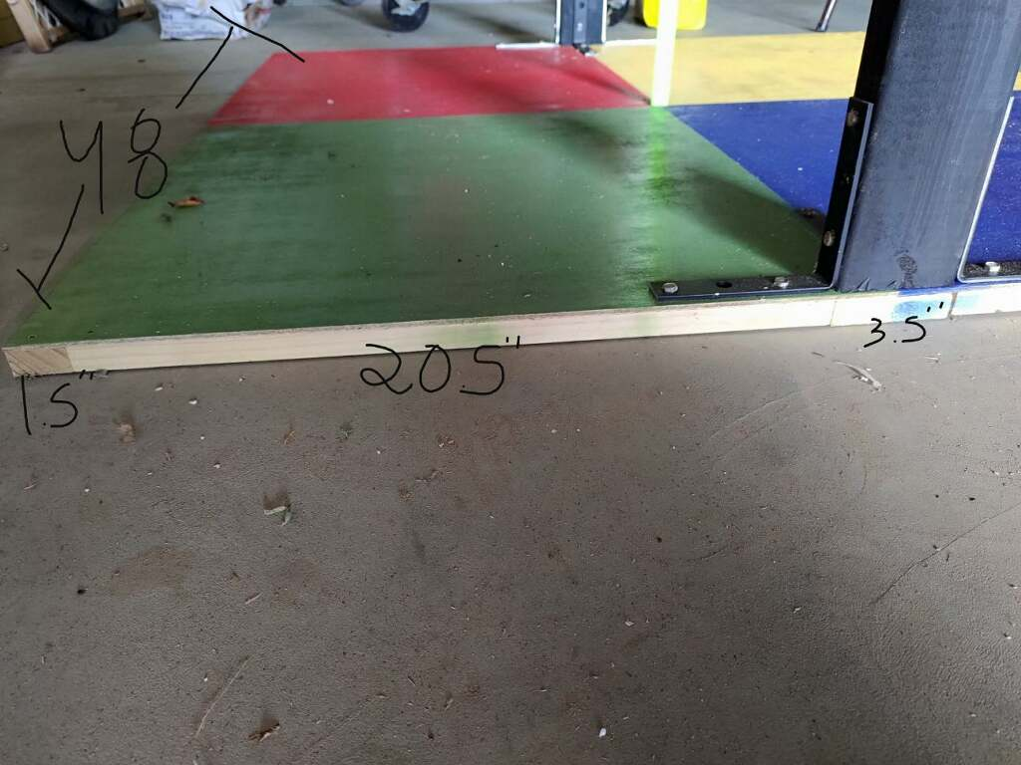
- Use a 5” x 1” corner brace across the top of each corner of the top frame assembly for added rigidity
  - Pre-drill holes for braces with a 3/16” drill bit
- Fish one end of the 1’’ ratchet strap through the slot in the baseboard assembly
- Using any reasonable size and amount of carpet staples secure one end of the 1’’ ratchet strap to the bottom of the slotted 1’’ x 4’’

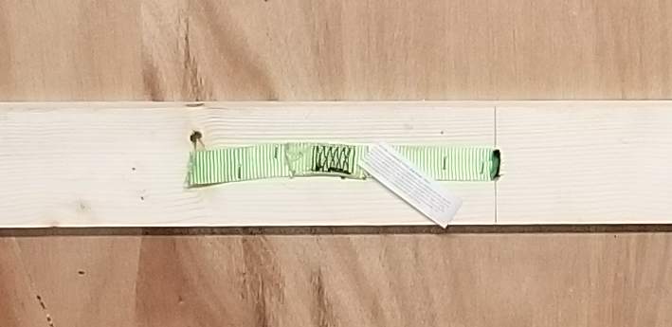
- Using any reasonable size and amount of carpet staples secure the strap attached to the ratcheting mechanism to the top board assembly with the ratcheting mechanism closest to the 1’’ slot

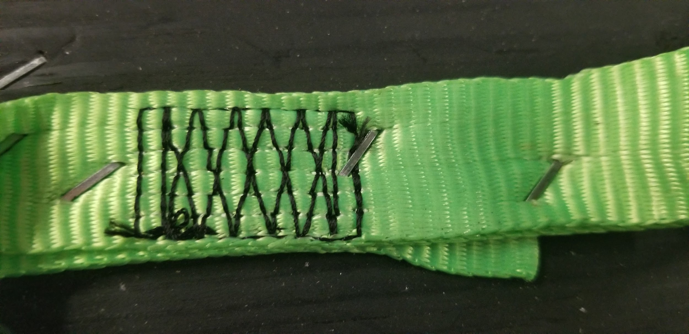

- Ensuring there are no twists in the strap, fish the loose end of the strap through the slotted top board assembly then feed the strap through the ratcheting mechanism above

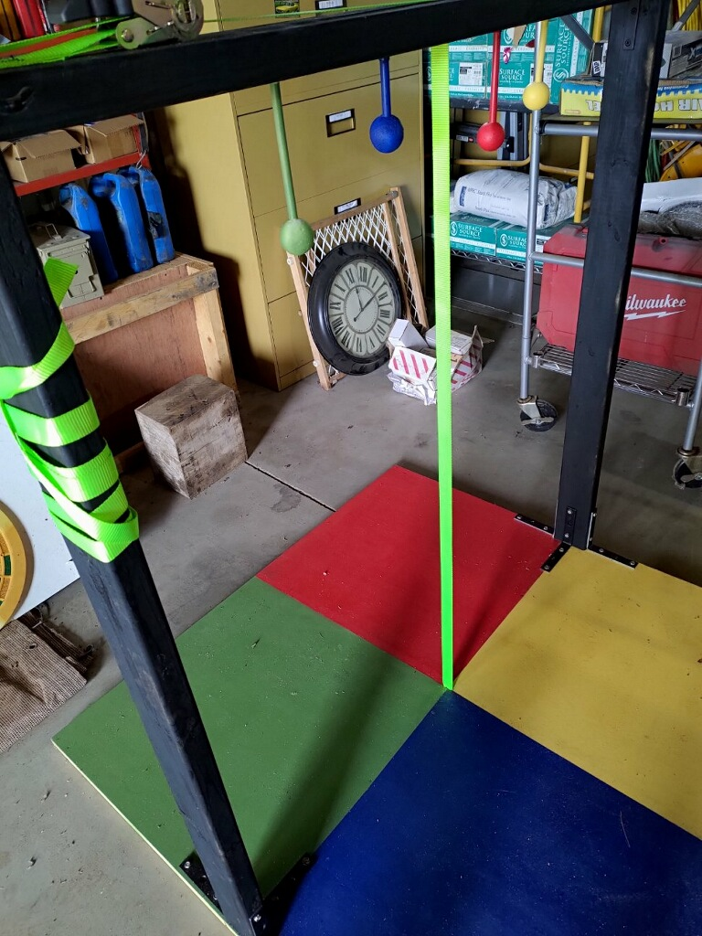

- With a ⅜” drill bit, drill a hole next to the slot in the top board assembly (during use a length of paracord can be fed through the hole and attached to the robot as a safety catch)

Step 6: Drilling Jig

- Cut a 3-½” X 5” rectangle from the remaining luan panel
- Cut two 3-½” sections of 2 X 4
- Cut two 12” sections of 1 X 4

- Drill a ⅜” hole in the middle of the luan panel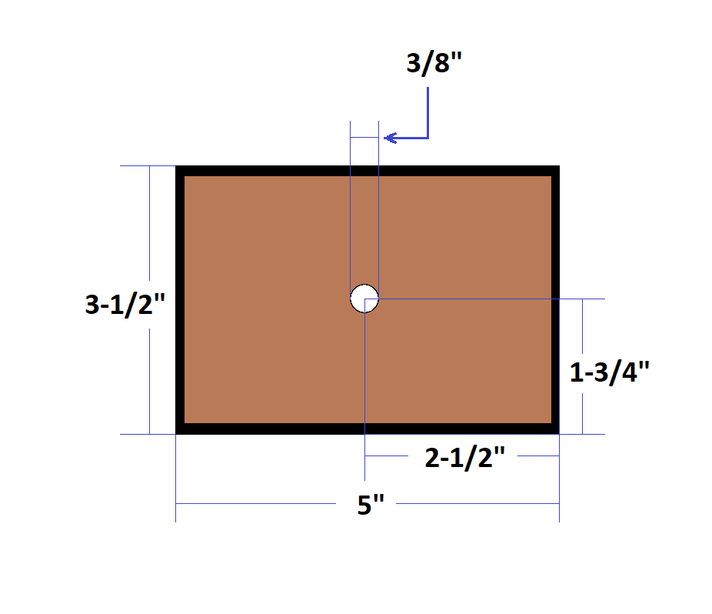
- Drill a hole in the middle of both sections of 1 X 4
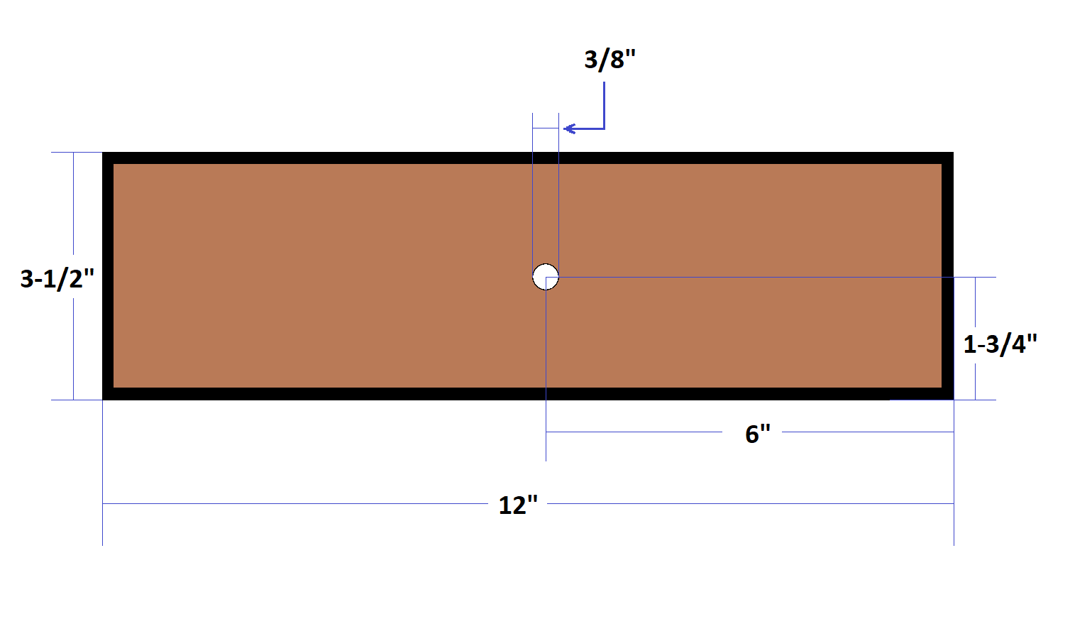
- Secure the luan and the two sections of 2 X 4 to one of the sections of 1 X 4
- Place one of the wooden spheres on the hole in the luan panel
- Secure the remaining 1 X 4 to the two sections of 2 X 4 to secure the the sphere for drilling
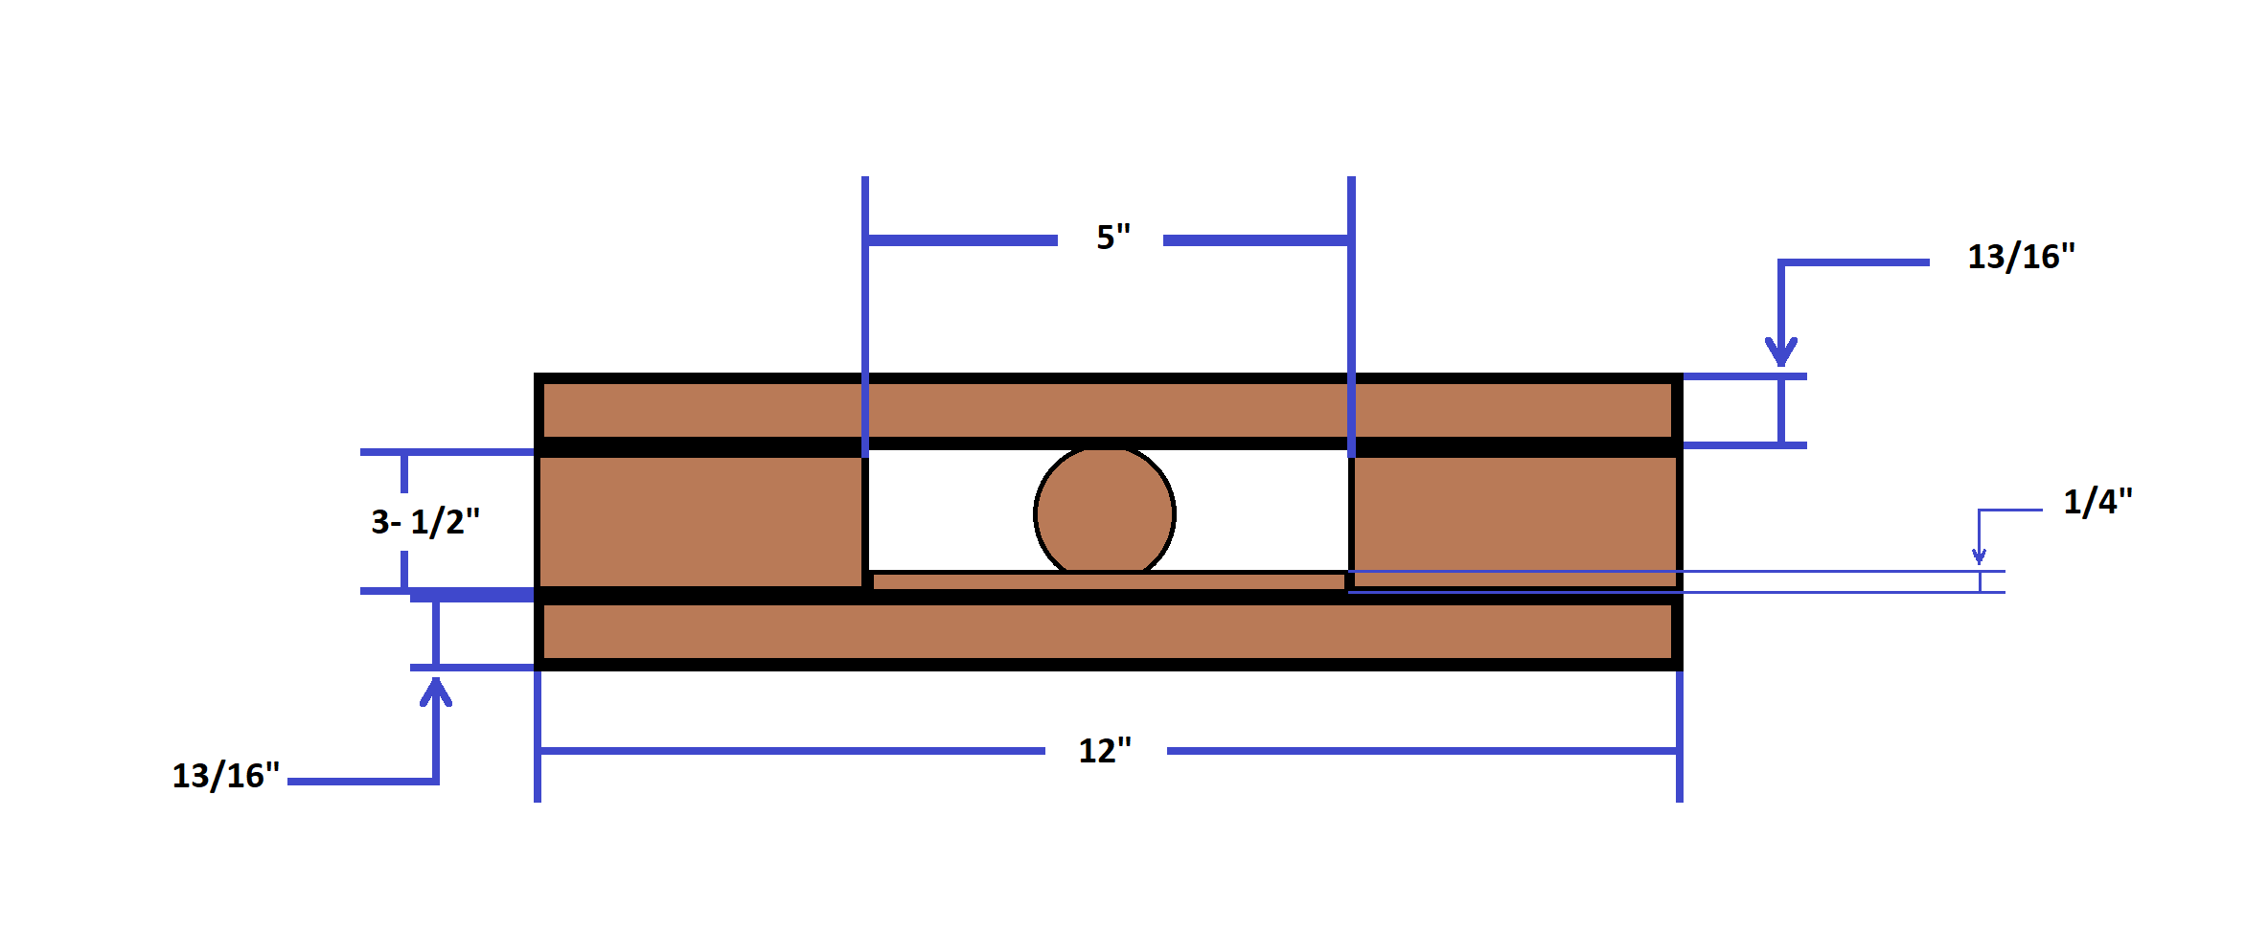
- Some adjustment is possible by making th hole in the luan bigger, but be cautious. If the jig gets too loose, the ball will spin during drilling.

Step 7: Planetary Assembly

- Using a ⅜" drill bit and the drilling jig, drill a hole roughly halfway through 4 of the wooden spheres.
- Apply wood glue to, and insert each of the 4 different lengths of dowel rod into the wooden spheres.
- Glue a ½" x 3/16" magnet on the opposite end of each dowel rod ensuring that the poles of the magnets are oriented correctly to stick to the top board assembly.
- Apply paint to the planet assemblies in this order.
  - 3"
    - Blue
  - 4"
    - Yellow
  - 5"
    - Red
  - 6"
    - Green
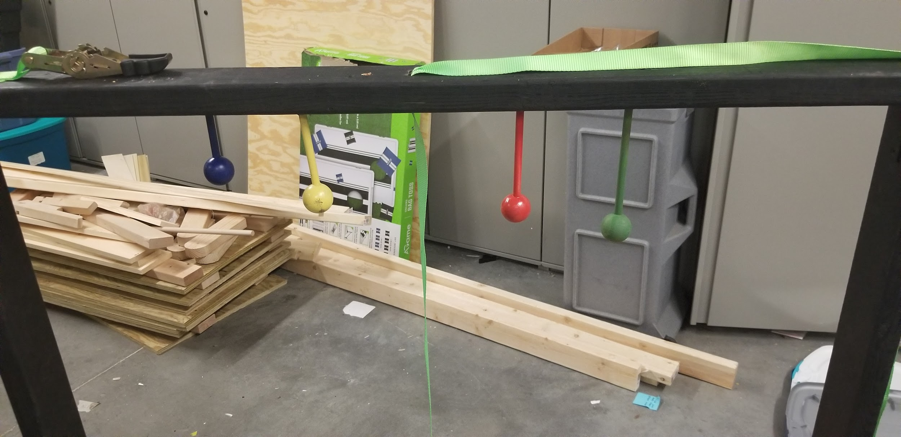
Step 8: Understanding The The Rules

- Total points: 1000
- Lift Off: 500 Points
  - Climb from the bottom to the top with a minimum of 18” of ground clearance
- Interplanetary Contact: 250 Points
  - Knock all of the planets off of the top board
- The Song of Our People: Play 10 seconds of your favorite space themed song

Final Step

- Plant a small section of 1” x 2” and tell the kids you’re “Growing next year’s courses”

