Building Instructions:
- Start with a 1”x 6” x 12’ board
- Cut the board to create a 1” x 4” x 12’ board and a 1” x 1.5” x 12’ board
- Cut the 1” x 4” x 12’ board to create two 1” x 4” x 47.5” boards and two 1” x 4” x 19” boards.
- Cut the 1”x 1.5” x 12’ board to create two 1”x1.5” x 46.5” boards
- Gather the 1”x 6” x 10’ board
- Cut both boards to create two 1” x 4” x 10’ board and two 1” x 1.5” x 10’ board
- Cut one 1” x 4” x 10’ board to create two 1” x 4” x 5’ boards.
- Cut one 1”x 1.5” x 10’ board to create two 1”x 1.5” x 5’ boards
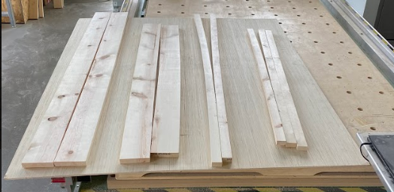
- Cut the plywood to 5’ length.
- To create the support structure, take the 4’ x 5’ plywood and the two 1” x 1.5” x 5’ boards
- Screw one board on the 5ft side of the plywood, then screw the remaining board to the other 5ft side.
- Take the two 1” x 1.5” x46.5” boards and screw them to the remaining sides of the plywood, making sure they are directly between the 5ft boards.
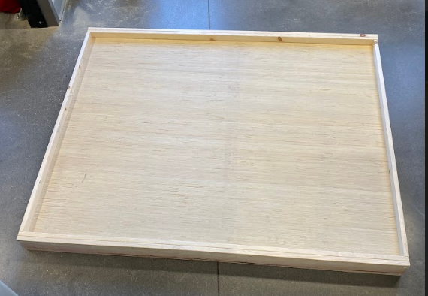
- To assemble the walls around the plywood, gather the two 1” x 4” x 5’ boards.
- Screw these boards on the 5ft sides of the plywood directly onto the support boards that are under the plywood.
- Take the other 1” x 4” x 10ft board and cut it into two 1”x4”x49.5” boards and two 1” x 4” x 10” boards.
- Screw the two 1”x4”x49.5” boards on the remaining sides directly to the support boards under the plywood.
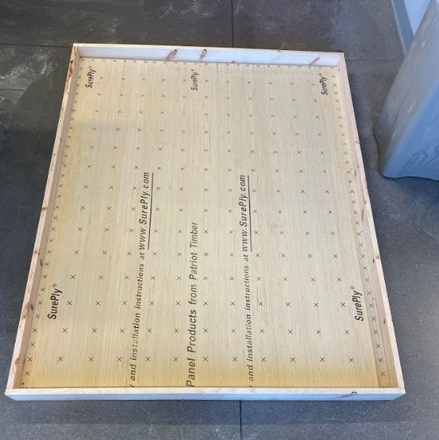
- To create the set of walls closest to the starting point, take the two 1” x 4” x 19” boards and glue them down 27 inches away from the starting point with at 10in gap between the two walls.
- For the next set of walls take the two 1” x 4” x10” boards and glue them 20 inches away from the end of the course. Each board is 9 inches from the side walls with a 10in gap between them.
- Once both sets of walls have dried, flip the board over and screw them in place.
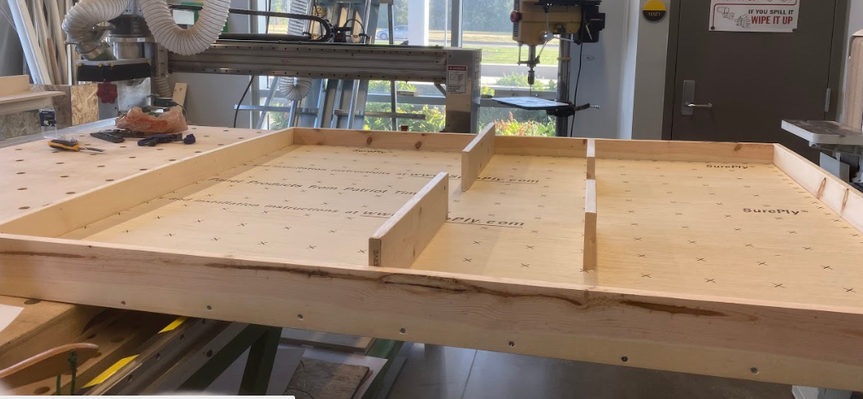
- To cut out the holes for the three goals, start at the opposite side of the starting point and sketch out three rectangles 1 inch from the end of the course.
  - The first goal is 4” x 8” and is 7 inches away from one side wall.
  - The second goal 2” x 6” and is 6 inches away from the first goal
  - The third goal is 4” x 8” and is 6 inches away from the second goal
- Once you sketched out the correct measurements for the goals, cut out the holes using an angle grinder.
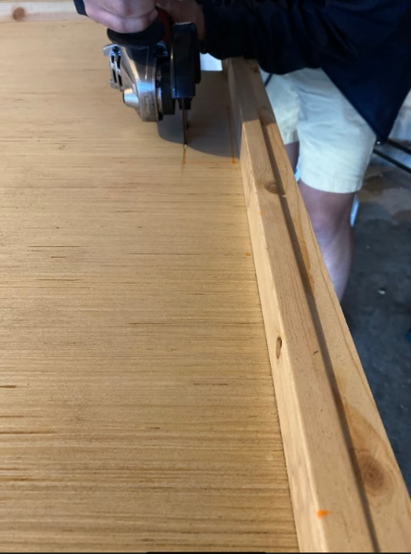
- Cut 11 dowel rods to a length of 11.25 inches. Using wood glue, glue the dowel rods using the dimensions given in the drawing.
- Take two wooden nickels and glue them together using wood glue. Do this 9 times.
- Take 9 single wooden nickels and the 9 sets of two that you glued together and glue them down using the dimensions given in the drawing.
  - Measurements of location on drawing are approximate.
- To create checkpoint 1 and the starting point box. Sketch out three 8” x 8” boxes then spray paint them red
- The first box is directly on the front left corner of the course
- The second box is 12 inches way from the first box
- The third box is directly on the front right corner of the course.
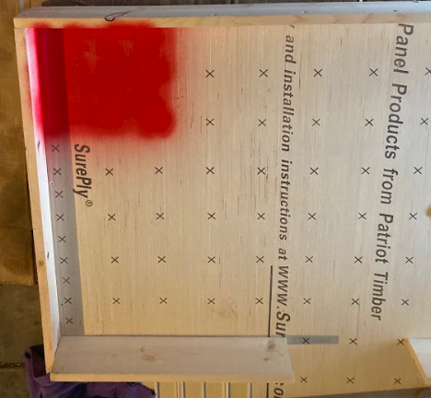
- Spray paint a 1” line 10in from the second set of walls within the course to create the penalty line.
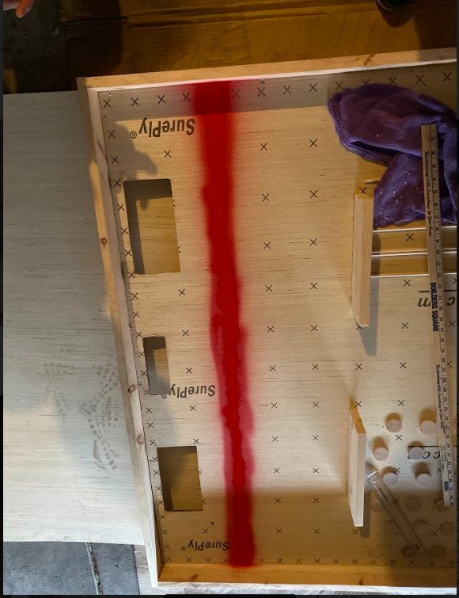
- Once dry, block off the penalty line, checkpoint 1, and starting point box with painter tape and spray paint the entire course white
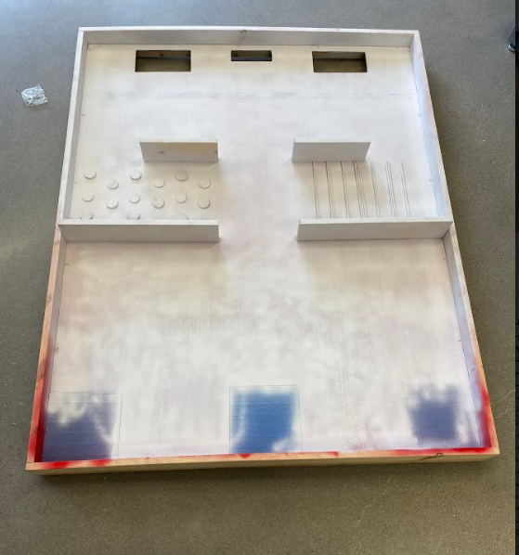
- With a sharpie, draw an 8in x 8in squares to create checkpoint 2 directly in front of the 19in walls. They should be 19in away from the starting point.
- Using the measurements from the drawing, draw the 5 defender outlines and puck outline with a sharpie.
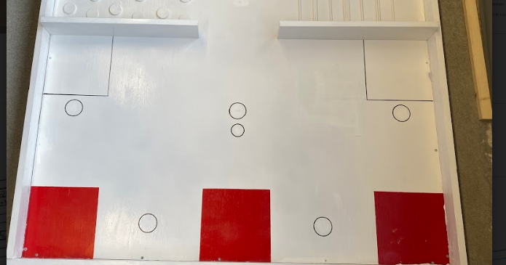
- To create the defenders, spray paint 4 pop cans black and 1 pop can red to represent the opposing team captain.
- To create the hockey puck, glue together 4 wooden nickels. Once the glue is dry, spray paint it black.
