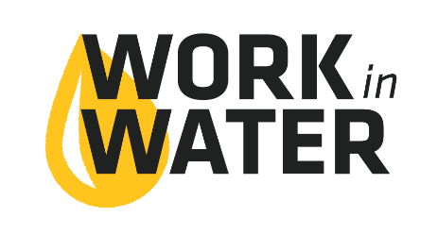

Capstone Project
As part of the Work in Water Summer Internship interns are asked to complete a Capstone Project that demonstrates what they learned and experienced during their 9-week internship.
The intern is able to choose what they want this project to be, but should display rigorous effort and scholarly work. However, we do want students to be creative and show their personality in the project.
The utility should give the intern some time, during business hours to work on the Capstone Project throughout the 9-weeks. However, some of the Capstone may need to be completed outside of the internship work day.
Capstone Projects could be:
- Power Point Presentation given after the internship
- A video
- Visual display that can be used at the utility or in City Hall
- A lesson they create and give to an elementary school class
- Blog
- Many other options – the sky’s the limit

Due dates for this project can be worked out between the utility and the intern.

Joint Conference
Interns are encouraged to set aside at least one, and up to three, days in August, to attend the KWEA & KsAWWA Joint Annual Water and Wastewater Conference.
The 2017 conference will be August 29-31 in Wichita, KS. Registration for interns is complimentary. They are encouraged to attend with a chaperon.
Interns will be given the opportunity to present, will be acknowledged, and be able to network with water industry professionals from across the state and nation.

