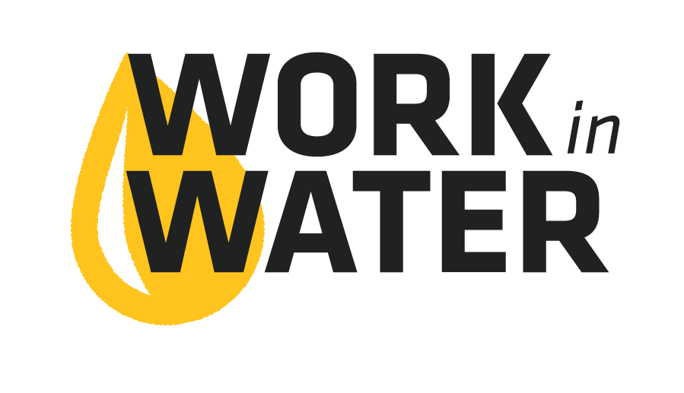
Internship Interview Question Library

- Why are you interested in the Work in Water internship?
- What are your expectations about this internship?
- Tell me about any volunteer, community service or job experience you have. And what did you enjoy most about those jobs?
- What did you find most interesting about the tours of the water and/or wastewater facilities?
- What skills or knowledge do you want to gain from the Work in Water internship experience?
- What qualities do you think will make you successful in this internship?
- What are your favorite classes in school?
- How would your teachers describe you?
- What are your college or career goals after high school?
- Describe a time when you solved a problem at work, school or at home.
- Tell us about a project or situation you are most proud of.
- Who is the most important person to you?
- What is your availability this summer?

