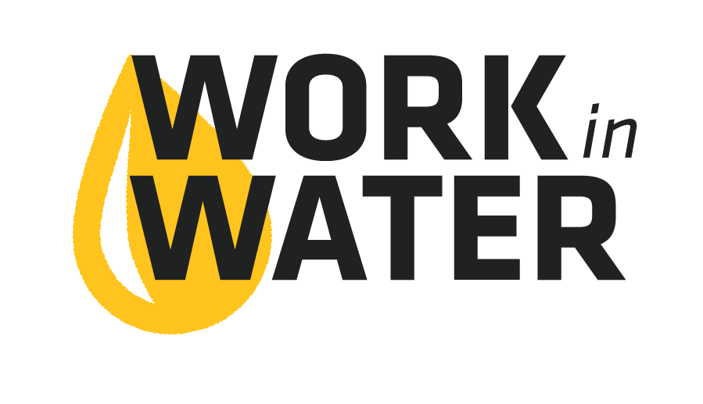
Copy and paste the template below into an email to your local high school counselor sometime in Nov – Feb in order to give the school enough time to plan for the event.

The highlighted sections below indicate portions of the email that need to be adapted to your utility, local high school, etc. Please, read through the email thoroughly before sending to make sure that it is edited to fit your community.

[INSERT SCHOOL COUNSELOR’S NAME HERE],

Are you looking to introduce students to well-paying science careers in their own community?
Careers that can start right after graduation or could be waiting for them after college?

My name is [INSERT YOUR NAME HERE] and I work for the [INSERT YOUR UTILITY’S NAME HERE]. We have a fun and educational water career exploration experience called Work in Water that we would like to invite your juniors and seniors to participate in.

The Work in Water Experience includes an interactive workshop for students to learn about drinking water and wastewater. Then, students will have the opportunity to tour the water and wastewater treatment facilities. Throughout the Experience students will meet water professionals (lab staff, biologists, mechanical engineers, water operators, managers, etc.). These water professionals will talk about how they found their water career, and they will share their passion for providing the community with safe and reliable drinking water and the ecosystem service of wastewater recycling.

Our next step is to start working with [INSERT HIGH SCHOOL NAME HERE] to find out which students or teachers to target for this opportunity. We are starting the conversation with you as the counselor because of the career connection. However, this project is very flexible and we can make it fit your school. Our goal is to conduct the Work in Water Experience in the Spring 2019, so that we can offer participating students the opportunity to apply for a summer internship this summer.

I would like to set up a time to talk about how we could bring Work in Water to your students. I am available [LIST TIMES YOUR ARE AVAILABLE].

Thank you.
[INSERT YOUR NAME AND CONTACT INFORMATION HERE]

Copy and paste the template below into an email to your local high school contact to forward on to students, parents and teachers. This email will encourage participation in your Work in Water program.

The highlighted sections below indicate portions of the email that need to be adapted to your utility, local high school, etc. Please, read through the email thoroughly before sending to make sure that it is edited to fit your community.
---------------------------------------------------------------------------------------------------------------------

Work in Water Experience Coming to School Name on Date.

The Work in Water Experience introduces both college and non-college bound students to the vast range of career opportunities in the water industry, and is a great activity to add to high school resumes.

Utility Name’s Work in Water Experience teaches City/Community high school students about the critical role that public water utilities fill in their community. This unique, hands-on learning program allows students to see the skills, technology and jobs that are working to ensure the public has access to safe, healthy drinking water and water recycling resources.

Why Should Students Attend?
- Fun day of career exploration and learning with friends.
- Hands-on experiments, interactive projects and a field trip to Water Facility Name.
- Participants can apply for an exclusive paid summer internship at Utility Name.
- Use this experience to build your resume!

See the attached flyer for more info. To register, contact: Name at emailaddress@email.com, or by calling (XXX) 555-5555.

