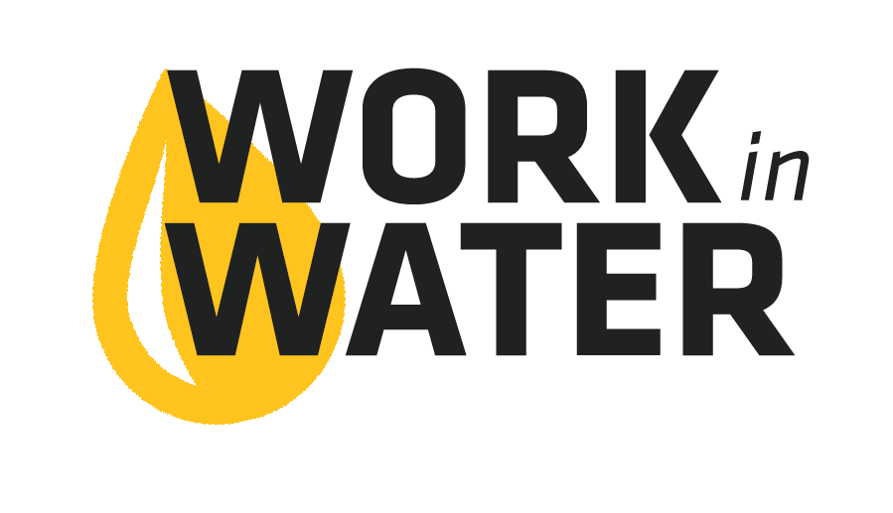
Internship Guidelines

Hiring
- Review applications and choose a handful of students to interview. The interview and application are all a part of the internship learning process. An additional goal of the internship is teaching students about what it is like to acquire a job in the ‘real world.’
- Ask traditional interview questions, including probing questions about why they chose to apply for the internship, what attracted them to a job in the water industry, etc.
- Choose a student who has the soft skills, not necessarily the knowledge. They will gain knowledge throughout the summer, which is the purpose of the internship. Necessary soft skills include: curiosity, ability to problem solve, written and verbal skills, ability to get along with others, adaptability and excitement about the possibilities.
Internship
- The purpose of this internship is to give students a broad overview of the water industry. The more experiences that can be provided to the student the better.
- Interns can provide maintenance support (mowing, painting, etc), but that should be a minor component of their responsibilities. The best approach is to provide the intern with a variety of job responsibilities in several different functions of the utility.
- Sometimes interns get frustrated when they are only observing and not “doing.” Let them know at the beginning of the day, or start of a project, how much they will be observing vs doing. If there will be a lot of observing let them know why it’s important that they observe, encourage them to look for specific things, and tell them how important the process is that they are watching. Encourage questions and provide explanations. Create dialogue.
- Experiences interns can participate in include, but are not limited to:
Plant tours | Going out on leak repairs
Observing or testing in the lab | Assisting with customer service or billing
Attending council meeting | Social media posts about experiences
Meter reading | Safety training
Hydrant testing & flushing | Sewer cleaning
Distribution system chlorine residual testing | General maintenance (<20% of time) – painting, mowing, repairing venting, etc.
Well maintenance | Residuals or sludge management

Capstone Project
As part of the Work in Water program, the interns are asked to complete a Capstone Project that demonstrates what they learned and experienced during their 9-week internship.
The intern is able to choose what they want this project to be, but should display rigorous effort and scholarly work. In addition, the interns are encouraged to be creative and show their personality in the project.
The utility should give the intern time, during business hours to work on the Capstone Project throughout the 9-weeks. A few hours each week is suggested.
Capstone Projects could be:
- Power Point Presentation given after the internship
- A video
- Visual display that can be used at the utility or in City Hall
- A lesson they create and give to an elementary school class or their own class
- Blog posts
- A combination of activities
- Many other options – the sky’s the limit
Due dates for this project can be worked out between the utility and the intern.

Joint Conference
Interns are encouraged to set aside at least one, and up to three, days in August, to attend the KWEA & KsAWWA Joint Annual Water and Wastewater Conference.
Registration for interns is typically complimentary. They are encouraged to attend with a chaperon.
Interns will be given the opportunity to present, will be acknowledged, and be able to network with water industry professionals from across the state and nation.

