General Education Committee Meeting

Minutes 11-28-2022

Members in Attendance: Natalie Delacruz, Sally Fiscus, Robin Folkerts, Linnea GlennMaye, Julie Henderson, Brittany Lockard, Mathew Muether, Roy Myose, Angela Paul, Sandra Sipes, Jan Wolcutt

Absent: Mark Barlow, Janus Hudson, McKenzie Lane, Cathy Phillips

Approval of minutes from 11-14-22 meeting: It was moved and seconded to approve the minutes. Approved: 9-0.

REPORT: Progress from Gen Ed Framework Subcommittee

Mathew reviewed the GEP “Buckets” handout, which did not change much from the previous meeting. The FAQ page is new, which is intended for the faculty. Answers are from the Regent’s web page.

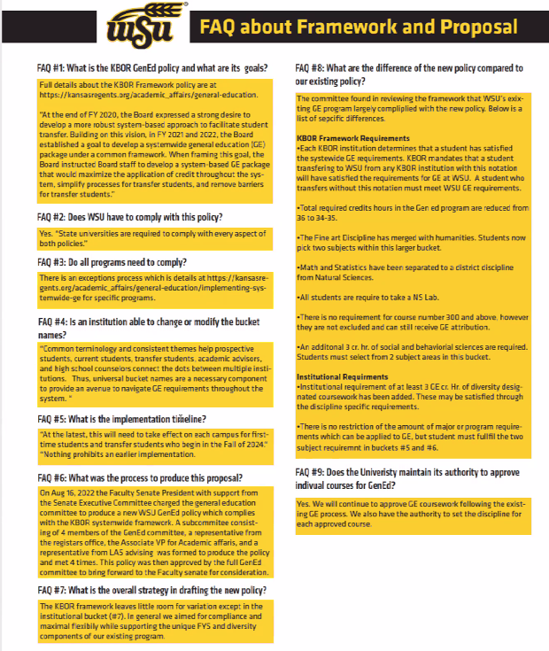
The Gen Ed committee tried to keep WSU’s current policy as much as possible, while adhering to the Regents policy, which WSU has no choice but to accept. FAQ #8 outlines the differences between WSU’s current policy and the Regent’s policy. If WSU does not do this, transfer students might end up with more than 120 hours for their degrees. Multiple people on WSU’s committee and from other universities posed this question during the regent’s informational webinar, but they were not answered.

The process for informing the students about the new policy has not been determined. There will be another Regents’ webinar at 10:00 am on December 16.

Clarifications:
- Students would still need to pay the fees for transcripts from every institution they attended.
- WSU’s policy on minors is that WSU requires 3 hours of unduplicated credit hours; “Duplicated hours” are courses used for Gen Ed or program requirements AND for the minor or other requirements.
- Sally will create sample degree programs, particularly for aerospace engineering and other programs that have accreditations requirements.
- The Regent’s policy seems to imply that program requirements that are also currently used for Gen Ed will NOT count as Gen Ed unless an exception is granted.
- If students have completed another institution’s Gen Ed program and did not use program requirements to complete the Gen Ed requirements, they will still have to take the required course, which will probably make the student take more than 120 hours. The issue is courses that are required for programs which can count as Gen Ed. WSU would like to list these courses as “required,” but the regents are balking at letting universities do that. It seems like institutions CAN let students double-dip but can’t TELL them they can double-dip. The board of regents seems to think that there will not be many exceptions, but the Gen Ed committee estimates that 1/3 of WSU’s programs would need to ask for an exception under the policy as written. A representative of the regents said they would answer send out answers to questions that came up in the seminar but were not addressed.

The following was added to the Regent’s website since the last full Gen Ed meeting.

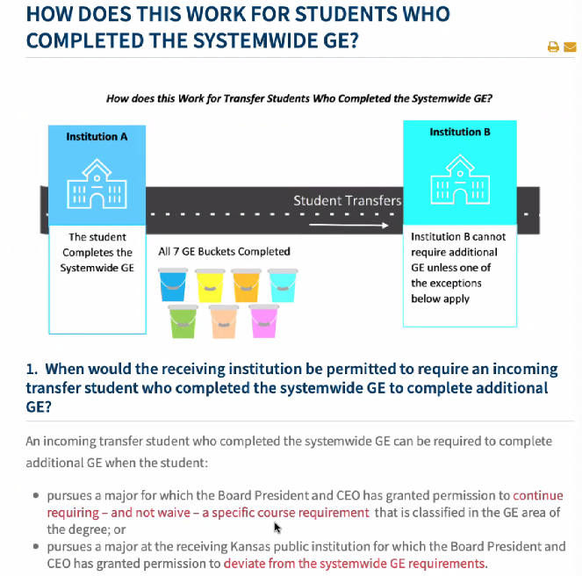
COURSE PROPOSALS

- Mathew spoke to the instructors for ETHS 381Q: Immigrations Today, HIST 547: Law and Modern American Civil Rights, and WOMS 380AB: Black Women in America and shared the committee’s comments. The instructors were fine with the comments but said it would likely be January before they were able to fix the proposals.

COURSE PROPOSALS:
- REL 303: The Bible and the Ancient Near East:
This was a special topics course, 311C, that asked to be a regular course, designated Gen Ed, with a new course number and description. Assessments are not linked to specific outcomes in the syllabus but were in CIM. It was moved and seconded that the course be approved, if Mathew sees the assessments attached to course outcomes in the syllabus. Approved 8-0.

- REL 393: Race and the Bible (cross listed as Ethics 393)
Some course specific measurable outcomes aren’t measurable (#1 and 2 for example) and aren’t linked to assessments. Mathew will send some feedback and ask the instructor to link specific GEP outcomes to assessments and ask the requestor to resubmit the proposal

- GEOL 301: Dinosaurs: Fantastic Beasts and Lost Worlds
Outcomes are not linked to assessments on the syllabus (but were listed in CIM) and the grading scale does not state percentages. It was moved and seconded that the course be approved, if Mathew sees the assessments attached to course outcomes and grade percentages in the syllabus. Approved 8-0

- HIST 547: Law and Modern American Civil Rights
The corrections are the same as previous courses from the same instructor, so the committee sent the proposal back to the originator with the same comments.

- PHIL 386: Biomedical Engineering Ethics
The course number is not identified on the syllabus and permission to enroll is required for students with less than junior standing (which is probably intended to allow the course to count as a Gen Ed humanities course, but give preference to engineering students, who have it as a requirement.) Mathew will reach out to Susan to see if the permission to enroll statement can be removed. The request was tabled until the next meeting. In the meantime, Sally will research to see if other already approved courses have this restriction.

- ENGL 234: Young Adult Fiction
The course description is not the same as the catalog description; there is no grade chart; CIM does have diversity content even though diversity is in the syllabus; outcomes not linked to assessments in the syllabus. Sally will talk to the Fran about changing the diversity requirement. It was moved and seconded that the course be approved, if Mathew sees the catalog description matches the description in the syllabus and CIM, that a grade chart is added, that assessments are attached to course outcomes in the syllabus, and that the faculty member resolves the diversity issue. Approved 7-0.

It was agreed that Mathew will not bring proposals forward to the committee if outcomes are not linked to assessments, but instead ask the originator to link outcomes and assessments and bring the proposal forward when that is done.

CONCERNS:
- Will the committee be changing policy that should be determined by the faculty if it states that, going forward, the committee will not approve courses that require permission to enroll.
- Committee members expressed concern that any course can be a Gen Ed course, when the intent of the Gen Ed policy is to encourage students to take courses outside their major requirements. The committee will discuss this in depth at a future meeting.

NEXT MEETING:

- The next subcommittee meeting is December 5 if Mathew gets the list of courses that count in various buckets from Sally
- The next Gen Ed meeting would be December 12.

ADJOURNMENT

The meeting ended at 2:02 pm

