General Education Committee Meeting

Minutes 12-12-2022

Members in Attendance: Gina Crabtree, Natalie Delacruz, Sally Fiscus, Linnea GlennMaye, Julie Henderson, Brittany Lockard, Mathew Muether, Roy Myose, Angela Paul, Sandra Sipes, Jan Wolcutt

Absent: Mark Barlow, Robin Folkerts, Janus Hudson, McKenzie Lane, Cathy Phillips

Approval of minutes from 11-28-22 meeting: It was moved and seconded to approve the minutes. Approved: 7-0.

Report – Progress from the Gen Ed Framework subcommittee.

GEP PROPOSAL: Revised to include where FYS course could be used.
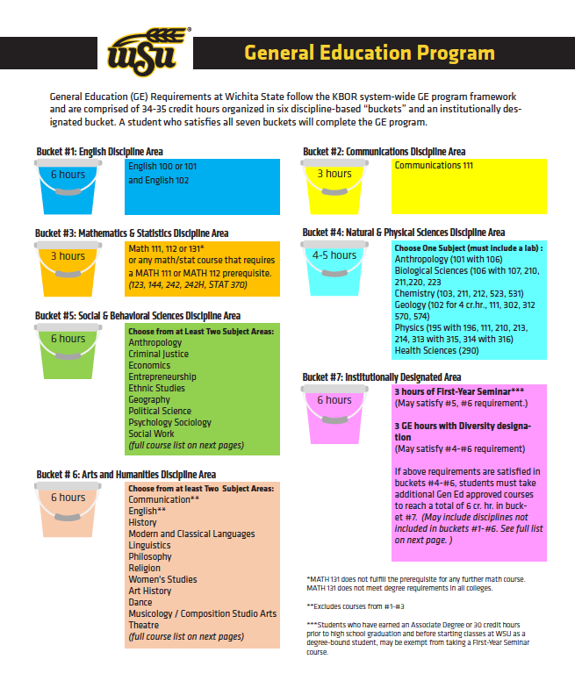
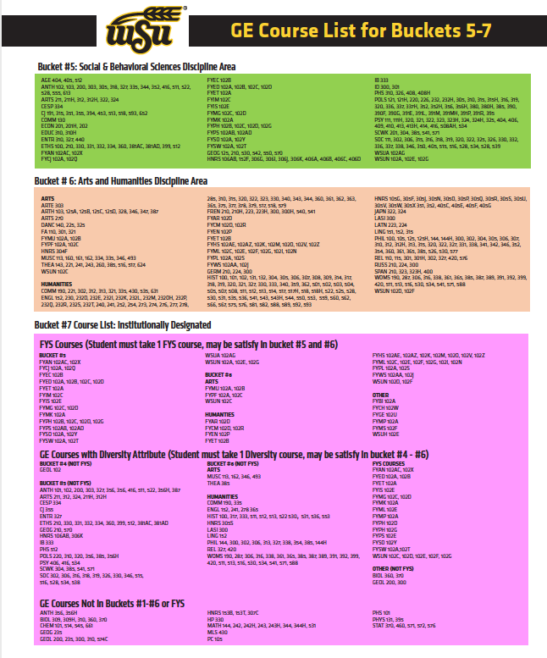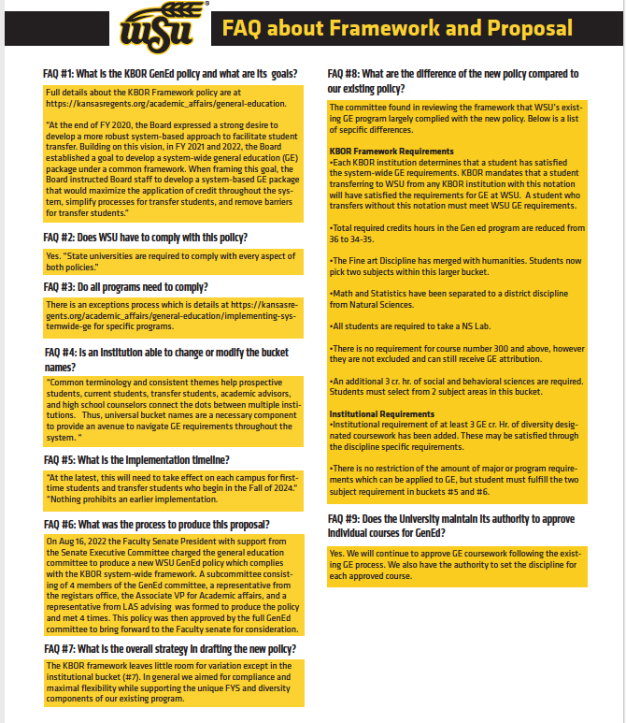
Chairman Mathew Muether shared the proposed GEP document with the Academic Forum. Comments were generally positive, with participants commenting on the clarity of the presentation. The main questions were about the process for incorporating the proposed diversity requirement. Currently, courses are approved by one person. The GEP committee will recommend the creation of a standing Senate committee to review and approve courses for the diversity component. This responsibility should not be part of the Gen Ed committee’s responsibility.

Should triple-dipping (letting a course count as a Gen Ed in a department bucket, diversity attribute and FYS) be permitted? The intent of a general education program is that triple dipping should NOT be permitted. The registrar’s office pointed out that the software system may not be able to enforce that restriction. After looking at several GEP samples from Engineering, the committee decided to allow triple-dipping, as the system will result in the same outcomes as WSU’s current program.

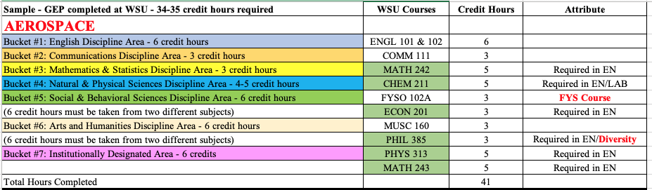
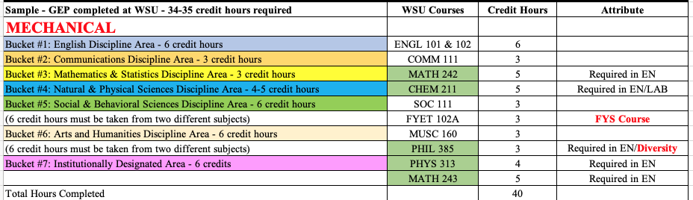
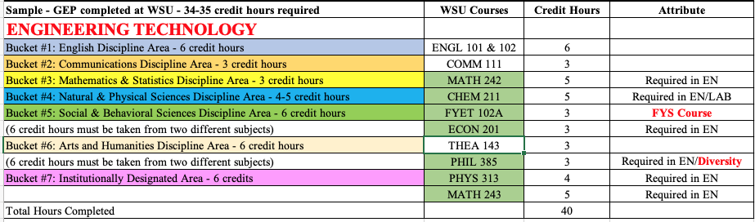
The FYS system does not identify an FYS course as belonging to a specific department, so the system will not be able to tell if an FYS course is in the same department as another course. taken in that same department. The Registrar’s office will work on this.

There is a perception that FYS courses can count as the only course in a discipline, but WSU’s current system only requires ONE Course in a discipline, but the Regent’s proposal requires TWO courses in two different departments. Perhaps this can be addressed in the FAQs or with sample programs.

The committee looked at sample GEPs for students in Engineering who would end up with 40-41 hours in Gen Ed as opposed to 34-35 hours, even with students using FYS course to double-dip. After seeing the samples, it became clearer that allowing double-dipping results in students taking essentially the same General Education courses that they take under WSU’s current Gen Ed.

There will be another KBOR webinar at 10:00 on Friday.

Shared in the chat: https://www.kmuw.org/news/2022-12-12/who-needs-college-algebra-kansas-universities-may-rethink-math-requirements

COURSE PROPOSALS:
Updates:

  - PHIL 386: Biomedical Engineering Ethics
    - PHIL 385 Engineering Ethics has been a required course for all engineering majors for several years. To ensure that students near graduation can get into the class and to help ensure that they're prepared for a 300-level course, it has been restricted to juniors and seniors - or instructor permission.
    - PHIL 386 Biomedical Engineering Ethics was created to give students in this major an option to take a course that includes material on human subjects’ protections and "biomed" issues that don't get much emphasis in PHIL 385. Engineering wants the courses to be parallel. Since Biomed Engineering is still relatively small, we should have room in the courses for the time being. We do, however, have an interest in ensuring that students are ready for the course.
    - If Dean Muscat and Dr. Mahapatro are willing to remove the restriction to junior/senior status, then I'm fine with it. The committee is uncomfortable with having GEP courses that can only be taken as juniors or seniors. Mathew will ask if they are willing to remove the junior/senior restriction.

  - REL 303: The Bible and the Ancient Near East
Approved following syllabus update.
  - GEOL 301: Dinosaurs: Fantastic Beasts and Lost Worlds
Approved after syllabus update.

PROPOSED REVIEWS
  - ARTS 312: Community Arts Engagement
The department is asking to let the course be repeatable for credit. The Registrar’s office could restrict the course so that only 3 hours can count towards the GEP. It was moved and seconded to restrict the course so that only 3 hours can count towards the GEP. There was a concern expressed that the committee could be making policy, so the motion was withdrawn. Mathew will send the proposal back with the committee’s concerns and ask for clarification from Robert.

  - REL/WEIS 393: Race and the Bible
The original syllabus did not tie assessments to outcomes but has been updated. It was moved and seconded to approve this course for General Education. Motion passes 8-0. Mathew will pass along feedback that students are not likely to understand “hegemonic paradigms of interpretation” in the description, and that it would be clearer if the syllabus had ONE grade table with percentages and points on the same table.

  - ENGL 333: Literature and Law
The chair requested a syllabus update from Fran with outcome and assessments connected. The updated syllabus has not arrived, so the proposal was tabled.
  - MUSC 164: Pop. Music of the Americas
Dr. Levine updated the syllabus to tie outcomes and assessments. It was moved and seconded to approve the course as a Gen Ed course. Motion passes 8-0. Mathew will pass along the comment that perhaps “interrogate” musical styles be changed to “evaluate” musical styles in the syllabus.

NEXT MEETINGS

The subcommittee will not meet again.

ADJOURNMENT

The meeting ended at 2:11 pm

