•
•
•

•
•

•

•
•

•
•

•

•
•

Concluded second year of the Widener Global Leaders Program (WGLP)
- Concluded the second year of the Widener Global Leaders Program (WGLP). This is an interdisciplinary program aimed to develop the next generation of global female leaders. Larisa Genin serves as the WGLP Director with faculty leads from the College of Liberal Arts and Sciences, College of Fine Arts, and the Barton School - Lisa Parcell, Andrea Banke, Dotty Harpool. In two years, the program has graduated 18 students (44% are first generation students). This is a privately funded program by Peri Widener with initial funding of $100k and additional funding of $300k to continue the program for the next 5 years. The WGLP Industry Advisory Board consisting of 9 female industry executives and business leaders.

Strengthen student engagement and connections with prospective Shockers
- Revitalized Barton School of Business Student Ambassadors group consisting of students with diverse backgrounds.
- Hosted numerous Professional Edge workshops through Barton School's Office of Career and Professional Development (OCPD) for undergraduate and graduate students featuring diverse industry executives and business leaders.
- Our faculty hosted a career day on June 9th for TRIO Upward Bound Wichita Prep for 40 high school students to showcase career paths in finance, real estate, management information systems, analytics, supply chain, entrepreneurship, and human resource management.

Promote diversity and inclusion through signature programs and leadership appointments
- Hosted our first minority Entrepreneur in Residence in the Fall of 2022 - Basil Hourani, Co­ founder, and Executive Partner in Capital7.
- Hosted our first woman as Entrepreneur in Residence in the Spring of 2023 - Susan Thomas, Founder and CEO of 10Fold.
- Hosted two distinguished speakers-Sunil Srivastava (Pandora SVP of Core Technology) and Navin Thukkaram (Lead Investor, Skykick)-representing minority groups.
- Margaret Dechant was appointed as the Dean's "Fabulous 50" Advisory Board Chair - the first woman since founding. Minority and women constitute about 40% of the Dean's Advisory Board.
- Launched the Dean's Alumni Advisory Board with one third of the members representing diverse gender and ethnical backgrounds and had Eric Cummings appointed as the Alumni Advisory Board - the first woman since founding.
- Launched the Institute for the Study of Economic Growth (ISEG) Advisory Board with one third of the members representing diverse gender and ethnical backgrounds.
- Launched the Marketing Industry Advisory Board with over 70% of the members representing diverse gender and ethnical backgrounds.

2023- 2024 Academic Year
Additional DEI activities planned for FY'24

- Expand the engagement in DEI activities of Barton School of Business (e.g., further strengthen representation of faculty and staff on the Barton School's DEI Committee, allocate time at Dean's Council and College meetings for DEI related updates/discussions, accessibility discussions, visit from Chief Diversity Officer, visit of ADA coordinator).
- Ensure diversity in faculty and staff searches.
- Promote all aspect of diversity through celebrations for faculty and staff.
- Celebrate the diversity of our students through cultural celebrations.
- Create school initiatives to support First Gen students.
- Create visuals to feature the diversity of our faculty, staff, students, and partners.

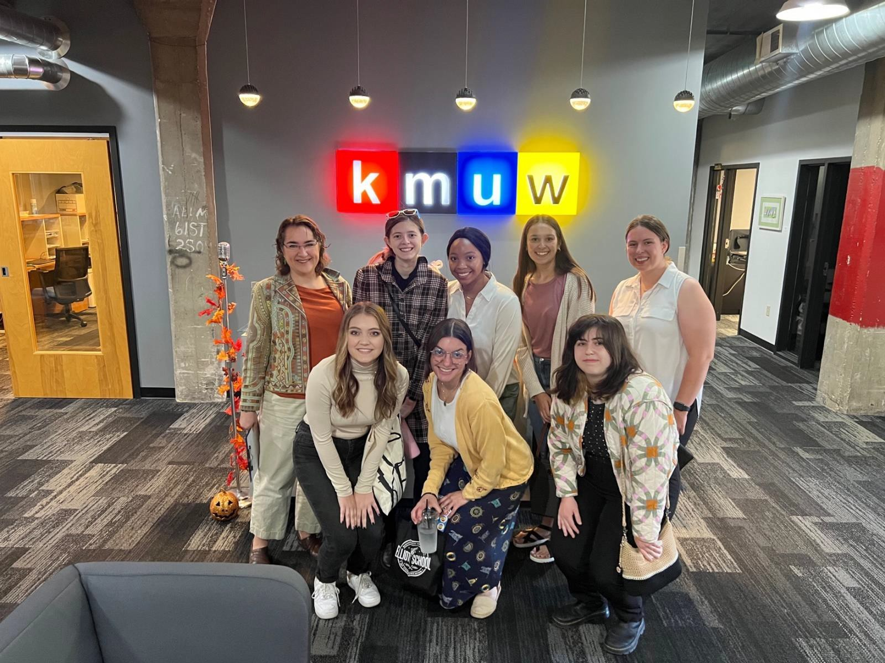
Widener Global Leaders Program: Immersion Experience – Communication Module – Company Visits (2022-2023 academic year)

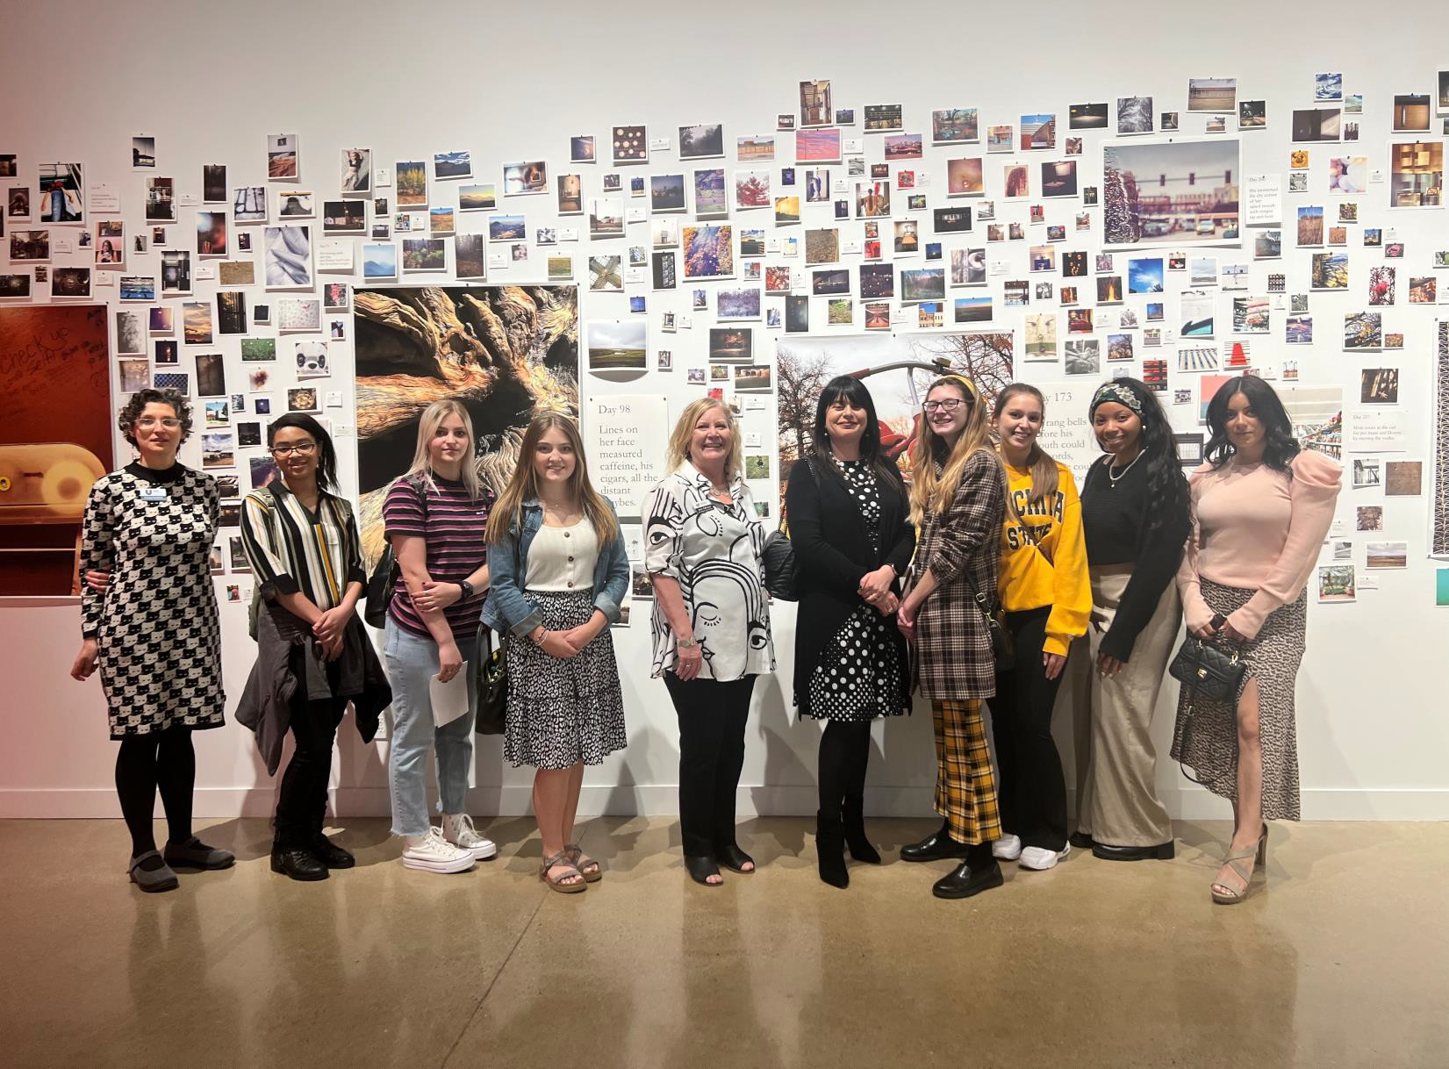

Widener Global Leaders Program: Immersion Experience – Art Module – Visits (2022-2023 academic year)

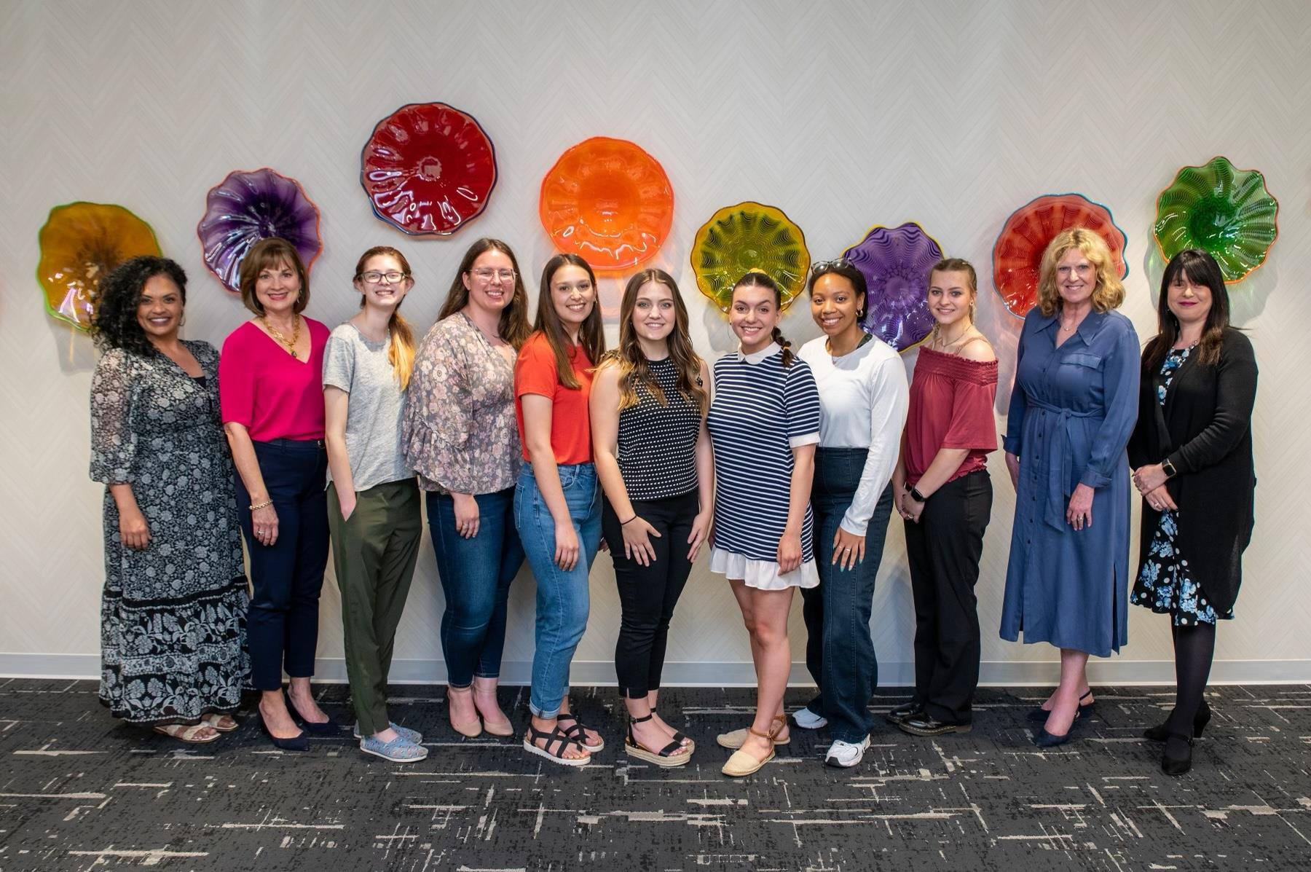

Widener Global Leaders Program: Developing a Philanthropic Mindset Educational Workshop presented by Dr. Elizabeth King, President, WSU Foundation (2022-2023 academic year)

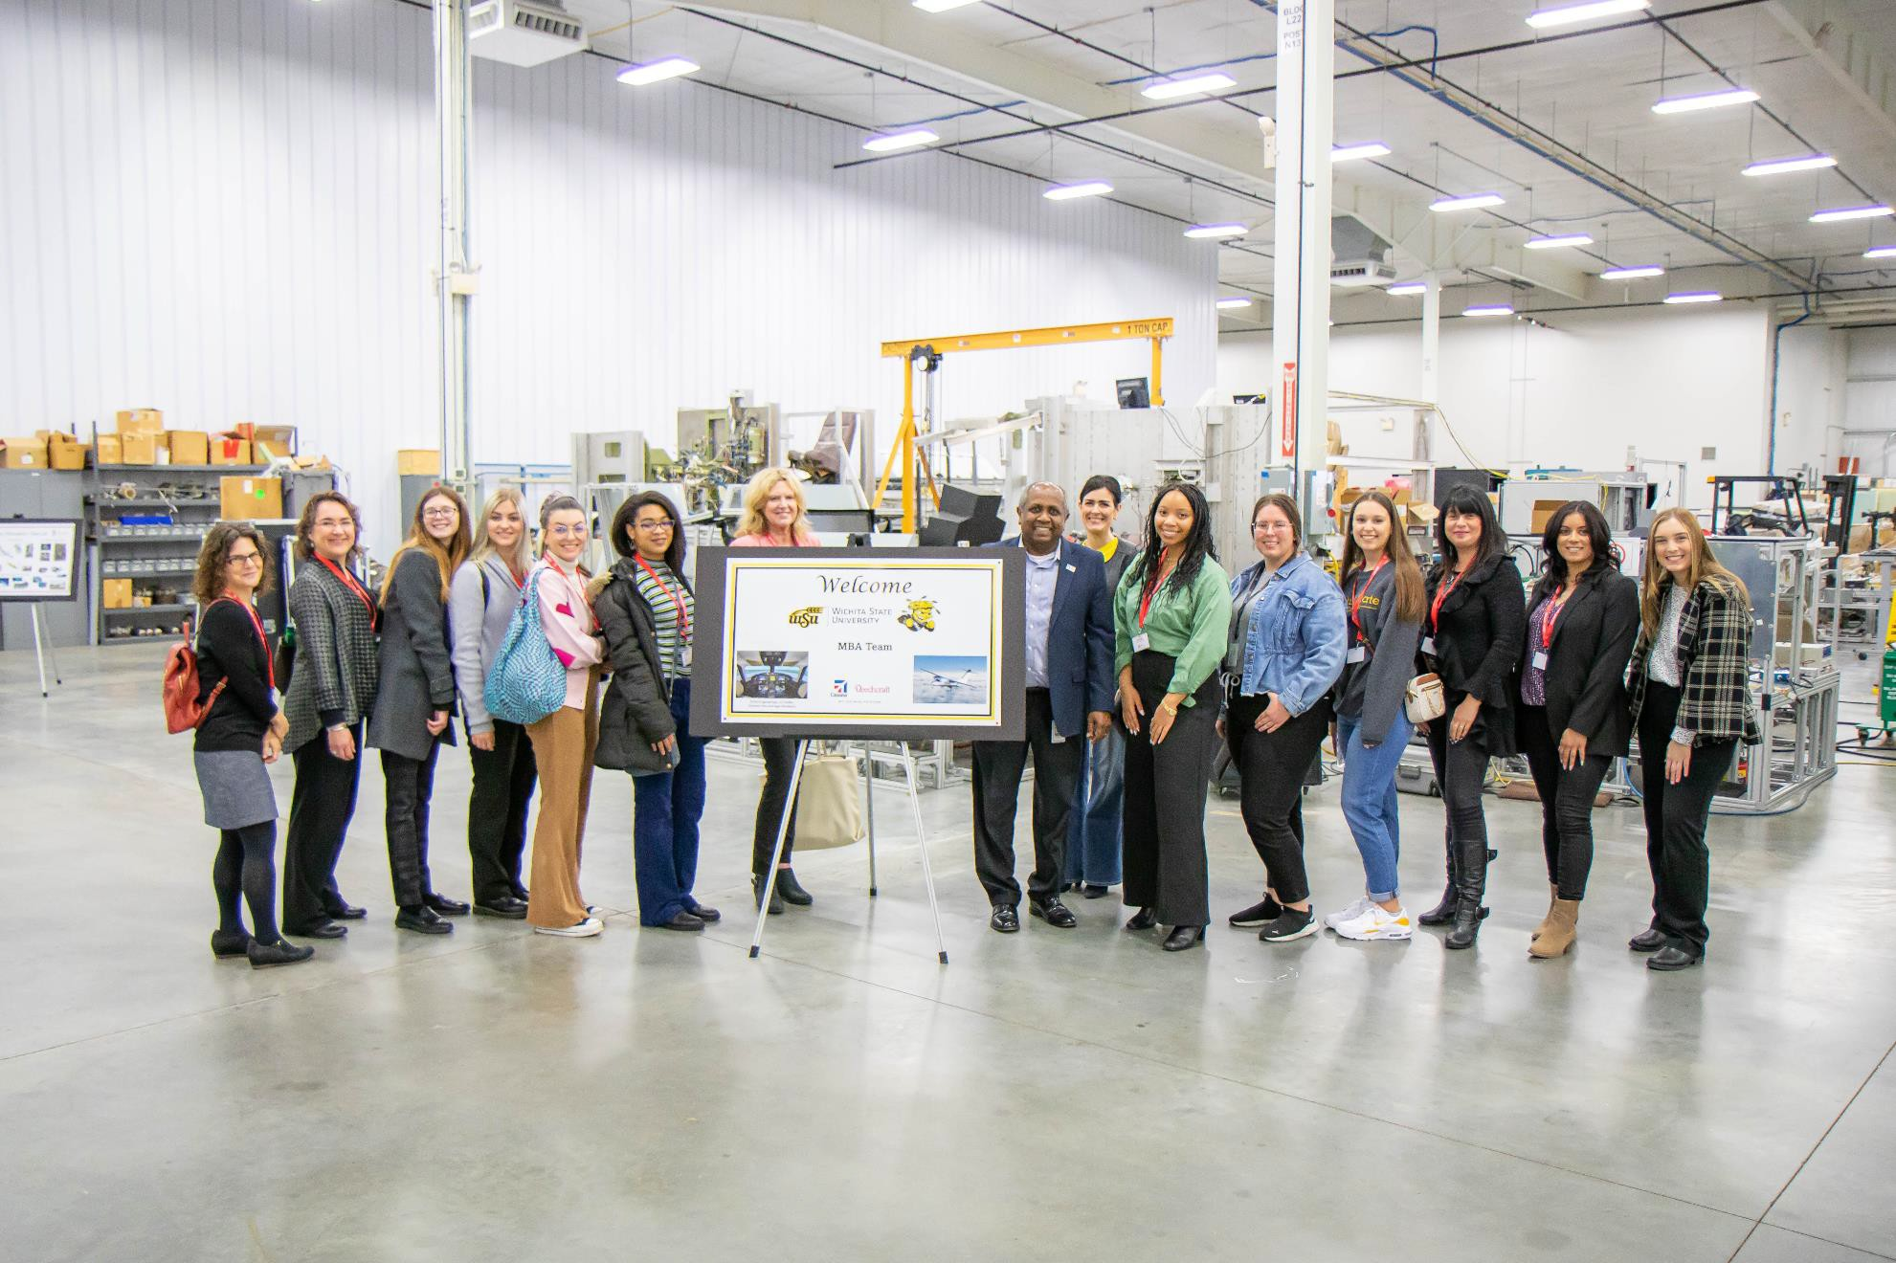

Widener Global Leaders Program: Immersive Experience – Business Module – Textron Company Visit (2022-2023 academic year)

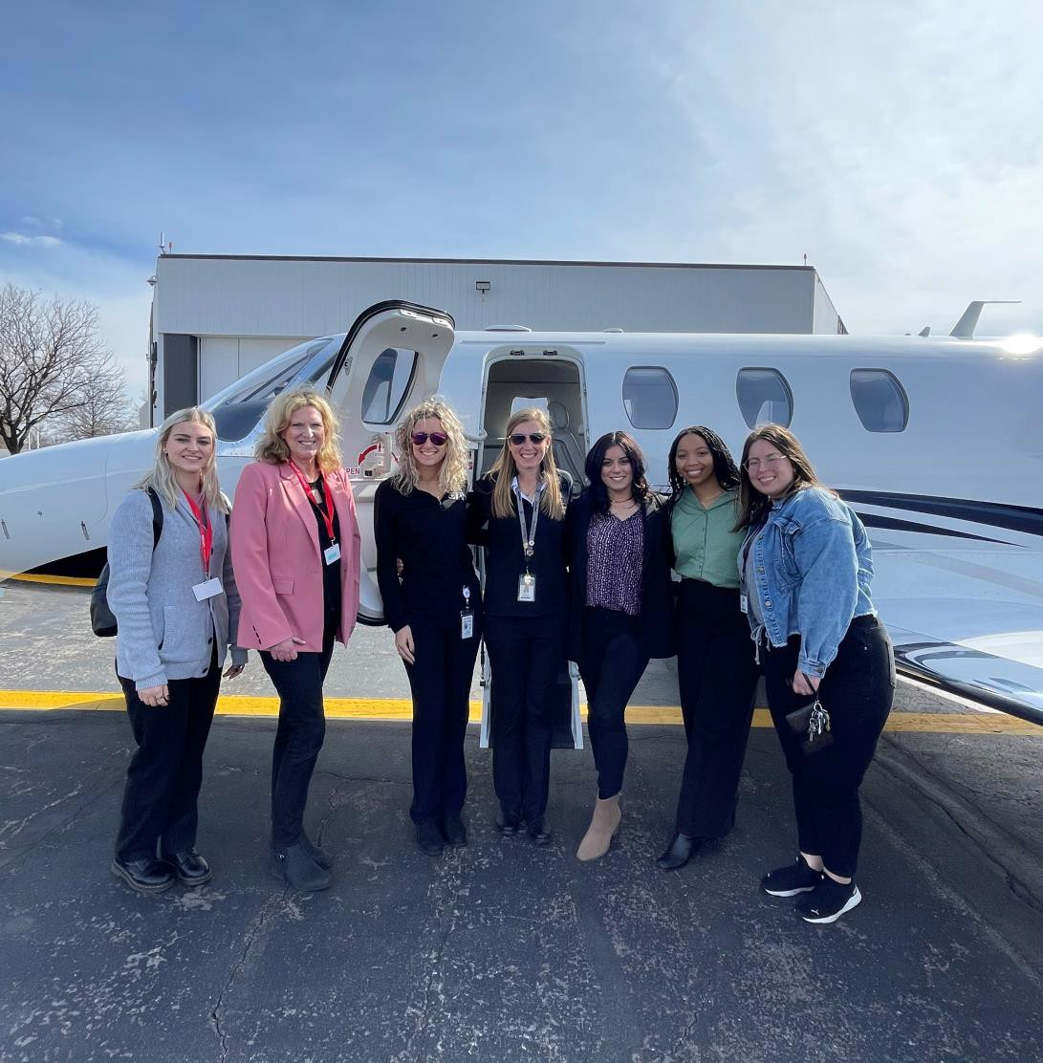
Widener Global Leaders Program: Immersive Experience – Business Module – Textron Company Visit
(2022-2023 academic year)

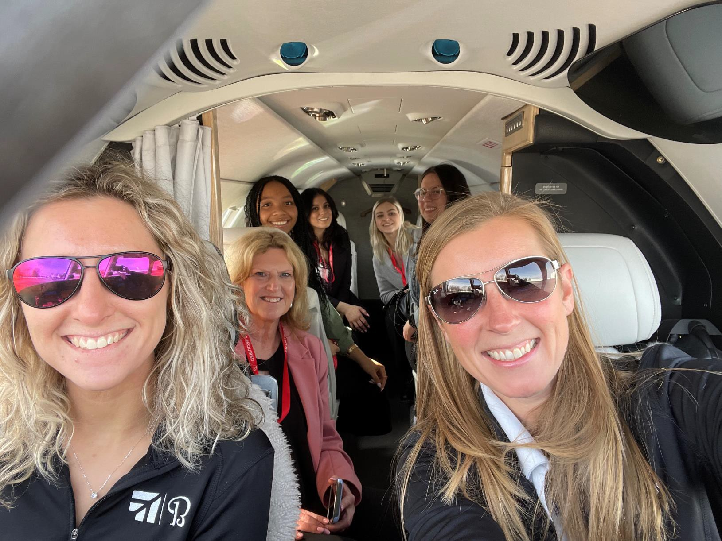

Widener Global Leaders Program: Immersive Experience – Business Module Textron Company Visit – Taking off with 2 female pilots
(2022-2023 academic year)

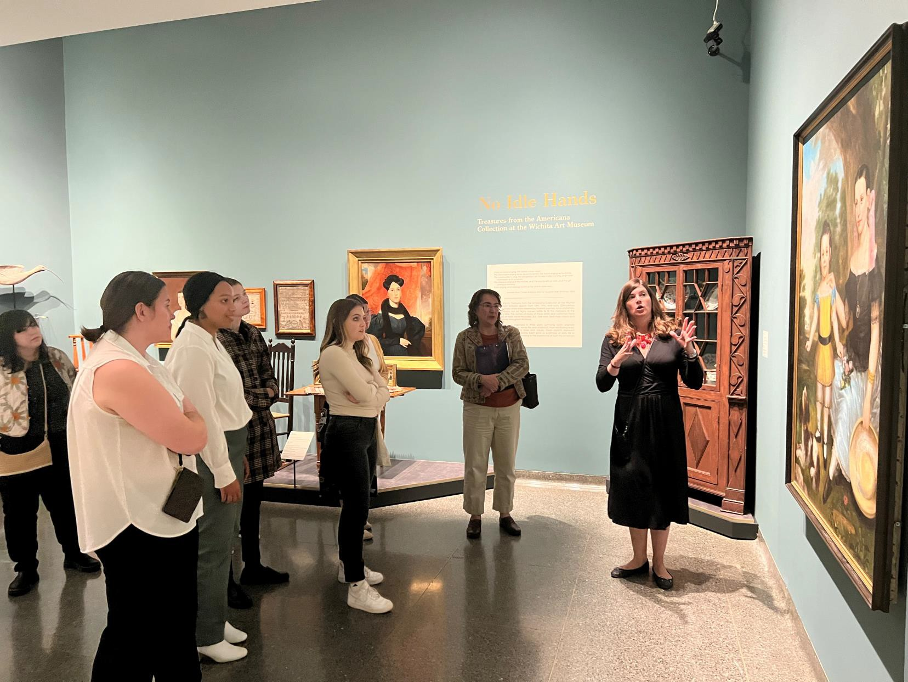

Widener Global Leaders Program: Immersive Experience – Art Module – Ulrich Art Museum Visit (2022-2023 academic year)

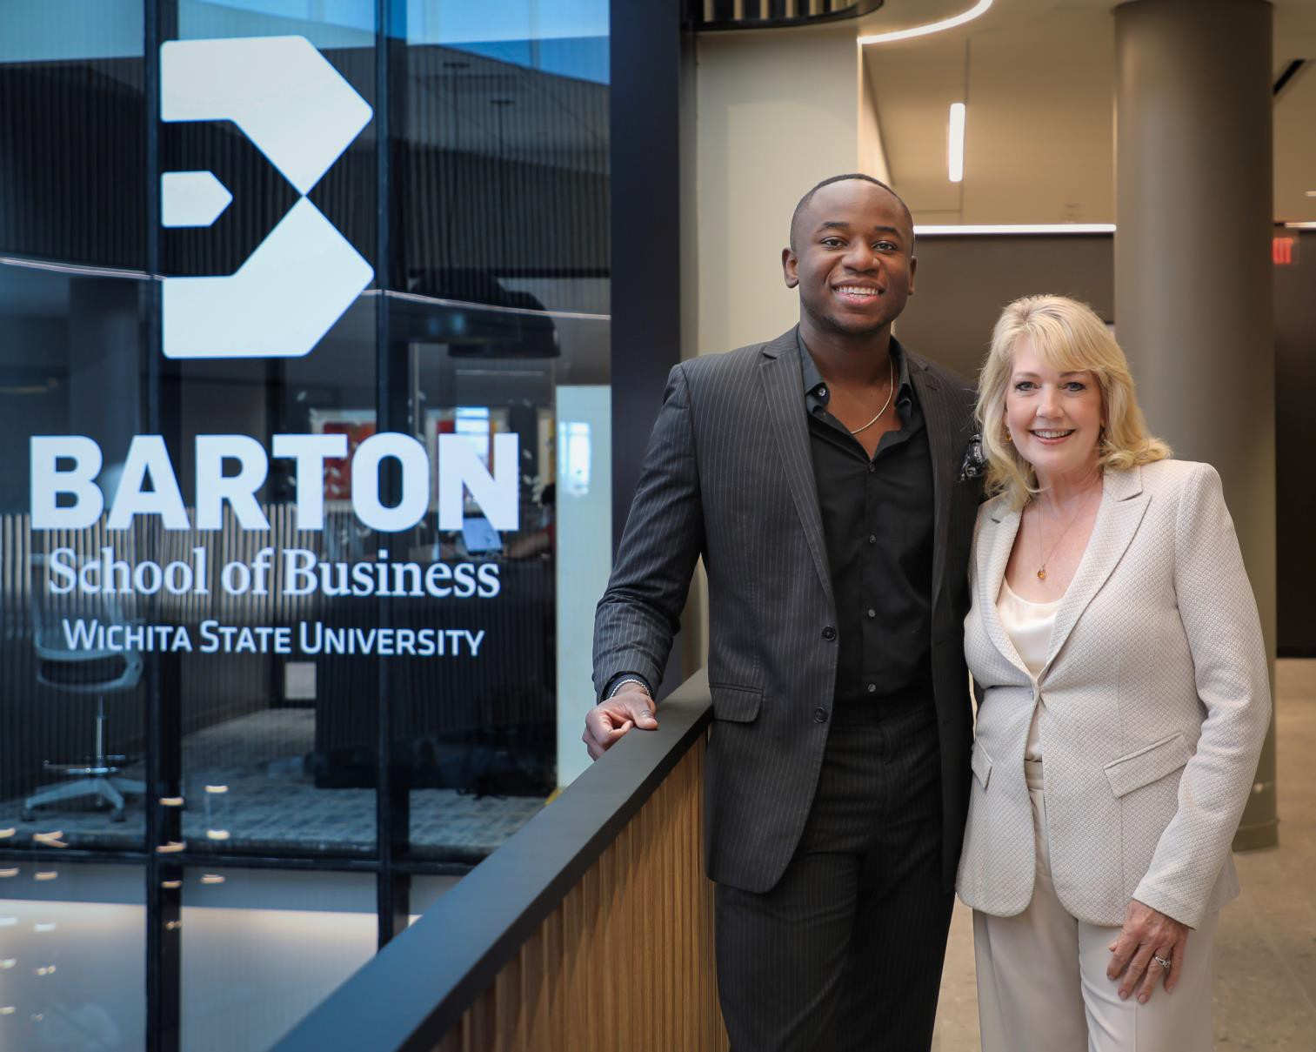
Entrepreneur-in-Residence Susan Thomas, Founder and CEO, 10 Fold (San Francisco, California) Keynote Presentation: An Entrepreneur’s Journey: Finding the Why to Drive Your Success Spring 2023

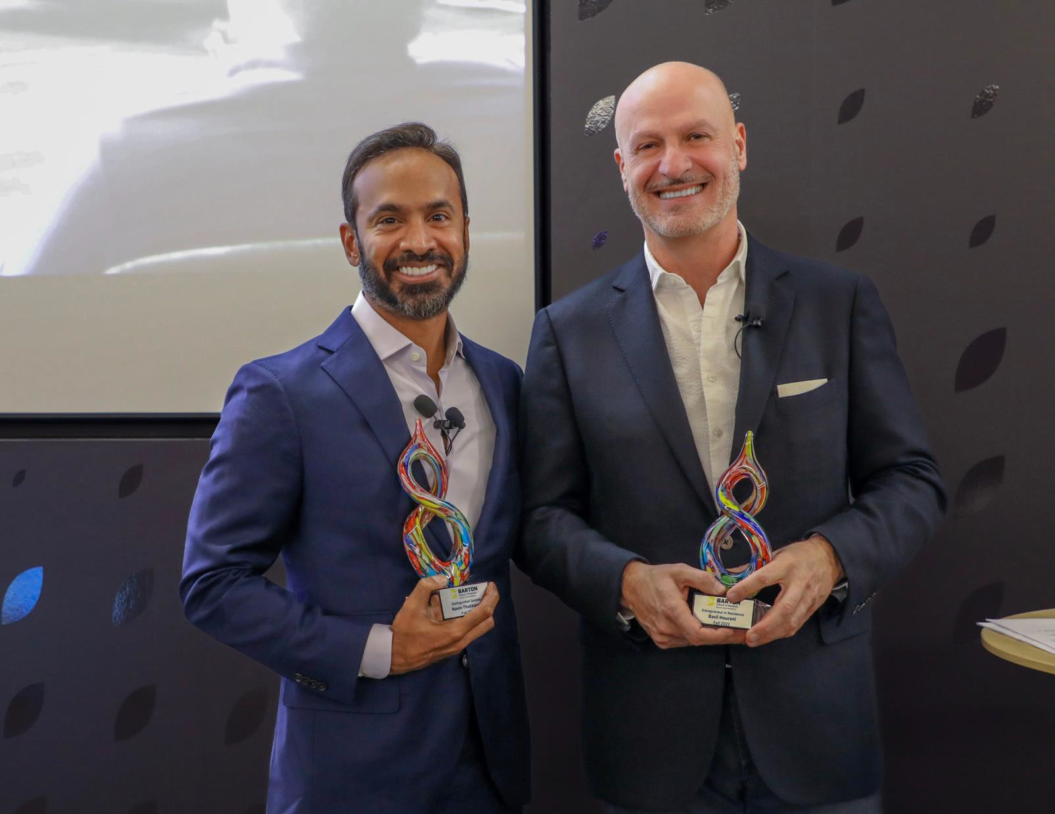

Entrepreneur-in-Residence Basil Hourani, Co-Founder and Executive Partner of CAPITAL7 with special guest keynote speaker Navin Thukkaram, Lead Investor, Skykick – Presentation: “Lessons learned from $3billion in exits”.
Fall 2023

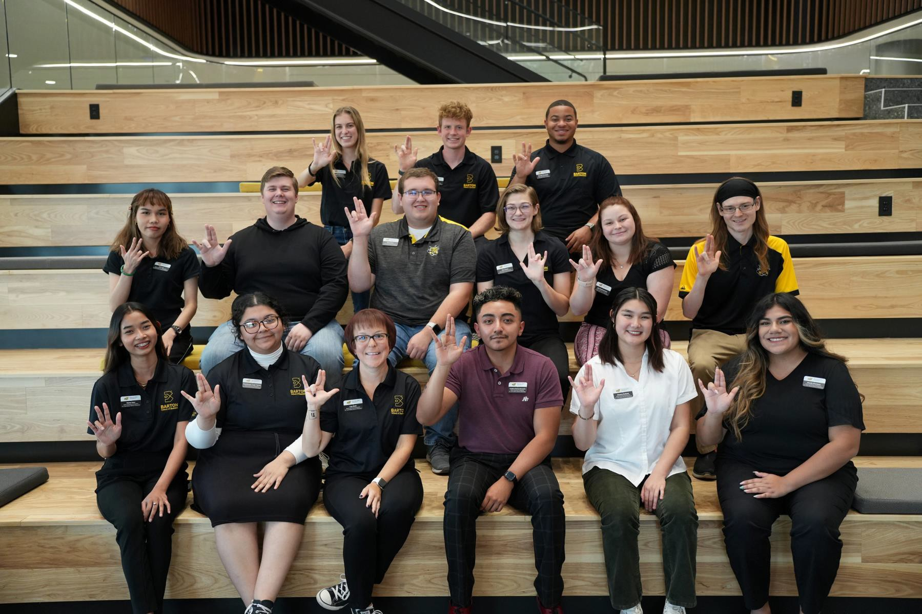

Barton School of Business - Student Business Ambassadors 2022-2023 academic year

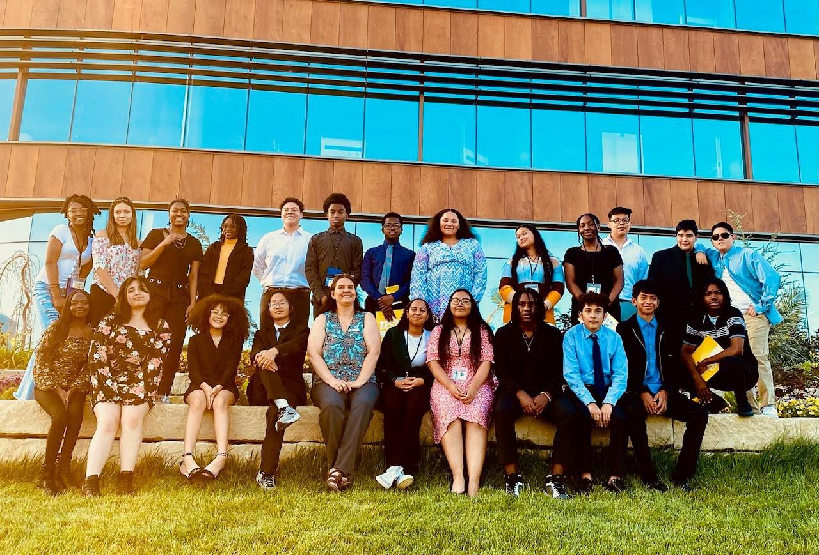

Barton School of Business - Career Day for TRIO Upward Bound Wichita Prep High School Students – Summer 2023

