Comprehensive DE&I report
Fall 2022-Spring 2023

College Mission Statement
The Graduate School provides strategic leadership, assessment, and support to ensure excellence in research and graduate education. Moreover, the Graduate School supports interdisciplinary activities through innovative educational programs and research collaborations to create new opportunities for the intellectual, economic, and social growth of our community.
College DE&I successes
- Creation of Graduate School's DE&I Plan.
- Application fee waiver for all participants of the McNair Scholars program, and students participating in the TRIO program at Wichita State.
- Application fee waiver for all PhD students for a fall term prior to December 1.
- Increased DE&I component in online Graduate School Orientation (information on Disability Services, ODI, Military and Veteran Services, etc.).
- Webpages updated with pictures that portray the diversity of our graduate student body.
- Pre-Arrival Fall survey for incoming students to better gauge their priorities and interests (over 1100+ respondents as of May 2023).
- Grad Student Welcome Week (every Fall semester): organization of activities such as panels on the experience of online, 1st generation, and international graduate students.
- Grad Life 101: peer to peer session (student to student) with the idea of providing a safe space where incoming students can ask current students about graduate life at WSU. Presented by members of the Graduate Student Council, including 1st gen, international and URM students.
- Increased diversity in presenters, panelists, judges, and moderators participating in Graduate School's Professional Development Series events.
- College of the game (Men’s & women’s basketball, baseball): Graduate faculty, graduate students and Graduate School staff were invited to attend the event. Free tickets were made available to them.

Fall 2023 Goals
- Website upgrade: creation of three entry pages: one for faculty, one for prospective students, and one for current students. Reorganization of existing information and creation of new content pages as needed.
- Continue giving priority to recruitment events that focus specifically on inclusive recruitment opportunities, in collision with a focus on research events, in consultation with Sara Mata, as funding permits. Our hope is that will include the following fall events:
- 2023 UNM McNair Scholars Research Conference (New Mexico)
- 2023 Ronald E McNair Heartland Research Conference (Kansas City, MO)
- 2023 National Diversity in STEM (NDiSTEM) conference, hosted by SACNAS (Portland, OR)
- Secure student representation in all existing Graduate School committees
- Prioritize DE&I in future staff searches.
- Seek funding to establish an annual award for underrepresented students.
- Seek funding to establish an annual award for international students.

Pictures
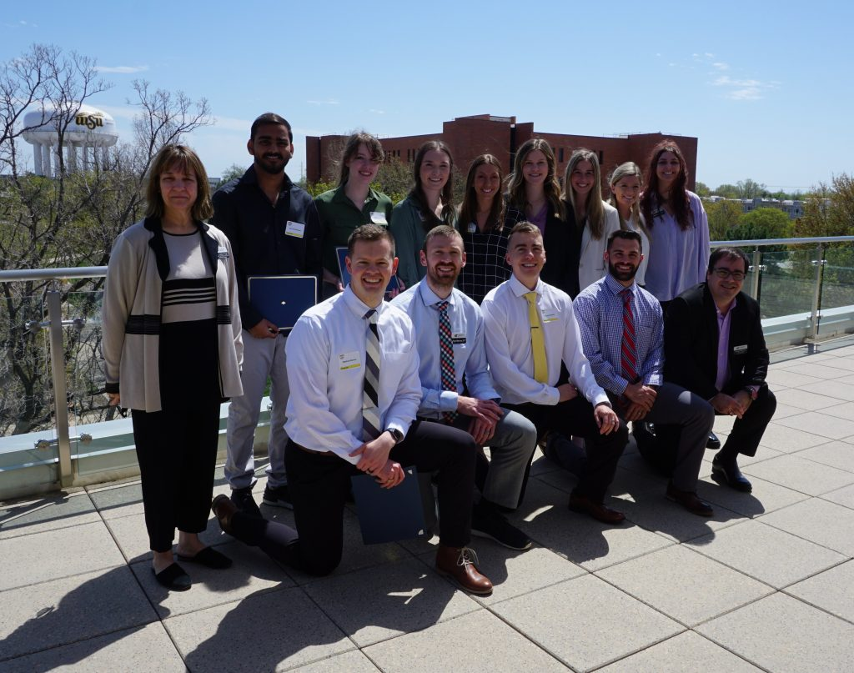GRASP 2023 awardees. | 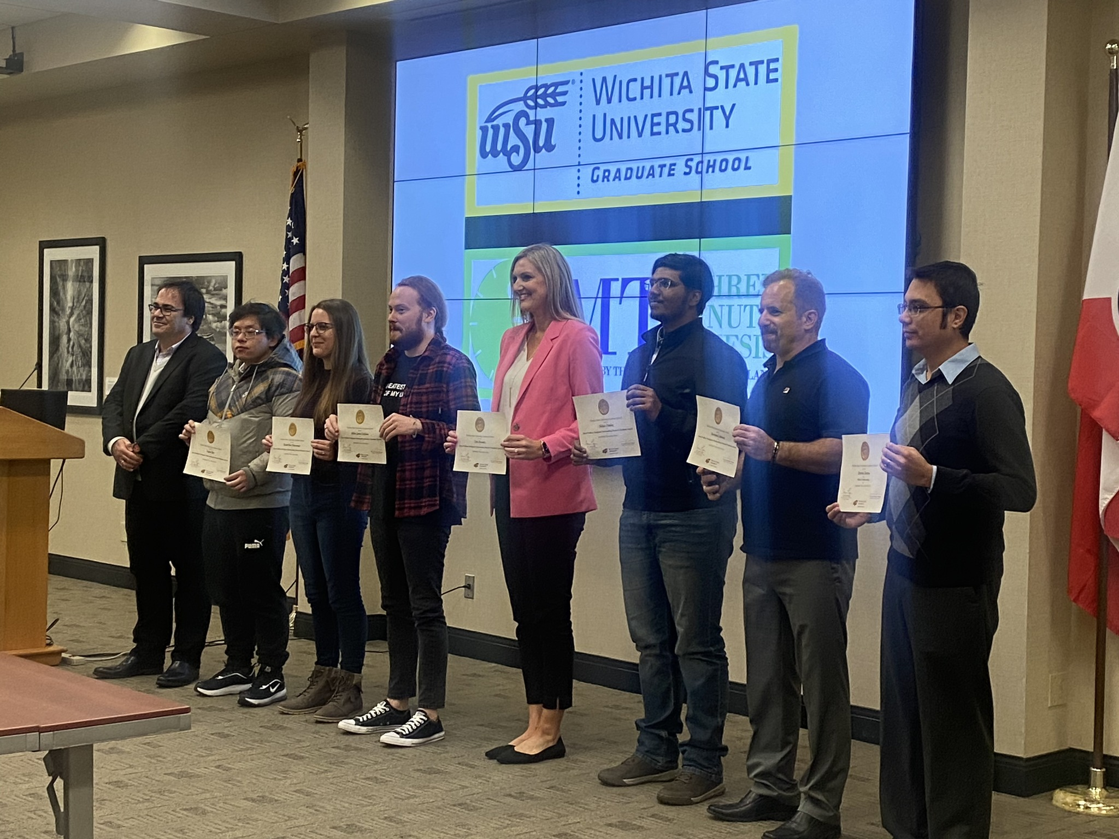Graduate School Awards 2022.
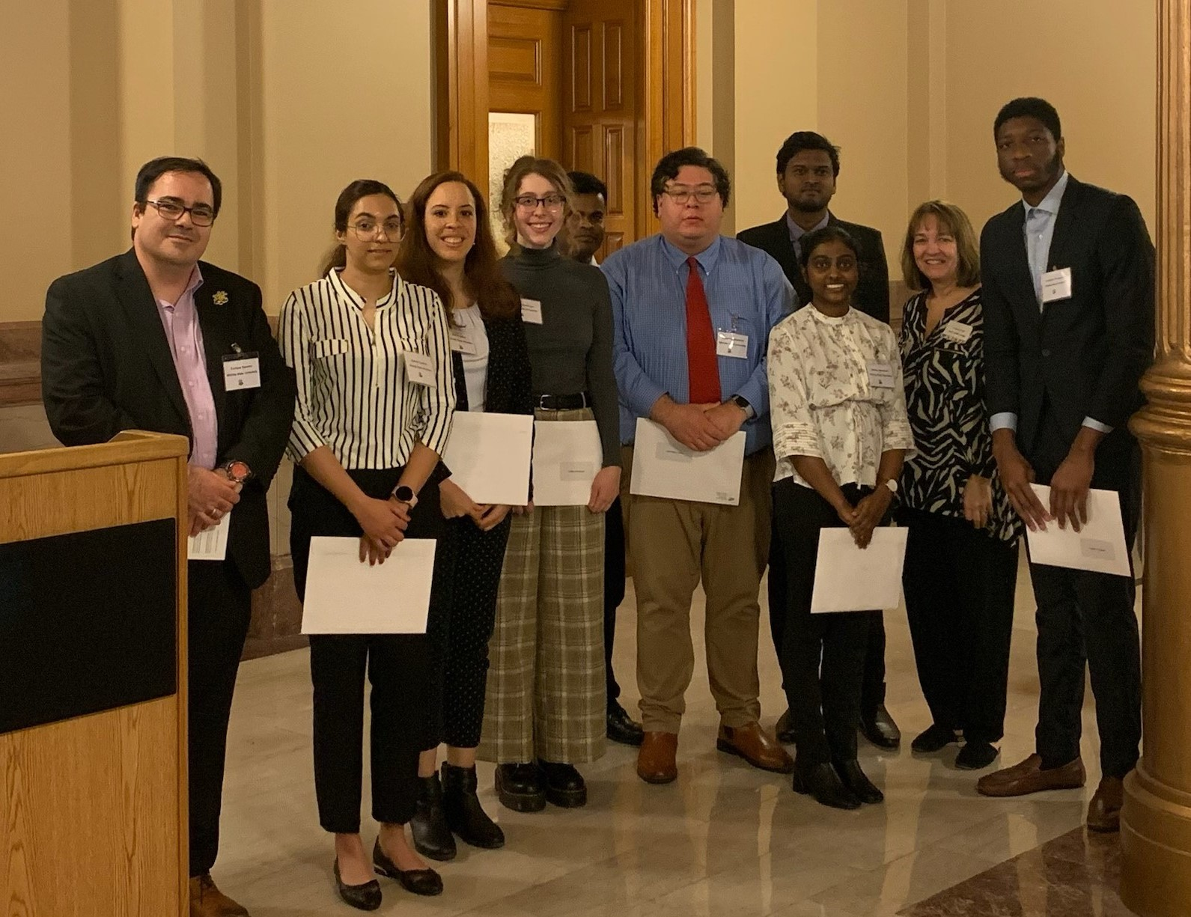Capitol Graduate Research Summit 2023 participants. | 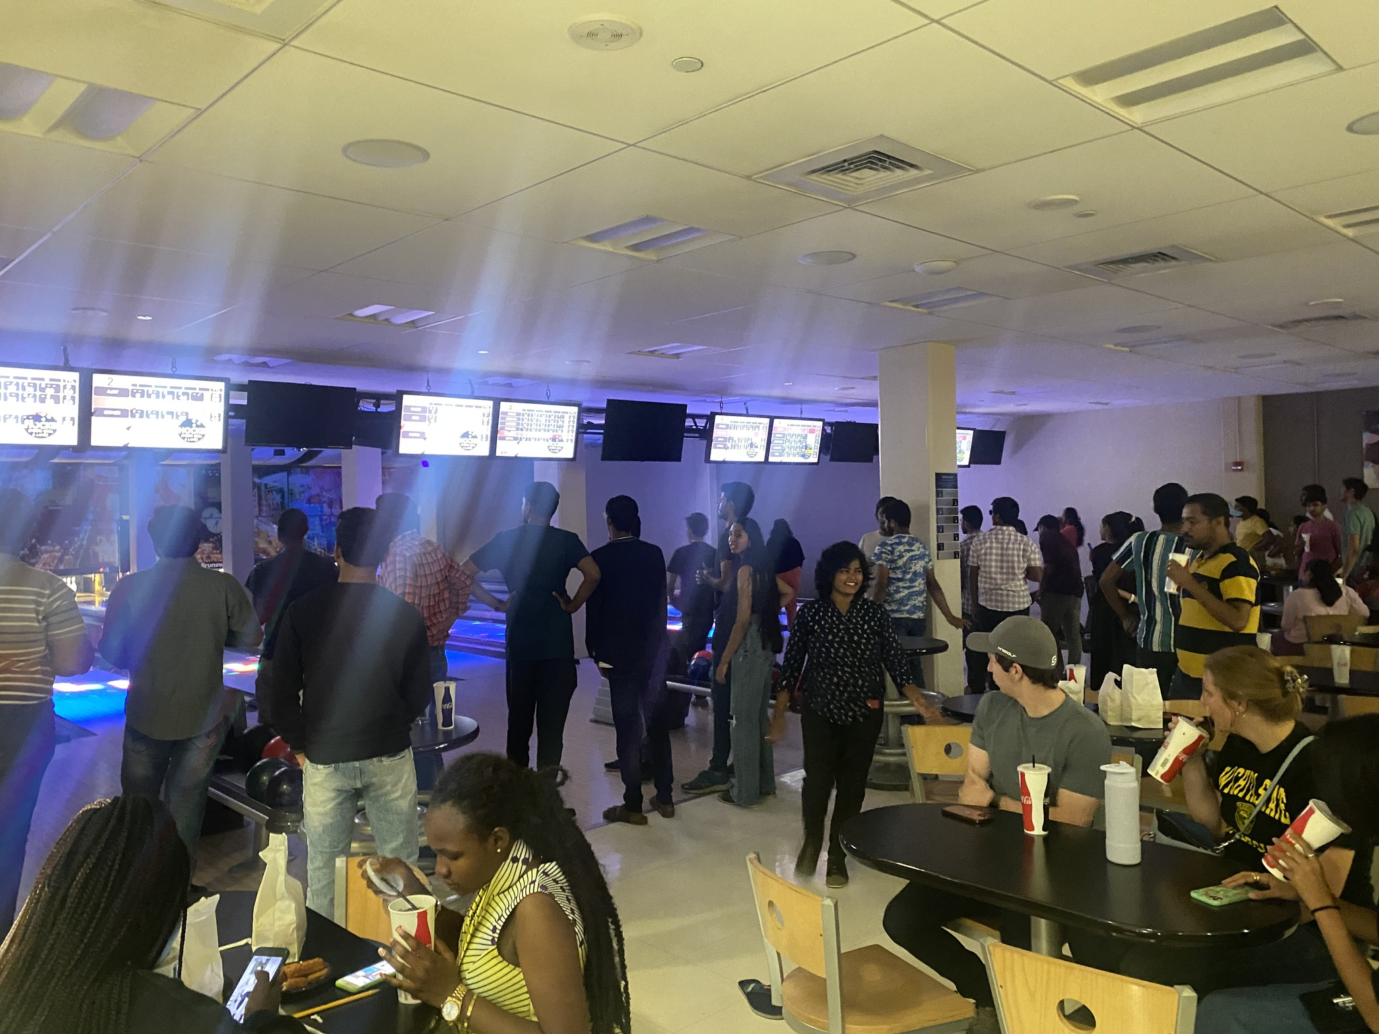Graduate Socials, co-organized with the Graduate Student Council.
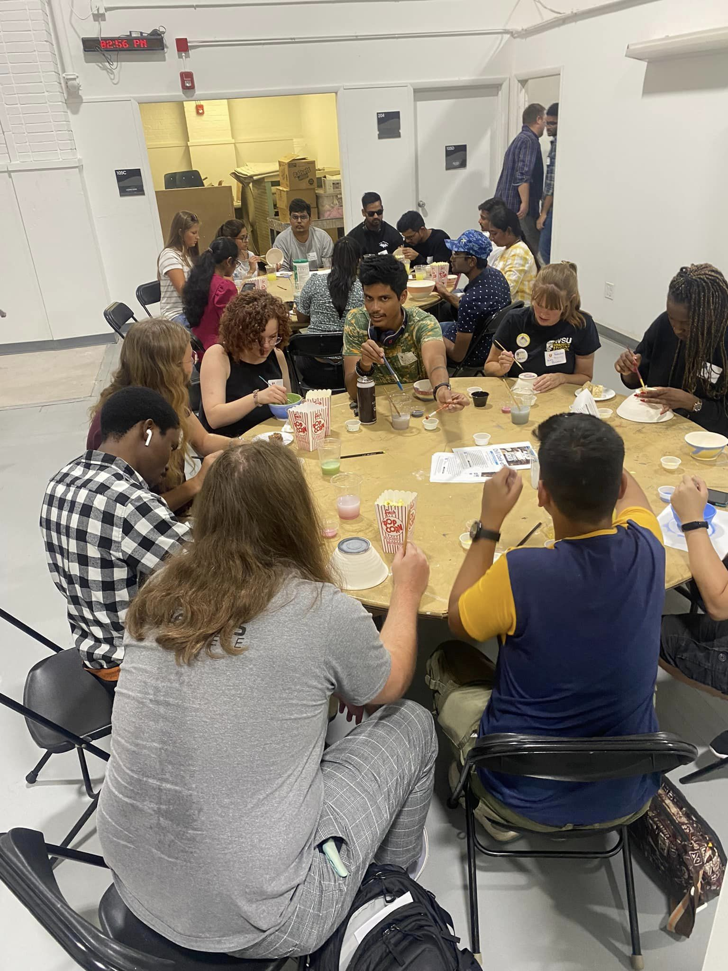  Welcome Week, Fall 2022: Glaze-A-Bowl Mixer, in collaboration with the Ulrich Museum and the College of Fine Arts. | 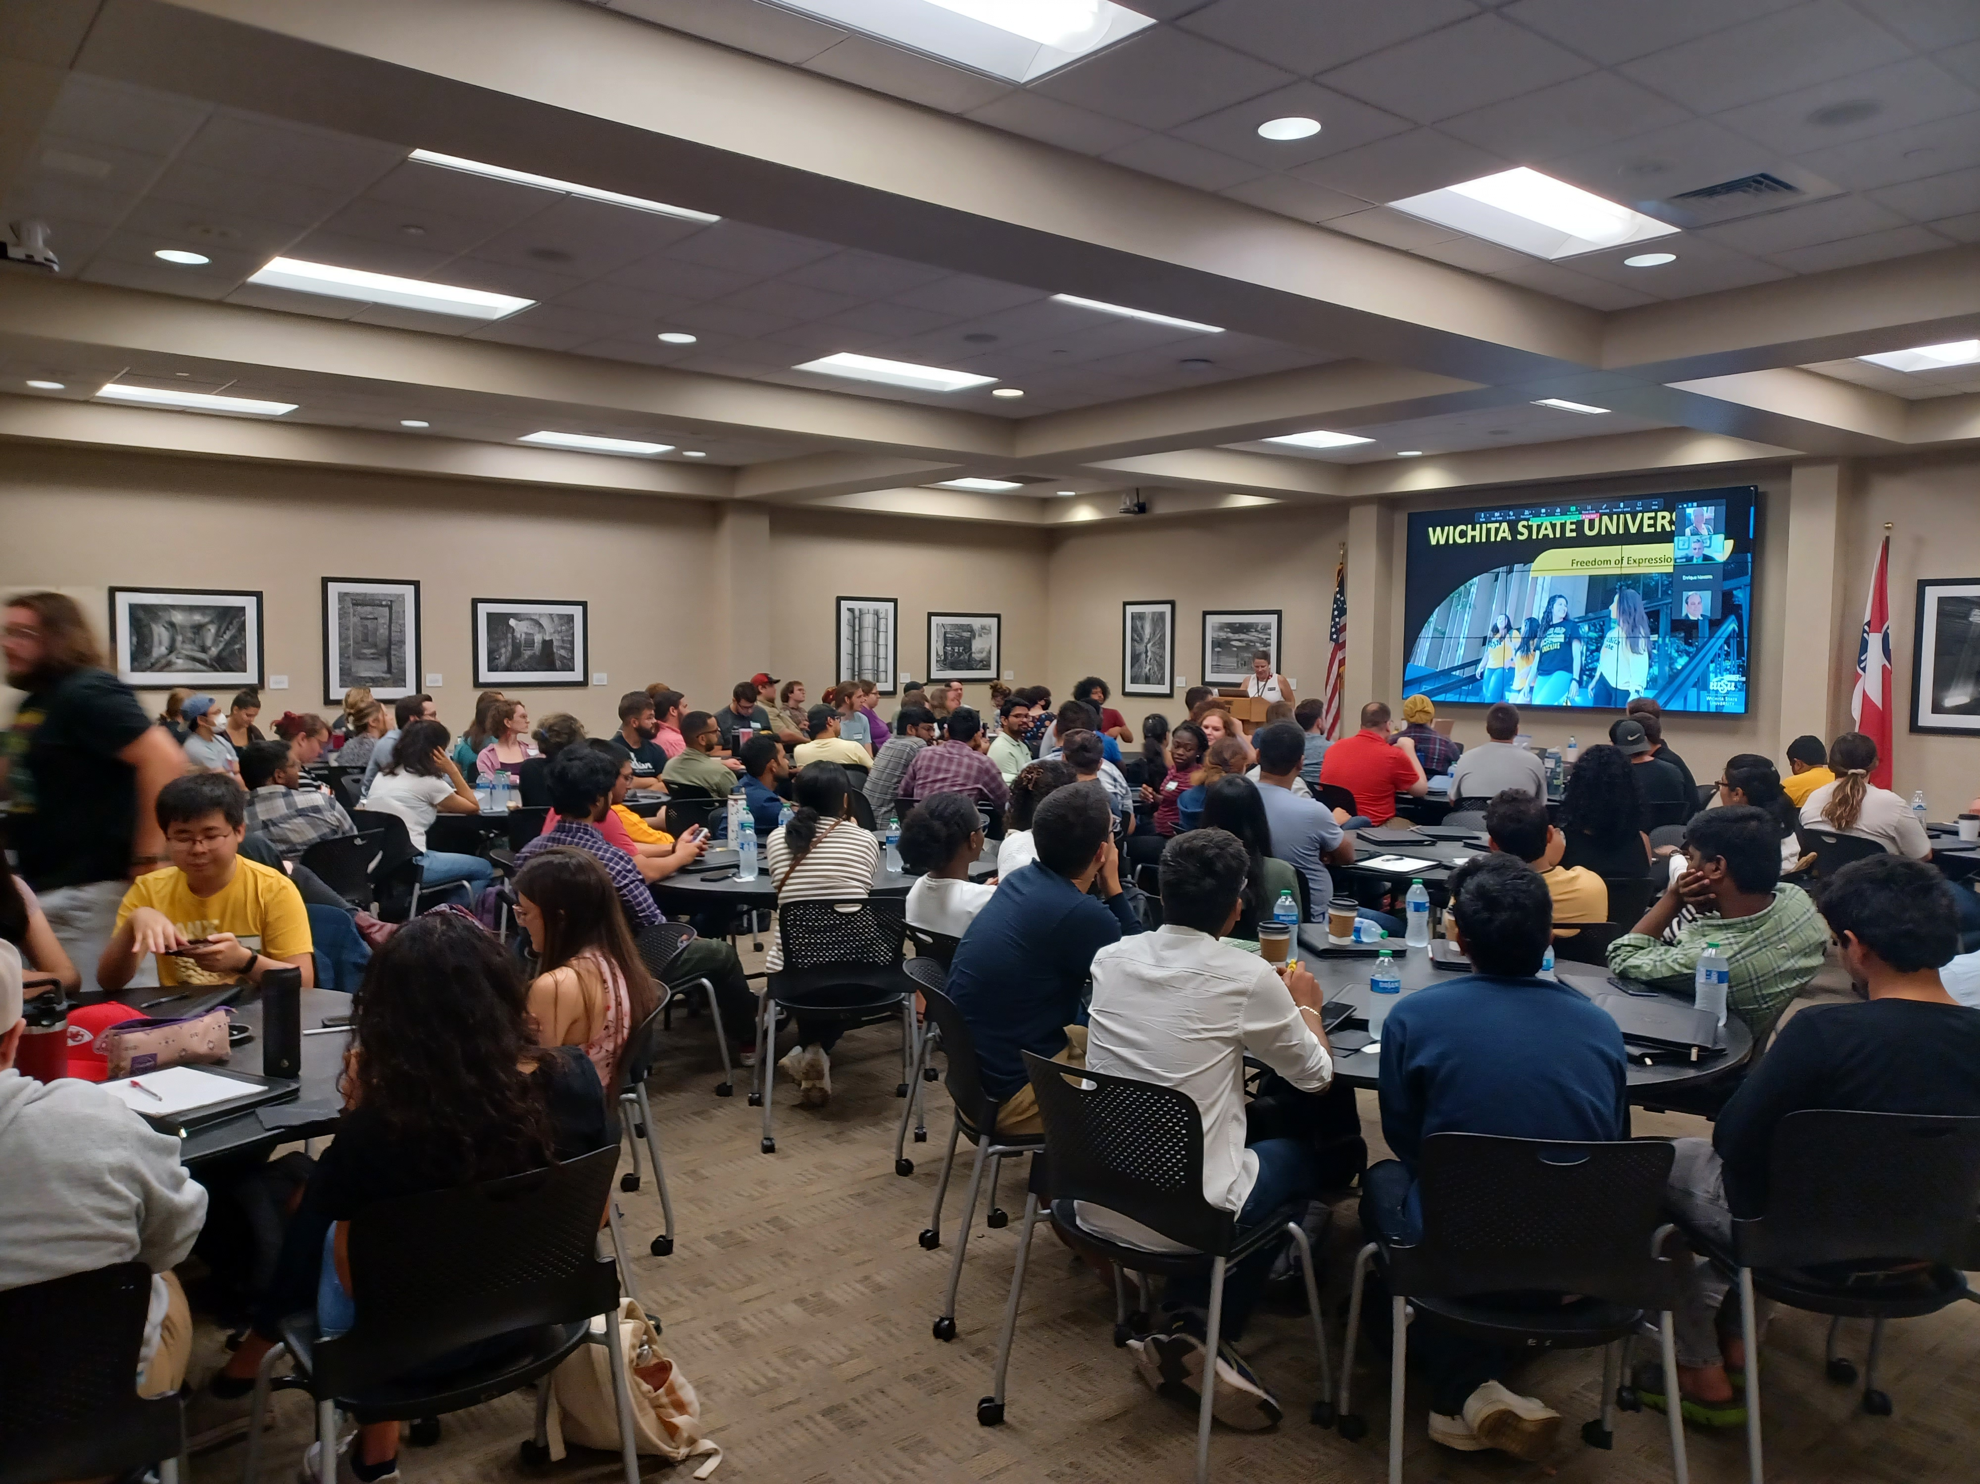GTA Training, Spring 2023, with the support of Office of the President, Academic Affairs, Student Affairs, Media Resources Center, and the Graduate Student Council.
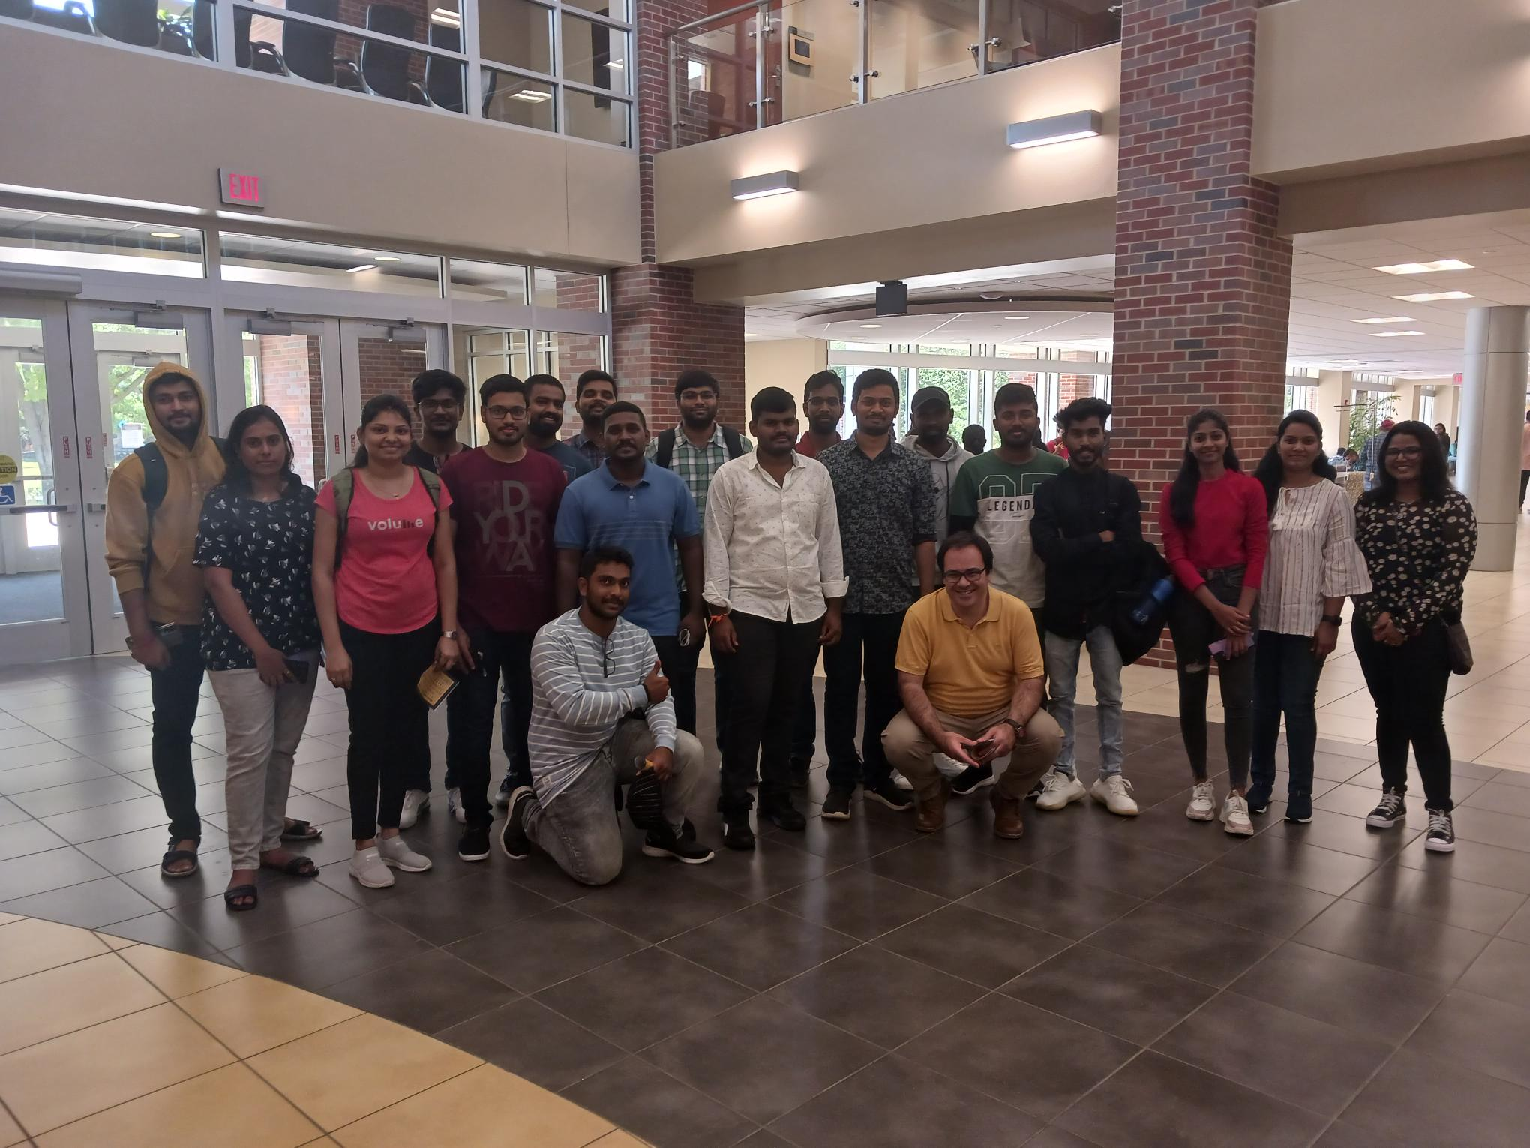Welcome Week, Fall 2022: Campus Tours, with the support of First-Year Programs. | 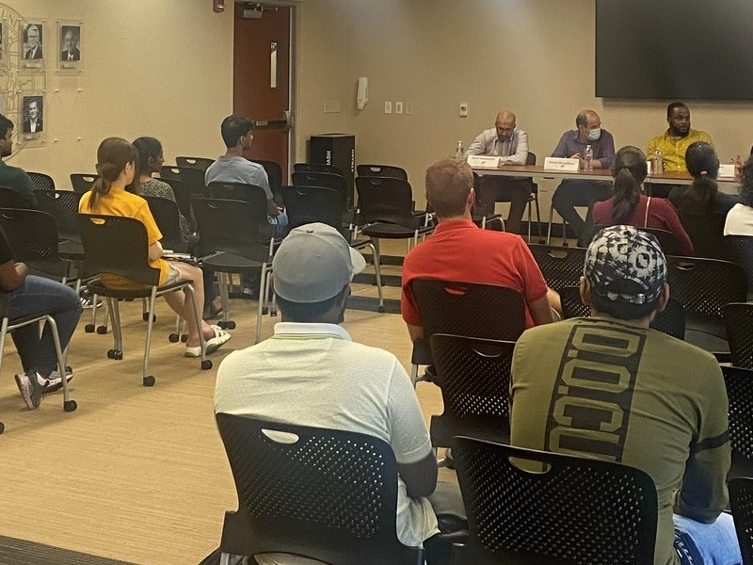Welcome Week, Fall 2022: “The International Graduate Student Experience” session.

