Printing Your WSU Student Insurance Card

- Go to www.uhcsr.com.
- Type “Wichita State University” in the search box.
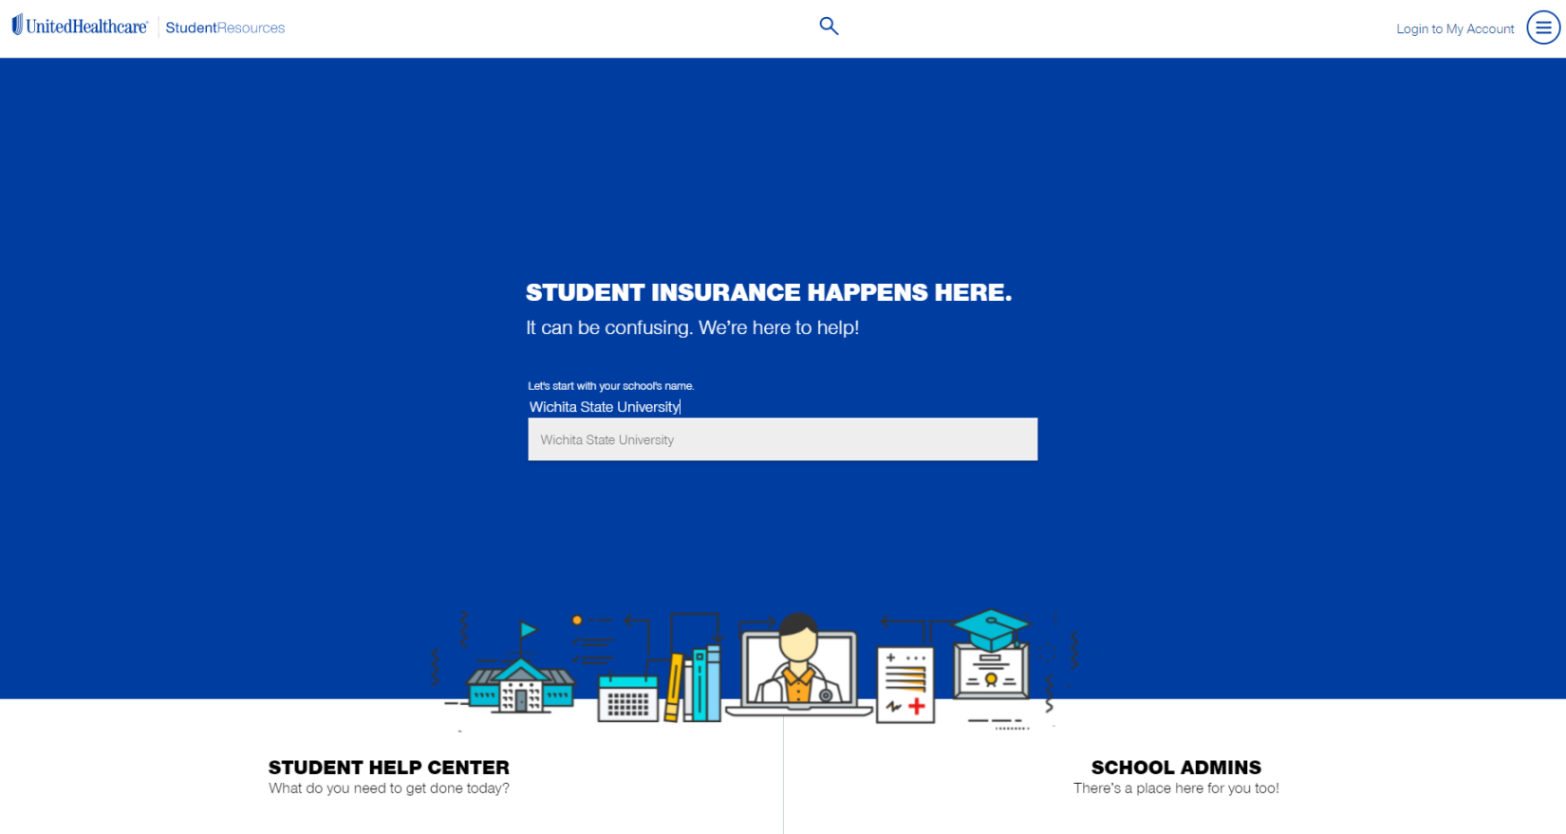
- Choose your Policy Year, which will be the same as the current school year (begins in Fall and ends in Spring)

- Click “Login to My Account”

- If this is your first time on the site, click “Create Account” or “SACM Member Create Account”
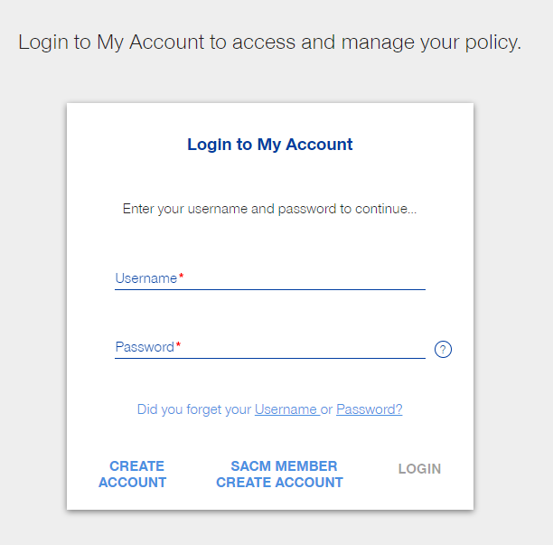

- Enter your personal information including your WSU ID here.
(ex: A123B456)
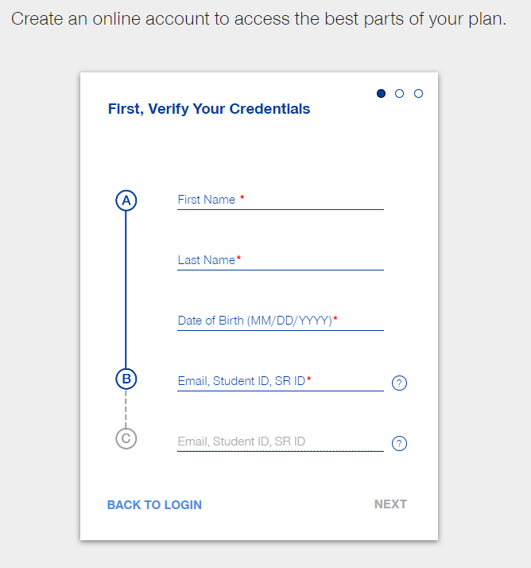

- Create a username and password.

- You’ll see this screen and you can click “Login.”

- Type your username and password, then click “Login.”

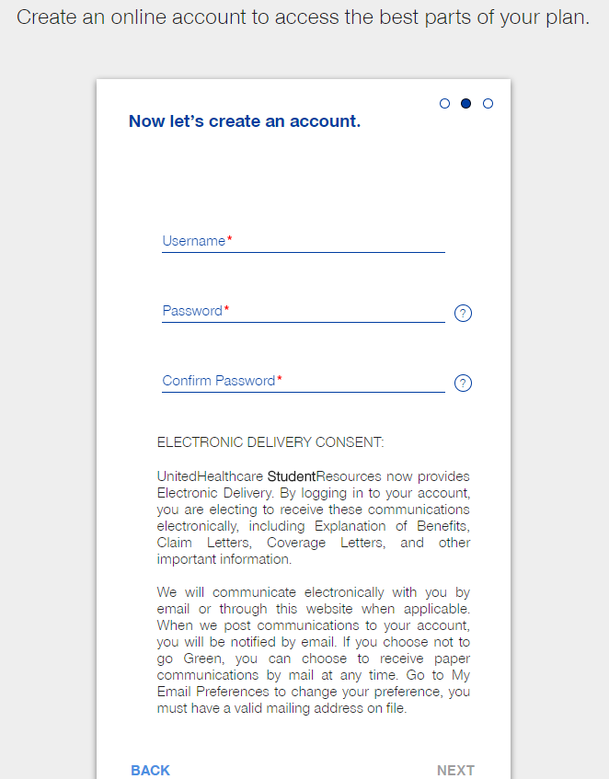
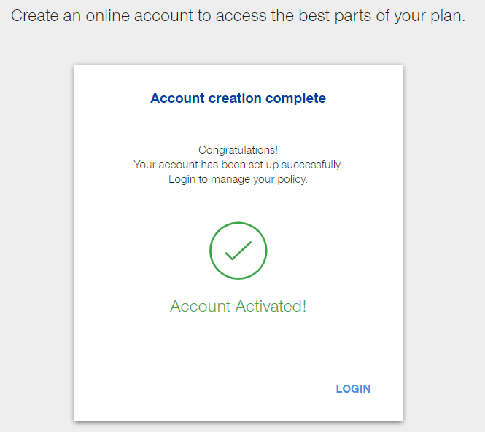
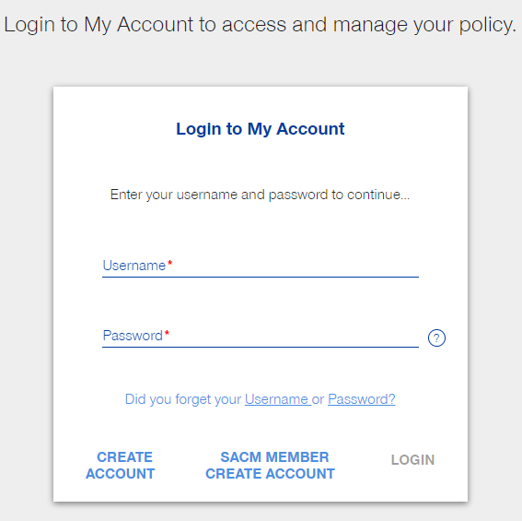
- The system may automatically log you out at this point, but just click the link to go to the home screen and log in once more.

- Click “Continue”
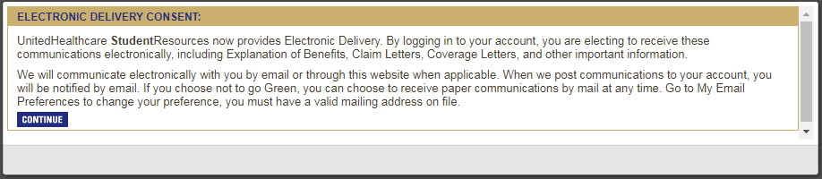

- You are FINALLY ready to print your insurance card! Click “ID Card Information.”
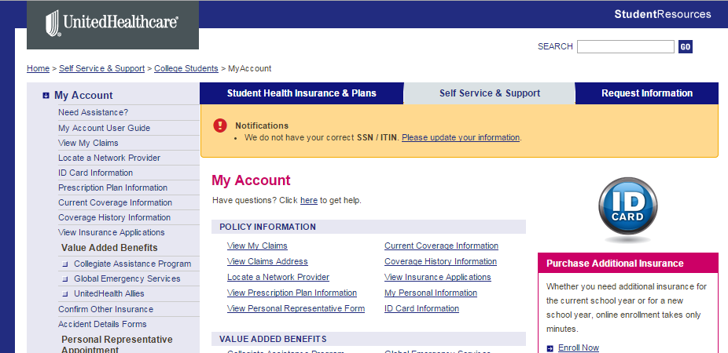

- You can now request a permanent card be mailed to your home address and/or view or print a temporary ID Card.
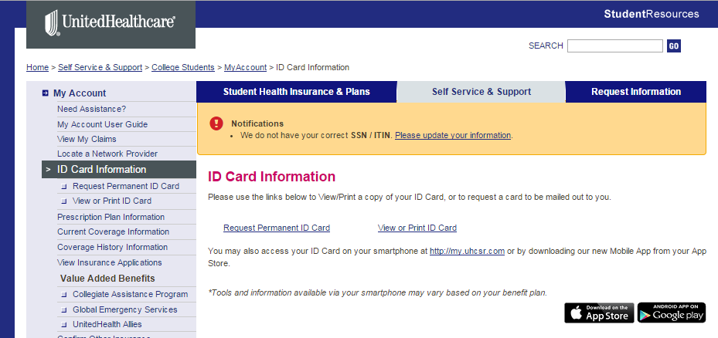

- If you choose to view or print the temporary ID Card, you will see this page. Click “View/Print.”
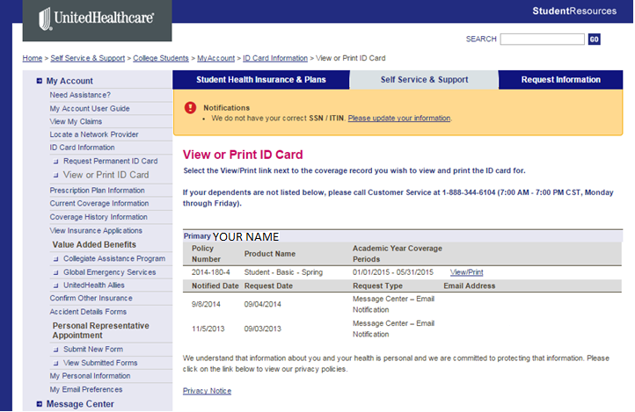

- If you choose to request a permanent ID card, you will see this page.
  - Make sure your mailing address is correct.
  - If it’s not, click on “My Personal Information.”
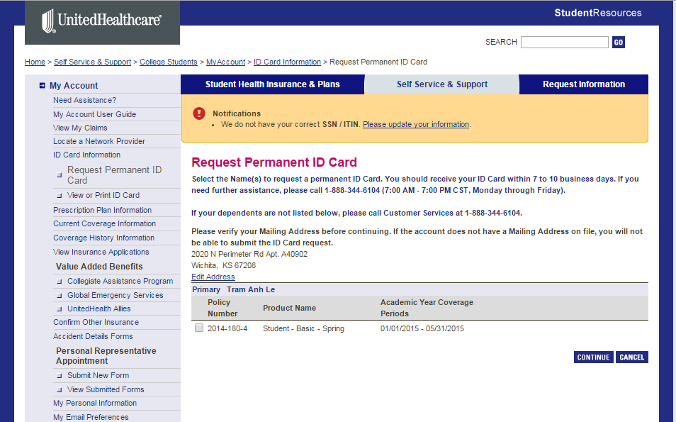
  - Update your address and click “CONTINUE.”
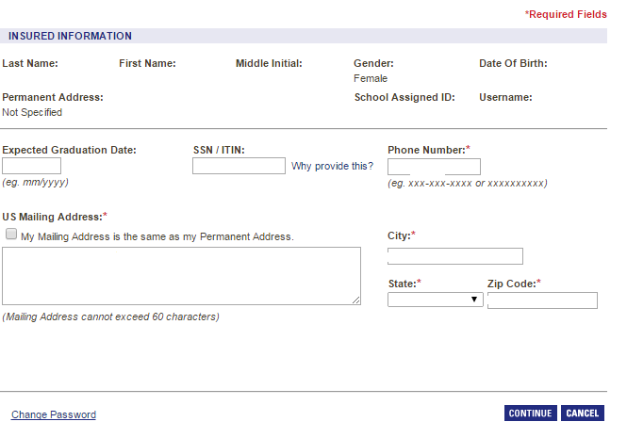

  - Click “Return to My Account” and go to the page where you can request the permanent card.
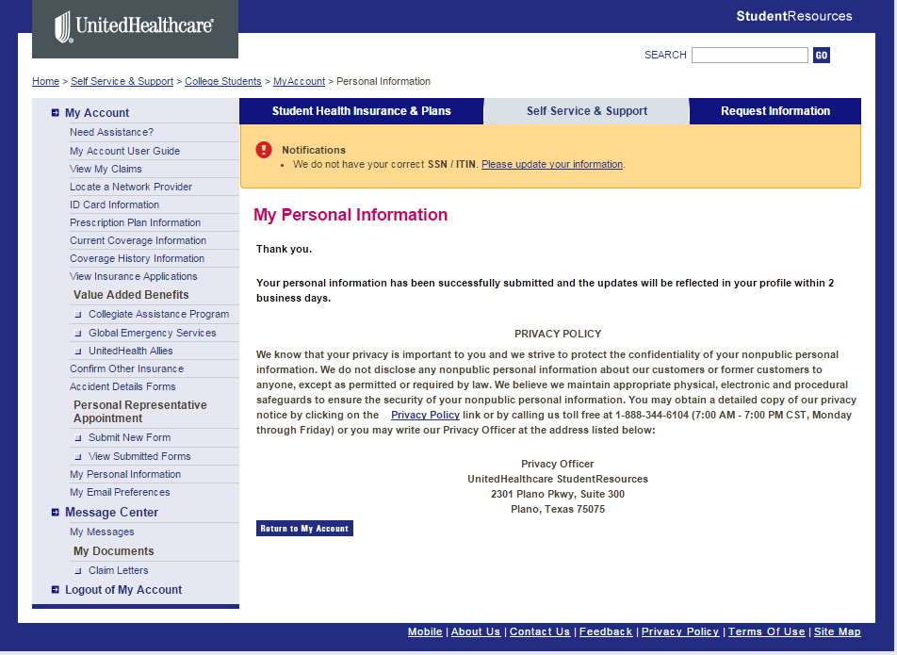
  - Verify your address information, then check the box for the current semester and click “CONTINUE.”
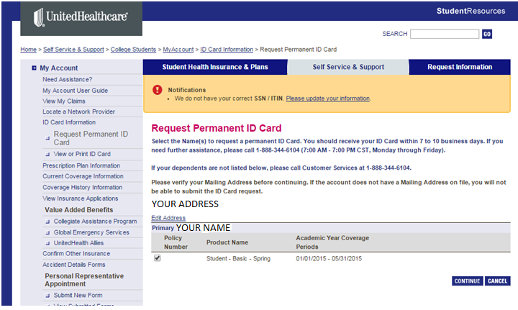

- After you click “CONTINUE,” you will see a red message showing that they received your request. You will also receive an email confirmation.
