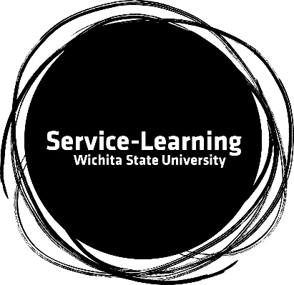
Service-Learning Faculty Scholars
Position Details

PURPOSE

As an engaged campus, WSU is fully committed to creating value through mutually beneficial partnerships where information and expertise is shared and applied for the common good.

The Service Learning Faculty Scholars program has been designed to empower committed service-learning faculty to cultivate and support interest in service learning in their fellow faculty members and through their classes and college. Our goal is to infuse the campus and community with a spirit of service-based academic engagement that ties the classroom experience to applied learning and experiential knowledge.
Service-Learning at Wichita State University is an experiential learning method that integrates community service with instruction and reflection to improve student civic-mindedness and build community capacity.
Outcomes for Service-Learning:
- Applied Learning
- Engage Diversity
- Critical Thinking
- Reflection
- Community Impact
- Student Experience
Service-Learning is a method. Best practices in Service-Learning should include:
- Pre-service education (social justice issue, population/community served, need)
- Service (direct service)
- Reflection throughout process (journaling, reflection-based group activities)

PROGRAM RESPONSIBLITIES AND REQUIREMENTS
Service Learning Faculty Scholars Course Requirement:
Faculty Scholars will:
- modify and infuse service-learning into an existing course (or within a newly created course) in your college. All courses must meet the requirements of the Wichita State University service-learning definitions and be approved by the service-learning team.
- Attend meetings as both a cohort of scholars and individual update/ consultation meetings with service-learning leadership.
- Submit reports, updates, data, and course syllabus as requested.
- Participate in service-learning campus wide trainings for fellow WSU faculty.
- Have a student submission presence at the annual Service-Learning Showcase in the spring semester.
- Participate in the Fall 2022 Service-Learning Faculty Spotlight as a conclusion of your year of service.
- Participate in regional or national trainings as opportunities become available.

Service Learning Faculty Scholars Recruitment & Support:
Faculty Scholars will:
- recruit WSU faculty members who have no or limited experience teaching service-learning courses to develop at least one new sustainable service- learning course offering
- mentor these recruited faculty members by:
  - assisting them in course and syllabus development
  - sharing teaching strategies and techniques
  - aiding in the development of a relationship with a community partner
  - providing guidance in the development of a research agenda related to their service-learning course outcomes

FACULTY SUPPORT
Service-Learning Faculty Fellows Team will be available to consult and support the Faculty Scholars. Team meetings will be conducted.

Additionally, a $1,500 stipend to be awarded in AY22-23 will be provided to each Faculty Scholar. Made payable at completion of all requirements (end of Spring 2023 semester).

WHO MAY APPLY
Tenure and non-tenure track professors, instructors and unclassified professionals teaching full-time from all WSU colleges.

SELECTION CRITERIA
The goal of the Faculty Scholars program is to involve faculty in the advancement of the service- learning pedagogy among fellow faculty. Applications will be evaluated on the following criteria:

1. Understanding of and commitment to service-learning
a. Understanding and application of the quality standards of service learning
b. Commitment in teaching service learning courses

2. Alignment with professional goals
a. Anticipated benefit of participation in Faculty Scholars program
b. Alignment of Faculty Scholars program with professional experiences and goals
c. Contribution to service-learning in field/discipline

3. Recruitment & Mentoring
a. Experience in networking and collaborating with other faculty members

APPLICATION MATERIALS

Please include the following in your application packet:
- letter of application which documents understanding of and plans to achieve designated program responsibilities and requirements, as well as past experience in teaching or applied learning/ service-learning, etc.
- Suggested courses with brief course descriptions for service-learning integration for Spring 2023 or Summer 2023.
- curriculum vitae

DEADLINE FOR APPLICATION AND NOTIFICATION
Submit all application materials listed above and to the Service-Learning Team as follows:
- Create a PDF of all application materials and email PDF application packet to Dr. Rhonda Lewis at rhonda.lewis@wichita.edu by midnight on Friday, April 1, 2022.

Any questions about the program or application can be directed to Dr. Rhonda Lewis (rhonda.lewis@wichita.edu), Dr. Chelsea Redger-Marquardt (chelsea.redger@wichita.edu) and/or Dr. Rachel Showstack (rachel.showstack@wichita.edu)

