You go to transfer.niar.wichita.edu in your web browser (chrome will work best). Then you will get to this page below. Log in with your Windows NIAR username and password.
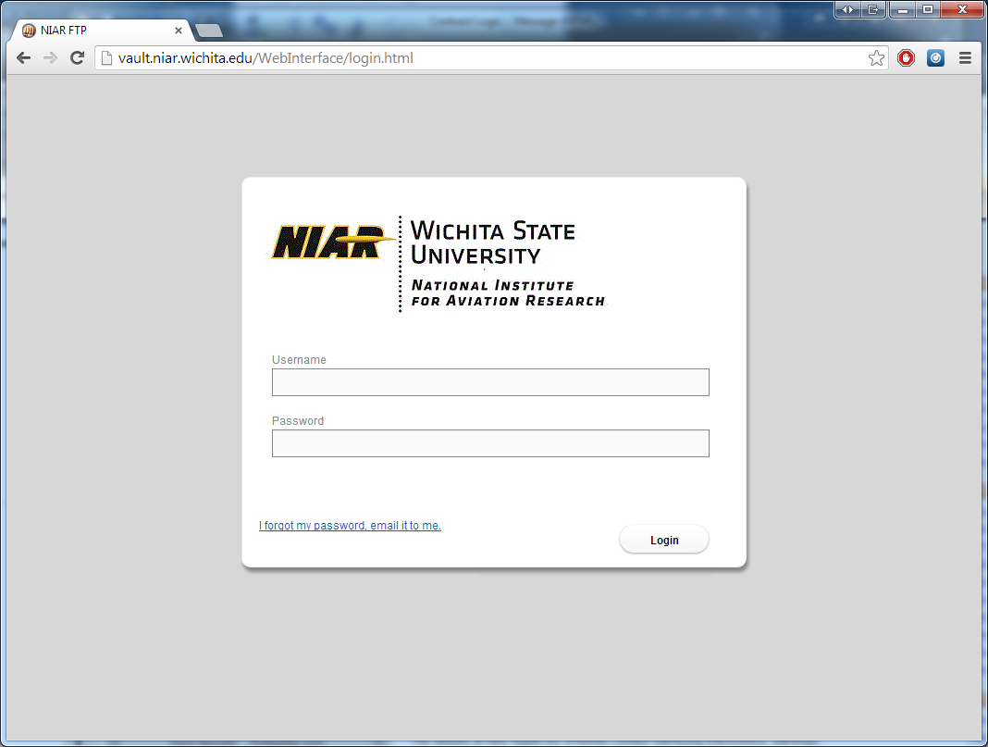

After you log in, you will see the screen below. Then, if you are using Google Chrome you can click and drag a file to the window where it will then show where you can drop it to upload it. If you are using Internet Explorer, you can click the add files, then browse to the files and select them.
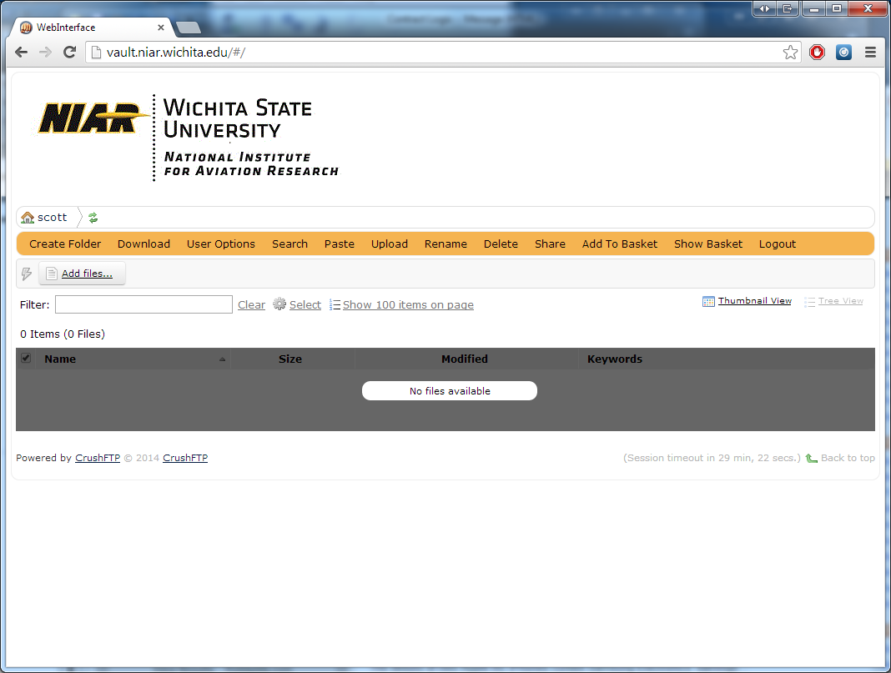

After you have uploaded the files, you will see the pop up below, and you will need to click start and it will upload them all.
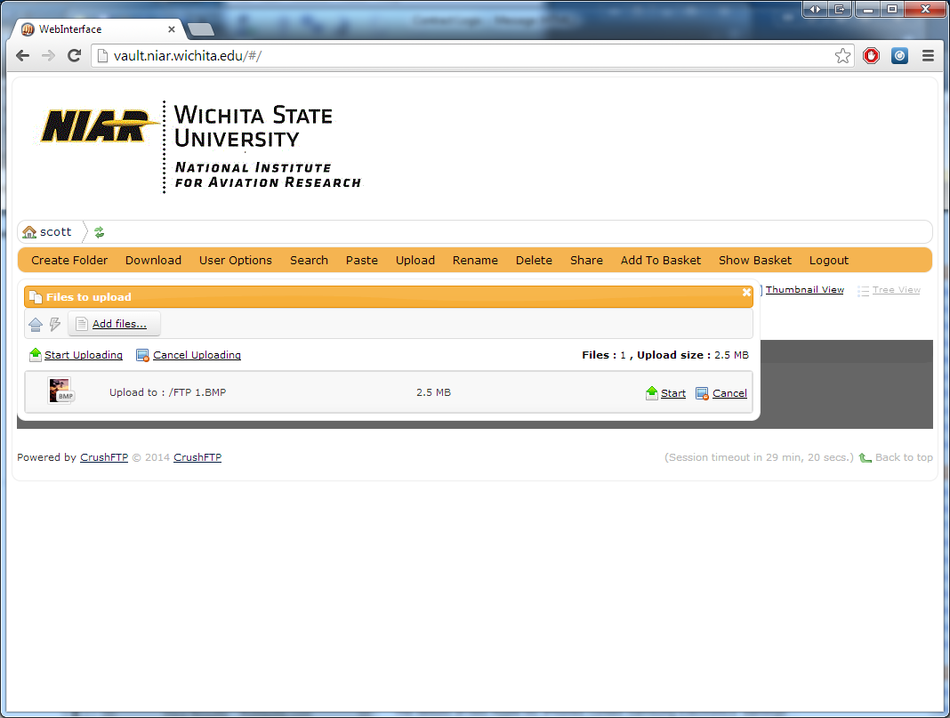

After the files are uploaded you will see them listed and it will look similar to the below image. You will want to put a check box next to the files you want to share with outside clients. After you check them all, you want to click the share button at the top.
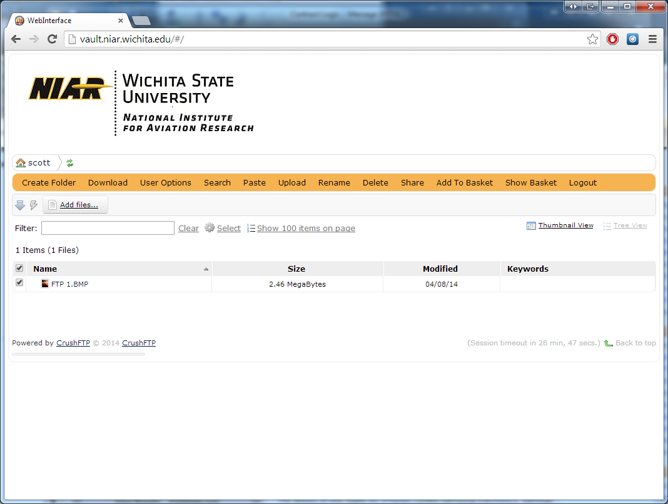

After you click share, this window will pop up. You will need to fill out the From, and To fields, and you can CC or BCC yourself if you wish to see what the client will see. Leave the Share method, and share type the same. Then when you filled it all out, you click send and they will get an e-mail, with a link that will be good for 7 days, where they can download the files you shared with them. After 7 days, the files you upload will be deleted from the FTP server and the clients you share the files with have 7 days to download the files. 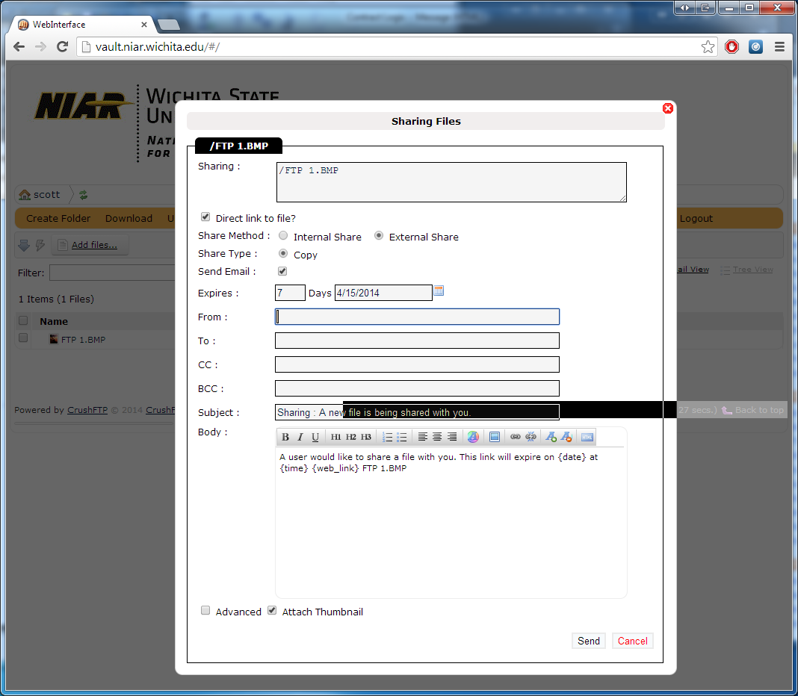

If you have any questions, please let IT know.

