2019 WSU Kansas SBDC Success Story

Fiber Dynamics, Inc.
Owner: Darrin Teeter

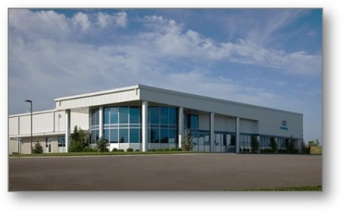

While working at the National Institute for Aviation Research, Darrin Teeter, founder and CEO of Fiber Dynamics, Inc., recognized a market need for the production of composite parts with greater manufacturability. Darrin knew the advantages of Resin Transfer Molding and decided to open his own business, Fiber Dynamics, Inc. in 1991.
In late 2007 and continuing through 2009, the country experienced an economic downturn that hit the Wichita aviation industry hard. At the time, Fiber Dynamics, Inc. was heavily leveraged in aerospace work. Darrin recognized the need to diversify and set this as a goal. Fortunately, Darrin met Alan Badgley, Business Advisor at the Wichita State University Kansas Small Business Development Center at that time.
Alan provided comprehensive strategic planning support to Darrin and his team with funding received by Wichita State University as a part of a Workforce Innovation in Regional Economic Development (WIRED) grant targeting the composite technology industry. The strategic planning process involved eight hours of facilitated meetings, a SWOT analysis, market research, financial analysis with Sageworks® Industry Data and ProfitCents® Report’s Industry Profile Analysis, and ongoing advising. The outcome of the process was a strategic plan with specific goals and action steps. The company is doing well. The number of employees has gone from 40 full time and one part time in 2010 to 66 in 2019 and sales have almost doubled.
Darrin and the staff at Fiber Dynamics, Inc. continued to work with the WSU Kansas SBDC over the years. Staff commented that one of the greatest benefits of working with the Kansas SBDC has been the connections with individuals who can aid and serve as a resource. Darrin wanted to get into government work but was not sure how to go about it. Alan Badgley introduced Darrin to Gary Stecklein, a mechanical engineer with extensive experience with technology commercialization who serves as President of the Inventors Association of South Central Kansas. Darrin considers Gary’s assistance invaluable for reading through and understanding government proposals. Alan also connected Gary with Scott Knapp with Kansas PTAC for support with government contract work.
Recently, Darrin connected with Kansas SBDC staff for help in developing and submitting SBIR proposals. Fiber Dynamics has been awarded two contracts from the Air Force’s Arnold Engineering Development Complex for the design and development of highly-engineered wind tunnel blades and has another proposal pending for the NASA-Ames wind tunnel fan blades, they are in the contract negotiations stage for a Phase I SBIR Grant for their Innovative Methods for Thermoplastic Composites on ATL/AFP, and they are working on the submission of a Phase II SBIR grant. Alan has enjoyed watching Darrin overcome the challenges he faced in 2010 to develop a successful, growing business.
To learn more about Fiber Dynamics, Inc. visit www.fiberdynamics.net.
