Your Guide
to Starting or Expanding a Business
in South Central Kansas

Produced By:
The Small Business Education Consortium
Call (316) 978-3193 for information.
The Small Business Education Consortium

Mission, Goals, and Projects

The Small Business Education Consortium is made up of federal, state, and local government agencies and of membership organizations working together to provide support services to area business owners and prospective business owners.

Mission
The mission of the Small Business Education Consortium is to facilitate the ability of participants to accomplish their missions more effectively by sharing ideas and by providing opportunities for collaboration.

Goals
- combine efforts to support small business development and enhance economic growth
- foster a routine interchange of information
- provide a structure for non-profit area agencies to meet and discuss common issues
- sponsor educational seminars and programs for area small business owners

Projects

Your Guide to Starting or Expanding a Business in South Central Kansas
The Consortium publishes a guide to increase awareness of area organizations that provide services to individuals interested in starting or growing a business.

Business Resource Expos
The Consortium sponsors Business Resource Expos to provide easy “one-stop” access to organizations that will help participants start, develop or expand a business.

Calendar of Area Business Workshops and Events
Consortium members use the NetWork Kansas website to promote their workshops and events. Please visit the site at http://networkkansas.com.

For additional information about the Small Business Education Consortium, contact the Wichita State University Kansas Small Business Development Center at 316-978-3193.

The WSU Kansas SBDC is funded in part through a Cooperative Agreement with the U. S. Small Business Administration.

Small Business Education Consortium

The organizations and agencies included in this guide offer services to area residents interested in starting, developing or expanding a small business. These groups want to help you! Contact them to learn more about what they can do for you.

Organizations

Center for Economic Development and Business Research at Wichita State University
Center for Entrepreneurship at Wichita State University
City of Derby
City of Wichita
Cowley County Economic Development Partnership (Cowley First)
e2e
Internal Revenue Service (IRS)
Inventors’ Association of South Central Kansas
Kansas Center for Entrepreneurship (dba NetWork Kansas)
Kansas Department of Commerce
Business and Community Development Division
Workforce Services
Kansas Department of Revenue
Kansas Global Trade Services
Kansas Procurement Technical Assistance Center
Kansas Small Business Development Center (Kansas SBDC) at Wichita State University
Kansas State University Small Business Environmental Assistance Program (SBEAP)
Mid-America Manufacturing Technology Center (MAMTC)
Mid-America Trade Adjustment Assistance Center
Nonprofit Chamber of Service
Patent and Trademark Resource Center at the Wichita State University Libraries
Sedgwick County Economic Development/Foreign Trade Zone (FTZ) #161
Service Corps of Retired Executives (SCORE)
South Central Kansas Economic Development District
Sumner County Economic Development
U.S. Small Business Administration (SBA)
Wichita Hispanic Chamber of Commerce
Wichita Independent Business Association (WIBA)
Wichita Metro Chamber of Commerce
Wichita Technology Corporation
Wichita U.S. Export Assistance Center U.S. Commercial Service – USDOC
Workforce Centers of South Central Kansas
WSU Ventures

Mailing Address
1845 Fairmount
Campus Box 121
Wichita, KS 67260-0121

Street Address
NIAR Building
1845 Fairmount
Wichita, KS 67260-0121

Telephone
316-978-3225

Fax
316 978-3950

Email Address
cedbr@wichita.edu

Web Site
www.cedbr.org

Center for Economic Development and Business Research
W. Frank Barton School of Business
Wichita State University

CEDBR collects, analyzes and disseminates reliable business, economic and demographic information. The Center conducts high-quality, objective research on issues related to the community’s current and future economic well-being.

Data
The CEDBR is a regional storehouse for local, state and national statistical and business data at www.KansasEconomy.org, which includes:
Economic indicators
Population and demographic characteristics
Housing and construction activity
Industry analyses

Services
The CEDBR staff is available to apply their knowledge and expertise to real business problems through such activities as:
Forecasting
Cost benefit analysis Population projections
Market Research Competitive Landscape Analysis
Custom data analysis Economic impact studies
Retail/Services Gap Analysis

Forecasts
Each year, CEDBR and the W. Frank Barton School of Business, along with other sponsors, host the Kansas Economic Outlook Conference. This event provides thought-provoking and informative presentations by nationally recognized professionals on the economic climate of Kansas, the Wichita area and the United States. A highlight of the conference is the annual economic forecast for the Kansas and the Wichita area.

On Line
Visit our website at www.cedbr.org to find the annual forecast and updates, demographics, research studies, instructional resources and economic indicators for the United States, Kansas and Wichita.

CEDBR e-connection
CEDBR publishes e-connection, a monthly email newsletter, to inform the community about data resources and reports on business, industries, and the economy. For a free subscription, go to www.newsletter.cedbr.org,.

Mailing Address
1845 Fairmount
Wichita, KS 67260-0147

Street Address
n/a

Telephone
316-978-3000

Fax
316-978-3687

Email Address
cfe@wichita.edu

Web Site
www.cfe.wichita.edu

Center for Entrepreneurship
W. Frank Barton School of Business, Wichita State University

The Center for Entrepreneurship (CFE) is part of the W. Frank Barton School of Business and is housed in Devlin Hall. The Center fosters and promotes entrepreneurial thinking through a wide range of academic and community programs.

We offer training programs for established business owners and for individuals considering launching new businesses or ventures.

Economic Development and Community Outreach

- Kansas Family Business Forum
- Business Booster
- Growing Rural Business
- E-Launch
- Launch Prep

The Kansas Family Business Forum is a nationally recognized, highly regarded membership organization of family business owners, their families and key employees. The Forum is designed to provide unique learning experiences to those involved with family businesses. Issues of ownership, management succession, family dynamics, family governance, etc., are covered.

Energize your entrepreneurial skills. Business Booster workshops provide practical know-how you can immediately put to use to build your business whether you are just starting or are scaling.

The Growing Rural Business model is an eight-week certificate program customized for rural businesses. GBR provides practical, applied information and examples necessary for rural communities.

E-Launch has been developed to foster entrepreneurial activity that will lead to the commercialization of technology-based ideas. Through an interactive process, participants will learn to clearly conceptualize how the product or service can provide real value to customers. Validation of a value proposition with customers and others will be at the core of this training.

Launch Prep, a partnership between the e2e Accelerator and Wichita State University’s Center for Entrepreneurship, provides your early-stage company access to a select group of Wichita’s most successful entrepreneurs. Their one-on-one mentorship will enable you to get your venture off the ground.

16 point type for organization name

12 point type for description of services; bold for headings
10, 11, or 12 point type for bullet points in description of services

10 point type for contact information


Mailing Address
611 Mulberry Road, Ste 300
Derby, KS 67037

Street Address
611 Mulberry Road, Ste 300
Derby, KS 67037

Telephone
(316) 788-3081

Fax
(316) 788-6067

Email Address
marciahartman@derbyweb.com

Web Site
www.derbyweb.com

City of Derby – Economic Development

Located in southeast Sedgwick County, Derby is the 2nd largest city in the Wichita Metropolitan Statistical Area (MSA) and is home to more than 23,000 residents. With a wide range of retail, service and manufacturing businesses, Derby has a reputation for quality living and for being progressive while maintaining the practical sensibility for which Kansas is known. Derby offers the best of small-town values combined with the resources of a progressive and growing community.

The City of Derby’s Development Manager promotes healthy and sustainable growth by serving as a single point of contact for developers and businesses looking to relocate or grow in Derby. The Development Manager functions as a liaison between businesses and various city departments to help address business concerns, remove barriers, and help businesses navigate the development process.

Whether you are a large or small company, entrepreneurial or established, we strive to provide resources that will make businesses successful in our community. The Development Manager is available to provide one-on-one guidance, manage resources such as the Derby Business Center and provide information on State and other resources available to local businesses. Derby’s Register and Start Your Business web page was created expressly for businesses needing information about operating a business in Derby.

Derby’s ability to carve out a distinctive identity within the metro community has been a major factor in earning Derby its reputation as a great place to be. Its outstanding school system, community amenities, extensive parks and bike paths, low crime rate, friendly atmosphere, and commitment to excellence have all helped Derby mature into a premier community.

Our vision is to be a community where dreams take root and thrive. Our mission is to create vibrant neighborhoods, nurture a strong business community, and preserve beautiful green spaces. Derby is a city large enough to have all the amenities you need, yet still small enough to feel like home. This is a place where you can raise your family, grow your business, and retire in a community you'll love forever - Derby truly is the place to be.



Mailing Address
455 North Main
Wichita, Kansas 67203

Telephone
316-268-4524

Fax
316-858-7890

Email Address
tgoodpasture@wichita.gov
Web Site
http://www.wichita.gov

Purchasing Division Web Site
https://ep.wichita.gov

The City of Wichita

The City of Wichita provides many services for businesses in Wichita. Whether you are an existing business or looking to start a new venture, the City can be an important resource for you.

Environmental Services
Environmental Services provides services in the areas of environmental code enforcement, air quality and water quality monitoring and inspections, permitting of on-site sewage and water well installations, food establishment and child care permitting, and animal control. For more information, call 268-8351.

Express Office
City Hall Express Office is a convenient payment center that combines services into one location for the quick payment of a variety of fees ranging from traffic and parking tickets to water bills and bus passes. The office also assists with dog licensing, business licensing, and garage sale permits. The Express Office is located on the first floor of City Hall and is open from 7:45 AM – 5:15 PM Monday through Friday. For more information, call 268-4375.

Metropolitan Area Building and Construction Department
The Metropolitan Area Building and Construction Department provides services related to building construction and renovation, housing maintenance, zoning and land use issues, home occupation and regulatory licensing, condemnation and removal of abandoned structures. For more information, call 660-1840.
Office of Urban Development
The Office of Urban Development coordinates city projects involving economic development, downtown redevelopment and neighborhood redevelopment. For more information, call 268-4524.

Purchasing
The office is responsible for overseeing the formal and informal bid process, negotiating blanket purchase orders, managing the overall procurement process, registering vendors, and administering the Emerging and Disadvantaged Business Enterprise program. For more information, call 268-4636.

Water Utilities
The Wichita Water Utilities supplies and distributes high quality water, and collects and treats wastewater for the City of Wichita. Services provided include pumping and purifying water, maintaining the water distribution and wastewater infrastructure systems, treating wastewater, managing facilities and planning for future needs, as well as information for business specific needs. For more information, call 265-1300.

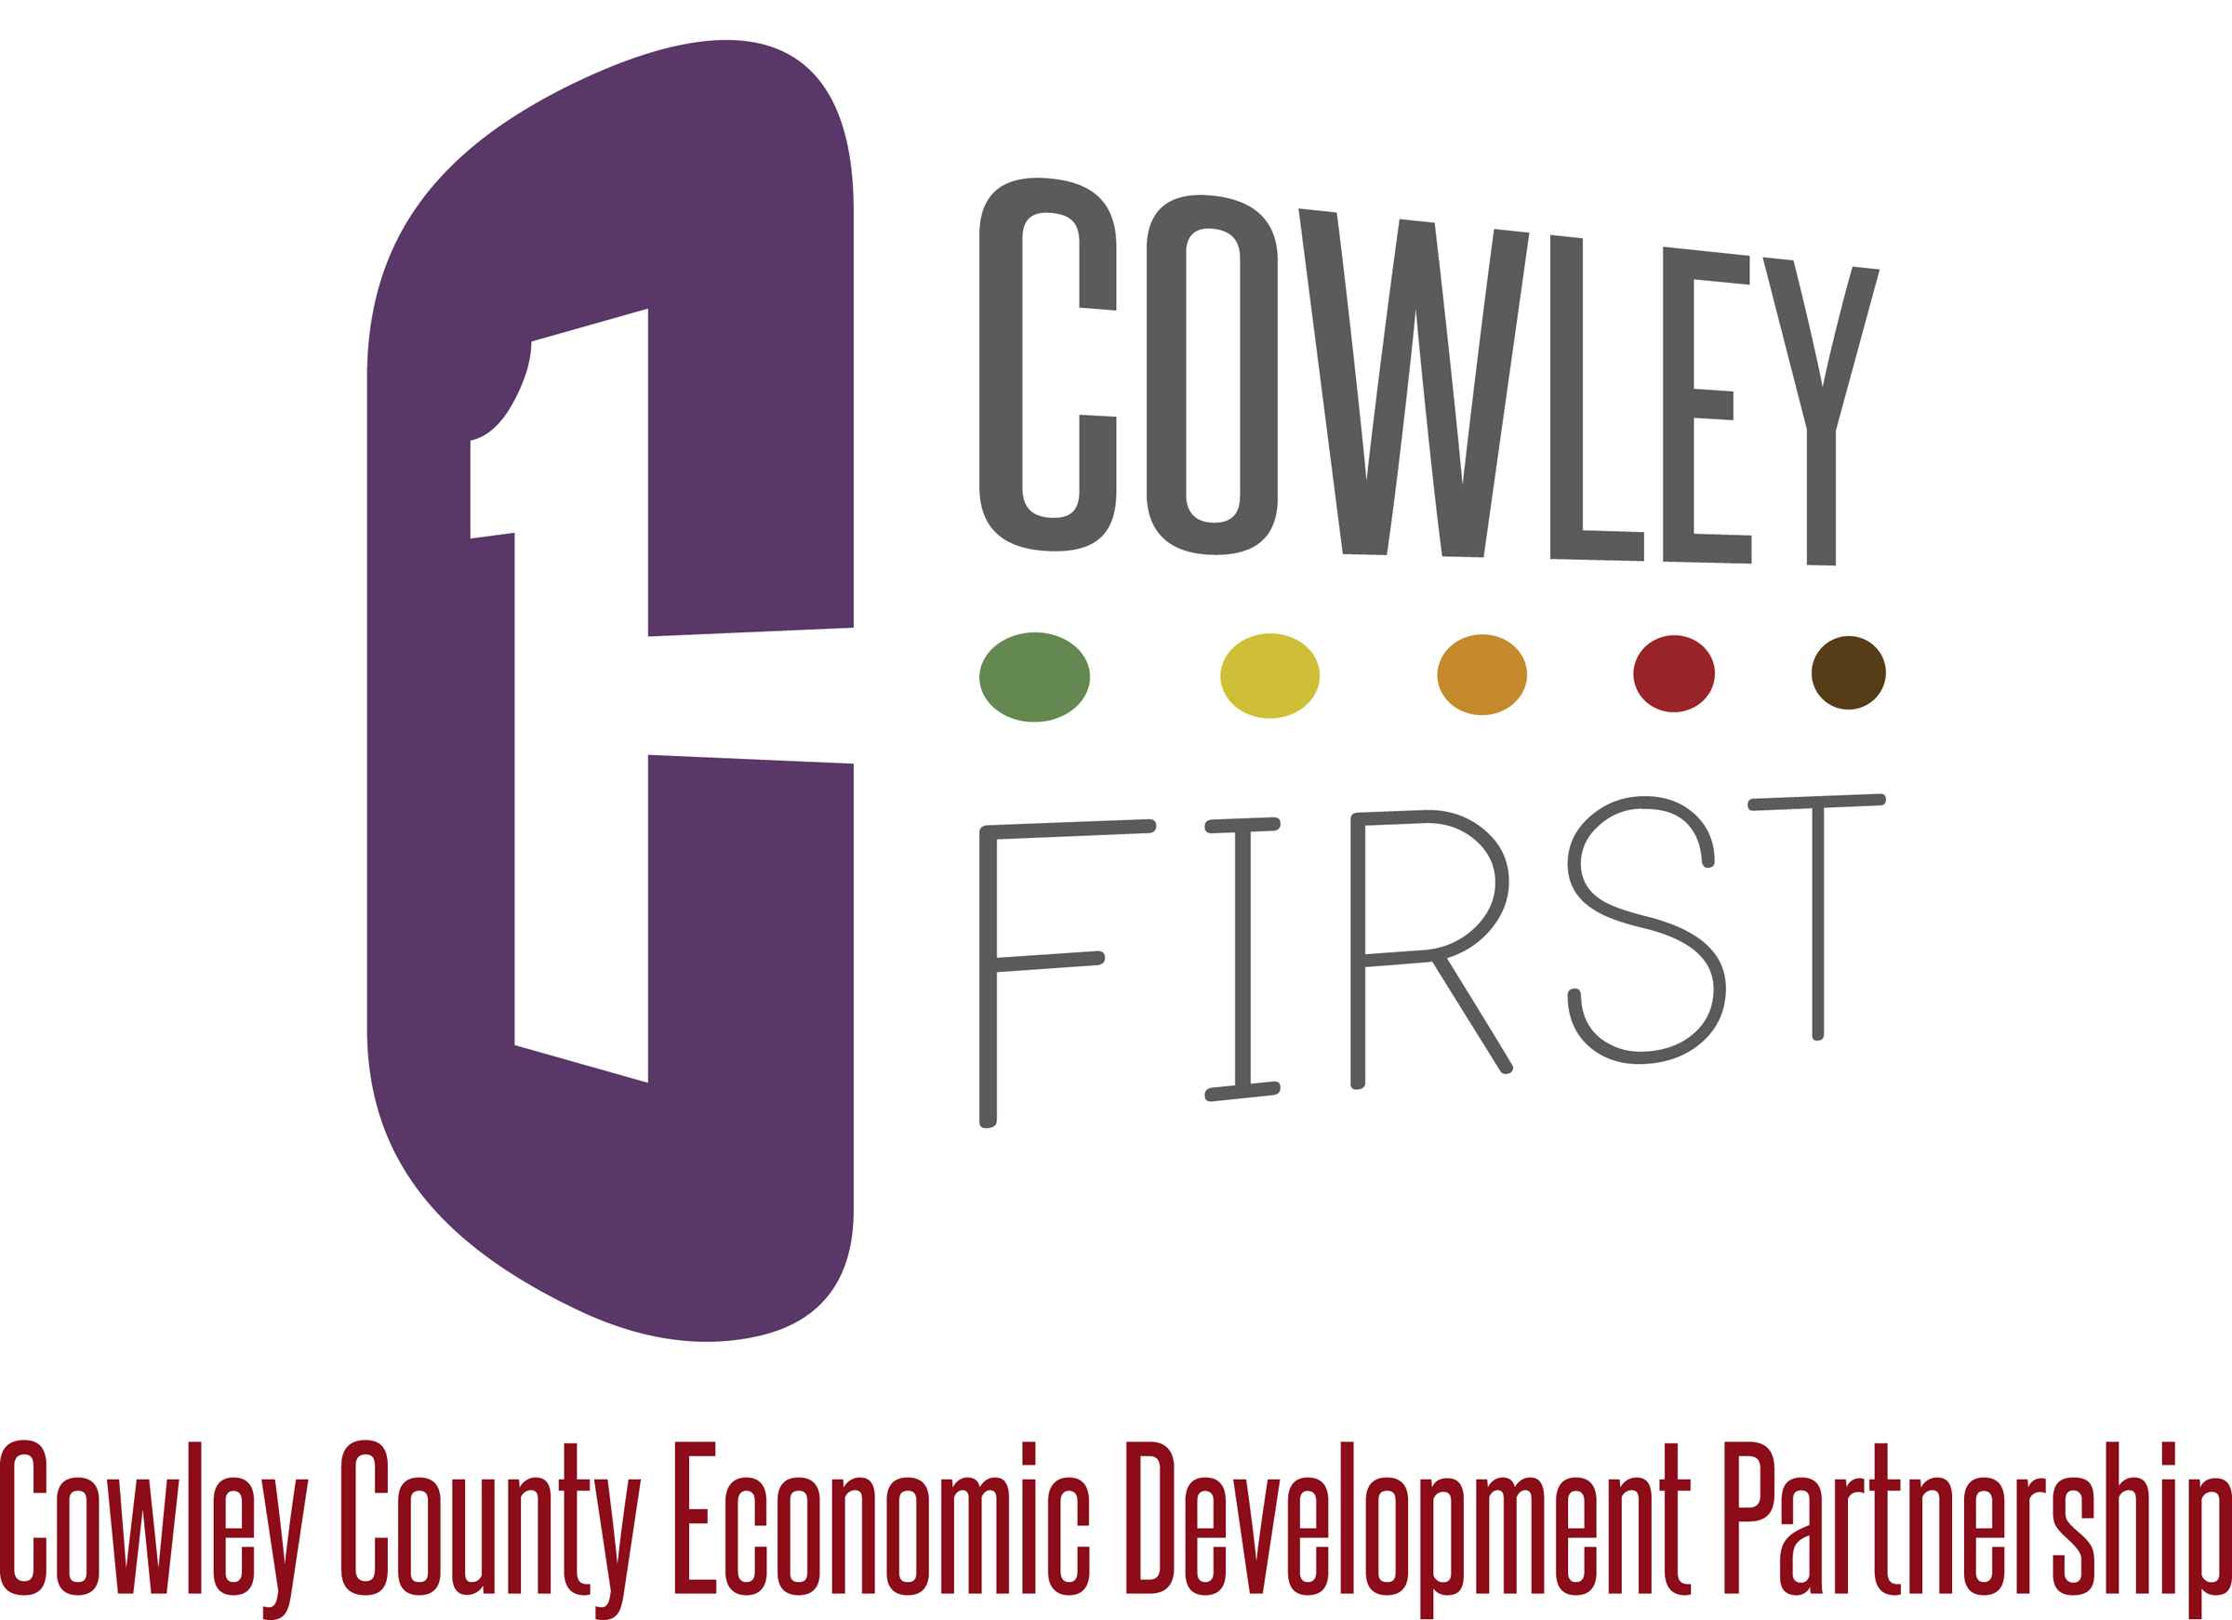
Cowley County Economic Development Partnership (Cowley First)

Cowley First is a countywide economic development partnership dedicated to assisting in expansion and retention of existing businesses, support local entrepreneurs, attract new businesses and industries while utilizing Cowley County’s prominent business atmosphere, high quality of life, recreation and tourism opportunities and excellent education facilities. See why Cowley County is the right place for your business.

Our Program of Work:
- Business Retention - Programs to enhance the stability and expansion of existing business and industry
- Entrepreneurship - Stimulating new business start-ups, emphasizing entrepreneurship and industrial innovation
- Workforce Recruitment and Development – Provide and cultivate skilled workforce for business and industry
- Marketing – Market resources and quality of life showing Cowley County as the place to live and work
- Rural Development - Promoting all of Cowley County, including assets in rural communities
- Business Recruitment - Promote Cowley County as an ideal location to bring in new industry
- Vision 20/20 - Cowley County’s strategic plan and vision for the year 2020
- Housing – Serve as a resource to communities for development in order to encourage growth in county population
- Additional activities include:
  - Assistance with available sites and buildings
  - Assistance with local, state, and federal programs and incentives to assist new and existing businesses
  - Providing a resource and acting as a liaison for our businesses and communities to service providers and partner agencies
  - Providing support to Chambers and communities in community development issues and needs

Address
22193 Tupper Street, Ste. 1
Winfield, KS 67156

Telephone
620-221-9951 (Winfield)
620-442-3094 (Ark City)

Email Address
kfalletti@cowleycounty.org

Web Site
www.cowleyfirst.com
www.cowley-works.com

Mailing Address
110 S Main, Ste 101
Wichita, KS 67230

Street Address
110 S Main, Ste 101
Wichita, KS 67230

Telephone
316-361-0323

Fax
n/a

Email Address
connect@e2eaccelerator.com

Web Site
www.e2eWichita.com

e2e

e2e is a private business community driven organization that will incubate, accelerate, mentor and invest in growth-oriented companies with the overall mission to accelerate the Wichita area entrepreneurial ecosystem. The name e2e stands for “entrepreneur-to-entrepreneur”. It embodies our unique approach that accelerating the Wichita entrepreneurial ecosystem can best be accomplished by e2e being the Center of Gravity for seasoned entrepreneurs and industry experts to mentor and invest in the next generation of entrepreneurs.

Accelerator
An acceleration program utilizing best practices modified to the unique history and strength of Wichita’s entrepreneurial ecosystem. e2e accepts emerging, high-growth companies into a coaching program custom designed to meet each cohort company’s individual needs. Wichita area mentors whose backgrounds match each
company coach and inspire entrepreneurs on all aspects of growing their business. The result is sound commercialization plans minimizing the risk inherent in new ventures.

Incubator
An incubator facility that will become the Center of Gravity for Wichita’s entrepreneurial ecosystem. The e2e Incubator provides shared office space to entrepreneurial companies in an open and dynamic environment that by nature facilitates the flow of ideas and energy. Featuring a membership model that provides for a diversity of co-working options and access to networking and event opportunities. It also hosts professional and social events targeted to entrepreneurial companies.

e2e Fund
Investment funds providing growth and venture capital to Wichita’s most promising entrepreneurial companies. e2e has also established
a revolving loan fund called the e2e E-Metro Community for companies coming into the e2e Accelerator or contributing to the entrepreneurial ecosystem.

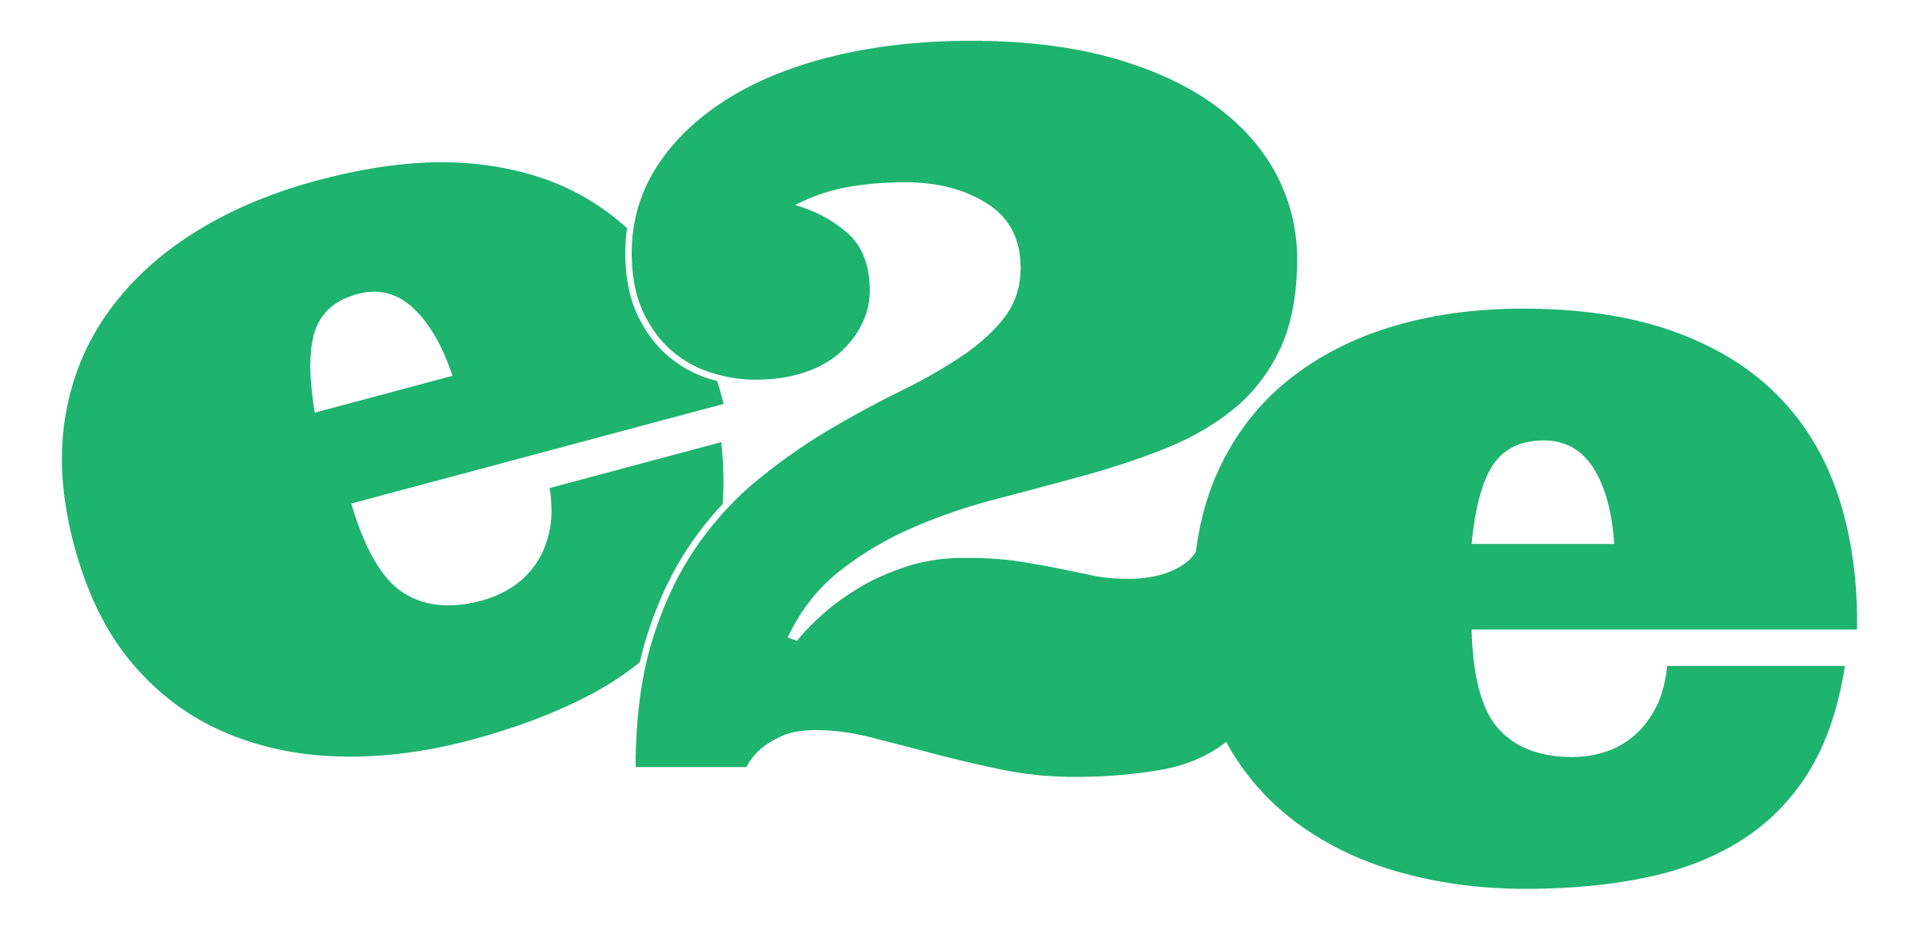

Mailing Address
6717 Shawnee Mission Pkwy
Overland Park, KS 66202

Street Address
6717 Shawnee Mission Pkwy
Overland Park, KS 66202

Telephone
Business Tax Questions
1-800-829-4933
Organizational Contacts
1- 913-722-7551
Web Site
http://www.irs.gov/smallbiz

Internal Revenue Service
Small Business/Self Employed Center

Stakeholder Liaison
The IRS Small Business and Self-Employed Stakeholder Liaison (SL) establishes relationships with organizations representing small business and self-employed taxpayers. They provide information about the policies, practices and procedures to ensure compliance with the tax laws. SL collaborates with tax professional organizations, small business groups and industry associations to provided tax education and information for their members. Services include our Small Business/Self-Employed Community Web Site, which provides tax information for new businesses. A Virtual Small Business Tax Workshop is available on-line at https://www.irsvideos.gov/Business/virtualworkshop.

Taxpayer Advocate Service
The Taxpayer Advocate Service is for individual and business taxpayers who have been unable to resolve federal tax problems through normal channels. The Taxpayer Advocate is independent within the IRS and reports directly to Congress through the National Taxpayer Advocate. As an advocate on behalf of the taxpayers, the Taxpayer Advocate Service educates taxpayers to help prevent any future problems or issues, and recommends changes to mitigate those problems for taxpayers in the future.

If you have an ongoing issue with the IRS that has not been resolved through normal processes, or you have suffered, or are about to suffer a significant hardship as a result of the application of the tax law, contact the Taxpayer Advocate.

Mailing Address
555 N. Woodlawn St., Bldg. 4, Suite 112, Stop 1005-WIC, Wichita, KS 67208

Street Address
555 N. Woodlawn St., Bldg. 4, Suite 112, Stop 1005-WIC, Wichita, KS 67208

Telephone
Voice: 877-777-4778
316-651-2100
Fax
866-571-0147 toll free
316-651-2101

Web Site
http://www.irs.gov/advocate


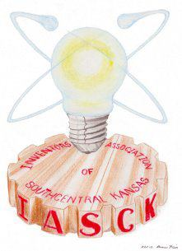
Contact Information

Gary Stecklein, President
11918 North 279th Street West
Burrton, KS 67020
316-667-2497
Email
inventor@inventkansas.com
Web Site
http://www.inventkansas.com

Inventors’ Association of South Central Kansas

IASCK is a not-for-profit organization, founded in 1997 for the purpose of fostering, promoting and encouraging the development and distribution to the public of useful inventions and discoveries.

To assist in accomplishment of these goals, IASCK holds monthly meetings on the 4th Monday of the month except May and December due to the holidays. These meetings generally include a guest speaker and time for discussions by members and guests.

Members pay annual dues, but guests may be invited to attend a meeting without charge. All guests and members are required to sign a Code of Ethics-Non-Disclosure Agreement as found on the Membership Application.

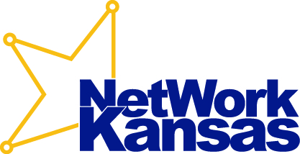
NetWork Kansas

NetWork Kansas is devoted to the growth of entrepreneurship and small businesses throughout the state of Kansas. Our mission is to promote an entrepreneurial environment by providing a central portal that connects entrepreneurs and small business owners with the Expertise, Education and Economic Resources they need in order to succeed. In pursuit of this mission, we partner with well-respected business development organizations and educational institutions that work with entrepreneurs and small business owners who have the vision and potential to succeed. The result is a seamless system that helps accelerate economic and community development in Kansas.

Entrepreneurs and small business owners are encouraged to visit www.networkkansas.com or call (877) 521-8600 to speak with a NetWork Kansas referral coordinator to be connected with local resource partners who can assist them.

StartUp Kansas

StartUp Kansas provides funding for startups and expansions of existing businesses in rural and distressed Kansas communities in the form of matching grants and unsecured loans. Competitive rounds are held monthly and applications are submitted by a NetWork Kansas funding partner working on behalf of the entrepreneur. These partners administer the loan and/or grant and provide a minimum of 40% in matching funds.

NetWork Kansas E-Community

E-Communities partner with NetWork Kansas to establish a fund for entrepreneurs and small business owners that is administered at the local level. Each E-Community maps local, regional and state assets available to assist entrepreneurs and businesses and establishes a long-term tracking and accountability system to measure business and economic growth. They also engage in a long-term partnership with more than 500 NetWork Kansas partners statewide that assist entrepreneurs and small businesses to provide a positive impact on the Kansas economy.

Go to www.networkkansas.com for more information on these and other offerings, such as, Economic Gardening and the Kansas Capital Multiplier Loan and Venture Funds.

Mailing Address
P.O. Box 877
Andover, KS 67002-0877
Toll-Free (877) 521-8600
Fax (316) 733-8373

Telephone
877-521-8600
316-425-6025

Fax
316-733-8373

Email Address
info@networkkansas.com
jpgendron@networkkansas.com

Web Site
www.networkkansas.com

Kansas Center for Entrepreneurship

Contact Information

Bob Fettke
Regional Project Manager
South Central Regional Office Business and Community Development Assistance
PO Box 9041
Wichita, KS 67277-7055
Phone: 316-655-7055
rfettke@kansascommerce.com

Renee Lippincott
Regional Project Manager
South Central Regional Office
Business and Community Development Assistance
125 West Cooper
Sterling, KS 67579
Phone: 620-204-0855
rlippincott@kansascommerce.com

Wichita Workforce Center
Administrative Offices
R. H. Garvey Building
8th Floor
300 W. Douglas
Wichita, KS 67202
316-771-6800
Web Site
http://kansascommerce.com

Kansas Department of Commerce

As the State’s lead economic agency, the Kansas Department of Commerce strives to empower individuals, businesses and communities to realize prosperity in Kansas. The Department administers programs and services that create jobs, attract new investment, provide workforce training, encourage community development and promote the state as a wonderful place to live, work and play. These programs are managed by a dynamic staff that is dedicated to improving the quality of life of all Kansans.

Business and Community Development Assistance
Business and Community Development Assistance staff can assist clients in identifying programs and incentives for business expansion, meeting licensing requirements and assessing the strengths and weaknesses of a local community.
On the community development side, staff can help rural communities seek assistance in developing community driven strategic plans to attract businesses, workers and investment.
Regional Project Managers based throughout the state are available to ensure your business or community is prepared to achieve its goals. Managers will assist in identifying incentives and assistance available to help grow your business; can provide training, strategic planning facilitation and identification of community development assistance programs; and will serve as liaisons to other state and federal agencies.

Workforce Services
The Workforce Services Division links businesses, job candidates and educational institutions to provide Kansas businesses with skilled employees. The Division utilizes the state’s higher education system in the delivery of training services supported by federally and state-funded employment and training programs. Employment services are provided to employers and job candidates electronically and through KANSASWORKS Centers, which are located throughout the state. Services include:
- Recruitment
- Screening
- Assessment of job candidates

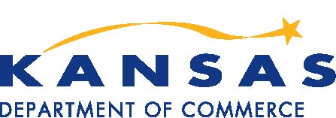

Mailing Address
Kansas Department of Revenue
ATTN: Taxpayer Education
915 SW Harrison
Topeka, Kansas 66612

Street Address
Kansas Department of Revenue
915 SW Harrison, Room 230
Topeka, Kansas 66612

Telephone
785-296-1048

Fax
785-296-7928

Email Address
carl_york@kdor.state.ks.us

Web Site
www.ksrevenue.org

Kansas Department of Revenue
Taxpayer Education

The Kansas Department of Revenue maintains a Taxpayer Education Unit whose mission is to assist both taxpayers and professional tax practitioners in understanding and applying the Kansas tax laws. The Education Unit regularly conducts classes
for the following Kansas taxes: Individual Income, Individual Estimated, Foodsales Tax Refund, Homestead Refund, Retailers’ Sales, Consumers’ and Retailers’ Compensating Use, and Withholding.

A wealth of Kansas tax information may be obtained from the Kansas Department of Revenue’s web site: www.ksrevenue.org For example, businesses are able to register for “tax numbers”
on-line at the KDOR web site, all forms and publications are available on-line, and taxpayers are able to file returns for and
pay the tax due for many of the taxes administered by KDOR
on-line. All inquires relating to electronic filing or electronic payment of taxes can be addressed toll-free at 1-800-525-3901.


Kansas Global is a full service trade consulting firm dedicated to building international growth and commerce.

At Kansas Global, we have a variety of services that can fit your company’s individual needs, ranging from global information to strategic marketing. We believe that every company should be
looking globally for its next sale.

We make sure you meet compliance guidelines.

We research new markets and give you confidence that your product will sell.

We find you lower-cost suppliers to keep you ahead of the game.

Membership
Numerous membership options are available which provide membership benefits including discounted rates for many of our services. For more information, visit www.kansasglobal.org.

Education & Training
We offer education and training seminars and webinars on different import/export topics throughout the year. Price per seminar/webinar varies. Members receive discounts to all seminars. For more information on upcoming seminars/webinars and rates, visit www.kansasglobal.org.

International Trade Services
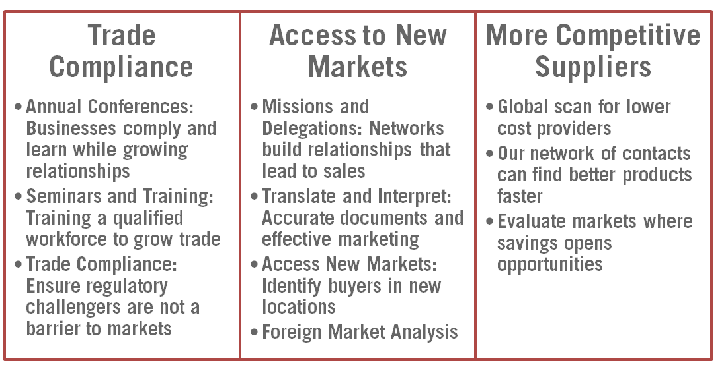

Let us become your trade advisor and help build your own trade department.

Contact tradeservices@kansasglobal.org for more information.

Mailing Address
Old Town Center
800 E. First, Suite 200
Wichita, KS 67202

Telephone
316-264-5982

Fax
316-264-5983

E-mail Address
tradeservices@kansasglobal.org

Web Site
www.kansasglobal.org

Kansas Global Trade Services

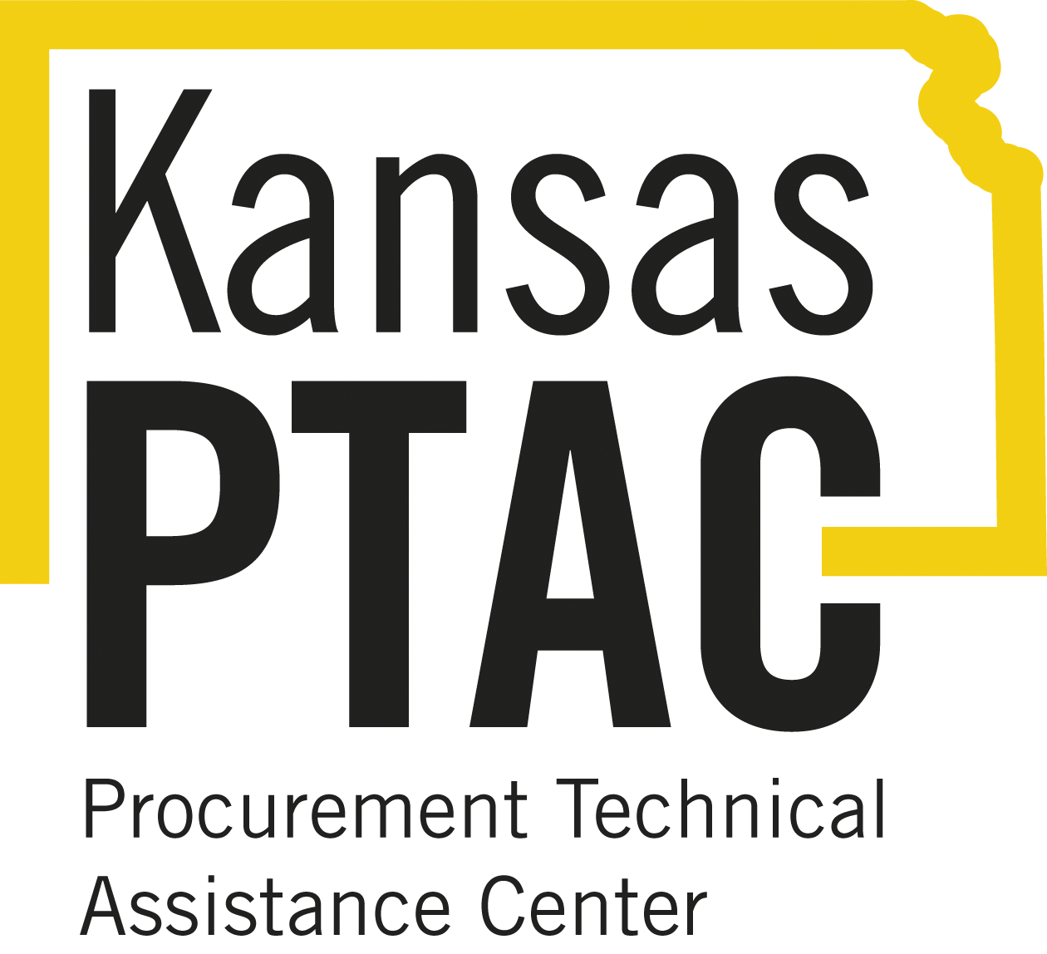
Kansas Procurement Technical Assistance Center

Kansas Procurement Technical Assistance Center (PTAC) is funded by a cooperative agreement between the Department of Defense and Wichita State University to help Kansas businesses market their products and services to federal, state, and local governments and to support government agencies in reaching and working with suppliers.
Services offered by Kansas PTAC include:
One-on-One Counseling:
Kansas PTAC works with clients individually on a variety of topics such as bid/quote/proposal preparation, pre-award and solicitation assistance, and post-award contract administration guidance.

Bid-Matching:
Bid-matching is an automated, web based system that notifies businesses daily (M-F) of bidding opportunities advertised on almost 2,900 federal, state, and local procurement web sites. A Kansas PTAC counselor will work with a client individually to develop a detailed search profile specific to the client which includes keywords, National Stock Numbers (NSNs), North American Industry Classification System (NAICS) codes, etc., used to “query” procurement web sites.

Registration, Certification and Verification Assistance:
Kansas PTAC can assist with the various vendor registrations, certifications and verifications required by federal, state, and local governments, including the System for Award Management (SAM), Historically Underutilized Business Zone (HUBZone), Service-Disabled Veteran-Owned Small Business (SDVOSB), Disadvantaged Business Enterprise (DBE), etc.

Training:
Various training events are conducted and provided by Kansas PTAC. Topics include learning the basics of doing business with the government, how to write government proposals—including a U.S. General Services Administration (GSA) proposal, how to create a proper capability statement, etc.

Networking Opportunities:
Kansas PTAC offers workshops and procurement conferences where government buying officials, and both large and small companies come together to discuss government contracting.

WSU Kansas PTAC, which serves as a Procurement Technical Assistance Center (PTAC), is funded in part through a cooperative agreement with the Defense Logistics Agency (DLA). The content of any written materials or verbal communications of the PTAC does not necessarily reflect the official views of or imply endorsement by DoD or DLA.”

Home Office
Kansas PTAC
Wichita State University
Mailing Address
1845 Fairmount St.
Wichita, KS 67260

Telephone
316-978-6788

Email
kansasptac@wichita.edu
scott.knapp@wichita.edu
Web Site
http://wichita.edu/kansasptac

Wichita Sub Center
455 N. Main Street, 12th Floor
Wichita, KS 67202

Telephone
316-268-4417

Email
CHaislett@wichita.gov

Go Topeka Sub Center
120 SE Sixth Avenue, Suite 110
Topeka, KS 66603

Telephone
785-234-2644

Overland Park Sub Center
Johnson County Community College
Regnier Center, Room 244
12345 College Blvd.
Overland Park, KS 66210

Telephone
913-469-2313

Kansas Small Business Development Center
at Wichita State University

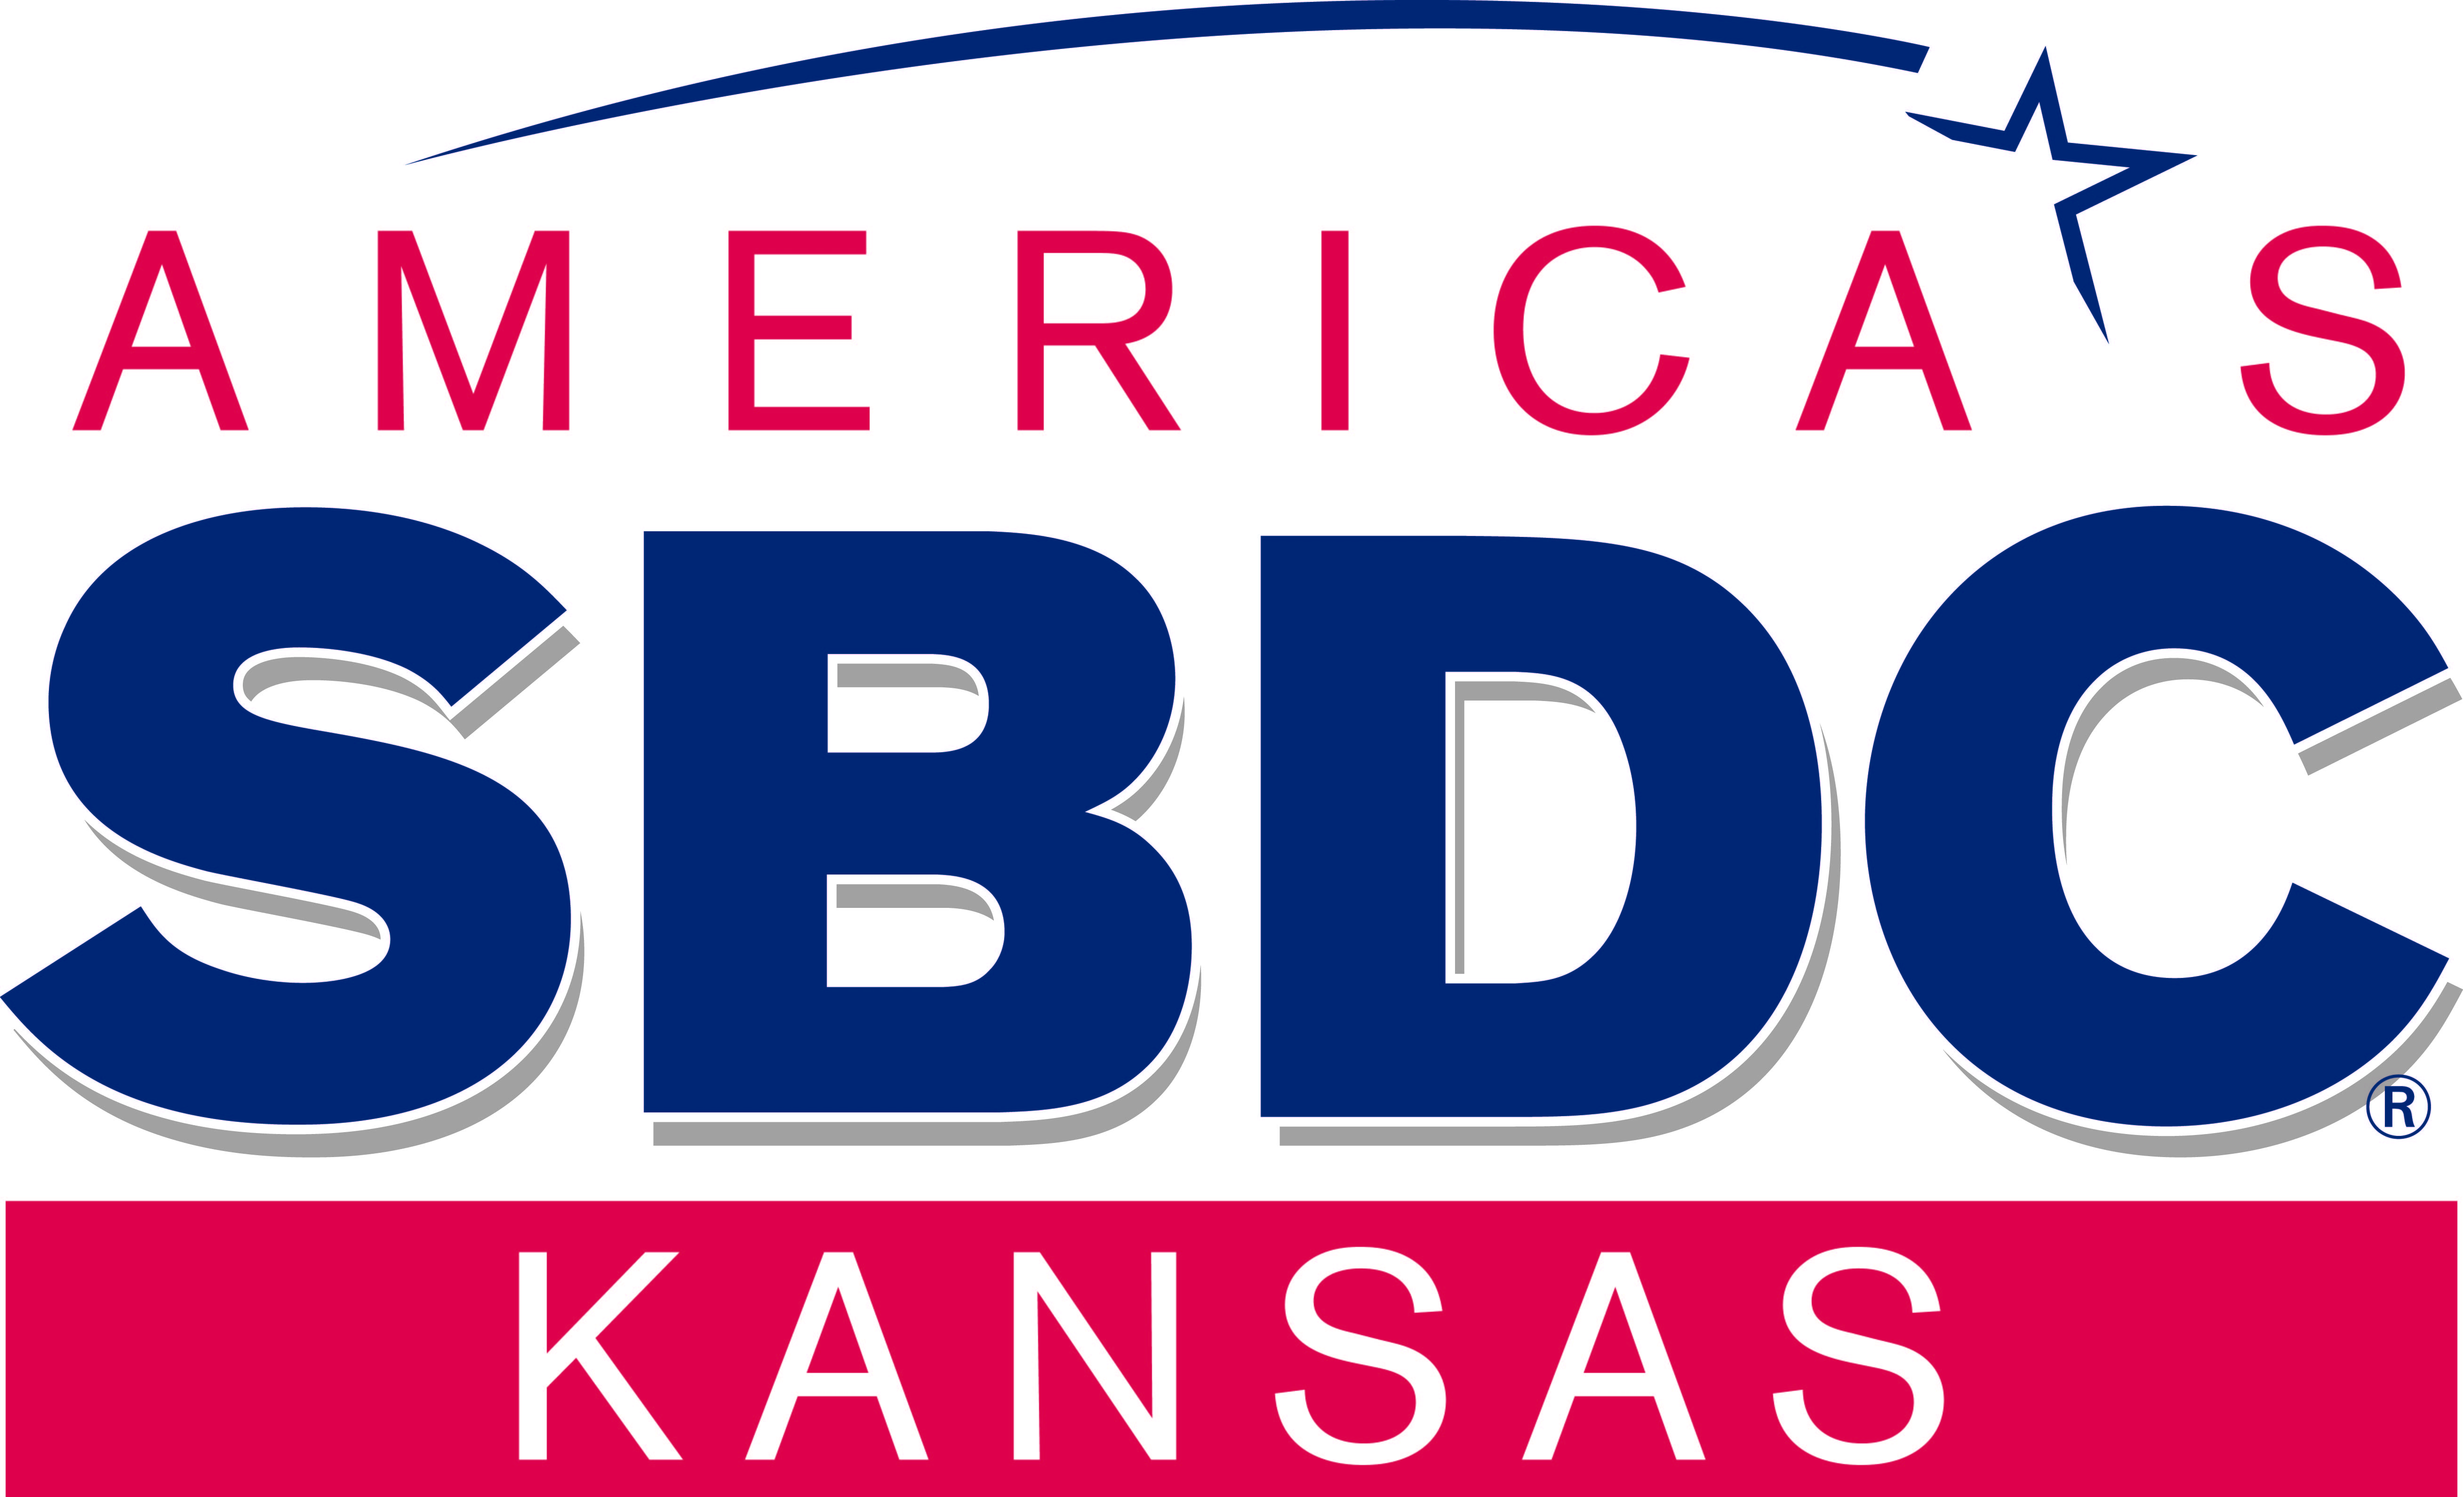
Mailing Address
1845 Fairmount
Wichita, KS 67260-0148

Street Address
5015 E 29th Street N
Wichita, KS 67220
(29th and Oliver)

Telephone
316-978-3193

Fax
316-978-3647

Email Address
ksbdc@wichita.edu

Web Site
http://www.wichita.edu/ksbdc

The Wichita State University Kansas Small Business Development Center will help you start, operate, and grow your business.

We offer no-cost advising services and affordable training to owners of established business and to entrepreneurs ready to start a business.

No-Cost Advising Services
Our professional advisors will assist you with business plan development, marketing, market research, financial analysis, strategic planning, technology commercialization, export, and many other areas.

If you need market research, we can order reports from our state and national centers that include:
- customer profile reports • competitor lists • industry overview and trends
- industry trend reports • demographics • psychographic data
- GIS Reports: consumer expenditures, ring study, drive time, retail opportunity gap

We use SageWorks ProfitCents™ to provide you with high quality financial analysis. Receive a report card in these areas:
- Liquidity • Borrowing • Sales
- Profits & Profit Margin • Assets • Employees

If you are an innovator interested in technology commercialization, call us. With extensive training and a national network of contacts, our advisors will help you identify funding sources, apply for SBIR/STTR grants, connect you with intellectual property, manufacturing, and product development experts, and help you develop your commercialization plan. Join us for Encountering Innovation Week. http://www.wichita.edu/encounteringinnovation.com.

Affordable Training and Business Events
We offer over 100 workshops each year along with major events. Our annual Business Transitions Conference offers tracts for Buy, Sell and Succession Planning. View our website for a schedule of upcoming workshops and events targeting businesses at all stages of development.

We will also design training to meet the needs of you and your staff. Contact us for a free needs assessment and a price quote.

Business in Motion:
Making Business Expansion Easier
Are you ready to grow your business? Our Business in Motion program makes business expansion easier. Expand through

• new products • new markets • the web
• franchise • export • government contracts

Funded in part through a Cooperative Agreement with the U.S. Small Business Administration.

Mailing Address
7001 W 21st Street N
Wichita, KS 67205

Or

133 Ward Hall
Manhattan, KS 66506-2508

Telephone
316-660-0104
800-578-8898
Fax
785-532-6952

Email Address
sbeap@ksu.edu

Web Site
www.sbeap.org

Kansas State University
Small Business Environmental Assistance
The Kansas Small Business Environmental Assistance Program (SBEAP) will help businesses identify and understand environmental compliance and pollution prevention.

SBEAP offers free consulting through a toll-free environmental hotline, site visits, workshops, and Webinars. These services are funded in part by the Kansas Department of Health and Environment.

Free Technical Assistance
Trained regulatory and pollution prevention specialists can answer your questions or research options related to several different environmental compliance and pollution prevention topics including –
- Air permits
- Air emissions record keeping and compliance
- Hazardous waste identification
- Hazardous waste compliance
- Waste water permits
- Storm water permits
- Energy efficiency and conservation
- Waste minimization opportunities
- Water conservation opportunities
- Process engineering and material substitution
- Environmental interns
- Environmental awards

On-line Resources
The sbeap.org Web site is full of on-line resources including –
- Interactive training modules
- Archived Webinars
- Risk assessment tools
- Publications
- Case studies and cost-benefits
- Specialized resource links

SBEAP services are free, non-regulatory, and completely confidential. Call SBEAP with your environmental compliance questions.

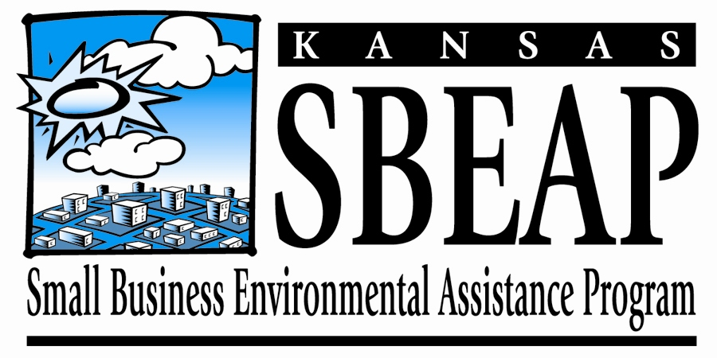
Kansas Global is a full service trade consulting firm dedicated to building international growth and commerce.

At Kansas Global, we have a variety of services that can fit your company’s individual needs, ranging from global information to strategic marketing. We believe that every company should be
looking globally for its next sale.

We make sure you meet compliance guidelines.

We research new markets and give you confidence that your product will sell.

We find you lower-cost suppliers to keep you ahead of the game.

Membership
Numerous membership options are available which provide membership benefits including discounted rates for many of our services. For more information visit www.kansasglobal.org.

Education & Training
We offer education and training seminars and webinars on different import/export topics throughout the year. Price per seminar/webinar varies. Members receive discounts to all seminars. For more information on upcoming seminars/webinars and rates, visit www.kansasglobal.org.

International Trade Services

Let us become your trade advisor and help build your own trade department.

Contact tradeservices@kansasglobal.org for more information.

Mailing Address
Old Town Center
800 E. First, Suite 200
Wichita, KS 67202

Telephone
316-264-5982

Fax
316-264-5983

E-mail Address
tradeservices@kansasglobal.org

Web Site
www.kansasglobal.org

Kansas Global Trade Services

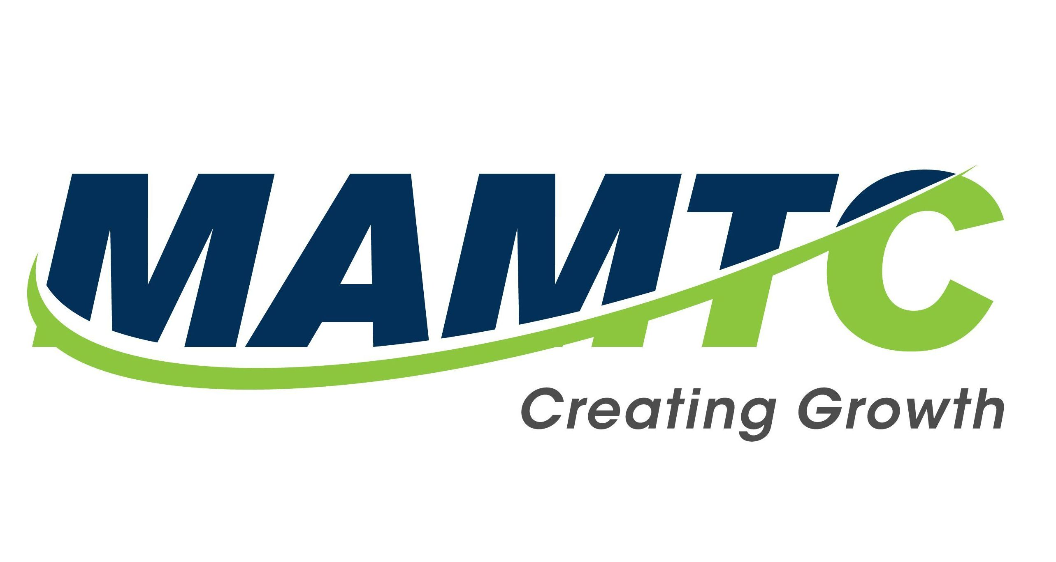
Mailing Address
350 West Douglas Ave
Wichita, KS 67202

Street Address
350 West Douglas Ave
Wichita, KS 67202

Telephone
316.807.2149

Fax

Email Address
info@mamtc.com
jshea@mamtc.com

Web Site
http://www.mamtc.com

Mid-America Manufacturing Technology Center (MAMTC)

The Mid-America Manufacturing Technology Center (MAMTC) was founded in 1991 with a simple purpose: To help Kansas companies realize never ending growth in the rapidly changing global marketplace.

MAMTC’s in proud to be an Innovation Engineering Management System Certified provider. The Innovation Engineering movement is based on the systemic approach of Dr. W. Edwards Deming and applying it to growth and innovation.

MAMTC’s certified Black Belts provide the knowledge and expertise to help companies increase the speed and decrease the risk of new products, services and processes.

MAMTC also has a renowned expert in the Energy Efficiency world to help companies reduce their energy usage and become more efficient in the work of the company.

MAMTC is an affiliate of the National Institute of Standards and Technology Manufacturing Extension Partnership and the Kansas Department of Commerce with the mission of helping make American businesses more innovative at home and more competitive aboard.

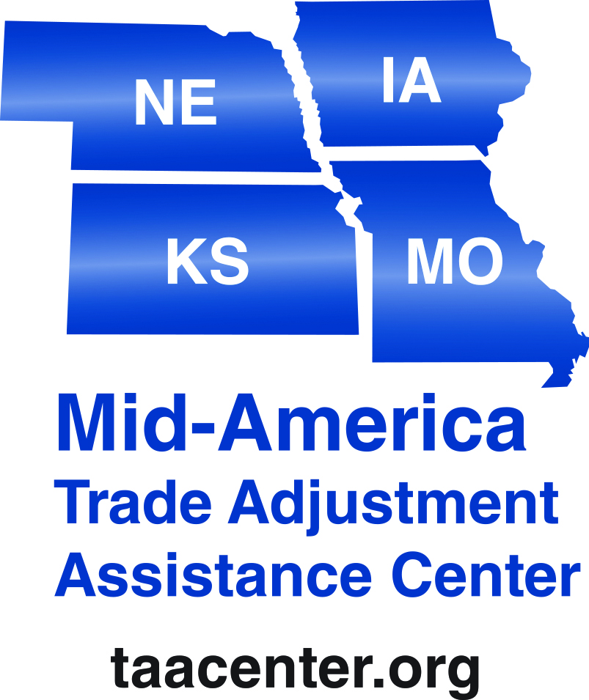

Mailing Address
4200 Little Blue Pkwy, Ste 590
Independence, MO 64057

Telephone
800-336-8205
816-666-9407

Fax
816-666-9407

Email Address
Mid-amer@taacenter.org

Web Site
www.taacenters.org

Mid-America Trade Adjustment Assistance Center

The Mid-America Trade Adjustment Assistance for Firms (TAAF) program provides cost share grant funding to import-impacted U.S. manufacturers to strengthen their global competitiveness, expand markets, strengthen operations, increase profitability, and increase U.S. jobs.

The Mid-America Trade Adjustment Assistance Center (TAAC) administers the TAAF program in IA, KS, MO & NE through a Cooperative Agreement between the Department of Commerce’s Economic Administration Agency (EDA) and the University of Missouri.

Technical and Financial Assistance:
Mid-America TAAC assist in determining eligibility, in preparing application documents and acts as an intermediary between the firm and EDA.

TAAC staff conducts a thorough assessment of the firm to identify and prioritize opportunities for increased profits, job creation and long-term financial stability.

Cost share grant funds are used to implement projects with consultants or industry-specific experts that are focused on improving a firm’s internal operations and competitive abilities. The smaller cost share grant of $30,000 requires a 25% company match. The larger cost share grant of up to $150,000 requires a 50% company match.

Project Funding Categories:
Manufacturing, Engineering and Production; Financial and General Management, Marketing and Sales, and IT Support Systems.

Benefits of the Trade Adjustment Assistance for Firms Program: Improved Cash Flow/Leverage, Align and Maximize Resources, Strengthen Competitive Abilities and International Market Expansion

Program Phases:

Mailing Address
P.O. Box 637
Wichita, KS 67201

Street Address
610 N. Main
Wichita, KS 67203

Telephone
(316) 440-6744

Fax
None

Email Address
membership@nonprofitchamberks.org

Web Site
www.nonprofitchamberks.org

Nonprofit Chamber of Service

The Nonprofit Chamber of Service serves to establish and grow successful nonprofit organizations that contribute to improving the quality of life in our community. We achieve this by providing training, networking, support and resources and by encouraging collaboration and alliances between nonprofit organizations, businesses, government, educational institutions and the community.

Programs and Services
- Networking Lunches
Our monthly luncheons not only provide opportunities to make connections but our presenters cover topics that will help you build a successful organization.
- Executive Director Survival Series
Executive Directors have the opportunity to participate in a peer-to-peer group to share challenges, ideas and experiences.
- Board University
Board University sessions are held seven times a year and each session covers different topics related to being a better board member and building a better board.
- Emerge & Lead
A 6-month leadership program, in partnership with the Kansas Leadership Center, specifically designed for nonprofit staff, board members and volunteers.
- Mixers
We provide the opportunity to connect with others from nonprofits, businesses, educational institutions, as well as political candidates.
- Employee Recruitment
Post a job on our job board and we will work with you to help recruit the right person for the position as well as provide advice on transitions and onboarding.
- Board Recruitment
Post a board opening on our website or on our Facebook page (Kansas Nonprofit Board Member Match-Up) and we will work with you to promote the opening and try to connect you with someone from our board bank.
- Consulting & Training
We provide consulting, training, and strategic planning at affordable rates and can connect you with others that provide similar services. We are also available for a phone call or meeting to just provide some advice and direction.
- Assistance with Finding Resources
We keep you updated with information on grants, emerging issues, the latest research on nonprofit trends, and provide information on resources for your organization. Need legal, accounting, HR or other services? We can connect you with businesses that specialize in services for nonprofits.
Membership
The Nonprofit Chamber of Service offers affordable memberships for students and student groups, individuals, nonprofits, businesses, universities, and government departments. Membership rates can be found on our website.

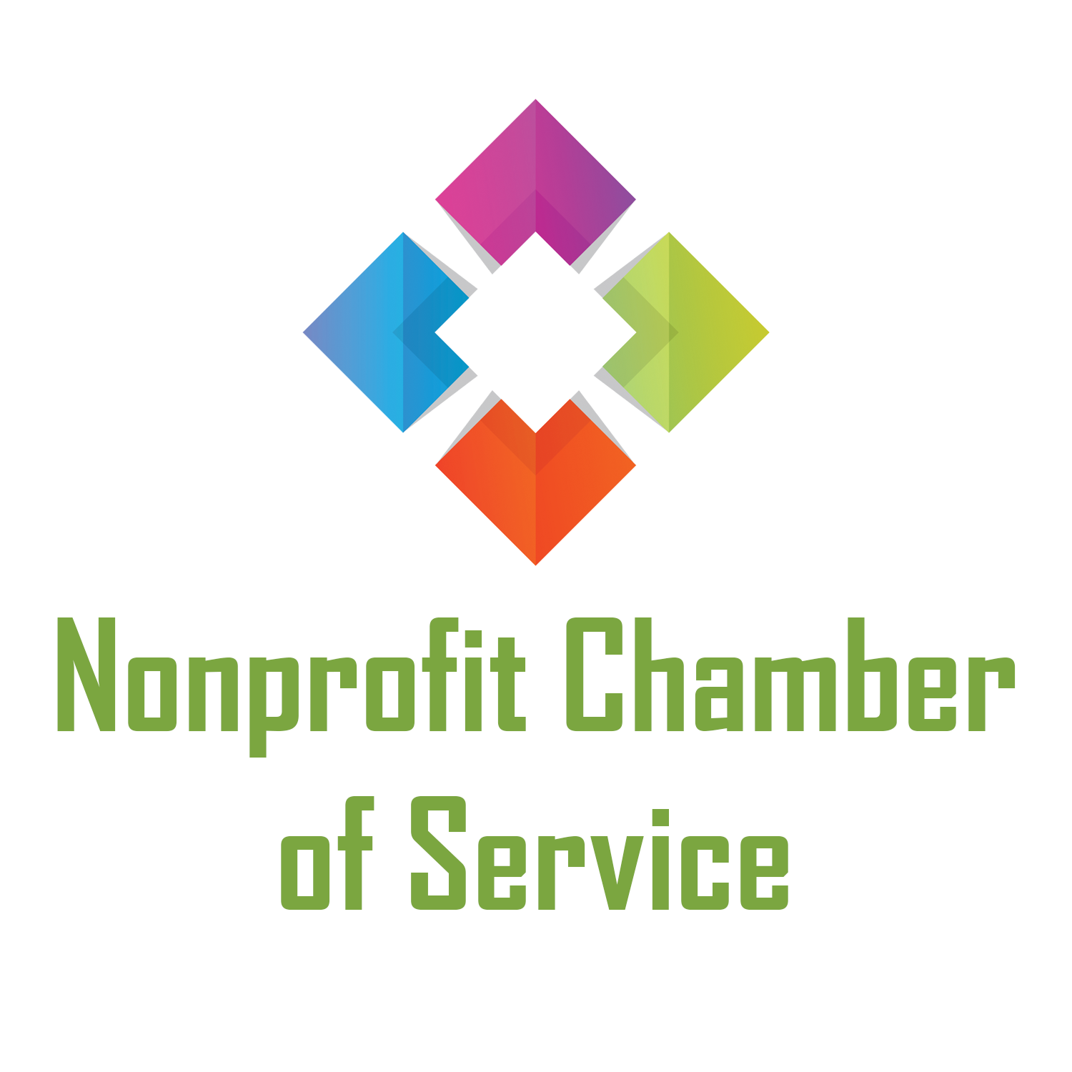


Mailing Address
Ablah Library
Wichita State University
1845 Fairmount
Wichita, KS 67260-0068

Street Address
Wichita State University
Ablah Library
1st Floor
Wichita, Kansas 67260-0068

Telephone
316-978-5017
316-978-5130

Email Address
sara.butts@wichita.edu
nan.myers@wichita.edu

Web Site
http://libresources.wichita.edu/patents/trademarks/copyright


Patent and Trademark Resource Center at the Wichita State University Libraries
Wichita State University's Ablah Library is one of 84 U.S. Patent and Trademark Research Centers (PTRCs) in the country and the only PTRC in Kansas. Since receiving this designation in 1991, the PTRC has received copies of U.S. patents and a variety of patent and trademark searching tools in both print and electronic formats, as well as extensive training in providing patent and trademark research assistance.
The Library is open to the public, and staff members assist with preliminary patent and trademark research by appointment at no charge.

Collections of U.S. government publications include complete U.S. patents -- on microfilm, optical disks and the Internet -- from 1790 to the present, and all federal trademarks that are registered or pending. Collections contain additional indexes and finding aids for both patents and trademarks. All PTRC publications and documents and their reference materials may be found in the Government Documents Stacks on Level One of Ablah Library, in compact shelving, and on the web pages for the U.S. Patent and Trademark Office (USPTO) at www.uspto.gov.

The PTRC offers general information on all areas of intellectual property and assistance/training with preliminary patent searches and trademark searches. Please consult a patent attorney for legal advice.

For an in-depth consultation, please schedule an appointment with Nan Myers at 978-5130 or nan.myers@wichita.edu or with Sara Butts at 978-5017 or sara.butts@wichita.edu.

Mailing Address
Sedgwick County Courthouse
525 N Main, Suite 807
Wichita, KS 67202

Street Address
Sedgwick County Courthouse
525 N Main, Suite 807
Wichita, KS 67202

Telephone
316-660-7261

Email Address
sherdeill.breathettsr@sedgwick.gov

Web Site
www.sedgwickcounty.org

Sedgwick County Economic Development / Foreign Trade Zone (FTZ) #161

Economic Development

Economic Development promotes a strong and diverse regional economy by helping local businesses grow, increasing opportunity for international trade, and attracting new jobs to Sedgwick County. Several programs are coordinated under Economic Develop to achieve this goal.

Sedgwick County Foreign Trade Zone (FTZ) #161

FTZ is a general purpose zone where foreign and domestic goods are not within U.S. Customs territory. The zone is ready to work for businesses involved in international trade whether it is manufacturing, assembly or even distribution. Air, rail and surface transportation users find the international trade services and facilities convenient, user friendly and highly cost effective in the long run

Users of the FTZ are exempt from paying duty or federal excise taxes while the goods remain in the zone until exported goods are picked up for local distribution and use. Funding is used to promote the zone also for training and travel expenses for the economic development staff.

Sedgwick County Micro-Loan Program

The program is designed to assist low to moderate income small business owners by providing loans and technical assistance, for businesses expansion and help insure success over time.

Loan funds can be used for:
- Startup equipment
- Expansion equipment
- Increase inventory
- Advertisement
- General working capital

Loan sizes:
- Up to $15,000 for an existing or start-up business
- No limit on total project debt.
- Other funds available through companion programs for projects that qualify

Applications are available from: South Central Economic Development Dist.
Website: www.sckedd.org or call (316) 262-7035 and ask for Christie Henry


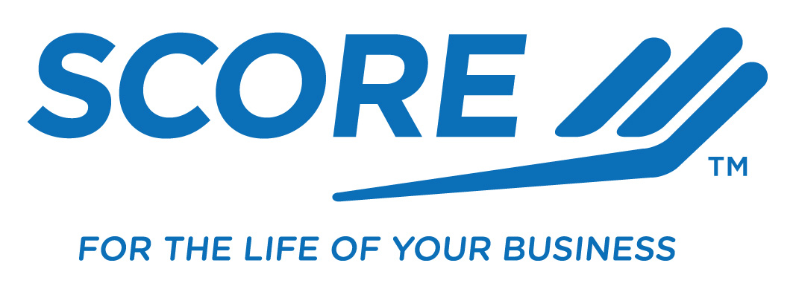
Address
220 W. Douglas Ave. Suite 450
Wichita, KS 67202

Telephone
316-269-6273

Fax
316-269-6499

Email Address
SCORE143@sbcglobal.net

Web Site
http://wichita.score.org

Service Corps of Retired Executives (SCORE)
Wichita Chapter 143

SCORE "Counselors to America's Small Business" is a national non-profit organization affiliated with the U.S. Small Business Administration. Its purpose is to provide free counseling and mentoring to small businesses and to individuals thinking of starting small businesses.

Wichita’s SCORE chapter has counselors with over 500 years of business experience. Counselors come from backgrounds in banking, manufacturing, logistics, operations, legal, accounting, and small business ownership just mentioning a few. After-hours counseling is also available most week days and weekends by appointment with a SCORE counselor.

Our counselors focus on development of business plans and reviewing business improvement opportunities. They offer a confidential ‘new set of eyes’ to review financial data. People interested in seeking small business counseling at no charge can reach SCORE by calling 316-269-6273.

The Wichita SCORE chapter also offers workshops from 9:00 AM to 12:00 PM on the third Saturday of each month, excluding May and December, to help people start and grow their own small business. There is a nominal charge of $20 for these workshops.

Mailing Address
9730 E. 50th Street N.
Bel Aire, KS 67226

Street Address
9730 E 50th Street N
Bel Aire, KS 67226

Telephone
316-262-7035

Fax
316-262-7062

Email Address

Web Site
http://www.sckedd.org
South Central Kansas
Economic Development District
The South Central Kansas Economic Development District (SCKEDD) is one of eleven planning and development regions in Kansas. SCKEDD consists of 14 counties including Butler, Chautauqua, Cowley, Elk, Greenwood, Harper, Harvey, Kingman, Marion, McPherson, Reno, Rice, Sedgwick and Sumner.

Our goal is to provide professional leadership and technical assistance in finance packaging and advice, and procedures to individuals, companies and government agencies for the purpose of stimulating the economy within this 14 county area. Our resources also extend towards programs that assist our cities and counties with community improvement, housing, and urgent need.

Loan Programs
SBA Microloan—If you own or are in the process of starting a small business and your loan request is for $50,000 or less, you may qualify for a Microloan.

Revolving Loan Fund—If your business needs call for less than $300,000, you may qualify for the Revolving Loan Fund (EDA).

SBA 7(a)—SCKEDD packages SBA guaranteed loans for banks and other lenders. If you are working through your bank to secure additional funding for your business, the SBA 7a loan may be the program you need.

SBA 504—The SBA 504 program provides long-term, low down-payment capital for growing businesses that enhance an area’s local employment. SCKEDD can fund up to 40% of project cost with an injection of at least 10% from the borrower.

Intermediary Relending Program (IRP)—SCKEDD, through the U.S. Department of Agriculture (USDA) Rural Development (RD) offers direct loans up to $250,000 with a 25% required match from other sources.

Community Development Block Grant (CDBG)—SCKEDD assists in packaging and administering CDBG funds for economic development and community improvement projects.

Rural Microenterprise Assistance Program (RMAP) —If you own or are in the process of starting a business in a rural area of our district (all locations outside the City of Wichita), and need less than $50,000, you may qualify for a Rural Microenterprise Assistance loan.

Weatherization/Home Repair
SCKEDD provides weatherization and emergency repair to low-income residents in the SCKEDD area for owned or rented dwellings. There are also programs in some areas for moderate rehabilitation to homes.



Mailing Address
P.O. Box 279
Wellington, KS 67152

Street Address
123 N. Jefferson
Wellington, KS 67152

Telephone
620-326-8779

Fax
620-326-6544

Email Address
scedc@co.sumner.ks.us

Web Site
www.gosumner.com

Sumner County
Economic Development Commission

The Sumner County Economic Development Commission (SCEDC) provides assistance to new and existing business in Sumner County.

Our focus:
      - Retention and expansion of existing businesses
- Recruiting businesses to locate within Sumner County and its communities
- Providing entrepreneurs/business startups with access to business plan writing, marketing, financial resource assistance
- Assistance with available sites and buildings
- Assistance with local, state, and federal programs to assist new and existing businesses
- Providing a resource and acting as a liaison for our businesses and communities to service providers and partner agencies
- Providing support to Chambers and communities in community development issues and needs

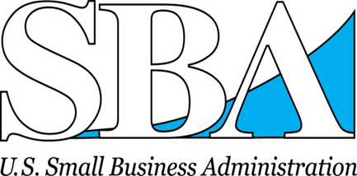
Address
220 W. Douglas Ave. Suite 450
Wichita, KS 67202

Telephone
316-269-6616

Fax
316-269-6499

Email Address: Wichita_DO@sba.gov

Web Site: http://www.sba.gov/ks

Kansas Small Business Resource Guide: Click HERE

U.S. Small Business Administration
Wichita District Office

Realize your dreams of entrepreneurship with a wealth of resources from the U.S. Small Business Administration. Whether your enterprise is a startup, an established or an expanding business, the SBA’s resources and services can help you succeed.

As Your Small Business Resource, the SBA can connect you with a network of services to fit your needs.

SBA Loan Guaranties
- Obtain the financing you need for startup, expansion, to export or working capital with a 7(a) loan through SBA participating lenders.
- Secure long-term, fixed-asset financing with a 504 loan provided by SBA Certified Development Companies.

Federal Contracting Assistance
- Certify your company with the 8(a) Business Development Program, which provides business development and federal contract support to eligible small, disadvantaged businesses.
- Obtain federal contract preferences in the HUBZone Program if your business is in a qualified historically underutilized business zone and meets ownership, control and employee residency requirements.
- Make one-to-one connections with procurement managers at Business Matchmaking events or online.

Business Counseling and Training
- Attend training workshops and receive one-on-one free consulting at the Wichita State University Small Business Development Center.
- Consult SCORE, “Counselors to America’s Small Business,” for mentoring and management counseling.
- SBA’s Learning Center is a virtual campus complete with free online training courses and a comprehensive e-library with hundreds of publications, workshops, podcasts and tools.
- Emerging Leaders initiative is an intense seven-month entrepreneurship training program for executives of existing small businesses to help them create a strategic growth plan for their firms. The curriculum is designed to accelerate the growth of high-potential small businesses, stimulate job creation and help drive economic development.

Disaster Assistance
SBA provides low interest disaster loans to homeowners, renters, businesses of all sizes and private, nonprofit organizations impacted by a declared disaster.

Address
350 W. Douglas Avenue
Wichita KS 67202

Telephone
316-265-6334

Fax
316-462-9965

Email Address
whcc@wichitahispanicchamber.org

Web Site
http://wichitahispanicchamber.org

Wichita Hispanic Chamber of Commerce

Who We Are
The Wichita Hispanic Chamber of Commerce, Inc. (WHCC) is a volunteer membership driven organization comprised of individuals, small business owners, corporate representatives, and associates representing various nonprofit organizations

When We Began
In March of 2002, Hispanic business leaders gathered and created the Wichita Hispanic Chamber of Commerce (WHCC). These Hispanic business leaders envisioned the need for an organization to represent their interest and meet the needs of the Hispanic business community. The WHCC was incorporated later that year, creating a coherent and strong organization within the Wichita Hispanic business community. WHCC was incorporated with the Kansas Secretary of State’s office in April 2002 and was established in June 2002 as Wichita’s first minority Chamber of Commerce.

Why Join Us
WHCC membership offers many benefits, both directly and indirectly. Members have access to networking opportunities and special events. WHCC hosts the Annual Meeting and Awards Dinner, which honors outstanding leaders, businesses and corporate partners.



Mailing Address
200 E. 1st St., Ste. 101
Wichita, KS 67202
Telephone
316-201-3264

Fax
316-201-3268

Contact
Alicia Holloway, President
Tristan Carter, Director of Marketing

Email Address
Alicia@wiba.org
Tristan@wiba.org

Web Site
http://www.wiba.org

The Wichita Independent Business Association (WIBA) is an association of privately owned businesses throughout the state of Kansas. Membership ranges from sole proprietors operating a home-based business to medium and large companies with thousands of employees – such as Koch Industries.

WIBA believes every business should have the opportunity to succeed.

WIBA connects people, provides expertise, opportunities and an influential voice to help businesses thrive. We do this because we believe strong businesses build strong communities.

CONNECT TO SUCCESS

Partnership
Networking that broadens your reach in the community.

Events
- Women’s Leadership Alliance Luncheon
- Monthly Membership Luncheons
- WIBA Simply Social networking events
- WIBA On Tap mixers
- Educational Seminars

Resources
Educational opportunities and group discounts for you and your employees.

Advocacy
- Political advocacy that impacts issues of concern to your business.
- Government Affairs Committee monthly meetings
- Tracking of state legislation
- Annual Day in Topeka (March)
- Annual Legislative and Elected Officials Luncheon (November)

Wichita Independent Business Association/
Kansas Independent Business Coalition

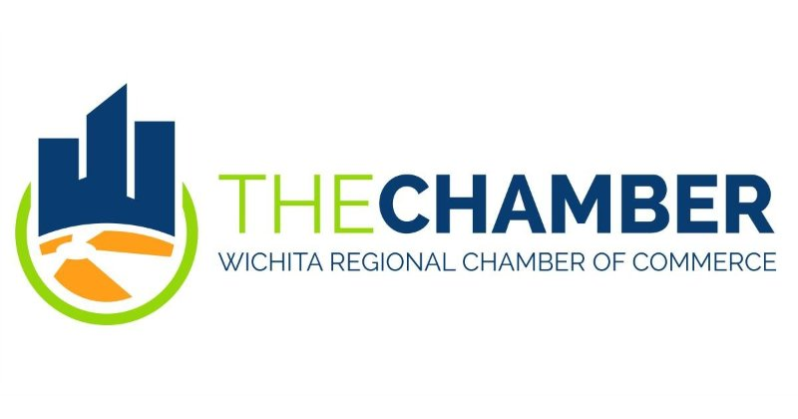
Mailing and Street Address
350 West Douglas Avenue
Wichita, Kansas 67202-2970

Telephone
316-265-7771

Fax
316-265-7502

Email Address
aelliott@wichitachamber.org
Web Site
www.wichitachamber.org

Contact:
Angie Elliott
VP, Membership & Engagement
The Wichita Regional Chamber of Commerce is a nonprofit membership organization for people who recognize that a competitive business environment provides businesses a distinct advantage in achieving their objectives. Achieving a competitive environment requires constant activity in four focus areas:

CONNECTING - Providing opportunities to build relationships to help members become more profitable and competitive

PROMOTING - Championing the community to attract and retain top talent and improve the quality of life in the region

ADVOCATING - Representing business interests by advocating for responsible regulations and policies

INFLUENCING - Providing political action to impact the election process

What are the main reasons businesses join the Chamber?
- Increased visibility for the business, products or services
- Education/Information regarding business and community issues
- Civic Responsibility/Supporting the Business Environment/Government Advocacy

The Chamber is your primary voice to legislative bodies and your resource for professional connections and development opportunities. We respond to the specific needs and interests of our diverse business members by providing tailored, value-based business, employee, educational and personal development experiences.

The Chamber also has several affiliate organizations with specific objectives and opportunities for involvement:

- Young Professionals of Wichita (YPW) - works to attract, engage, and retain diverse young talent to effect positive change for a brighter future.
- Friends of McConnell (FOM) - expresses community pride and appreciation of the military by supporting Commander-directed programs at McConnell Air Force Base.
- Wichita Educational Foundation - The Foundation provides education and training for lifelong learning,and improvement of jobs skills.
- Wichita Manufacturer's Association (WMA) - promotes area manufacturers and supports educational activities to develop manufacturing interests, methods and employees.
- Political Action Committee (PAC) - supports candidates and issues at the local, regional, and state levels that reflect the goals and objectives of the Chamber.

Wichita Regional Chamber of Commerce

Address
(located in the High Touch Building) 110 S. Main, Suite 101
Wichita, KS 67202

Telephone
316-651-5900

Fax
866-810-6671

Email Address
wtc@wichitatechnology.com

Web Site
http://www.wichitatechnology.com

Contact:

Trish Brasted
President & CEO
brasted@wichitatechnology.com

Wichita Technology Corporation

- Fostering Technology Advancement, Transfer & Commercialization in Kansas

WTC provides a variety of business services to inventors, entrepreneurs and early-stage technology businesses. Our services fall into two categories; business assistance/consulting services and access to capital.

Business Assistance & Consulting Services

Our team has years of combined experience in business development and will assist you with business plan development, market analysis, strategic planning, financial model development as well as a number of other services. Consulting services are fee-based and may consist of an equity position in the company, a royalty on future sales, a cash fee or any combination of the three.

Following is a list of the most common business assistance services provided by WTC:

- Business Plan Consulting
- Market Research & Market Validation
- Competitor Analysis
- Sales and Marketing Strategy Development
- Business Model Development
- Business Valuation
- General Management, Operations and Accounting Assistance
- Public Relations and Promotion
- Patent and Trademark Assistance
- Assistance in Locating and Accessing Debt and Equity Financing

Access to Capital

Wichita Technology Ventures, LLC, founded in 1994, is a seed and early-stage venture capital fund managed by WTC and funded by the Kansas Technology Enterprise Corporation (KTEC) and Wichita Area Development. WTV is looking for opportunities in early stage high-growth businesses. WTV's investment decisions are driven by return on investment criteria and in optimizing opportunities to invest in high growth technologies with entrepreneurs located primarily in Kansas. For more information, visit www.wichitatechnology.com.

Midwest Venture Alliance (MVA) is a membership organization of accredited private investors committed to investing in high-growth seed and early-stage technology companies in Kansas. Members share their knowledge and expertise during the investment selection process and with the companies that are funded and supported by the Alliance. For more information, visit www.midwestventure.com.

Accelerate the Heartland will showcase high growth companies representing diverse fields including advanced materials, software & IT, energy, and life sciences. The Highlights Include: One Million Cups, Expert Venture Capital Panel, e2e Accelerator's Demo Day, Great Plains Capital Conference, and Pipeline Entrepreneurs.
Mailing Address
300 W. Douglas Ave., Suite 850 Wichita, KS 67202

Street Address
300 W. Douglas Ave., Suite 850 Wichita, KS 67202

Telephone
316-263-4067

Email Address
Andrew.Anderson@trade.gov

Web Site
http://www.export.gov

Wichita U.S. Export Assistance Center
U.S. Commercial Service - USDOC

The U.S. Commercial Service provides export counseling and advice, information on markets abroad, international partner contacts and advocacy services. We are a federal government agency helping companies export their goods and services and compete in international markets.

The Wichita U.S. Export Assistance Center is part of an international office network covering all 50 states and over 80 countries. We work with companies who are seasoned exporters as well as those exporting for the first time.

Services
- free export counseling and advice
- on-line market research library containing free country and industry specific research
- customized market research
- foreign distributor searches – Intl Partner Search and Gold Key Service
- foreign company investigations – Intl Company Profile
- trade missions and programs at major domestic and foreign trade shows
- resources for pre/post export finance and receivables insurance
- export controls and compliance help
- referrals to other service providers to support your export business


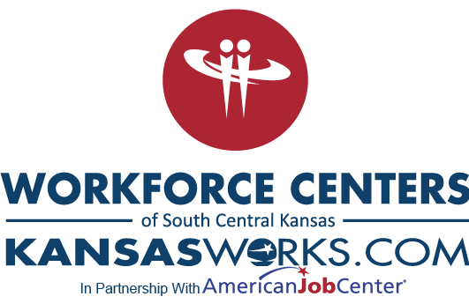
The Region's "One-Stop" For Workforce Solutions
Workforce Centers of South Central Kansas, is a one-stop resource for employers that provides a single point of contact for all workforce development needs in the region.

Our goals are to:
Provide valuable resources, such as
- Labor Market Information
- Referral assistance to other area resources

Assist with workforce recruitment by providing services, such as
- Job posting
- Regional employee outreach
- Hosting area job fairs
- Community orientations

Support with hiring efforts by
- Providing skill assessments and testing that are
  - standard to an industry
  - tailored to an employer
- Providing offsite interviewing facilities that includes
  - private office space
  - comfortable conference rooms

Provide support to help meet training needs, including
- Providing training needs assessment
- Facilitating the delivery of standard programs
- Facilitating the development of customized programs
- Selection and coordination of providers
- Classroom education
- Student recruitment / Career development

Provide assistance at accessing funds established by
- State Programs, such as the
Kansas Industrial Training (KIT) Program
Kansas Industrial Retraining (KIR) Program
- Federal Workforce Investment Act Programs, such as the
Incumbent Worker Training (IWT) Program

Workforce Centers of South Central Kansas
Mailing Address
Administrative Offices
R. H. Garvey Building
8th Floor
300 W. Douglas
Wichita, KS 67202

Telephone
316-771-6800

Fax
316-771-6690

Email Address info@workforce-ks.com

Web Site
www.workforce-ks.com

mi
Mailing Address
WSU Ventures
1845 Fairmount Street
Wichita, KS 67260-0129

Telephone
316-978-5363

Email Address wsuventures@wichita.edu

Web Site
www.wsuventures.org

WSU Ventures

WSU Ventures assists innovators from all backgrounds and acts as a one-stop support hub for product and process development.

- We work with WSU faculty, staff and students to help them advance, protect and license ideas and intellectual property.

- We connect industry, external inventors, entrepreneurs and investors with WSU’s expertise, resources and technology.

Bringing an idea to life is a challenge, and WSU Ventures is here to help clear roadblocks during every step of product development by providing assistance with:

- Intellectual Property Protection – Identifying the best way for WSU faculty, staff and students to safeguard through patents, copyrights, trademarks, contracts and agreements.

- Access to Resources – Connecting startups and established businesses with the university research labs and resources

- SBIR/STTR Funding – Meeting with inventors, innovators and entrepreneurs who want to learn more about America’s Largest Seed Fund, the U.S. Small Business Innovation Research (SBIR)/Small Business Technology Transfer (STTR) Programs.

- Technology Transfer, Entrepreneurship and Startups – Providing customer discovery, validation, research and prototype development services to aid in the development of new and innovative products and services.

- Commercialization – Identifying commercial applications, exploring potential licensees, executing non-disclosure and licensing agreements for WSU faculty, staff and students.

From an abstract idea to a finished product – and anywhere in between – let WSU Ventures meet you where you are and connect you with the expertise, technology and business capabilities of Kansas’ innovation university.

Organization Referrals

If you are not sure which organization can best assist you, contact these groups for a targeted referral.

Network Kansas
A NetWork Kansas Resource Coordinator will listen to you and learn about your exact needs. They will research their resource partner network and connect you to the resources you need today. Call toll free at 877-521-8600 or use the “Resource Navigator” at http://networkkansas.com

Kansas Small Business Development Center at Wichita State University
The WSU Kansas SBDC staff members stay in regular contact with area resources. They will be glad to refer you to the organizations that can best meet your current needs. Call 316-978-3193 for assistance.

