This form is used to submit requests to the University Budget Office to add, remove, or transfer budget authority. General guidelines for using the form include:
- All fields at the top of the form must be completed, including a brief outline of the purpose/reason for the request.
- If a transfer, increases and decreases must be in equal amounts. Transfers can only occur on existing, unexpended budget authority.
- General Use (GU) transfer requests must be within the same GU fund (e.g., A0003 to A0003 or A2000 to A2000). Transfers cannot cross GU funds.
- General Use (GU) funding increases are generally not allowed without prior authorization through the University Budget Office. For such requests, make sure you have coordinated with your Budget Analyst prior to submitting the request.
- Restricted Use (RU) expenditure budgets can be increased. For such requests, you must also complete the revenue section of the form.
- Restricted Use (RU) transfers can be processed only if the related organization and WSU fund are assigned to the same State fund. Normally, this is not an issue, but if in doubt please contact your Budget Analyst prior to submitting the form.
- Restricted Use (RU) requests involving health benefit costs must be manually entered.
After completing the form, the Budget Review Officer for the impacted organization should email the form to their assigned Budget Analyst.
This budget form only impacts the “planning” of how financial resources are intended to accomplish goals/responsibilities through the budget. It does not impact actual expenditures or revenue collections. For example, to process a Restricted Use (RU) cash transfer, please use the Financial Operations form.
Using the Form
The form is designed so that when a user enters a fund/organization/account code, the name will populate automatically. In the instance that the name does not populate correctly, a user can unprotect the form by going to “Review”, and then selecting “Unprotect Sheet” to then be able to manually enter the correct name.
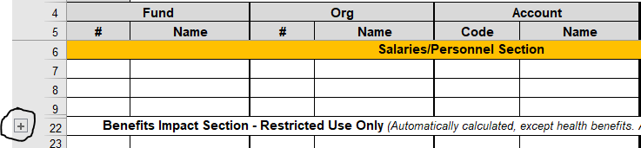
If the request requires additional rows, the form includes expansion buttons to the left of the worksheet to expand the number of rows available within each section. Prior to selecting the expansion button a user must unprotect the form by going to “Review”, and then selecting “Unprotect Sheet”.
For Restricted Use (RU) requests involving personnel, the form will calculate the impact on fringe benefit accounts based on the rates included in the “Benefit Rates” tab. Keep the following exceptions in mind:
- Health Benefits: Because health benefit costs vary based on the type of benefit selection chosen by each employee, as well as the timing of when the budget change is effective, this entry must be manually entered.
  - A safe methodology for estimating these costs is to assume the employee(s) has selected the most expense benefit option of Family (single + dependent) and then to estimate the remaining costs based on the number of months remaining in the fiscal year. Another methodology is to use the average cost per FTE from the adopted budget.
- Retirement: This is estimated based on the Regents retirement rate. The real retirement rate can vary depending on the type of employee or their chosen selection.

The excel workbook includes a “Common Account Search” tool. If you’re not certain of the correct account to use in your request, this tool can make it easier to identify the correct selection(s).
Completed Form – Simple Example
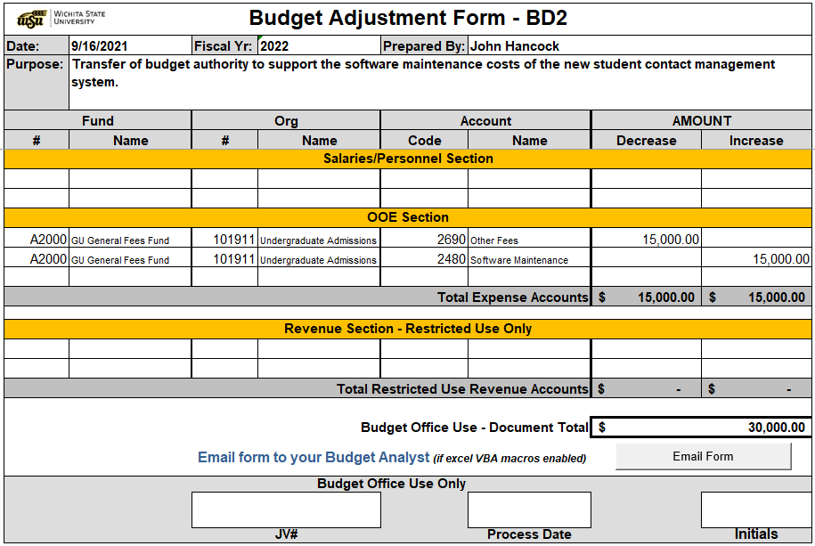
Below is a simple example of a completed form transferring budget authority between OOE accounts within the same org. and fund combination.

Other Tools
The excel workbook also includes a tool to search for commonly used accounts. To the right, simply select the likely revenue or expense rollup within the slicer selections where the appropriate account would likely reside to then see the detail accounts to the left.

