Counseling and Prevention Services (CAPS)

Fiscal Year 2021 Impact Report

# Mission

Counseling and Prevention Services provides mental health treatment, training and prevention to support WSU community wellness, while fostering optimal academic and personal growth.

# Student Snapshot

Served 1077 of the campus population.

**Gender** 35% Male  
60% Female  
4% Self-Identify/Transgender  
2% No Response

**Ethnic Minorities** 10.5% Asian  
11.6% Hispanic  
6.9% African American  
9.6% Other  
.9% No Response

**Sexual Orientation** 21% Lesbian/Gay/Bisexual/Questioning  
4% Self-Identify  
73% Heterosexual/Straight  
3% No Response

**First Generation College Students** 30.80% Students self-identified as such

**International Students** 9.9%

**Care Team** Approximately **23%** of students served at CAPS had an open CARE Team case in FY20

# Clinical Services

* **Number of total appointment attended:** FY20 has **5984** which is a **12.33% increase** from FY19 and is the most individual appointments attended at CAPS.
* **Number of students using services:** FY20 has **1077** which is a **11.72% increase** from FY19 as well as the most students ever served in a fiscal year by CAPS.

# Clinical Training

* CAPS continues to provide applied training opportunities for both WSU students and students from other universities. During the 2019-2020 academic year, **16 of our clinicians were in dedicated training positions.** We have **15 dedicated training positions year**.
* WSU CAPS has a long history of participating in an accredited, nation-wide, psychology, doctoral internship program and will continue to provide training to students recruited through that program in the upcoming year.
* This year, **our office will provide training opportunities for students across three different programs at WSU** (Psychology Department and Counseling Educational Leadership, Educational Psychology, and School Psychology (CLES), and Social Work) **and for students from five other universities** (Emporia State University, Fielding Graduate University, Alliant – Los Angeles, Georgia Southern University, and University of South Alabama).
* Due to increasing training opportunities, CAPS has been able to provide increased access to mental health services on campus. **Our trainees provided 3386 hours of clinical services in FY20, which represents a 33% increase from the year before**.

# Prevention and Outreach

* Over the past two years, the introduction of the #WeSupportU Preventing Suicide Training resulted in a 426% increase of suicide prevention training over 3, third-party trainings offered the two years previous.
* CAPS engaged in **399 hours of prevention and outreach** and had **14,530 contacts with students, parents, staff/faculty, and community members**. This is a 14.6% increase from the previous fiscal year.
* Created and implemented the Prevention Ambassador Peer Education Program during Spring Semester.
* From March-June we published over 50 videos and livestreams, producing at least 3 videos/livestreams every week in order to provide resources for the WSU community to manage the mental health impacts due to the COVID-19 epidemic.

# CAPS Initiatives and News

* Provided most mental health, outreach and prevention services via **telehealth** and digital formats
* Licensed the **#WeSupportU Suspenders4Hope Mental Wellness and Suicide Prevention Program** to our first community partners
* Leading University response to student **mental wellness during the Covid 19** pandemic launching the Shocks Supporting Shocks and Faculty/Staff Mental Health Advocate initiatives 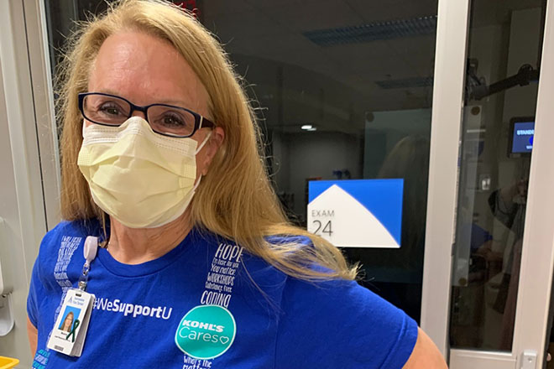

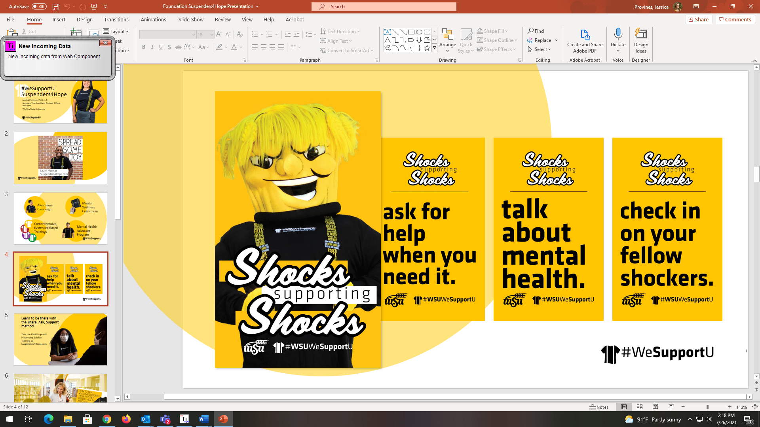

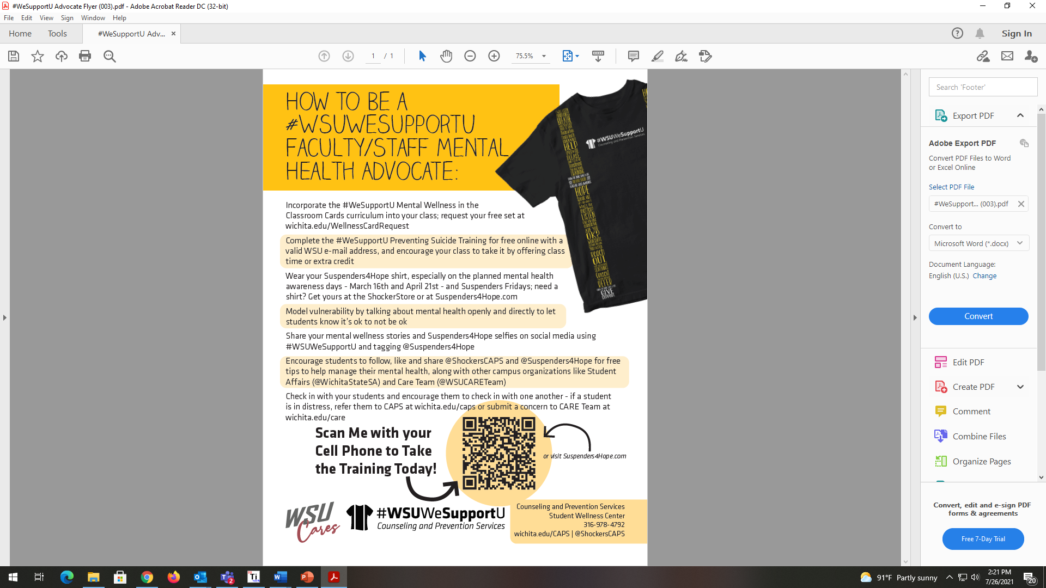

CAPS Director Report FY2021

*Jessica Provines, Ph.D., AVP for Student Wellness & Chief Psychologist, CAPS*

No one could imagine the entire FY2021 would be spent in Covid restrictions. Most University services were conducted remotely, students learned from home and workforces remained reduced for the whole year. To say it tested the limits of the Counseling and Prevention Services’ team and staff is an understatement. I am proud of how the team adapted, retooled, and led on the importance of mental health on campus and in our community throughout this past year. The department will continue to be tested as new hybrid models of service delivery and work life emerge. The charge is to embrace change while keeping quality treatment, access, training and prevention at the heart of CAPS services. The list of CAPS accomplishments this year is not exhaustive and has taken a group effort. Thank you to the CAPS staff for contributing to this list, for holding space for others pain and struggles as we struggled ourselves and for showing up every day and giving it your best. Your commitment and dedication to the students is inspiring.

Highlights

* CAPS clinical mental health services were offered 100% online due to pandemic precautions including individual, couples, and group therapy offerings, as well as, crisis services and medication appointments.
* Made strides toward the goal of becoming a national symbol for supportive mental health communities by growing the Suspenders4Hope campaign awareness with multiple promotional and marketing initiatives including upcoming large-scale events with community partners including Ascension Via Christi, Wichita Festivals and Stop Suicide ICT.
* Integration of Student Health Services and Counseling and Prevention Services was disrupted due to the demands of the pandemic, different service devilries and workforce arrangements. Recently resumed intentional efforts to build a more integrated culture.
* Continued to see increase demand for mental health services on campus demonstrated by two record breaking months for service delivery at the close of the academic year and planning for continued growth as students return to more in person class offerings in the fall with flexible, hybrid service delivery.
* Successfully met growth in demand with minimal wait times and avoided needing to implement other limits to treatment by continuing to use predictive analytics for points of access, precise clinical case management and referrals to group services.
* Resumed LD/ADHD formal psychological assessments safely after putting assessment on hold for the pandemic and expanded role of assessment coordinator and number of applied learning opportunities in assessment.
* Partnered with WSUtech to offer services to students and help grow their student Care Team.
* Refined telehealth business operations including on-line scheduling, text message reminders, and updated forms.
* Initiated HIPAA regulation implementation to bring University in compliance.
* Trained future mental health providers in the delivery of telehealth services and suicide specific treatment protocols.
* Awarded an additional 10 years of accreditation for the Wichita Collaborative Psychology Internship Program, which is in its 68th year, by the American Psychological Association accrediting body.
* Restructured CAPS leadership team to a matrix structure and promoted several key positions to help us grow in the areas of clinical services, prevention, training and assessment.
* Onboarded the first split position with Athletics to focus on student athlete mental wellness.
* Initiated a successful search for the first BIPOC focused mental health providers at CAPS.
* Secured additional revenues through student fees, donations, licenses, fees for service and grants, including the DOJ Violence against Women grant and the SAMHSA Campus Suicide Prevention Grant.
* Initiated conversations with University Foundation to explore philanthropic funding sources.
* Expanded the #WeSupportU Mental Wellness and Suicide Prevention Program to the community and partnered with our first licensees for the program.
* Delivered regular weekly educational content on social media to build students coping skills and resilience.
* Created #WeSupportU Faculty/Staff Mental Health Advocate Role to provide resources for employees who want to support their students’ mental wellness more intentionally.
* Worked with Student Affairs, Student Government and other Wellness Units to implement the Shocks Supporting Shocks campaign, which encourages Shockers to talk openly about mental health, check in on others, and ask for help when needed.
* Demonstrated leadership and scholarship in the field of University Counseling by presenting at multiple professional conferences and submitting a manuscript for publication to a professional journal.
* Conducted many campus and community media interviews on the impact of Covid on mental health helping Wichita State emerge as a local leader in population based mental health.
* Launched the Suspenders4Hope website and on-line training materials helping to reach more people in a physically distanced reality.
* Disseminated the #WeSupportU Mental Wellness Cards to instructors and adapted to workplace wellness and bilingual offerings.
* Grew peer ambassador program by creating a specialized athlete peer ambassador program.
* Added Community Clinical Psychology graduate applied learning opportunities to assist with prevention efforts.
* Staff served a critical mental health expert role on many campus committees and community coalitions including but not limited to Care Team, Covid Operations Team, Strategic Enrollment Management, Prevention Services Advisory Board and Sedgwick County Suicide Prevention Coalition.
* Helped draft a non-discriminatory University involuntary withdrawal policy.
* Remain committed to the values of clinical judgement and autonomy in practice and treatment decisions, balance between access and treatment, and balanced professional and personal life with emphasis on provider self-care.

This list highlights just some of the many accomplishments of CAPS staff this past year. It is truly impressive when you look back and realize all of this was done during a global pandemic. The circumstances challenged CAPS to grow and reimagine services in a physically distanced world. As the leader of Wellness Services and CAPS, I am honored to have served the University with this team. Thank you!

Wichita State University

Counseling and Prevention Services Clinical Services Report

Associate Director Christopher Leonard, Psy.D.

FY 2020

Counseling and Prevention Services Mission

Counseling and Prevention Services provides mental health treatment, training and prevention to support WSU community wellness, while fostering optimal academic and personal growth.

Clinical Services Mission

Clinical services strives to provide efficient, ethical, and culturally competent clinical services to students to assist them in increasing wellbeing and academic achievement.

FY20 Clinical Services Goals

* Increase interpersonal process groups to 3 options during fall & spring semester
* Provide clinical services data to increase outreach marketing for unserved groups and track for changes in use of clinical services
* Assess and revise current clinical services delivery model
* Increase tracking of wait time between scheduling and first appointment
* Develop assessment model that is in line with Student Affairs Assessment Committee standards
* Review and develop recommendations for improving clinical service model which are in line with HIPPA and integration with SHS.
* Become members of CCMH and start contributing CCAPS data
* Develop and administer new student satisfaction survey

CAPS Client Profile for FY20

Served 6.7% (n=1077)of the campus population.

**Number of sessions** 68% 1-5  
17% 6-10  
7% 11-15  
4% 16-20  
4% 21+

* Busiest intake times were September (n=163) & October (n=165)
* Average wait time for new students seeking services – **5.02 business days** (including holidays)

*Please see comparable fiscal year data for more information in the graphs below.*

Issues/Challenges Facing the Clinical Services

* COVID-19 Pandemic influence on service delivery and demand
* Transition into WSU Student Wellness Center with SHS
* Transition to remote services
* Loss of a Licensed Psychologist
* Increasing demand
* Onboarding of new staff members

Proposed Goals for FY21

* Develop more efficient ways to provide clinical services remotely by incorporating more technology into CAPS service delivery
* Create a greater understanding of clinical demand during a pandemic and revise current clinical service delivery model to better meet demands
* Provide clinical services data to outreach coordinator to increase outreach marketing for unserved groups and track for changes in use of clinical services
* Improve CCAPS administrations to better align with national standards
* Continue to review and develop recommendations for improving clinical service model which are in line with HIPPA and integration with SHS
* Administer student satisfaction survey

Clinical Services Fiscal Year Comparisons



Group Therapy Coordinator Report

Samantha Fulcher, MS

FY21

FY21 Highlights

* In efforts to continue providing needed mental health services to students during the COVID-19 pandemic, CAPS offered group telehealth services throughout FY 20 (See Total Client Hours in Group graph below for impact)
* Multiple Dialectic Behavioral Therapy (DBT) groups are now being offered in fall and spring semesters in addition to multiple Understanding Self and Others interpersonal process groups to increase student access to treatment (See Group Offered and Made graph below)
  + This has also allowed for greater training opportunities for practicum students and for interns throughout the year
* CAPS has continued and expanded campus and community partnerships to offer support groups in conjunction with the Wichita Area Sexual Assault Center and the Graduate School

FY22 Group Coordination Goals

* Increase interpersonal process groups to offer both in-person and telehealth options during the Fall and Spring semester
* Increase overall marketing of groups through the following ways in preparation for adapting to hybrid services:
  + Make sure all staff have group flyers in their offices and mention group option at intake as well as a digital copy to share with clients virtually in session.
  + Use TV screens across campus to display information about CAPS groups.
  + Use WSU Today and Shocker Blast to advertise all of the CAPS groups, especially at the beginning of each semester.
  + Advertise groups on CAPS website, through social media, and during outreach presentations or tabling events.
* Collaborate with BIPOC-Focused Therapists to develop potential population-specific groups

*Data not available for summer 2018

*From Summer 2020 to current, all group hours were online through telehealth services.

**Spring 2020 data displayed prior to university shut down due to Covid-19.

Prevention and Outreach Services

*Marci Young, Psy.D.. Director Prevention Services*

FY 21 Summary

**Prevention is Intervention for the community**

Prevention Services has been established in an effort to provide education and support in areas that can significantly impact our campus community. These areas include promoting wellness, alcohol/substance abuse, sexual assault and interpersonal violence, and suicide prevention. Our hope is to increase students’ resources and healthy/helpful behaviors, reduce high risk alcohol and other drug related behavior, change attitudes and behaviors that contribute to sexual assault, and improve awareness and education regarding mental health in the WSU community.

Area of Focus: 1 Prevention Services

* Presented at two national conferences (NASPA and AUCCCO) regarding our prevention efforts.
* Provided support to the WSU community through engagement in committees (e.g. Clery ,Title IX, HRL) and consultation on campaigns and projects.
* Served on the planning committee for the annual Kansas Prevention Conference that had attendees from various organizations across Kansas.
* Wrote suicide prevention article and submitted to NASPA journal

Area of Focus 2: #WSUWeSupportU Suspenders4Hope Program

(These are efforts that are only for WSU students, faculty, and staff)

* #WeSupportU suspender gear item sales totaled $5,073 over the FY. These sales have allowed us to continue the incentive of a free #WSUWeSupportU shirt to any students, faculty, or staff who complete the Preventing Suicide training as a self-sustaining program for the coming year.
* Continued partnership with Public Health Sciences to enlist students to engage in expansion and implementation of #WeSupportU programs as part of class curriculum.
* Partnered with SGA and other Student Affairs departments for a large Shocks Supporting Shocks campaign in Spring 2021. This campaign engaged in positive social norming, destigmatizing mental health messaging, and education on how to support other individuals who are struggling.
* Launched online training portal collaboration with T3 to allow for increased access to prevention information.

Area of Focus 3: #WeSupportU Suspenders4Hope Prevention Program

* Signed our first licensing partners Ascension Via Christi (AVC), and Nebraska Wesleyan University
* Launched website in September 2020 making the University’s on-line suicide prevention training available to the public
* Collaborated with AVC to bring Suspenders4Hope program to their employees, a local high school, and Sedgwick county.
* Adapted Wellness in the Classroom cards to create a Wellness in the Workplace card set
* Worked with local billboard company who provided free space in Sedgwick county to advertise program, and mental health promotion messages
* Presented in the WSU Foundation annual event regarding Suspenders4Hope program and progress
* Contacted national influencers and provided them with suspender t-shirts to help promote mental health destigmatization and suicide prevention
* Launched Suspenders4Hope.com
* Started new social media accounts on Facebook, Twitter, and Instagram for the larger #WeSupportU Program community.
* These social media accounts have 411 followers. There were 144 posts across the 3 platforms and there were 1,177 engagements.

Area of Focus 4: Prevention Services Advisory Board (PSAB)

* Restructured PSAB into subcommittees that correspond with Prevention Ambassador subcommittees. This was done to both increase focus on each area in the PSAB and provide additional reciprocal support between the PSAB and the Prevention Ambassadors.
* Utilized 2020 NCHA data to determine current campus needs
* Utilized 2020 in different PSAB departments to inform focuses of awareness campaigns, programming/activities for students. (Due to COVID, these took place via social media, or via Zoom)
* Created a spreadsheet and utilized all past NACHA administration data to look at campus trends over time
* Reviewed WSU’s results from the 2021 College Alcohol Survey, and areas of focus
* Reviewed WSU Crisis Response Protocol and, provided feedback on areas that need to be completed/updated
* Collaborated to have a shared definition of Wellness at WSU in order to focus on aspects that most impact our students (6 dimensions; Physical, Social, Spiritual, Emotional, Occupational, Intellectual. From the National Wellness Institute).
* Created collection of Wellness related resources from across campus
* PSAB social media have contributions from the Prevention Ambassadors, Prevention Services, and also cross-promotes prevention related information and events from other PSAB departments.
* Social media accounts began this year with 877 followers and ended with 948 followers. There were 201 posts across the 3 platforms with 420 engagements. Part of the Prevention Ambassadors goals for the coming year include promoting this as a resource for students.

Area of Focus 4a: Prevention Ambassadors

* There was a total of 11 Prevention Ambassadors for FY 21.
* Added NASPA Peer Educator training series to ambassador training semester consisting of 16 trainings on evidence-based strategies to engage the student body in prevention related topics.
* Restructured Prevention Ambassadors into subcommittees that correspond with PSAB subcommittees. This was done to both increase focus on each area in the WSU community and provide additional support and structure for the Prevention Ambassadors.
* Additional structure was created such as:
  + Created evaluation process
  + Created “membership statuses”
  + Created tracking of attendance/participation
  + Re-formulated PA Handbook
  + Created GTA Handbook for the coordinator role for the PAs
  + Outlined role/expectations
  + Outlined instructions for responsibilities
  + Set-up use of Basecamp
  + Facilitated new ambassador recruitment + conducted interviews
  + Conducted semester evaluations
* Created end-of-year celebration/recognition event for Prevention Ambassadors

Area of Focus 5: Applied Learning Opportunities

* Prevention Services offered 24 applied learning opportunities in FY 21, including those who participated in the Prevention Ambassador programs.
* Created Social media assistant position to assist in providing engagement and connection via social media.
* 6 students completed Community Psychology practicums.
* Provided 1 Program Evaluation applied learning opportunity each semester of FY 21.
* Provided 2 additional applied learning opportunities for students

Area of Focus 6: Grants

* Awarded OVW DOJ 3-year, $300,000 grant, partnering with campus partners, WASAC, and Sedgwick County DA office. (See specific section related to this grant for more information).
* Submitted proposal for, and awarded Garrett Lee Smith (GLS) grant. Grant will begin in Fall of 2021.
* The GLS grant is a 3-year, $300,000 grant that will focus on suicide prevention, wellness promotion, and substance abuse prevention.

Area of Focus 7a: Wellness Promotion

* Implemented Wellness in the Classroom program beginning in Fall 2020. This is an easy-to-use wellness classroom curriculum for instructors to infuse wellness content into their course content delivery designed to strengthen peer connections between participants and develop healthy coping skills
* 608 sets of Wellness in the Classroom cards were requested and distributed across campus
* Data from a pilot study indicates that both students and faculty have found this to be a useful tool in creating connection and providing resources for students and faculty.
* Developed a Faculty/Staff Mental Health Advocate Program to give employees who want to more intentionally support their students’ mental health the tools to do so
* Launched a large-scale spring 2021 multimedia mental wellness campaign encouraging campus to talk about mental health, check in on peers, and get help when needed including wide scale campus signage with large 3’x6’ ceiling banners in prominent buildings across campus
* 2,088 online mental health screens were completed. This is a 98% increase from FY20. This resource has been increasingly promoted and utilized over the past three years. This year’s utilization represents a 575% increase from FY 18.

Area of Focus 7b: Preventing Suicide

* Created videos about hope and resilience after experiencing suicidal ideation
* Suicide prevention resource information on back of all new WSU IDs.
* Launched online training portal to host Preventing Suicide training that allows on-demand access to the WSU community, as well as have ability to license to outside entities.
* Connected with members of the WSU community who completed the Preventing Suicide training online to provide them with follow-up materials, resources, and a free suspenders t-shirt.
* 2,017 individuals completed the Preventing Suicide training in FY 21. This is a 557% increase over the previous year.
* This brings the total of people trained in #WeSupportU Preventing Suicide to 2,827 since its launch in September 2018.
* Data collected from pre and post-tests indicate the training is effective in it’s goals and meet standards to be represented as an evidence-based suicide prevention training.

Area of Focus 7c: Preventing Sexual Violence

* Conducted student focus groups for Sexual Violence prevention training feedback
* Launched 13 webpages for sexual violence prevention information
* Was awarded OVS DOJ Grant, and hired grand project director (See DOJ Grant section in this report for further information related to sexual violence prevention activities)

Area of Focus 7d: Preventing Substance Abuse

* Completed biennial Drug Free Schools and Community Act (DFSCA) Report
* Completed 2nd and 3rd Tier AOD sanctions in collaboration with Student Conduct and Community Standards.
* Completed national 2021 College Alcohol Survey in collaboration with Student Conduct and Community Standards. This allows us to look at our practices at WSU regarding alcohol and compare them to national practices.
* Completed research needed for evidence based Preventing Substance Abuse training for campus.

CAPS Assessment Coordinator Report

Dr. Lindsey Backer-Fulghum

**FY 21**

**Number of Referrals**

# 

**Month**

# Types of Referrals

* 82% ADHD or ADHD/LD Testing
* 14% LD Testing
* 4% Personality Testing

# Highlights

* Training experiences in ADHD/LD assessments
  + 1 practicum
  + 1 advanced practicum student
  + 2 master’s level interns
  + 2 doctoral interns
  + 1 post doc
* Working with UCCs across the United States to provide psychoeducational testing and assessment supervision during the pandemic with both remote and in-person services
* We completed 27 psychological assessments, hitting a new record!
  + 12.5% increase from last year
  + 286% increase since FY 2016
  + We have also already completed 4 assessments for FY 2022 and have 3 in progress
* Referrals for assessments continue to grow with a 33% increase from the previous fiscal year

Diversity Committee Report

*Samantha Fulcher, MS*

FY21

* Committee consisted of 4 internal CAPS members and met on a monthly basis
* Hosted a professional development event in October with Office of Diversity and Inclusion, Danielle Johnson, to have a CAPS-focused Real Talk on the 2020 Presidential Election
* Advocated for and contributed to updating clinical data forms and other documents to better capture underrepresented identities and further collaborated with senior staff to improve services

Goals:

Increase and elevate trainings

Expand diversity committee to include students and campus partners

Work in conjunction with Prevention and Outreach Services to examine and create strategic plans for students that are underutilizing services

Outreach Coordinator Report

*Jessica Grossnicklaus, Psy.D.*

FY21 Summary

Outreach

11802

**11020**

**12680**

* Prevention Services engaged in 295.3 hours of prevention and outreach and had 11,020 contacts with students, parents, staff/faculty, and community members. This averages out to providing services to approximately 37 individuals per hour.
* FY20 resulted in 14,530 contacts. The discrepancy between FY20 and FY21 is likely largely explained by orientation numbers. In FY20, orientation for new students transitioned to online modules due to the COVID-19 pandemic. These numbers were tracked by the First Year Programs Office during FY20 and included in FY20 report. Orientation for FY21 was also conducted via online modules; however, numbers of students engaging in the modules were not tracked.
* 194 presentations were completed totaling 198.6 hours and 9,311 contacts (avg, of services to 47 individuals per hour).
* FY20 had a total of 161 presentations were completed totaling 217 hours and 8,479 contacts (avg. of services to 39/hour). These numbers do not include complete orientation numbers from FY20. FY19 had a total of 152 presentations totaling 213.5 hours with 10,429 contacts (avg 49/hour).
* Provided 21 informational tables totaling approximately 37 hours and had 586 contacts (provided information to an average of 28 individuals per table).
* FY20 provided 41 informational tables totaling approximately 145 hours and had 2,657 contacts (provided information to avg 65 individuals per table). FY19 had a total of 33 tables totaling approximately 78 hours with 2,044 (avg of 62/table)
* Provided 60 hours of drop-in services and had 1,123 contacts (provided drop-in service to average 19 individuals per hour). Drop-in services resulted in 839 more contacts from the previous year.
* FY20 provided 31.5 hours of drop-in services and had 284 contacts (avg 9 individuals per hour). FY19 provided 46.8 hours of drop-in services and had 207 contacts (avg 4 individuals per hour).
* Shifted majority of outreach engagement to virtual platforms including livestreams, social media, and Zoom presentations in response to COVID-19 pandemic.

Social Media

* Increased followers on Facebook and Instagram
* Currently, we have 3,294 followers on social media
* Obtained over 5,500 engagement across all social media platforms
* Offered #WSUWeSupportU giveaways on social media to increase engagement and followers
* During the COVID-19 pandemic, we initiated two new series on social media to engage with students
  + Mental Health Toolbox offered quick tips and recommendations for improving mental health and managing stress
  + FAQ Fridays allowed students to vote on topics they wanted to learn more about each week and hear from our clinicians about the most frequently asked questions about that topic
* Collaborated with Student Health Services and Campus Recreation to create a Home for the Holidays series on social media to offer tips for students as they returned home for the winter break
* Collaborated with various campus departments to provide a sexual violence prevention livestream panel during Sexual Assault Awareness month
* Of note, started new social media handles in FY20 in order to be consistent across platforms and with new branding, therefore, no data is available to compare FY21 numbers to previous years

Athletics Coordination

Brianna Ward, Ph.D., Athlete Mental Health Coordinator/Staff Psychologist

FY 21

* Established .5 day drop-in office hours on September 22, 2020 and expanded to 1 full day (2 half days) on October 22, 2020
* Developed appointment codes in Titanium to track number of student-athletes seeking out mental health services
* Appointed to the Athletics Policy and Culture Task Force to review and provide recommendations on the culture and policies within the athletic department
* Presented at Powerful Minds Week (American Athletic Conference initiative to support student-athletes seeking out mental health assistance) in Fall 2020 and created a video on smart goals in Spring 2021 for social media
* Formed our first Athletic Prevention Ambassadors cohort with 4 total students (3 graduate coordinators)
* Athletic Prevention Ambassadors created a social media platform in Spring 2021
  + Instagram: goshockersmentalhealth: 19 posts, 50 followers
  + Facebook: WSU Athletics Prevention Ambassadors: 17 posts, 19 likes
  + Twitter: goshockersmh: 11 Tweets, 25 followers
* Joined the Diversity and Inclusion Committee within the Athletics Department
* Joined an Athletics Consultation group with other professionals in similar split positions at various Universities
* Developed a partnership with the Sport Counseling program at WSU and opened a practicum position for their students
* Invited to attend 9 out of 13 NCAA Division I sport team practices and/or team meetings
* Developed strong relationships with coaches and staff to assist with mental health integration into the department and within sport teams
* Appointed a direct report (Senior Women’s Administrator) in the Athletics Department
* Met individually with Athletic Trainers to understand student-athletes of concern and learn about team cultures and variables pertinent to mental health services
* Maintained visibility at athletic department events to support Student-Athletes and build relationships (i.e. Gold Carpet Awards, Freshman/Senior Culture Night)
* Developed sport psychology specific presentations for Conflict Resolution and Composure Under Pressure
* Completed initial appointments for 39 student-athletes

DOJ: OVW Campus Program DVSAS Prevention/Intervention Grant

Prepared by Cora O. Olson, M.P.H, M.A.

FY2

Grant Goals:

1. Create a new Campus Community Coordinated Response Team (CCCRT) that is made up of stakeholders at the University, a community crisis and advocacy organization, and the District Attorney's office, dedicated solely to the issues of sexual assault, dating violence, domestic violence, and stalking.
2. Review and update protocols and policies surrounding stalking, domestic violence, dating violence, and sexual assault, especially communication protocols.
3. Develop an online, evidence-based training program that is mandatory for all incoming students, focused on the issues of stalking, domestic violence, dating violence, sexual assault, and emphasizing bystander intervention, under the #WSUWeSupportU campaign.
4. Update the current employee training for faculty and staff in line with the most up-to-date information and best practices.
5. Develop a trauma-informed, research-based police training program for university police officers on campus to respond to instances of sexual assault, domestic violence, dating violence, and especially stalking.
6. Create an additional, in-depth training for faculty, staff, and community members focused on prevention, reporting, and bystander intervention, as part of our larger #WSUWeSupportU campaign.

Campus Community Coordinated Response Team (CCCRT):

* A project specialist for Prevention Services (OVW project director) was hired in February to coordinate and oversee the grant.
* The CCCRT has been meeting monthly, focusing on building the team structure and integrating with the PSAB SV Prevention Subcommittee. Many CCCRT members are also attending the quarterly PSAB meetings to help facilitate communication and coordination regarding sexual violence prevention efforts on campus.
* Departments/teams represented on the CCCRT include: Counseling and Prevention Services, Student Affairs, Assessment and Retention, and CARE Team, Housing and Residence Life, Psychology Department, Sociology Department, Student Conduct and Community Standards, Office of Institutional Equity and Compliance, WSU Police Department, and Student Government Association. The District Attorney’s Office and WASAC serve as community partners.
* The main task of CCCRT in this planning year of the grant has been drafting and revising the strategic plan and building relationships on campus and in the community. SGA and the Prevention Ambassadors are becoming better connected with the CCCRT.
* The CCCRT attended the March and June three day, virtual OVW Technical Training Institute covering topics of team building and collective impact, law enforcement, student conduct, and prevention.

Sexual Violence Prevention Training:

* The CCCRT has supported the work of OIEC in developing policies and communication for the new enforcement guidelines for the mandatory sexual violence prevention training that all students will have to take before they register for Spring 2022 courses. This support has come in the form of consultation on communications messaging derived from successful public health and behavior change communication techniques as well as in identifying logistical needs, challenges, and potential solutions to new personnel needed to address the enforcement.
* The project specialist has provided consultation on prevention, trauma informed responses, Clery Act incorporation, and prosocial, bystander engagement aspects of the #WSUWeSupportU sexual violence prevention training that is being developed.
* The project specialist has worked, in consultation with CAPS staff, to develop an evaluation plan for the WSU created training.
* The CCCRT has drafted a rollout plan for the WSU created training, which will ultimately replace the vendor purchased training. This plan includes focus group feedback, consultation from OVW technical assistance experts, and trial completions to assess LearnDash platform functionality.

Goals for 2021-2022: See Strategic Plan (final draft due October 2021)



FY21

**Liaison Report**

Anna Wray M.S., T-LMLP

* Increased knowledge of CAPS services to faculty, staff, and students through outreach programing.
* Increased accessibility of CAPS services for students through outreach information sharing.
* Fall 2021 – In-person individual therapy serves and crisis walk-in services for WSU Tech student on South Campus.
* Efforts to create a formalized Care Team reporting system for WSU Tech students through Maxient.
* Continue to improve reporting services for WSU Tech Care Team to improve tracking, academic, conduct, mental health, and resource concerns.

