**Bloodborne Pathogens Safety**

**Post-Exposure Procedures**

**Immediate action:**

* Thoroughly wash the affected area with soap and warm water for several minutes.

* If exposure is by splashes of infectious materials to the nose, mouth, or eyes, the affected area should be flushed extensively with water, saline or sterile irrigating solution.

* Report all exposures to your supervisor and seek medical attention as soon as possible.

****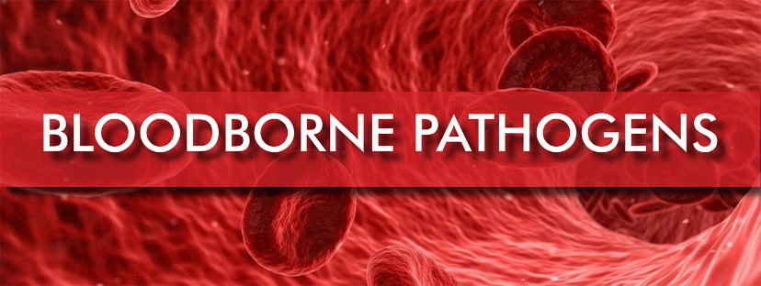

**Follow-up:**

* Medical Treatment will be provided at no cost to the student or employee.
* An Exposure Report must be filed with Wichita State University-Student Health Services. [Exposure Report](https://www.wichita.edu/services/studenthealth/_documents/Exposure_Report-Rev_ada_02_20.pdf) (pdf)
* If directed, your physician may prescribe the hepatitis B vaccination. When given within 24 hours of exposure, it will prevent the Hepatitis B virus.