Approver for Web Time Entry Guide
This guide is for the Approvers for hourly employees who enter their time on Web time entry using the self-service application in myWSU and is accessed through the Employee Dashboard

How to Approve Time for Web Time Entry
To Approve time:
- In myWSU, select Employee Dashboard, located on the Faculty/Staff page
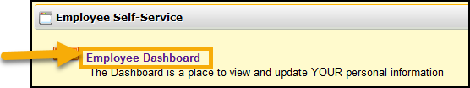
- Click Approve Time under My Activities on the Employee Dashboard
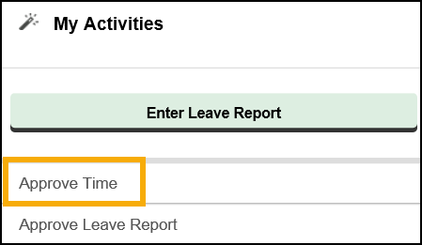
- Under Approval:
  - Select Department, Pay Period, and Status
  - Click the drop down to view all employees in each category or leave status as “all except not started”
  - View the Distribution Status Report displaying all records and their status
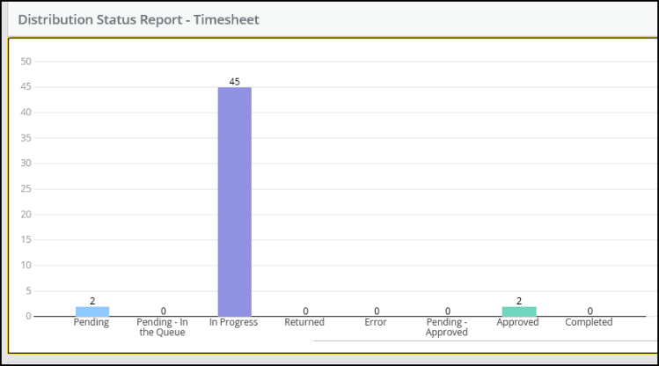
- Select the employee to Preview the employees timesheet
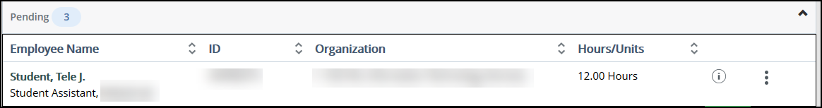
  - Preview the hours the employee worked
  - You have the option to:
    - Approve, Return for Correction, or view Details
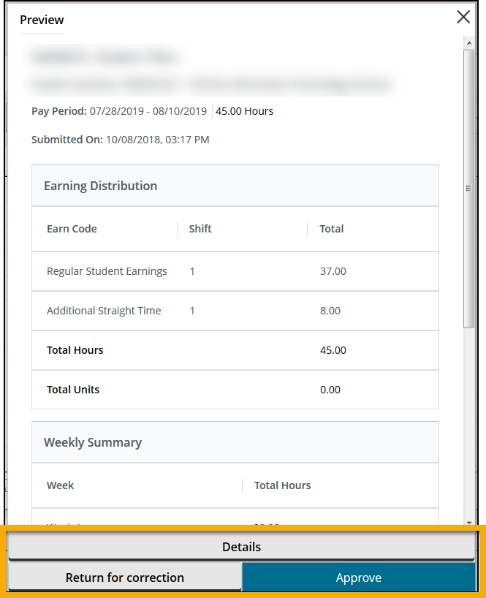
- Click Details to view the type of earn code used for each day
- Click Preview to return
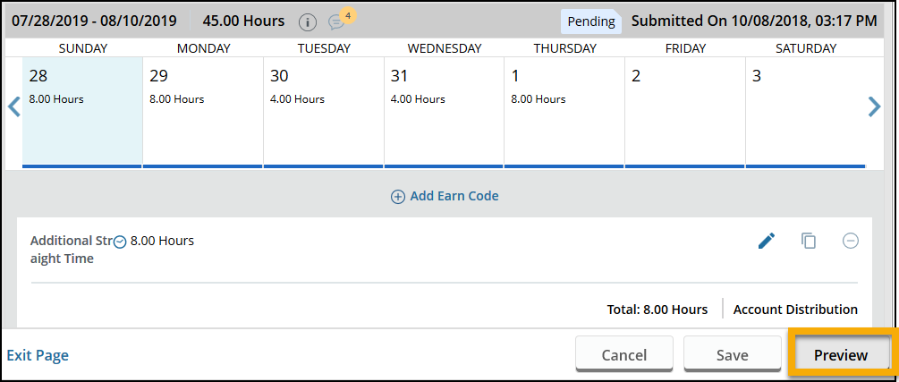
- Click Return for Correction to have employee change earn code or time entered.
  - The employee will modify time and resubmit
- If no changes are needed, Click Approve to Approve Time
  - Once Time is approved, no changes can be made by the approver or employee.
    - Contact timekeeping@wichita.edu for changes to time entered and approved.
- Status shows as Approved and notification will indicate successful approval
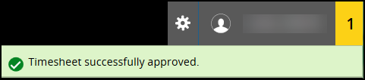
- Distribution Status will indicate Pending, In Progress, and Approved
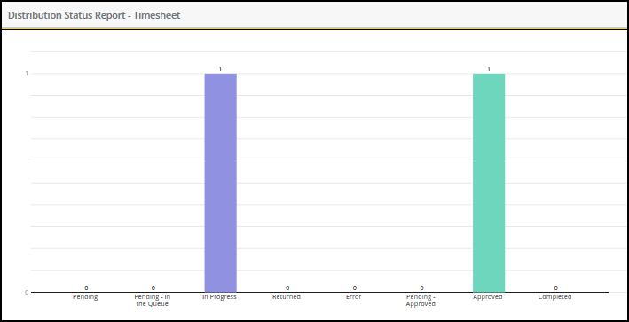

Contact Information
- Web Time Entry Questions: Timekeeping: (316) 978-3074 or timkeeping@wichita.edu
- Training & Support: ITS Applications Training: (316) 978-5800 or training@wichita.edu
- Password Assistance: Technology Help Desk: (316) 978-HELP or helpdesk@wichita.edu

