Approvers – Helpful Tips & Tricks

Additional information you may find useful.

* ***Cannot approve your own timecard.***

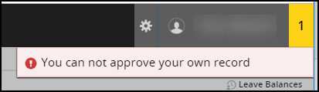

* Click on the **Information Icon (i)** to view the list of approvers and status

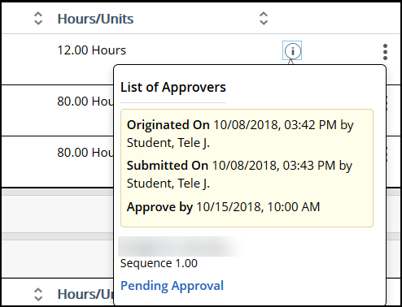

* **Message Bubble** indicates that there are comments, click to read.

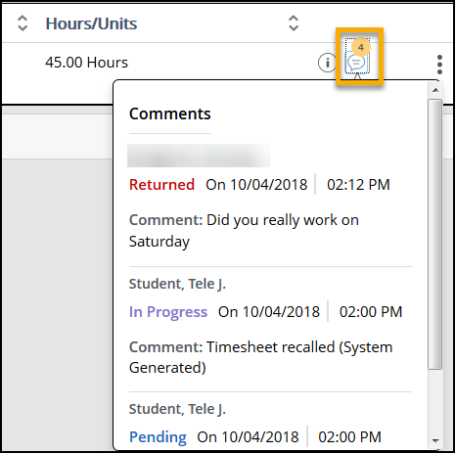

* **Click 3 dots** to the right to view employees leave balance and preview timesheet

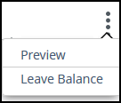

* + Click **Leave Balance** to verify that Employee balances available

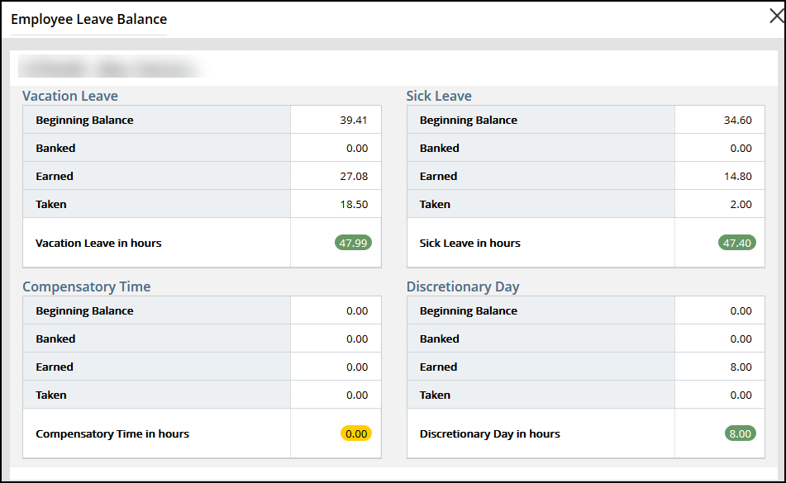

Contact Information

* Web Time Entry Questions: Timekeeping: (316) 978-3074 or timkeeping@wichita.edu
* Application Training: ITS Applications Training: (316) 978-5800 or [training@wichita.edu](mailto:training@wichita.edu)
* Password Assistance: Technology Help Desk: (316) 978-HELP or [helpdesk@wichita.edu](mailto:helpdesk@wichita.edu)

**Back to Top**