Banner 9 Faculty Grade Entry

Contents
Where to Access 2
Grade Entry Alert Channel 2
Banner Self-Service 2
Overview of Banner 9 Grade Entry 3
Navigating Grade Entry 3
Grade Entry Tips 4
Failing Grades: FF, FN, FQ 4
Incomplete Grading 5
Incomplete Grade 5
Change of Grade Process 6
Export and Import Grade Entry 6
Export Grade Template 6
Import Grades 7
Questions? 10
Contact information 10

Where to Access
There are two ways to access Faculty Grade Entry: Grade Entry Alert Channel and Banner Self-Service.

Grade Entry Alert Channel
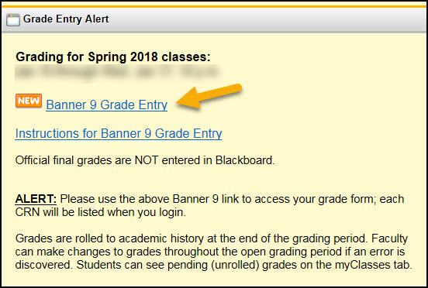
- Log on to myWSU
- Select the Teach/ Advise tab
- Select Banner 9 Faculty Grade Entry from the Grade Entry Alert Channel

Banner Self-Service
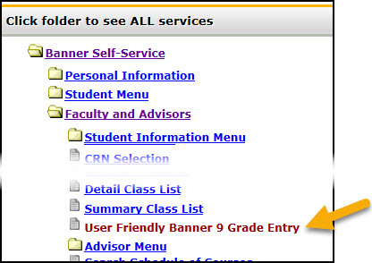
- Log on to myWSU
- Select Banner Self-Service
- Select Faculty and Advisors
- Select Banner 9 Grade Entry

Back to Top

Overview of Banner 9 Grade Entry

Navigating Grade Entry
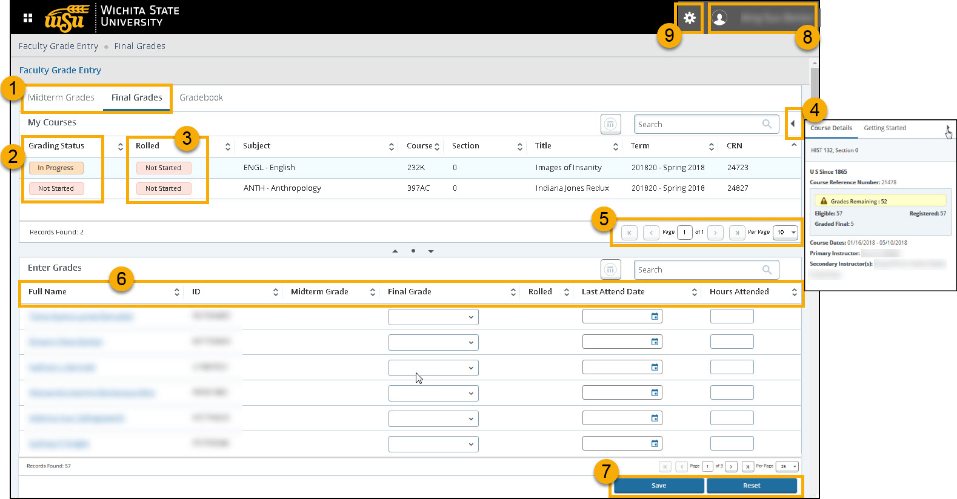

- Select Midterm or Final Grade Entry
- Select a course to begin Grade Entry. Grading status indicates if grading is In Progress or Not Started.
- Rolled Grades are grades that are ‘rolled’ to academic history at the end of the grading period.
Changes to grades are made throughout the open grading period. Rolled grade require a ‘Change of Grade’ form.
- Course information and other details.
- Page through the records. Change the number of records per page.
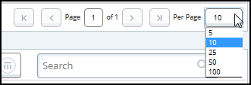
- Click on the column header to change the sort.
- Select Save to submit grades, Reset to clear grades not saved.
- Faculty’s name is shown at the top right. Be sure to Sign Out and close the browser when finished.
Notifications from Banner during the grade entry process will display here.
- Use Tools to Export Grade Template or Import grades into Banner.

Back to Top

Grade Entry Tips
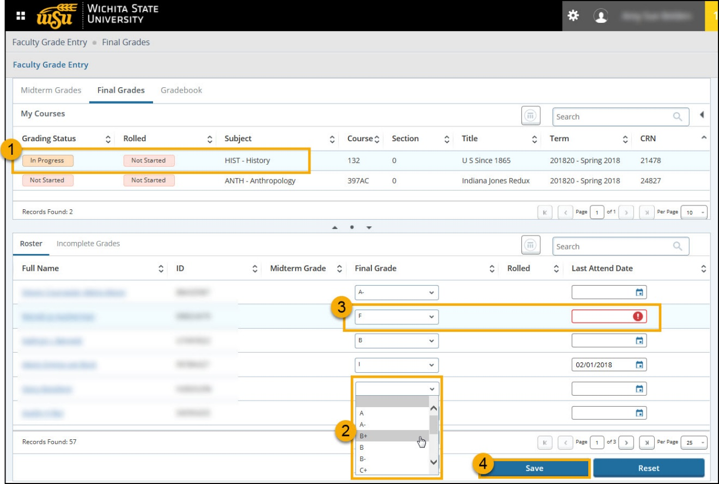

- Click a course to open grading and the student roster will display in the lower section of the page.
- Select a grade from the drop down list.
- The Last Attend Date is required for grades FQ, I, U and NCR
  - The date entered is the last date of educationally related activity.
  - If the date is not entered, a Notification will display and the student’s grade cannot be saved.
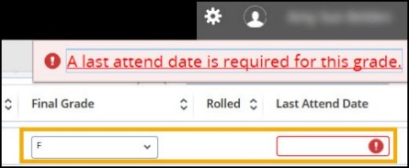

- Click Save to submit the Grades

Failing Grades: FF, FN, FQ
Starting in fall 2019, additional options are available when an instructor submits a failing grade.
Instructors will see three failing grade options: FF, FN, FQ

This distinguishes between an earned F and one given because a student stopped attending or never attended the course.

The grade drop down displays:

- FF = attended all term, earned F
- FN = never attended the class
- FQ = stopped attending at some point; only this grade will require last date of attendance or educationally-related activity (LDA)

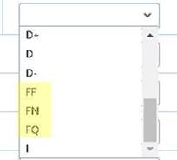

The expanded failing grade options allow for grade entry to indicate the student never attended the course (or interacted on Bb for online courses). It also eliminates the need for Financial Aid staff to contact faculty for clarification on failing grades and/or last date of attendance.

The same F, N and Q characters will apply to failing grades of U, NCR and NBG (e.g., UF, UN, etc.).

Back to Top

Incomplete Grading

Incomplete Grade
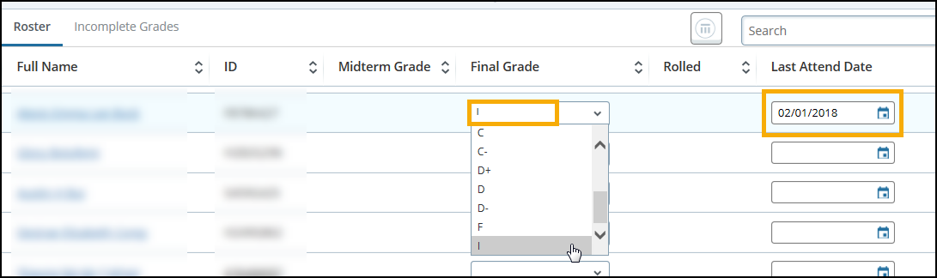

After entering an incomplete grade (I) and the required Last Attend Date, the Incomplete Grades tab will display.

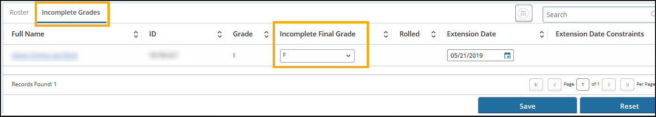

- The Incomplete Final Grade is the default grade given if the student does not complete the coursework for which an extension of time was given.
- The default grade is automatically set to FF. The instructor can change the grade on this tab during the grade entry period.
- The default grade will be permanent if a Change of Grade form is not submitted within the one year extension time allowed by WSU policy.

Select the Roster tab to return to main Grading Roster
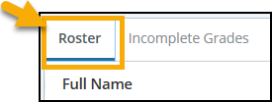

Change of Grade Process
- A Change of Grade form must be submitted to change any grade that has already been processed (rolled).
- The Online Change of Grade form is located on myWSU > Teach/Advise page.

Questions? Contact the Registrar’s Office at (316) 978-3055

Back to Top

Export and Import Grade Entry
With Banner 9 Faculty Grade Entry, Faculty have the option to export excel template or import an excel spreadsheet.

Export Grade Template
The following steps explain out to export a course grade template from Banner 9 Grade Entry. The Grade Template includes student names, WSU IDs, and grades that have been entered.

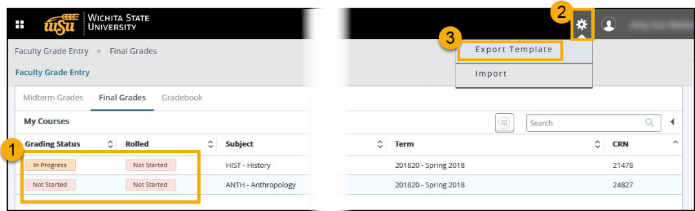

- Select the course to export
- Click the Tools Gear icon
- Select Export Template

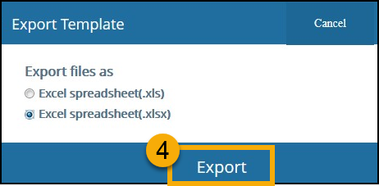
- Click Export

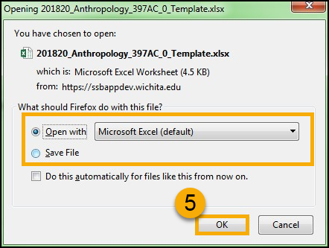
- Select either Open with Excel Document or Save File > Click OK
- Follow the directions to either Save the file or exported Excel Document opens with course grade information.

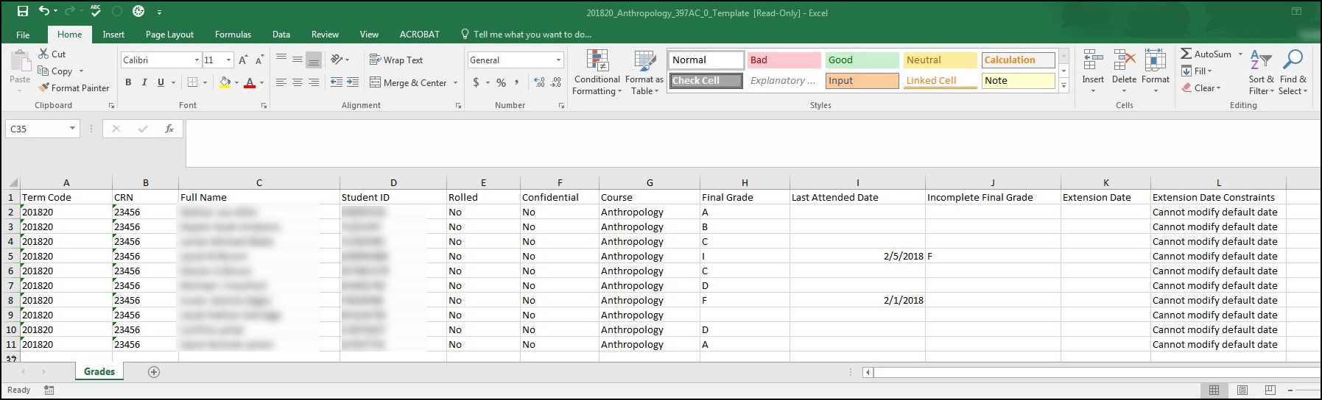

Back to Top

Import Grades
The following steps explain how to import grades into Banner 9 Faculty Grade entry using an excel spreadsheet.

Helpful Tip: Use the Export Template tool to create an Excel Spreadsheet template to use for Importing grades into Banner.

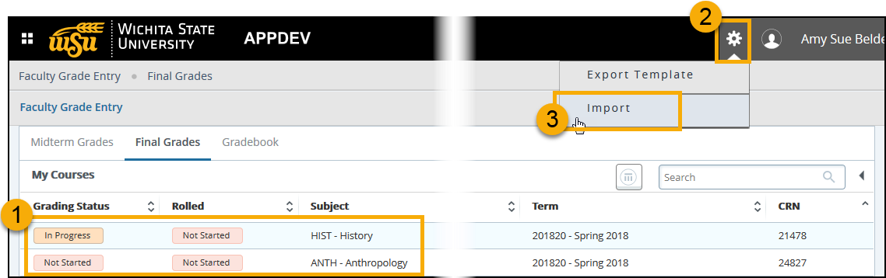
- Select the course to export
- Click the Tools Gear icon
- Select Export Template

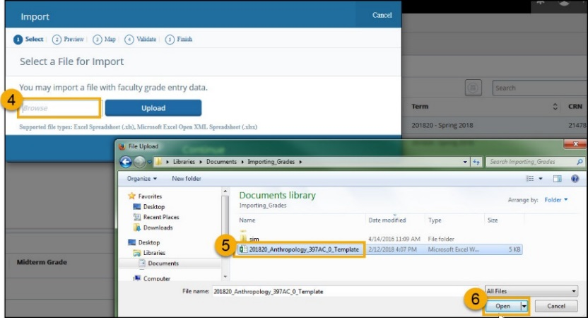
- Click Browse to search for file
  - Supported File types include: Excel Spreadsheet (.xls). Microsoft Excel Open (XML), Spreadsheet (.xlsx)
- Select the File
- Click Open

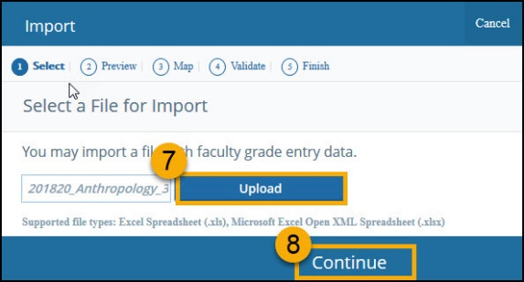
- Selected Spreadsheet will appear in the Browse box. Click Upload.
  - Preparing will briefly flash in dialog box as the upload is completed
- Click Continue

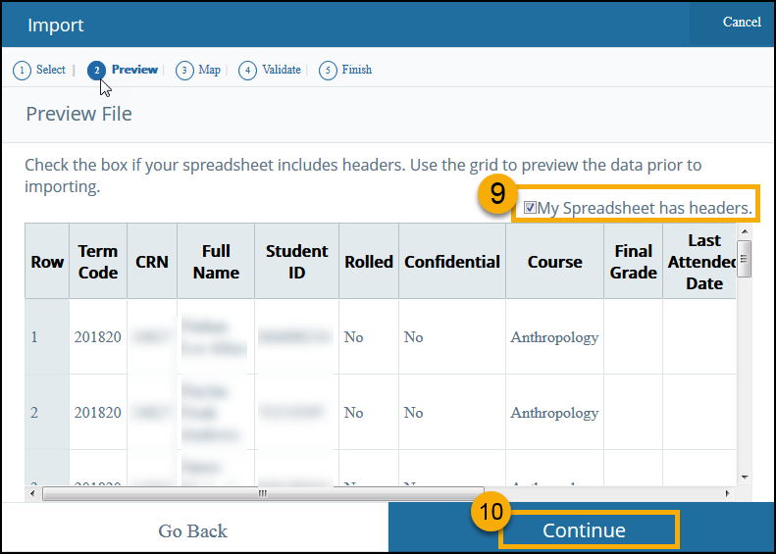
- Preview the file. Check box if Spreadsheet includes headers.
- Click Continue

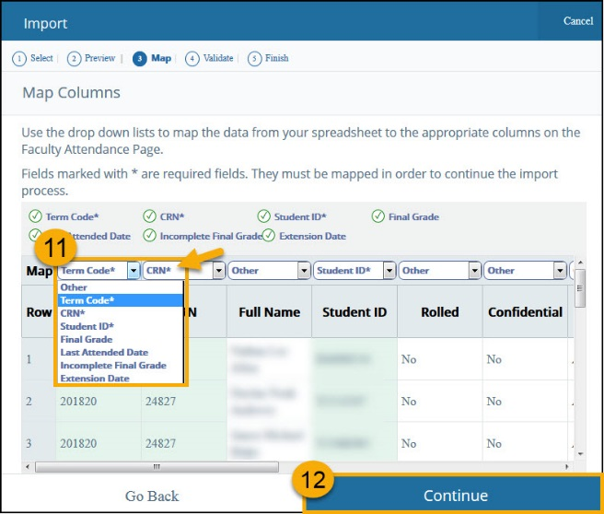
- Use the drop down lists to map the data from your spreadsheet to the appropriate columns on the Faculty Attendance Page.
  - Fields marked with an asterisk * are required and must be mapped.
- Click Continue

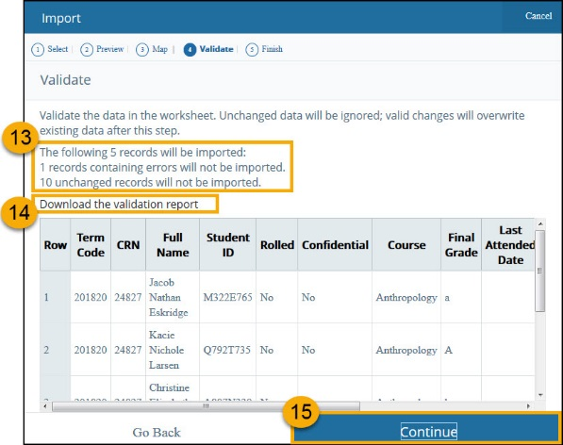
- Validate the data in the worksheet.
  - Unchanged data will be ignored
  - Valid changes will overwrite existing data
- Click to view Validation Report
  - Validation Report lists which grades have errors, which are ignored, and which will be uploaded
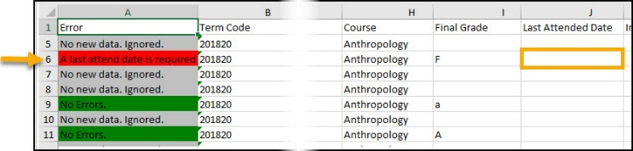
- Click Continue

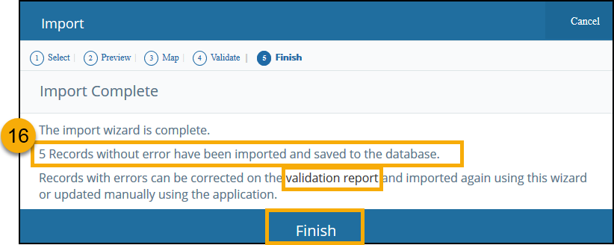
- Import Complete message
  - Lists the number of records imported
  - Open the Validation Report to correct errors and reupload the file
  - Click Finish to close

Back to Top

Questions?

Contact information
Password Assistance:
- Technology Help Desk: (316) 978-HELP or helpdesk@wichita.edu

Grade Entry Assistance:
- Registrar’s Office: (316) 978-3090
- ITS Applications Training: (316) 978-5800 or training@wichita.edu

Back to Top

