AI Showcase Examples from Carolyn Speer

Bing using a provided rubric to grade a paper

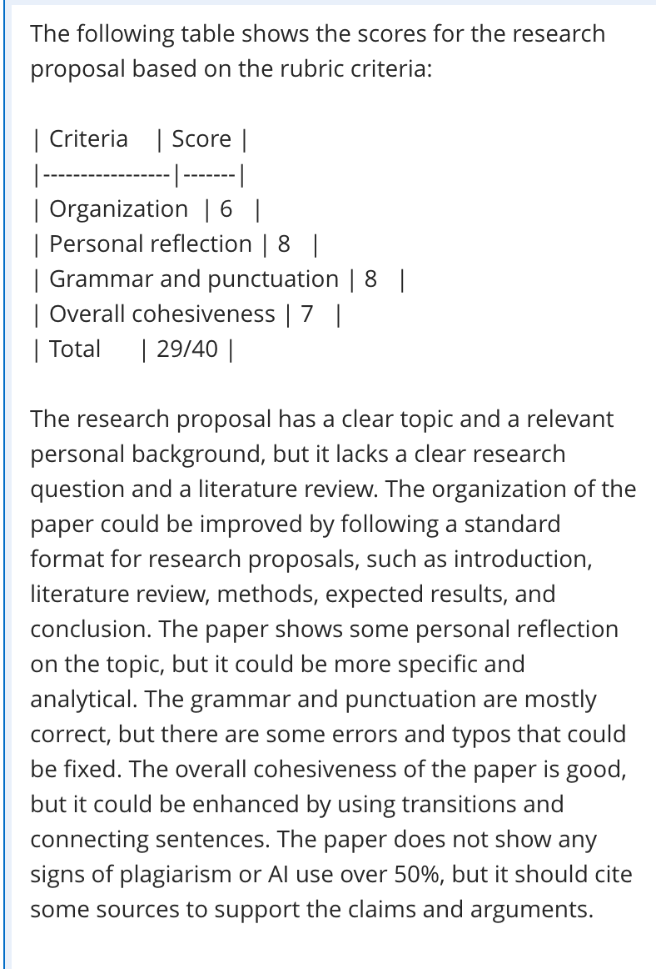

ChatGPT provides the questions and the Excel-ready code to create a Bb test

- Step 1: Ask ChatGPT to evaluate provided text for the number of multiple choice questions it can reasonably generate without undue repetition
- Step 2: Ask ChatGPT to create the desired number of multiple choice questions with the correct answers identified
- Step 3: Ask ChatGPT to convert these questions into tab-delimited code suitable for dropping directly into Excel.
- Step 4: upload Excel document to Bb test creator

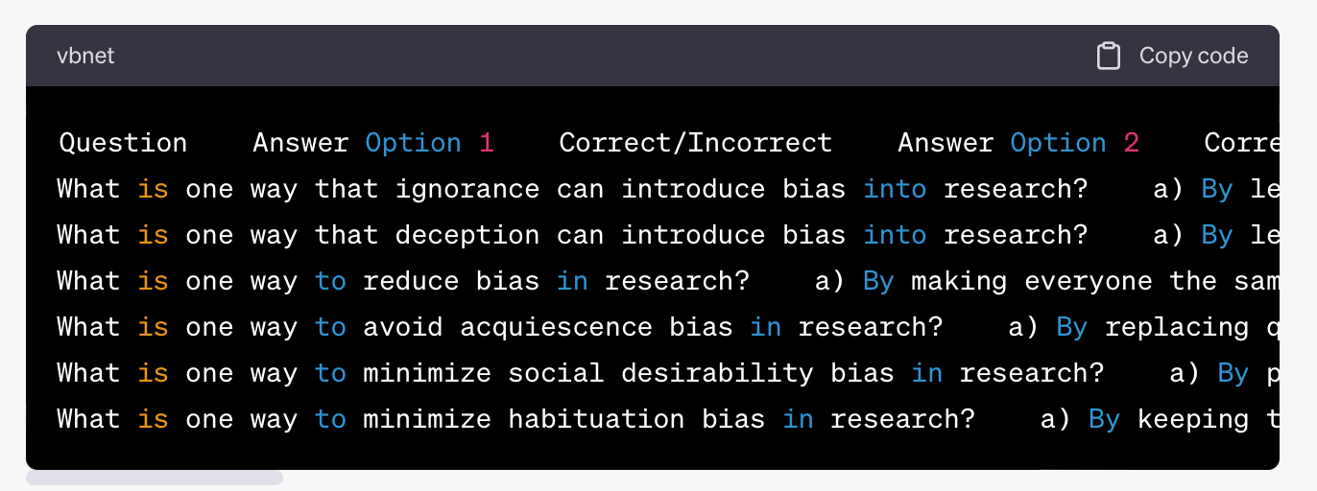

100% “human-created” essay 100% written by AI

