Microsoft Office 365: for Home Use

Document links may not work in Firefox. Scroll down to view information.
About Office 365
How to Access Office 365 Online
myWSU
Questions?

About Office 365
Office 365 for WSU Faculty and Staff is for use on personal computers only. For WSU owned devices, contact the Help Desk at 978 4357 to have an updated version of Microsoft Office installed.

Microsoft Office 365 contains:
- Excel
- Word
- PowerPoint
- OneNote
- OneDrive storage
- And more!

A total of five (5) installations of Office 365 are allowed on PCs, Macs, tablets or smart phones. WSU does not recommend storing FERPA protected information on OneDrive.

Back to Top

How to Access Office 365 Online
To access Office 365:
- Go to o365.wichita.edu
- Log in:
  - Username: your myWSUID@wichita.edu (e.g. A123Z987@wichita.edu)
  - Your myWSU ID Password
At the top of the screen, shown below, note the ability to access various Microsoft Applications online, without downloading them. These can be accessed under “Apps” at the top of the screen, or by selecting the launcher grid in the upper left.

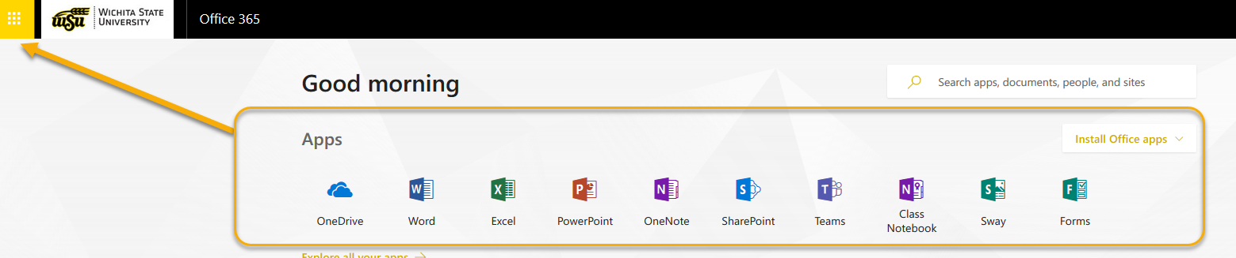

- To download desktop applications, select Install Office Apps in the upper right, and select the first option with the down arrow.
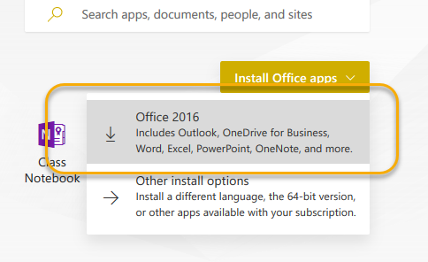
- Users may be asked to enter login credentials again upon installation.
- At any point, check the number of active installations by clicking on your initials in upper right and selecting My Account.
  - A total of five (5) installations of Office 365 are allowed on PCs, Macs, tablets or smart phones.

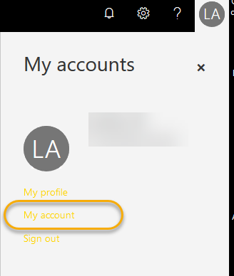

Back to Top

myWSU
Users may also access the 365 subscription by logging in to myWSU and selecting the Office 365 icon in the upper right.

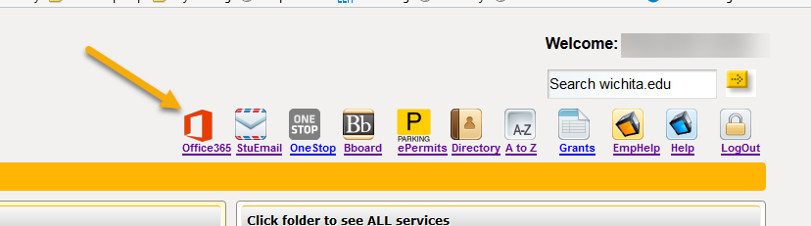

Questions?

Contact information
Password Assistance:
- ITS Technology Help Desk: (316) 978-HELP or helpdesk@wichita.edu

Back to Top

