ADOBE CREATIVE CLOUD ACCOUNT

Document links may not work in Firefox. Scroll down to view guide information.

Table of Contents
ACTIVATION 1
LOG IN 1
QUESTIONS? 3
CONTACT INFORMATION 3

ACTIVATION
To activate an Adobe Creative Cloud account, contact the Help Desk at 4357.

LOG IN
- Visit Adobe Creative Cloud.
- 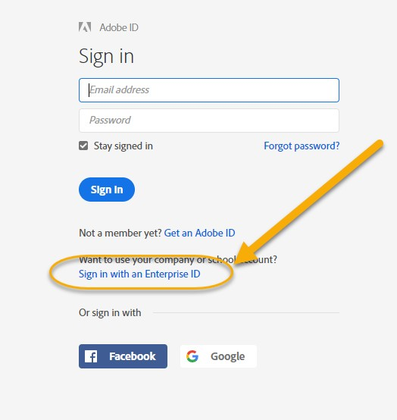In the upper right, select Sign In.
- Select Sign in with Enterprise ID.

- Log in:
  - Email address: your myWSUID@wichita.edu (e.g. A123Z987@wichita.edu)
  - Password: your myWSUID password.

- Note: You will be redirected to a WSU Log in screen after entering your email address.
- In the Adobe site, go to the upper right, click on the waffle (square grid), and select
Creative Cloud.
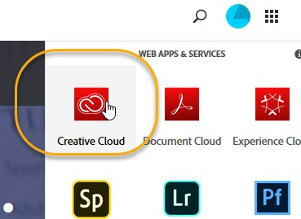
- On the upper left, select Apps.
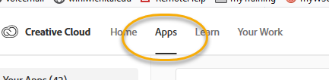
- Click the Install button to the right of the desired application(s).
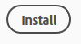

QUESTIONS?

Contact information

Password Assistance:
  - Technology Help Desk: (316) 978-HELP or helpdesk@wichita.edu

Assistance:
  - ITS Applications Training: (316) 978-5800 or training@wichita.edu

