Approver Guide
This guide will cover how to review, edit, decline, and approve requisitions.

Contents
Logging In 3
Approval Process 4
Approval Notifications 4
Notifications in Wu-Buy 5
Approval Process - Requisition View (Recommended) 6
Approve 8
Decline 9
Editing a Requisition 10
Approve 14
Decline 14
Comments 15
Approval Process - Approvals Page 16
Approve 17
Decline 17
Approval History 18

Logging In
To log into Wu-Buy, take the following steps:

- Open your web browser.
- In the address field, type https://wichita.unimarket.com/.
- The Wu-Buy Unimarket login page will appear.
- Enter your Wichita State SSO username and password and login.
- Your Wu-Buy Unimarket home page will appear.

If you experience any issues logging in, please contact accountspayable@wichita.edu.

Approval Process
Once buyers submit requisitions, they are routed for approval based upon various criteria including FOAP, UNSPSC commodity code, supplier tag, and amount. Email notices are sent to the approvers as their actions are required. If action is not taken within 24 hours from the first notice, a reminder email will be sent. If no action is taken, the requisition will wait for the approver to take action

Approval Notifications
You will receive an email from wu-buyapprovals@wichita.edu notifying you of the approval task requiring you to take action. An example of the email that will be received is shown below. The link in the notification email will take you directly to the approval task view in Wu-Buy.
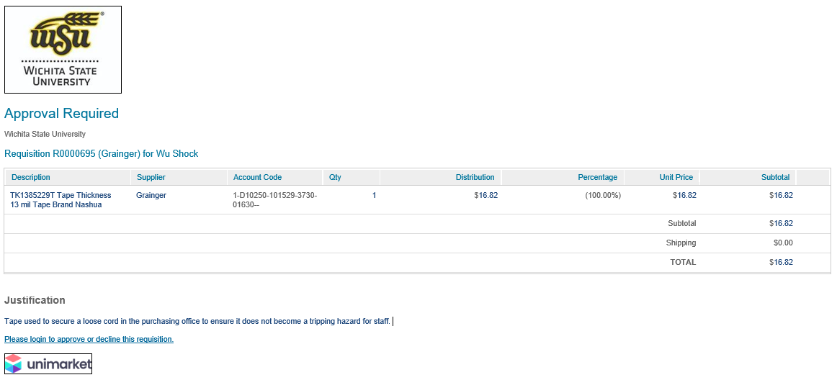
If you are a part of an approval group, each member of the approval group will receive an email. If another individual within the approval group has responded to the approval request, you will receive another email notifying you that your approval is no longer needed. An example of this type of email is shown below.
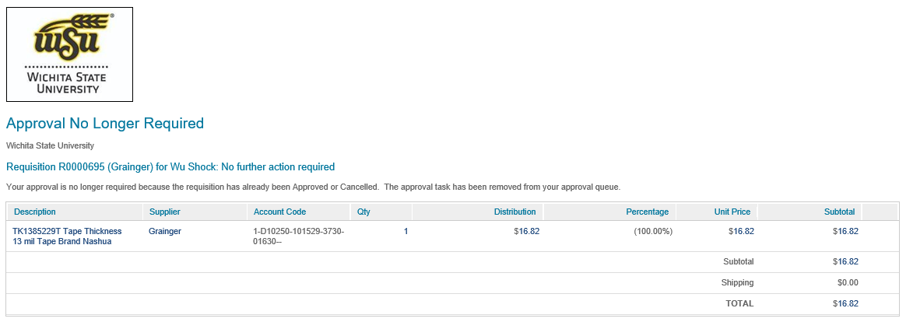

Notifications in Wu-Buy
You will know that you have approvals waiting for your review when a red number appears next to Tasks in the menu bar of Wu-Buy.
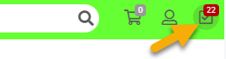
In addition to the Task menu alerts, you will have a quick view window for approvals once you click the Task menu icon. This view will display the 7 most recent requisitions awaiting your approval.
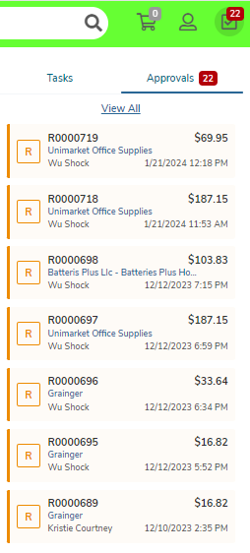
Clicking the View All link in the quick view window will take you to the Approvals page. The Approvals page will display all of your outstanding approval actions.
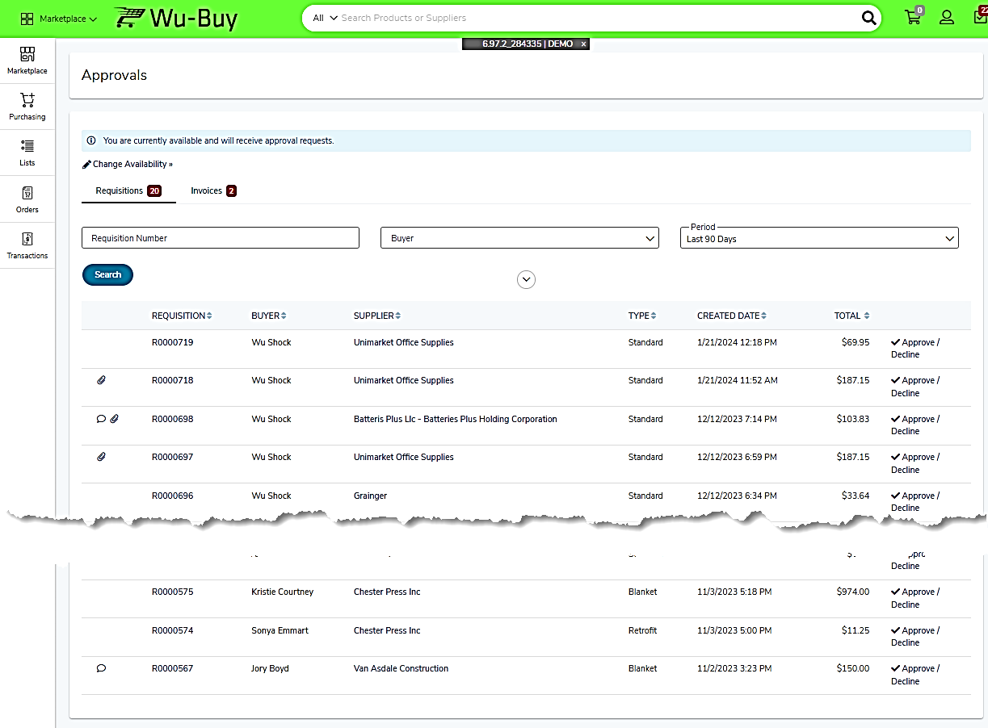

Approval Process - Requisition View (Recommended)
The following process outlines the recommended steps for requisition approval and review. Access your pending approvals either through the Approval Quick View or Approvals screen, and click on the requisition number.
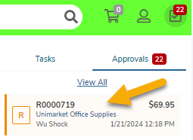
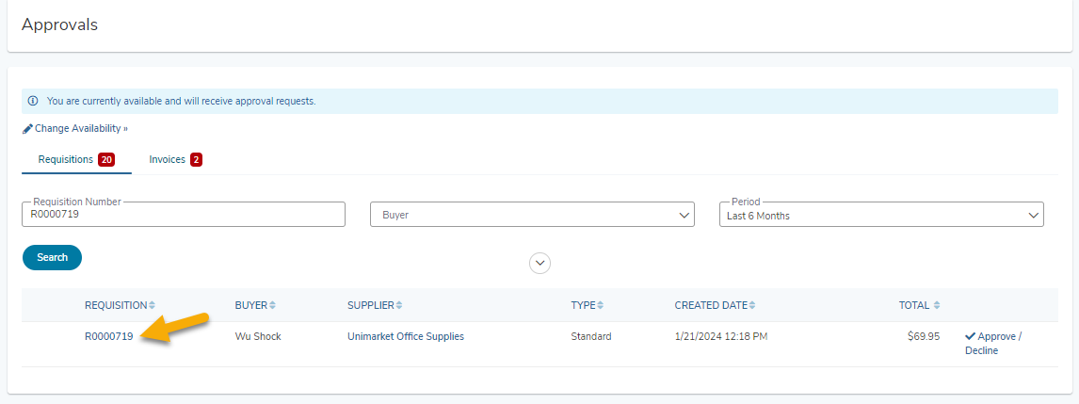
This will open the requisition page where all details associated with the requisition can be reviewed.
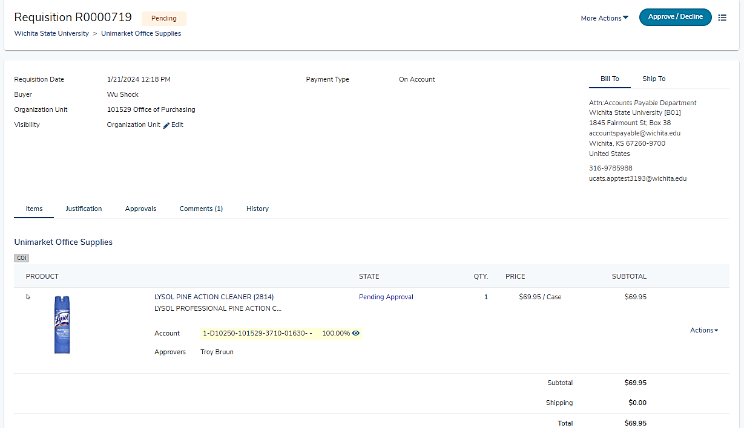

Approve
To approve the requisition as is, click the Approve/Decline button located in the upper right corner.
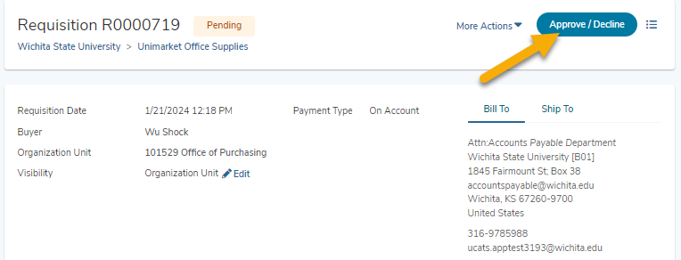
This will open the Approve/Decline Requisition dialog box.
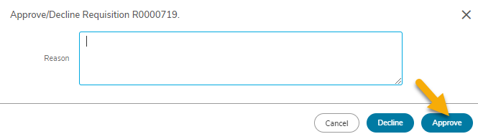
Clicking the Approve button will approve the requisition and move it forward in the approval process. Approvers are not required to add a Reason when approving requisitions.

Decline
To decline the requisition, click the Approve/Decline button located in the upper right corner.
This will open the Approve/Decline Requisition dialog box.
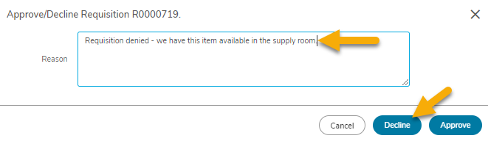
Clicking the Decline button will cancel the requisition. Approvers must enter a Reason when declining a requisition. Declined requisitions cannot be edited or resubmitted. The Buyer will need to create a new requisition if the goods or services are still needed.
Important – It is recommended to utilize the Comments feature (instead of Decline) if minor modifications or additional information is needed. This will allow transactions to progress more efficiently through the approval process. Remember – declined requisitions cannot be edited or resubmitted.

Editing a Requisition
Approvers can edit many aspects of the requisition prior to approving.
Access your pending approvals either through the Approval Quick View or Approvals screen and click on the requisition number.
This will open the requisition page where all details associated with the requisition can be reviewed.
To edit a requisition during the approval process, approvers must click the dropdown next to More Actions and select the Edit link.
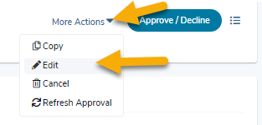
This will allow modification of the following details:
- Ship To and Attn fields
- Add or delete Attachments
  - Order Attachments will be sent to the supplier by default but can be selected to not be sent.
  - Justification Attachments stay internal and will not be sent to the supplier.
- Edit notes
  - Justification (Business Purpose) is used for internal use and will not be visible to the supplier. Each transaction must have an adequate business purpose
  - Special Instructions are sent to the supplier on the purchase order.
- Product Information
  - FOAP – editing the FOAP elements may change the routing of the approval, and will trigger the NSF checking process.
  - Product quantity and details on non-catalog items
After editing the requisition, approvers must click the Save button in the upper right corner.
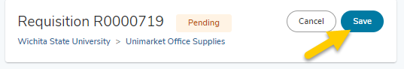
The system will display a dialog box requiring the user to provide detail of the changes made to the requisition.
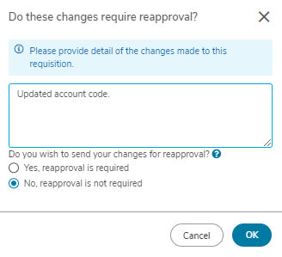
The user must indicate if the change to the requisition requires reapproval.
- Answering yes will route the requisition back through the approval process.
- Answering no will route the transaction forward in the approval process.
Regardless of the answer provided, the system will automatically route the transaction for reapproval if the any of the changes meet the criteria for established approval routing rules.
Click OK to close the dialog box.
After editing and saving the requisition, approvers must complete the approval process by clicking on the Approve/Decline button.
History
The detail of the change entered in the above process will be recorded on the History tab of the requisition.
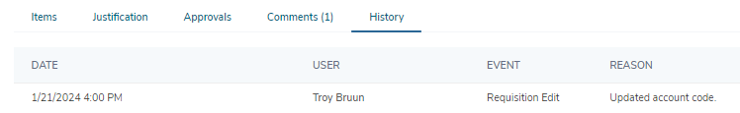

Approve
Clicking the Approve button will approve the requisition and move it forward in the approval process. Approvers are not required to add a Reason when approving requisitions.

Decline
Clicking the Decline button will cancel the requisition. Approvers must enter a Reason when declining a requisition. Declined requisitions cannot be edited or resubmitted. The Buyer will need to create a new requisition if the goods or services are still needed.

Comments
The comments feature on requisitions allows both buyers and approvers to post comments and be automatically alerted by email. This saves valuable time in those situations when approvers have questions around the need for an item or require more specifics relating to a product or service.
A comment from an approver will send an email alert to the buyer and a comment from the buyer will send an alert email to the current approver. All past and future approvers will be able to view the comments on the requisition within the Comments tab.
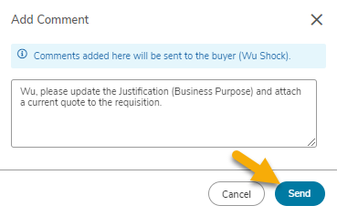

Approval Process - Approvals Page

Requisition Approval Overview
The approval page will present all outstanding approvals in your task list. Information displayed includes the requisition number, buyer’s name, supplier, order type, and total. Because you have received a high level of detailed information in the approval email notification, you may be informed enough to utilize the Approve/Decline option from this page.
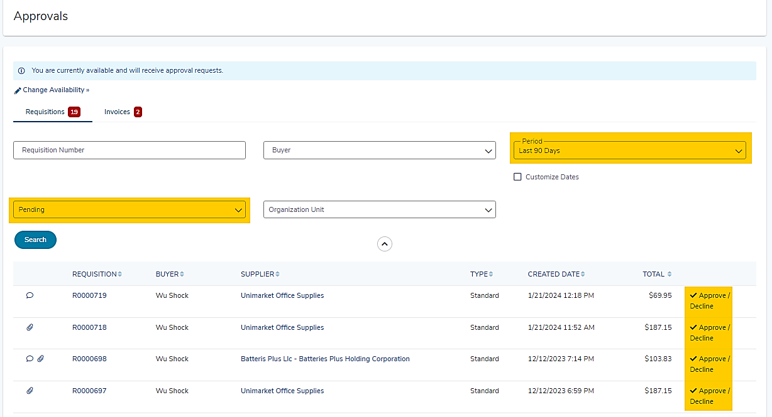
You can also change the Approval State search filter to view any approvals that you have already acted on, approved, or declined.
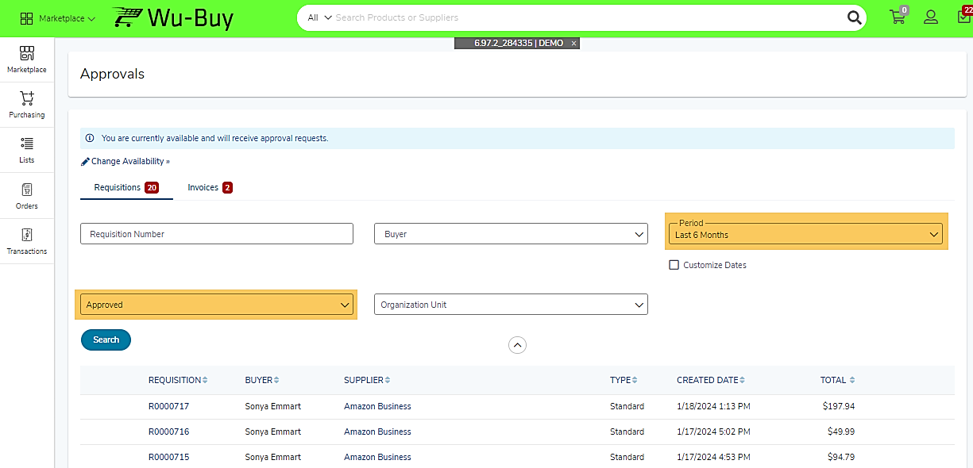

Approve/Decline Window
Clicking on the Approve/Decline link located on the far right side of the requisition line will open the Approve/Decline Requisition window.
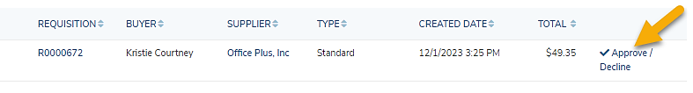
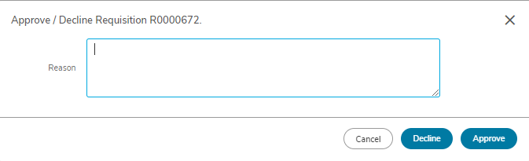

Approve
Clicking the Approve button will approve the requisition and move it forward in the approval process. Approvers are not required to add a Reason when approving requisitions.
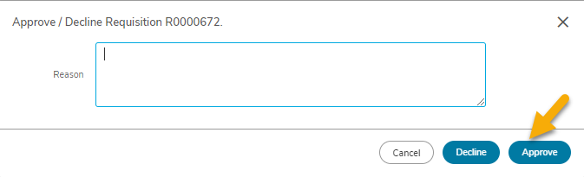

Decline
Clicking the Decline button will cancel the requisition. Approvers must enter a Reason when declining a requisition. Declined requisitions cannot be edited or resubmitted. The Buyer will need to create a new requisition if the goods or services are still needed.
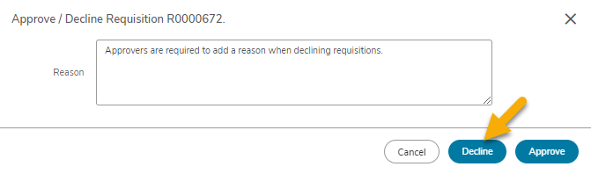

Approval History
Click the Approvals tab on the Requisition to view the approval history. The approval history shows all past approval actions and upcoming approvals needed before the requisition becomes a PO. The approval history can be viewed by anyone who has the ability to view the requisition.
The approval history shows the following information.
- Approval Chains name and routing basis
- Approver or approval group
- The task Created Date - date/time that the approval task was originated for the approver(s)
- Task Completed Date – date/time that the approval task was completed by the approver
- Action taken will display at the far right displaying if the action was Approved, Skipped, Escalated or Declined.
