Buyer’s Guide
This guide will review how to shop, create requisitions, and track your requisitions, and orders.

Contents
Logging In 3
The Buyer Role in Wu-Buy 4
The Browser Role in Wu-Buy 4
My Account Settings 4
Key Concepts 6
Searching 7
Filling your Shopping Cart 9
Shopping Cart 13
Incomplete Requisitions from Browsers 16
Creating a Requisition 17
Retrofit Orders 25
Tracking Requisitions 26
Reprocessing a Declined Requisition 28
Viewing Order 29
Canceling an Order 31
Changing an Order 32

Logging In
To log into Wu-Buy, take the following steps:

- Open your web browser.
- In the address field, type https://wichita.unimarket-demo.com (Demo/Test).
- The Wu-Buy Unimarket login page will appear.
- Enter your Wichita State SSO username and password and login.
- Your Wu-Buy Unimarket home page will appear.

If you experience any issues logging in, please contact accountspayable@wichita.edu.

The Buyer Role in Wu-Buy
The Buyer role in Wu-Buy is assigned to specific users who have the authority to submit requisitions for approval using the department’s funds based on departmental approval and the Banner finance org access granted. Buyers in the Wu-Buy system have the following permissions:
- Access suppliers in the online marketplace created specifically for WSU.
- Search and browse the pricing catalogs from the available suppliers.
- Fill an individual shopping cart for checkout.
- Accept and process requests from other users (Buyers or Browsers) in the department that do not have authority to route requisitions for approval.
- Create requisitions for purchases using the departments available funding.
- View the status and approval path of requisitions.
- View and export reports on purchase orders.
- Indicate that goods or services were received and are approved for payment.
- View and track invoices against related purchase orders.

The Browser Role in Wu-Buy
The Browser role in Wu-Buy is assigned to specific users who have the authority to shop and build a shopping cart. The Browser can begin the requisition process but must reassign the Incomplete Requisition to someone within their Organization Unit to complete the Checkout process and route it through Approvals. Browsers in the Wu-Buy system have the following permissions:
- Access suppliers in the online marketplace created specifically for WSU.
- Search and browse the pricing catalogs from the available suppliers.
- Fill an individual shopping cart for checkout.
- Begin the creation of requisitions for purchases.
- View the status and approval path of requisitions.
- View and export reports on purchase orders.
- Indicate that goods or services were received and are approved for payment.
- View and track invoices against related purchase orders.

My Account Settings
When you initially log into Wu-Buy it is recommended that you check your account details. You can find the My Account page under the silhouette of a person at the top right of the screen. Within the My Account page you can update your preferred first and last name, phone number, and email address as well as set your default FOAP. Setting segments of your default FOAP will make the checkout process more efficient if you use the same accounting segments repeatedly. It is NOT recommended that you set all parts of the FOAP as a default as you may forget to change the Account for different types of purchases. You can also access the online Help provided by Unimarket in the Help page under the My Account menu.
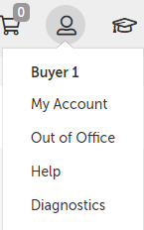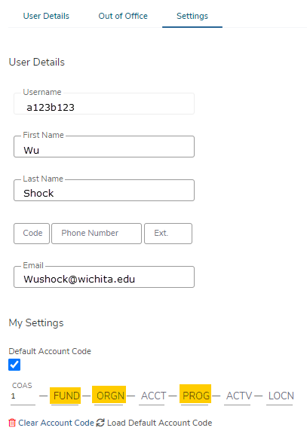

Key Concepts
- There are two types of suppliers found in Wu-Buy:
  - Catalog (Premium) Supplier – supplier who has a catalog in the Wu-Buy marketplace or who provides roundtrip/punchout access to their ecommerce site from Wu-Buy.
  - Non-Catalog Supplier – supplier who does not have a hosted catalog on Wu-Buy or provides roundtrip/punchout access to their site and instead requires products to be manually created in Wu-Buy.
- There are three methods in which to order products from a supplier:
  - Hosted/Standard Catalog – supplier products are “hosted” on the Wu-Buy website, meaning you do not leave the Wu-Buy website to search and order these products. Hosted Catalogs are identified with the folder icon.
  - Roundtrip/Punchout – supplier products are found on the supplier’s ecommerce website with a direct link to and from Wu-Buy. A Roundtrip/Punchout catalog features the cloud icon. Once clicked, a new window or tab will open in your internet browser and you will be signed into the appropriate user account on the supplier’s ecommerce site.
  - Non-Catalog Items – products that require their information to be entered manually in the Wu-Buy portal. Even Premium Suppliers may have products that can be entered manually if a product is not found in any of their catalogs.

Searching
Products or Suppliers can be located by searching the loaded catalogs of suppliers using the search options detailed below.

Product Searching
Complete product searches using the search function in the title section of Wu-Buy. Use the search field to find loaded catalogs, index catalogs (products pointing to a punchout site), or supplier keywords. This search field will also search for supplier names. To search in this method, complete the steps listed below:
- From the title section, type the product name or keyword search term in the search field.
- Click Search ().
- Any products, supplier names, or keywords that match the criteria will appear in the search results.

Searching Tips
- Search terms can be combined using the words AND and OR.
  - AND will search for both words/phrases.
  - OR will search for one word/phrase or the other.
- Wildcard searches can be performed if the exact search word/phrase is unknown.
  - ? will replace a single character; i.e. “Te?t” could be Test or Text.
  - * will replace multiple characters; i.e. “Test*” could be Tester or Testing.
Any products that match the criteria will appear in the search results.
NOTE: Results will not return products from roundtrip suppliers unless they have additional search functionality enabled such as an “Index Catalog”.

Supplier Searching
If you are searching for a specific supplier, there are multiple ways to locate the supplier.
- Like Product searches you can use the same search bar to find Suppliers
- From the Marketplace, you can search for suppliers by Name, Search Term and Banner Supplier ID. 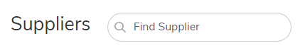
Note: Search Terms must be added by an administrator for them to be available.
- You also have the ability to only view your “Favorite” Suppliers by toggling on the option for “Favosrites Only”. This will show you only the suppliers who are the most frequently used by you or those you’ve selected to be your favorite by clicking on the “heart icon” on the supplier card.
- Guided Buying is another way to search for suppliers who have been given a tag to help curate them into specific categories.

Filling your Shopping Cart

Shopping by Catalog
After clicking on a Supplier’s name or icon, select the hosted catalog folder icon () for a supplier’s hosted catalog on Wu-Buy. The supplier may have multiple catalogs that appear.
- Click on the supplier catalog that you wish to shop.
- The products available within the catalog will appear.
- Browse items individually or use the search bar to search within the selected catalog.
- The sort by option defaults to the relevant search term Name. Sort by can be changed to Code, Lowest Price, or Highest Price.
- Click on the product title or product image to provide more information about the product.
- When you have decided on a product to order type the quantity in the Quantity field to the left of the Add to Cart button.
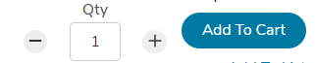
- Click the Add to Cart button.
- A confirmation message will appear, and the shopping cart will update to reflect the total number of products.

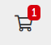
- Repeat steps 3 through 9 for as many products as you need from this supplier.

Shopping by Roundtrip (Punchout)
The cloud icon sends you to the supplier’s website and logs into WSU’s pricing catalog.
- Click the supplier that you wish to shop from the marketplace.
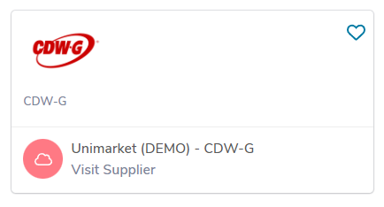
- Click the roundtrip icon or supplier name to go to the supplier’s website.
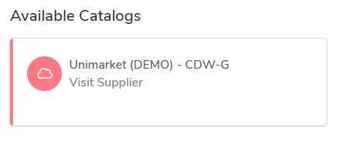
- Each supplier’s website will be different. Browse and search for products as if you had come to the supplier’s website directly.
- Add products that you wish to order on the supplier’s website by clicking the Add button.
NOTE: The terminology of the button to click will vary based on the supplier’s website.
- When finished shopping, click the Checkout or Submit Requisition button to return to Wu-Buy.
NOTE: The terminology of the button to click will vary based on the supplier’s website.
- You will be returned to your shopping cart in Wu-Buy with the products you had selected. The additional tab or browser window that opened for the supplier’s punchout site should close automatically.

Shopping with Non-Catalog Items
If a supplier does not provide a catalog, you will need to create a Non-Catalog Item. You will need to enter the product’s information in the Non-Catalog form.
      - Click the supplier that you wish to shop.
- Click the Create a Non-Catalog Item link to enter the product's details.
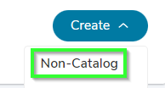
- Type in the product information.

NOTE: Fields marked with a red asterisk are required fields
  - *Item Name - will be filled in from your previous entry
  - *Quantity – enter the desired quantity
  - *Unit Price – type in the single unit price of the product.
  - *Unit of Measure - type in the Unit of Measure or select from the drop-down list. Each (EA) is the most common unit of measure.
  - Description – description of the product to ensure the supplier knows what you are ordering. The more detail, the better to ensure order accuracy.
  - Product Code - supplier’s product number or SKU.
  - Category – These are the UNSPSC international standard commodity codes. Type in the category code or select it by starting to type a commodity and selecting from the dynamic list that will appear.
  - Manufacturers Part ID – If the supplier is a reseller, you may enter the additional product ID number that refers to the manufacturer's product.
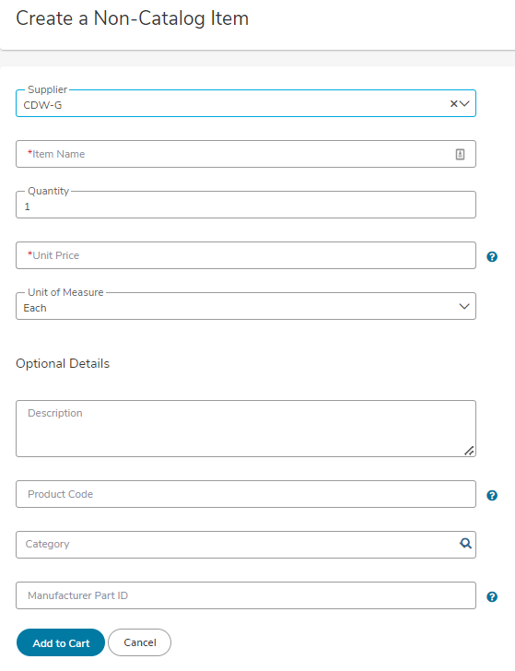
- Click the Add to cart button.
- You will be returned to the Create a Non-Catalog Item product screen to enter the next product line and a notification on screen will let you know that the product was added to your cart.
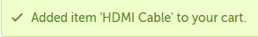
- Repeat steps 3 through 5 for each product line that you wish to order.

Shopping Cart
The shopping cart appears in the header bar at the top of the page. The number of products will appear in the cart.

Reviewing the Shopping Cart
- Click the shopping cart icon to view the products that have been added to your shopping cart.
- All products in the cart will be grouped by supplier with an individual supplier total.
- To adjust the quantity of any product, type the new quantity into the Quantity field of the product. The line item subtotal will update as you go. Quantities for items that came from a Punchout Catalog should not be adjusted. To add additional quantities please return to the Punchout Catalog and retrieve additional items.
- To remove any product from the cart, click the Remove icon next to the Quantity field.
- To remove all products from the cart, click Clear Shopping Cart in the upper right-hand portion of the screen.
- The Move button will allow you to move the product from your cart to a saved or incomplete requisition. From the requisition view, the Move button will allow you to move the item to a different requisition or back to your cart.

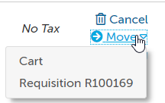

Creating a Shopping List of Frequently Ordered Products
If you have products that you regularly order, you can create a shopping list that can be reused every time you need to order those products. The products to be added to the shopping list need to be in the cart before proceeding. This is a great way to save time when you enter the product(s) manually on a frequent basis.
- From the cart screen, click the Add to Shopping List.
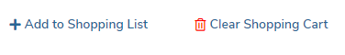
- The Create Shopping List screen will appear.
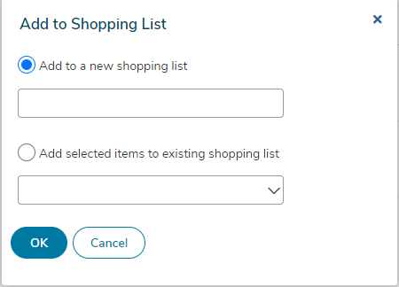

- The radio button for Create a new shopping list will be selected. Type a name for the shopping list in the field to the right.
- If a shopping list has already been created and needs to be changed, select Add selected items to existing Shopping List and select the shopping list from the available options.
- Click OK.
- Once a shopping list has been created, it can be accessed by clicking on Lists in the menu bar of the Marketplace module.
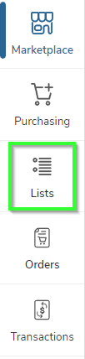
- The following options are available:
  - Add selected to Cart – select the products you want from the shopping list and click Add selected to Cart to add the products to your cart.

NOTE: Doing so will replace anything that is currently in the cart.
  - More Actions – for an entire cart include:
    - Share Shopping List allows the user to share the shopping list they created with other organization units.
    - Rename Shopping List allows the user to rename a shopping list.
    - Delete Shopping List allows the user to permanently delete a shopping list. A confirmation message will appear prior to deletion to confirm your selection.
  - More Actions – for a selected item include:
- Copy to List allows the user to copy the item to another shopping list.
- Move to Top allows the user to move the item higher on the shopping list.
- Remove selected items allows the user to permanently delete the item from the shopping list.

NOTE: When you use a Shopping List, the products will be added to any current products that you have in your shopping cart.

Incomplete Requisitions from Browsers
The users in your department that do not have Banner Finance posting authority will be able to shop and reassign their incomplete requisitions to you as the Buyer. As the Buyer, you will be alerted by email from purchasing.office@wichita.edu when an incomplete requisition has been assigned to you. See example email alert below.
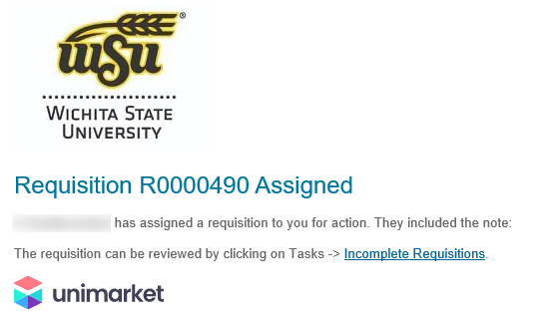
To find and process this incomplete requisition, go to the Tasks menu and Incomplete Requisitions.
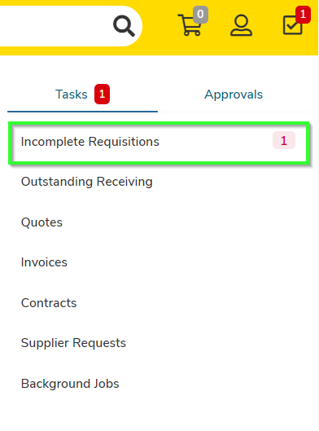
In the Incomplete Requisitions page, you will see all of the requisitions that have been assigned to you for completion. Click the requisition number to open and review the details or click Checkout to begin the checkout process for completion of the requisition and routing for approval.

Creating a Requisition
- Any products appearing in the shopping cart with a check in front of the product will be forwarded on to the checkout screen. If you do not wish to order a product yet but don’t want to delete it from the shopping cart, click the checkbox to remove the check.

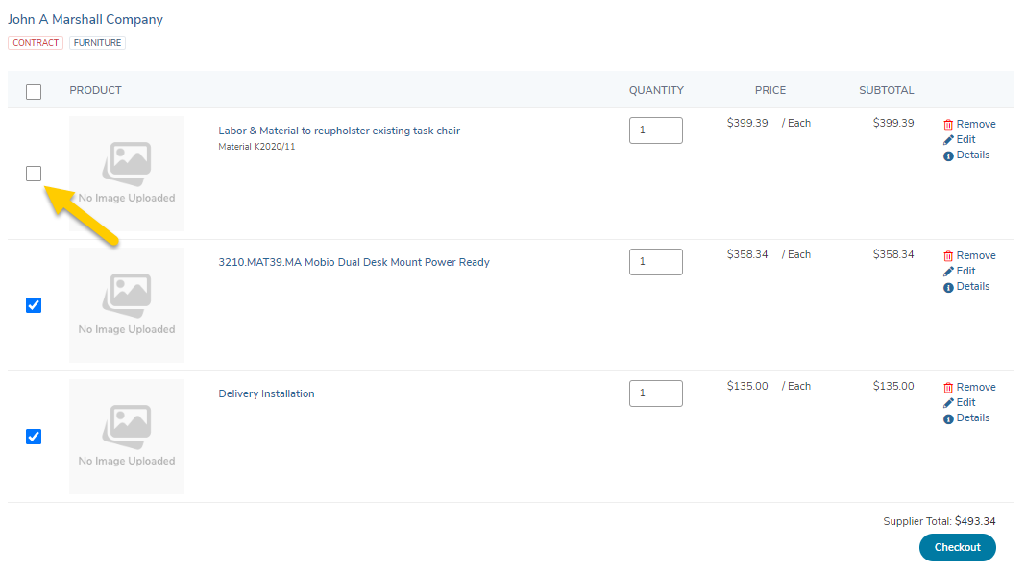

- Click Checkout to start the checkout and requisition process for the items being purchased for this supplier.
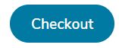

Locations
The shipping and billing addresses will be selected in the Locations section of the checkout screen. These addresses are preloaded in Wu-Buy. If you select another location and complete the checkout, your selection will be your new default for your next checkout process. You can type the first letter of the location, or the campus box number to navigate the dropdown list easily.

Attn Field
The Attention To field (Attn) is very important in your checkout process to ensure the accuracy of the delivery by the supplier. The most pertinent information for delivery should be first (left to right) in the “Attention To” field – i.e. lab or room # / Recipient last name / phone extension.
Example:
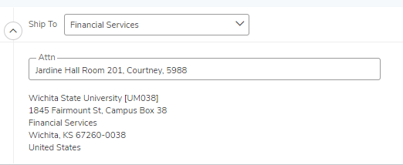
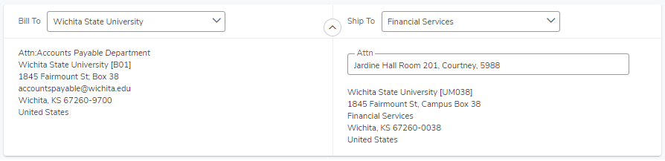

Organization Selection
Under the Bill To and Ship To section of the checkout screen will be an Organization section. This section is for visibility, receiving communication across your department and spend analytics within Wu-Buy across WSU for supervisors and other users.
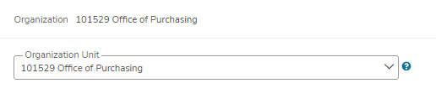

Select the Organization that is appropriate for your purchase. Selecting the correct Organization unit will allow others in your department to view. You may only have one selection available to you or you may have many depending on your department’s structure. This selection will also provide spend analytics on the Wu-Buy Procurement dashboard which is found under the Insights module. This selection does not have any impact within Banner nor does it impact the FOAP information entered on your requisition.

Checkout Items
The products or services that you selected and sent to the shopping cart will be listed as separate lines in your checkout items. Each line item will show the product name, Unit Price/Unit of Measure, Quantity and Subtotal. You may remove the line items from the checkout screen using the buttons to the right of the products.
Use the Account fields to enter the value of the required FOAPAL elements that will pay for the purchase.
  - If you have set any segment of your FOAPAL in your “My Profile Settings” page, these fields will auto populate in every checkout instance. It is not recommended that you default the Account Code field as that should change for each type of purchase that you are processing.
  - You can begin typing the number or description of the FOAPAL element value and a dynamic list will appear. Select one of these options.
  - Use the magnifying glass to open a search window if you have trouble finding the FOAPAL element that you are trying to allocate for the line item.
  - You can use the Copy Down button to repeat your selected FOAPAL values to each line below.
Delivery Date
  - Delivery Date is an optional field on the line item that can be filled in as a suggested or preferred delivery date to the supplier. For critical deliveries, please follow up with the supplier directly to confirm the delivery date.
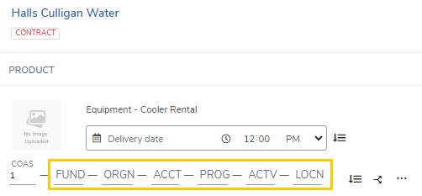

Special Instructions and Order Attachments
Enter any instructions to the supplier or attach any related documents to your order in the Special Instructions and Order Attachments section of the checkout screen.
  - The Special Instructions and Order Attachments are for sending information to the supplier and will be sent to the supplier with the final PO.

NOTE: If a different address is needed for delivery, alert the system administrators in Purchasing so they can add the new location to the pre populated list. Adding a different address in the delivery notes will not guarantee that the order is delivered to that address.
  - You can attach as many documents as needed with a single file size limit of 50 megabytes
  - You can also attach a file in the Order Attachments and choose not to send it to the supplier.

Justification Section
The Justification section is for internal justification use and will not be sent to the supplier. Justification information will always be on the requisition and not carried over to the Purchase Order.
  - The field labelled Justification is used to document the business purpose of the requisition. This is a required field and the information provided must document why the specific expense is a necessary and appropriate use of university funds.
  - The Justification Type field will pre-populate with the value of “Requisition”.
  - A series of questions about the procurement will be presented in this section. These questions are designed to assist users with purchasing policy compliance.
  - The Justification Attachments section is used to attach supporting documentation to the requisition that will not be transmitted to the supplier.
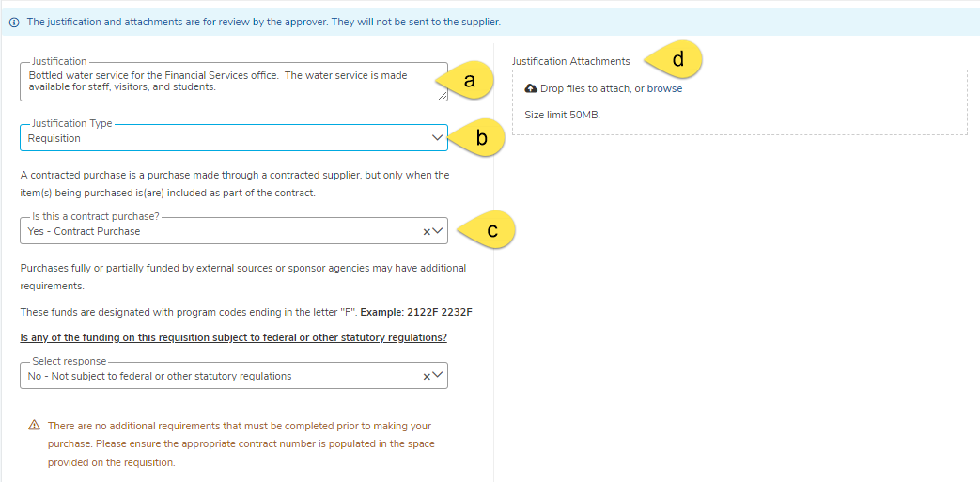

Saving a Checkout
If you need to enter more information and must come back to the checkout screen, you can Save your checkout progress.
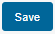
This will create an Incomplete Requisition that can be seen in the Tasks Menu.
Once your checkout screen is complete with all the needed information, click Checkout.
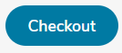

Reassigning your cart
- If you need to send this requisition to another buyer for more information or to complete the requisition and process for approval routing, click Reassign.
- A popup will prompt you to reassign your requisition to a Buyer. You can also include any important notes to the Buyer here. 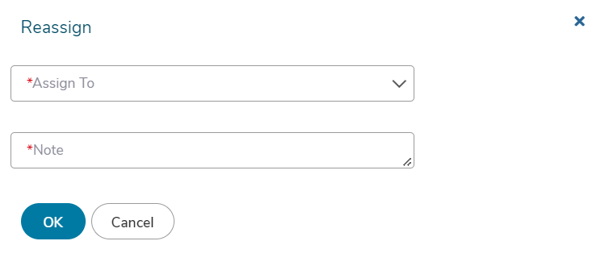
- A confirmation message will appear stating that the items have been forwarded to the designated individual. The Buyer will receive an email notification and the Incomplete Requisition will appear in the Tasks Menu for the Buyer to complete the requisition and route for approval. You can see the incomplete requisition status if you look at the View Requisitions page.

Retrofit Orders

Create a Retrofit Order
A retrofit order is used in cases where an order needs to be created in Wu-Buy after the fact.
When checking out, check the box next to Retrofit Order under Order Type Standard. Use this
if you are creating an order to match an invoice you have already received. Retrofit Orders will not be sent to the supplier.

To create a Retrofit Order:
- On the checkout screen, click the section Order Type and select Retrofit Order.
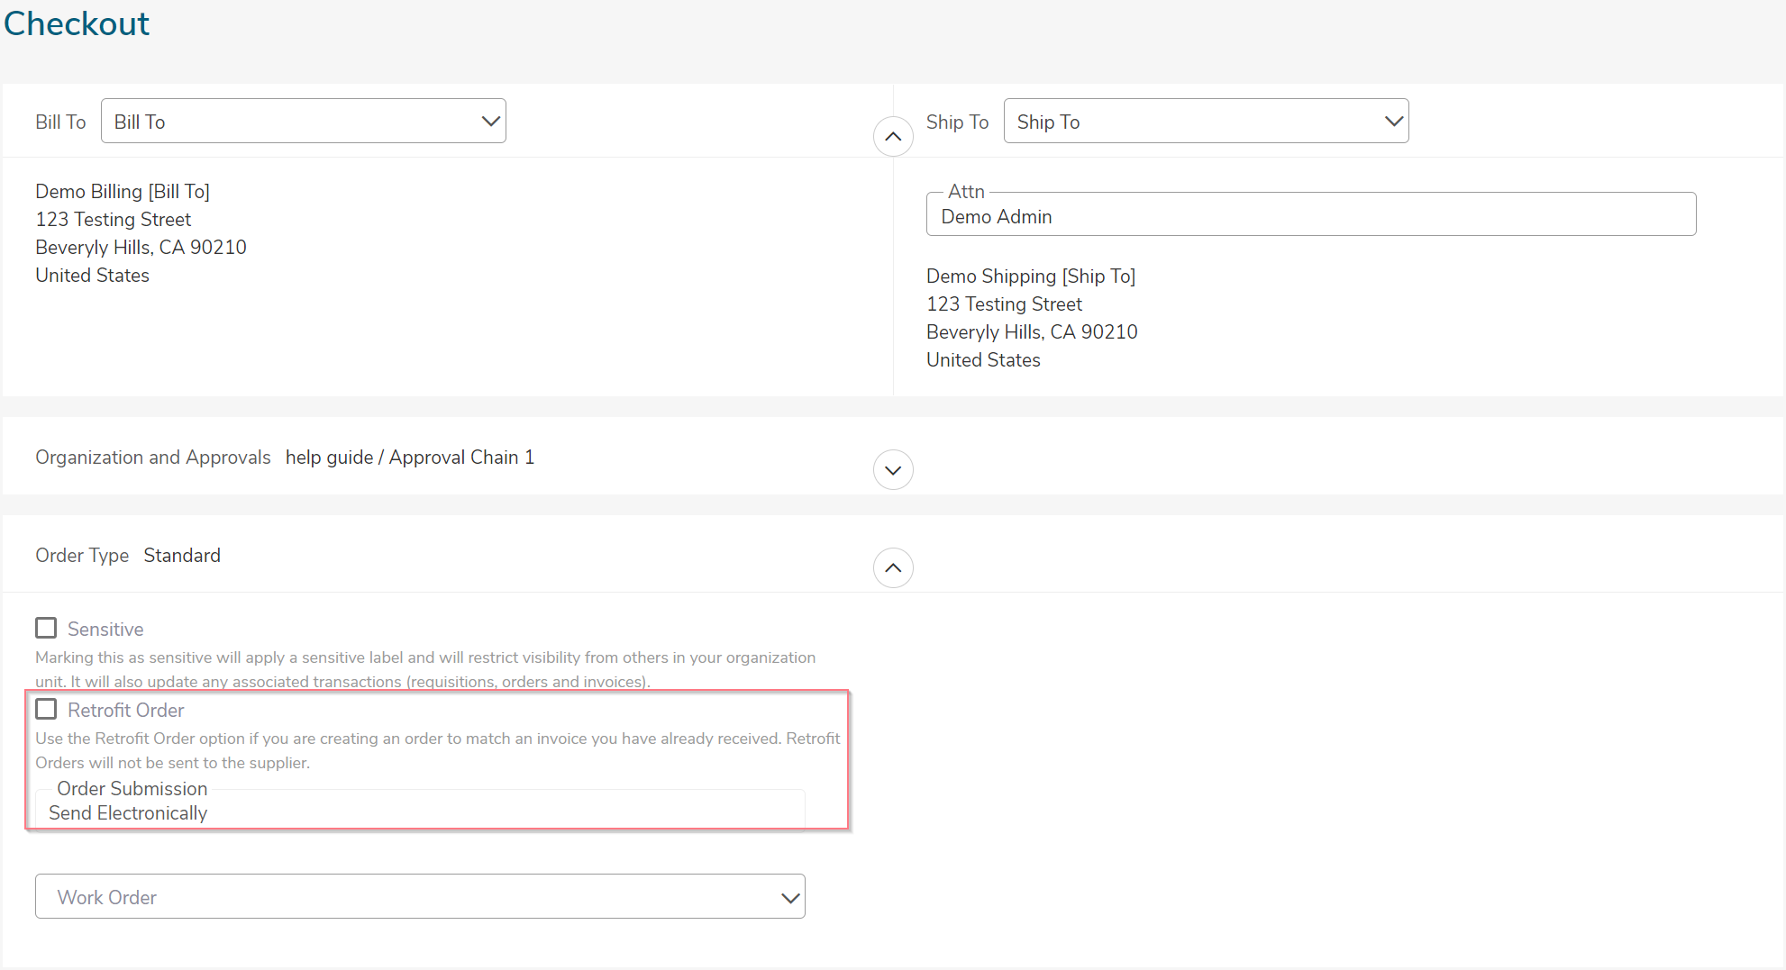
- Additional fields will appear including Related Invoice Number and Order Date (if enabled). Please note it will change the Order Submission field to Do not Send. For more information, check out the Unimarket HelpDesk page for Creating a Retrofit Requisition.

Tracking Requisitions
After successfully creating a requisition, you will be able to monitor the progress from your Dashboard on Wu-Buy or from the Requisitions page under the Orders menu.
- Click the Transactions button from your left side menu and select “View Requisitions”.
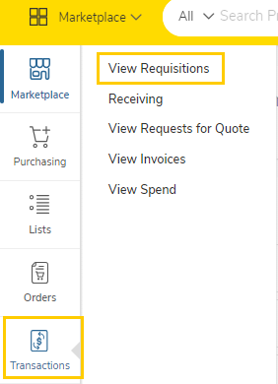
- Requisitions that have been submitted can be viewed on the Requisitions screen.
- Click on the desired Requisition from the list.
- You may also click 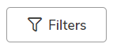 to view additional search filtering options.
  - The top portion of the screen will allow you to search for a requisition. Select from one or more of the following search options and then click the Search button.
    - Requisition Number
    - Period (when it was created)
    - Supplier
    - State
    - Buyer
    - Organization Unit
  - To select a requisition, click on the Requisition number from the list.
- The approval status will be listed in the “State” column but to view more approval details of the requisition, click the desired requisition and then on the Approvals tab. You will see the approvals that have happened, who the requisition is with now for approval, and the next approval steps needed before the order is created.
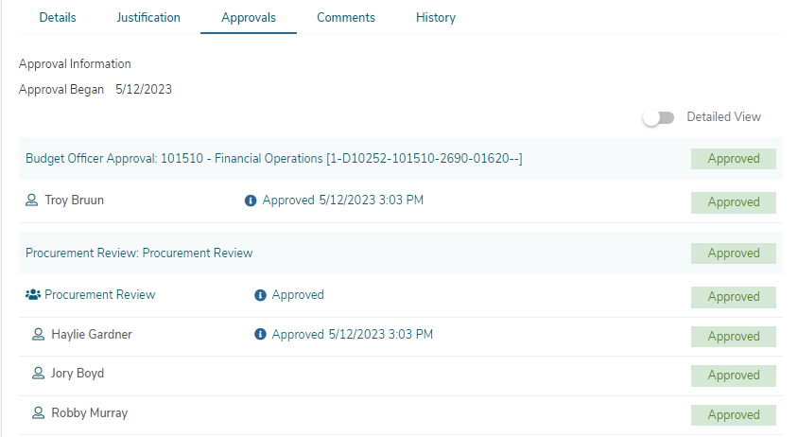
- The various approval statuses include:
  - Approved - approved and advanced to the next approval level
  - Declined – was not approved and sent back to the buyer
    - Declined requisitions can be copied and edited for resubmittal by the buyer who originally created the requisition
  - Escalated – skipped an individual and advanced to the next level
  - In Progress - current level of approval
- Once a requisition has been completely approved, a purchase order will be generated and sent to the supplier. An email with the purchase order number and details of the purchase order will be sent to the buyer and the originator of the requisition confirming that the supplier was sent the order.

Reprocessing a Declined Requisition
If your requisition is declined for any reason you will receive an email notification with the requisition number and details along with any notes that the declining approver provided. Reprocessing a declined requisition is easy. Follow the below steps to copy and resubmit the requisition with changes.
- Click the link to view the declined requisition from declined email notification or go to View Requisitions and search by Declined in the State search filter.
- At the top right of the requisition’s view page under the Actions menu, you will see the option to Copy the requisition.
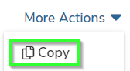
- When you copy the requisition, all information including the notes and attachments will be copied into a new Incomplete Requisition for you to edit and resubmit.
- When you click Copy, you will be taken directly to the Incomplete Requisition. Make any needed edits to the copied requisition and click Checkout to create the new requisition and route it for approval.
- The new requisition will have a new number, but will link and reference the old requisition for historical information.

Viewing Order

- Orders that have been created can be viewed in the Orders area of the information section under the Dashboard or from the Order menu and View Orders page.
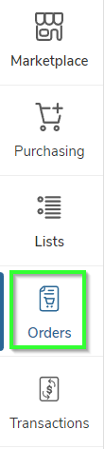
- If the order is visible, click on the order from the list.
- If the order is not visible, click 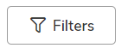to see additional filtering options.
  - The top portion of the screen will allow you to search for an order. Select from one or more of the following search options and then click the Search button:
    - Order Number
    - Created Date
    - Supplier
    - Order Type
    - Buyer
    - Organization Unit
    - Order State
    - Payment Method
    - Views
  - To select an order, click on the Order number from the list.
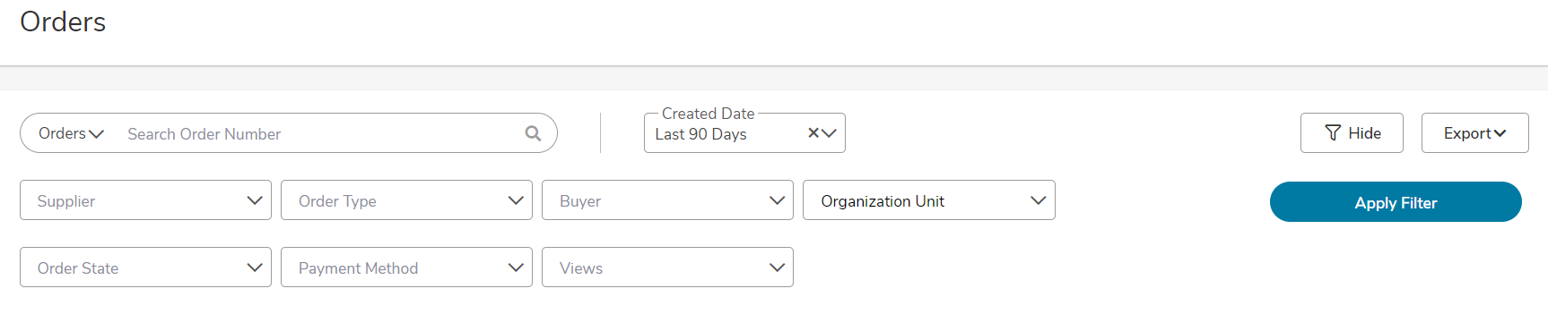

Exporting Order Reports
- From the View Orders page, you can use the down arrow on the search button to Export the current search results into an excel spreadsheet with the header level report or an export of the line item detail.
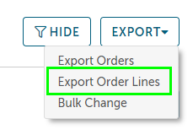
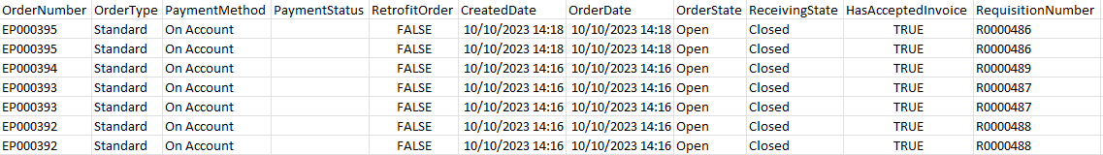

Canceling an Order
An order can only be cancelled if the order has not been invoiced or marked as having any receiving history. Some suppliers with Order Integration () can disable the ability to have a cancelled order since they are processing the orders as quickly as possible. If an order needs to be cancelled, contact the supplier to cancel the order or return the order once received. This would be the supplier’s preferred process if they have disabled the ability to cancel an order in Wu-Buy.
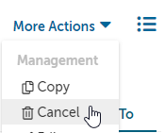
To cancel an order that has not been received against or invoiced:
- Locate and view the order from the View Orders screen.
- Select Cancel from the Action options in the top right.
- Confirm that you want to cancel the order.
The supplier will be notified via email that the order has been cancelled and you as the buyer will be CC’d for any added discussion through a reply to all email. The order will also be cancelled in Banner and the encumbered funds released.

Changing an Order
An order can only be changed if the order has not been invoiced or marked as having any receiving history. Some suppliers with Order Integration () can disable the ability to have change orders done since they are processing the orders as quickly as they can. If an order needs to be changed, contact the supplier to cancel the order and/or create a new order and return the initial order once received. This would be the supplier’s preferred process if they have disabled the ability to change an order in Wu-Buy.
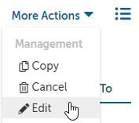
To change an existing order that has not been received against or invoiced:
- Locate and view the order from the View Orders page and select Edit in the Action items at the top right of the page.
- A new incomplete requisition will be created with the original order details and will be placed into the checkout.
- The original order details will be copied and can be modified as required from within the checkout screen. This includes Quantity, FOAPAL elements, Billing, and Shipping addresses as well as other related information like notes and attachments.
- Once you have made the desired changes, click Checkout.
The modified order will be routed for approval again IF the FOAPAL elements changed or the total value of the order is higher than the original. If the modifications to the order do not change the FOAPAL elements or increase the value, the changed order will be created with a new order number referencing the original order as a Change Of Order.
Once approved, a new order will be generated and sent to the supplier with a reference to the changed order. The Change Of Order link will provide an audit trail for the previous order. The original order will be cancelled with a notification to the supplier and cancelation in Banner to release the funds.

