Office Plus Ordering Guide

Placing an Office Supply Order
- Click on the Office Supplies tile.
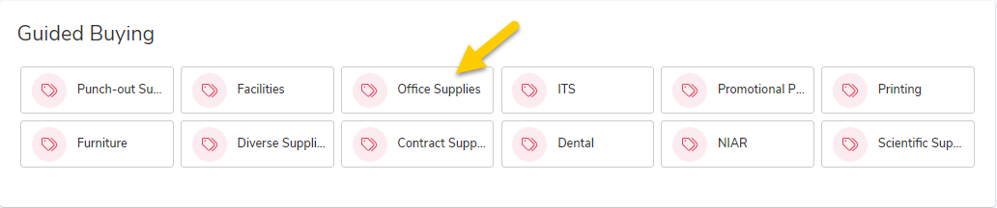
- Locate the Office Plus tile.
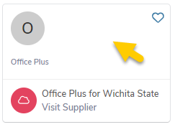
- Hover your mouse pointer over the tile to display the Catalogs button. Click the Catalogs button.
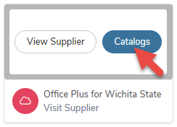
- Click on the Visit Supplier tile.
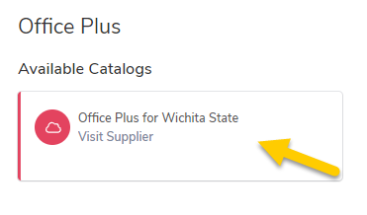
- You will be redirected to the Office Plus website. Locate the items you want to order.
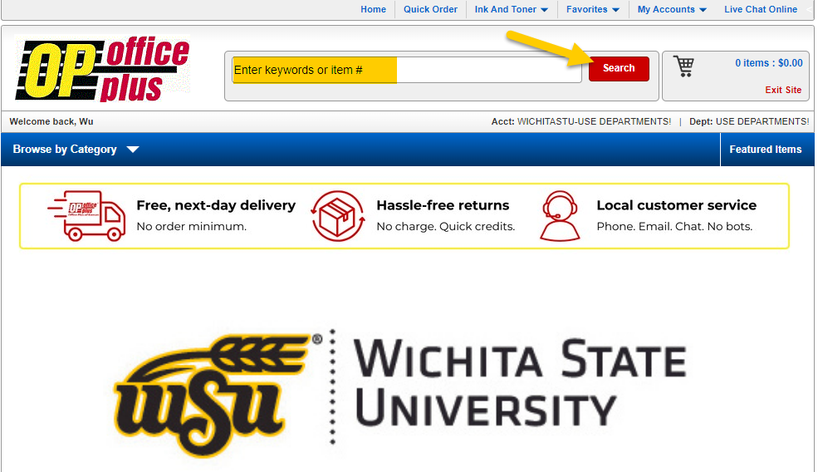
- Add the items to your cart.
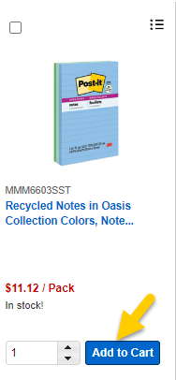
- View your Office Plus cart and make any needed modifications.
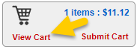
- Submit the cart.
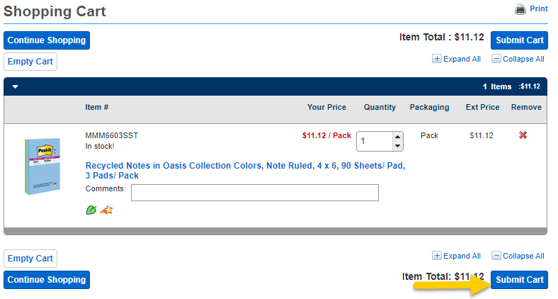
- You will be returned to Wu-Buy and your items will be placed in your shopping cart. Click Checkout.
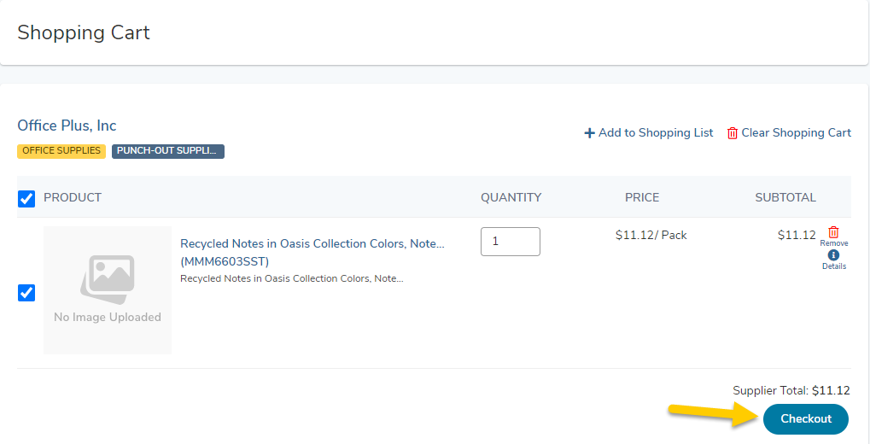
- Select the appropriate ship to location and enter your room number, last name and first name in the Attn field.
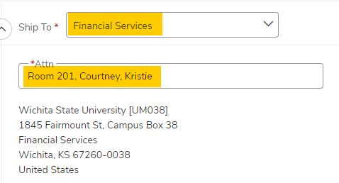
- Click the drop-down arrow and select the appropriate Organization Unit.
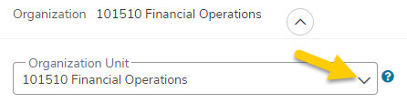
- Scroll down to the product section and add the appropriate funding. Make sure that you have added all the required elements; Fund, Orgn, Acct, and Prog.
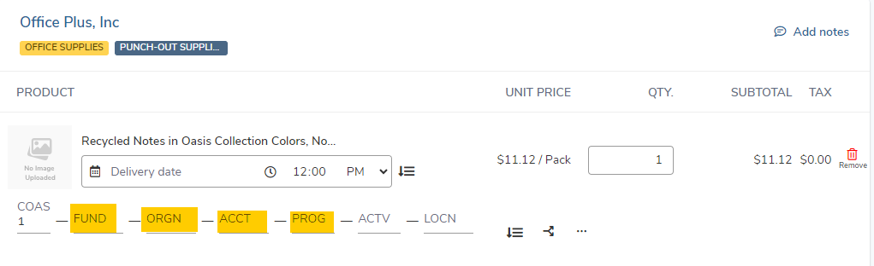
- Scroll down to the Justification field. This field is where you will enter the Business Purpose.
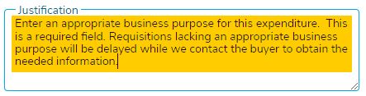
- Ensure that Requisition Questionnaire – Required is populated in the Justification Type field.
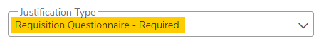
- Click the drop-down arrow to select the appropriate answer the displayed questions and follow any instructions provided.
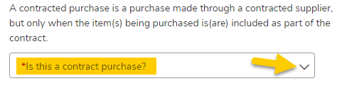
- If you are a Browser select the reassign option at the bottom of the page.
- Click the drop-down arrow to select the appropriate Buyer from the list displayed in the Assign To field.
- Click OK
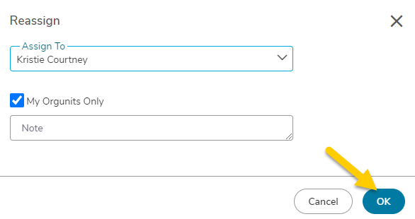
- Your requisition will be in an Incomplete status and the selected Buyer will be notified.
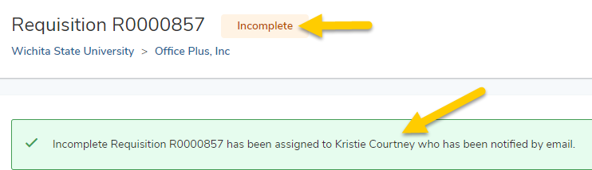

- If you are a Buyer, you will have a Checkout button at the bottom of your screen.
- The status of the Requisition will show as Pending.
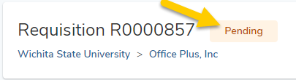
- The Requisition will now route through the approval process. When all approvals have been obtained, the status will update to Approved a Purchase Order number will be assigned, and the order will be placed with the supplier.
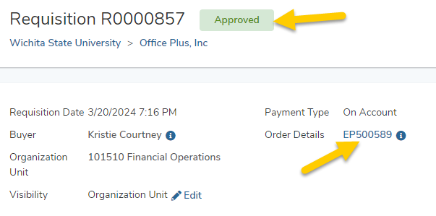
- Once your items have been delivered, return to Wu-Buy to complete the electronic receiving process. Click on the Orders icon on the left side of the screen then locate the appropriate order. Click on the link for the purchase order.
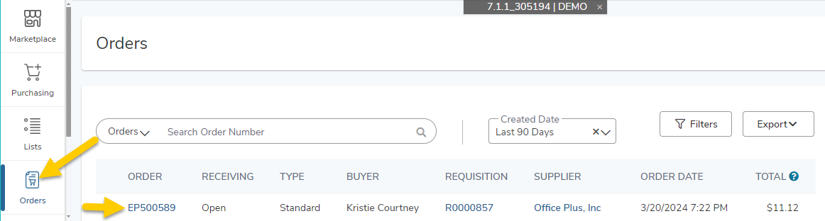

- Scroll down to the Item section and click the Receive link on the far-right side of the screen.
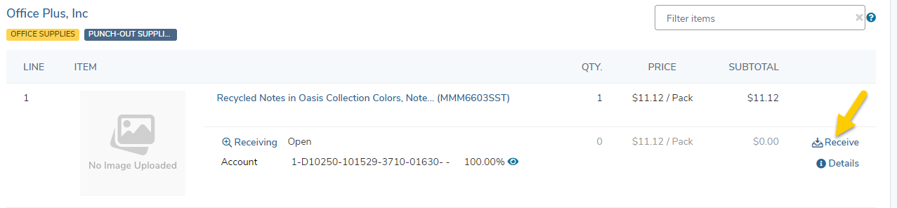
- Complete the appropriate information and click OK.
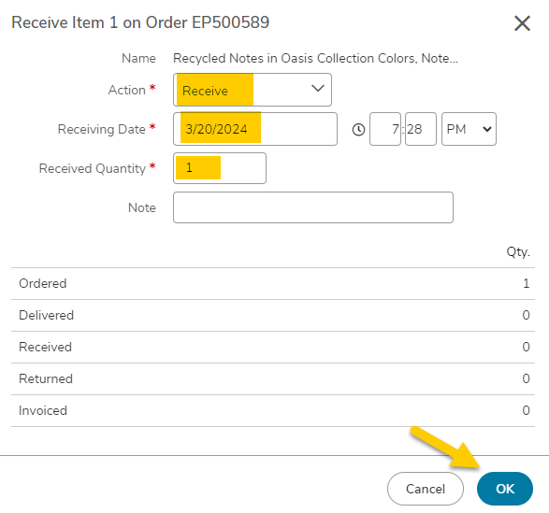
- When the invoice arrives in the system, the matching process will run to compare the Purchase Order, Receiving Report and Invoice quantity and price. Invoices that pass matching will be processed for payment. Items that fail the matching process will be routed to the Buyer for review and approval.

