Receiving Guide
This guide will review how to indicate goods and services are approved to pay, and how to mark items as returned or closed if they are not expected to be delivered.

Contents
Logging In 3
Receiving – Line Level (preferred method) 4
Alternate Receiving Methods 7
Receive All (alternate method 1) 7
Receiving Search Page (alternate method 2) 9
Receiving Field Details 11
Action 12
Receiving Date/Time 12
Received Quantity 12
Note 12
Undo Receiving 12
Viewing Receiving History 15

Logging In
To log into Wu-Buy, take the following steps:

- Open your web browser.
- In the address field, type https://wichita.unimarket.com/.
- The Wu-Buy Unimarket login page will appear.
- Enter your Wichita State SSO username and password and login.
- Your Wu-Buy Unimarket home page will appear.

If you experience any issues logging in, please contact accountspayable@wichita.edu.

Receiving – Line Level (preferred method)
The receiving action in Wu-Buy acts as the approval for the invoice matching when the invoice is submitted against the purchase order. The receiving action can be done before or after the invoice is submitted (ideally after the invoice has been submitted so you can review the invoice first).
Once the products or services have been delivered, you as the buyer or the initiator of the order will be tasked to mark the order as received to acknowledge the receipt of the goods or services. By marking the order(s) with the received status you approve payment of any invoice(s) for the specific item and quantity received.
- To view the orders with items not yet received, click on the Transactions icon and select Receiving, to be taken to the Receiving page. The filter criteria by default displays all orders within the last 90 days that still need to be marked as received or closed.
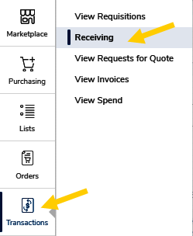
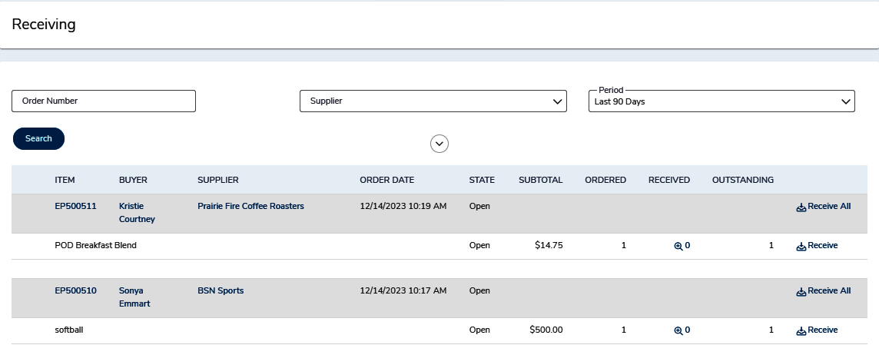
- Locate the desired order in the search results and click on the purchase order link to open the purchase order.
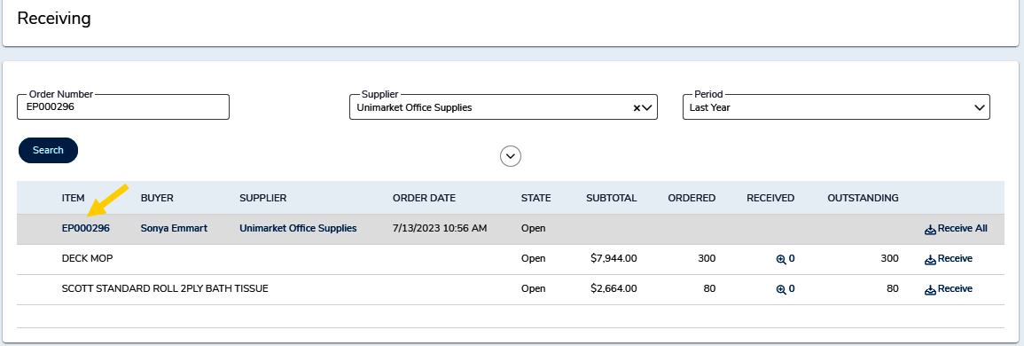
- On the purchase order page, scroll down to the item detail section. Locate the item you want to receive and click the Receive link next to the line.
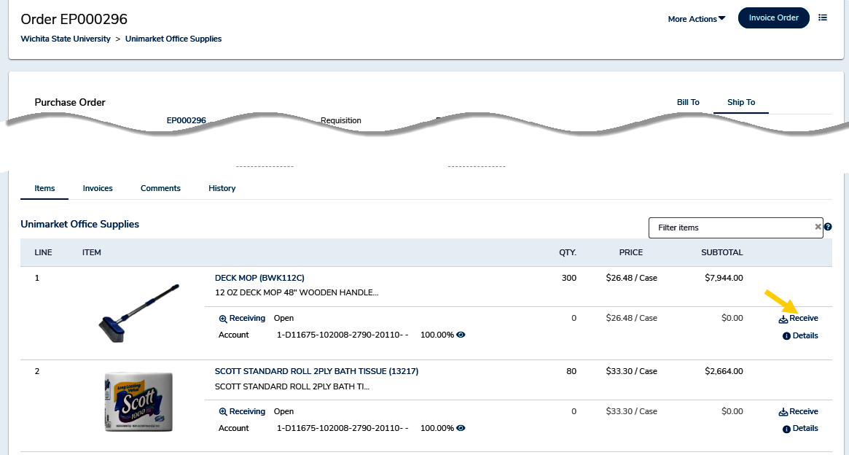
- The receiving window will open and display details of the selected line.
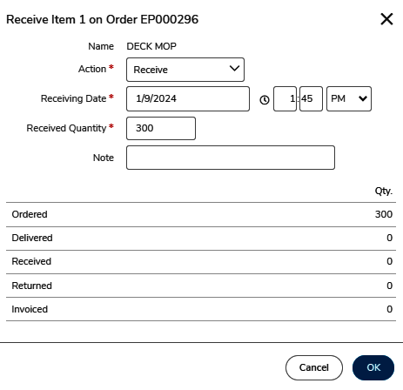
- Update the receiving information as necessary and click OK.
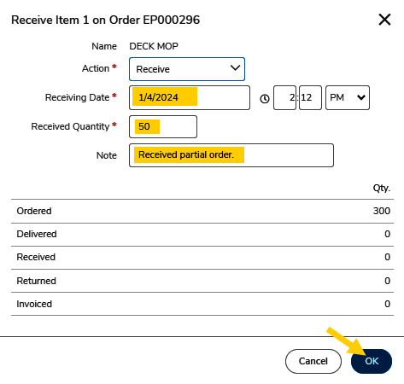
- Repeat the above steps for each line as appropriate.

Alternate Receiving Methods
There are multiple ways to complete the receiving process within Wu-Buy. Receiving at the line level (as shown above) is best practice, however, users can utilize any of the receiving methods shown in this guide.

Receive All (alternate method 1)
This feature is useful when receiving against large multi-lined orders.
- Locate the desired order in the search results found on the receiving page and click on the purchase order link to open the purchase order.
- In the upper right corner, click the arrow next to the More Actions menu and select Receive All.
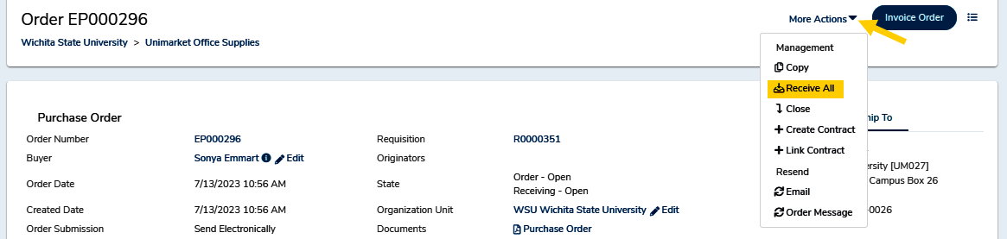
- The Receive Order window will display.
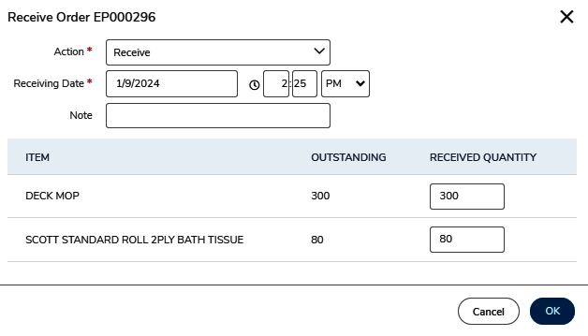
- Notice - all lines on the purchase order are displayed. Update the receiving information as necessary and click OK.
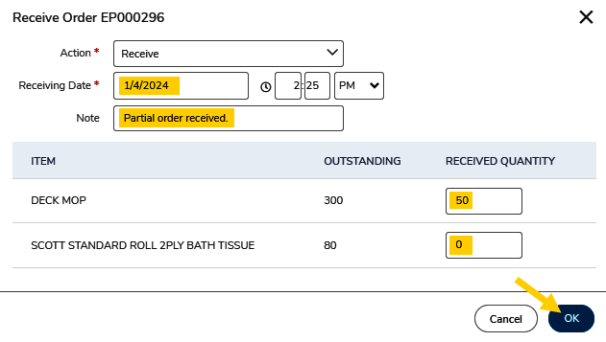

Receiving Search Page (alternate method 2)
Receiving can be completed directly from the Receiving page search results. Note – the recommended best practice for receiving is to receive at the line-item level from the purchase order page. This allows the receiver to review all details and comments associated with the order.
- On the Receiving page, locate the desired order in the search results.
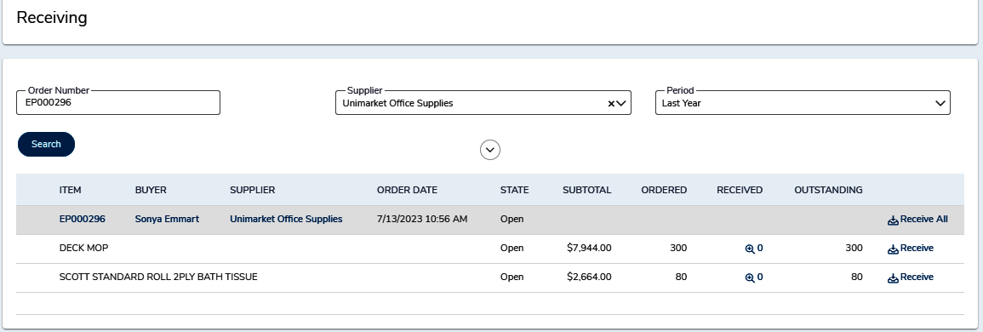
- Click the Receive All button to receive all the line items or the Receive button next to each line to mark the individual lines as received.
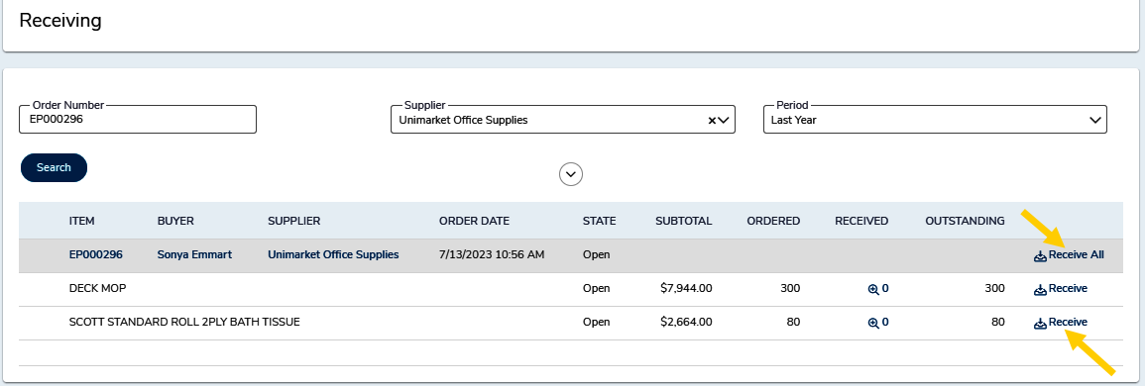
- The Receive All action opens the receiving window with all line items. The ordered or remaining quantity is prefilled for all line items on the PO.
Update as appropriate and click OK.
- The Receive function opens the Line Item Receiving window. This window will only display the selected line-item information and ordered quantity prefilled for the ordered or remaining quantity.
Update as appropriate and click OK.

Receiving Field Details
Regardless of the receiving method selected, users will be presented with the receiving screen which will require the user to enter the appropriate details. Below we will discuss each field and recommended usage.

Action
Receive - marks the products or services as being received in good standing and approves the matching of any invoice to be paid for those specific items and quantities received.
Manual Close - marks items as NOT being received and holds the invoice from being paid. If Manual Close is selected, a note explaining the reason is required and can be viewed by Accounts Payable for visibility of why the invoice may be rejected and held.
- Reasons for manually closing receiving items are for damaged items, returned items or items that were canceled and are not expected to be received.
- If an item is on backorder and is being shipped in a later delivery, you can choose not to receive the item by entering a 0 quantity in the line-item field or mark it as Closed and then Reopen the item when it is physically received.

Receiving Date/Time
The receiving date will default to the date and time that the receiving window is opened. You can select a different date in the past to indicate that the goods/services were received or accepted at an earlier date and time. Best practice is for users to record the actual date the items were received by WSU. Updating the time field is optional.

Received Quantity
This field is used to record the actual quantity received by WSU. It is very important for the end user to accurately complete this field because the information is used to authorize the payment of any invoice(s) for the item quantity received.

Note
This field is used to record any additional information pertaining to this receiving activity. Example: Sometimes the person recording the receiving activity in Wu-Buy isn’t the actual person who received the goods/services. This field can be utilized to document the name of the actual employee who confirmed receipt of the goods/services.
This field is optional unless the Manual Close option was selected in the Action field.

Undo Receiving
Once an order or line item is marked as received in full, the item and order receiving status will be “Closed” indicating that the total amount ordered has been received. If there is a return or mistake in the initial receipt of the item(s), you are able to Reopen the order or line item receiving and Undo the previous receiving action.
At the top of a Purchase Order, in the More Actions menu, you will see the Reopen All option. This option will reopen the receiving for all line items.
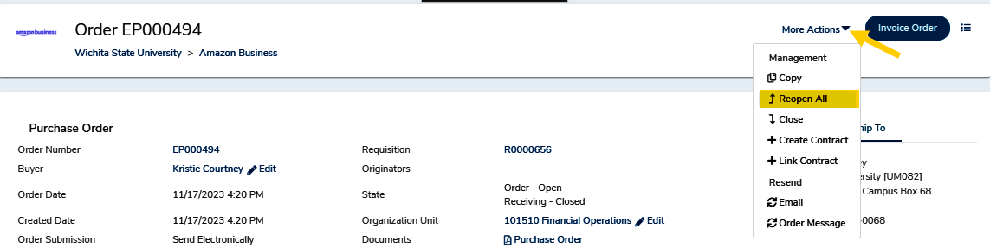
At the line level of items, you will also see a Reopen option to reopen the line item receiving.
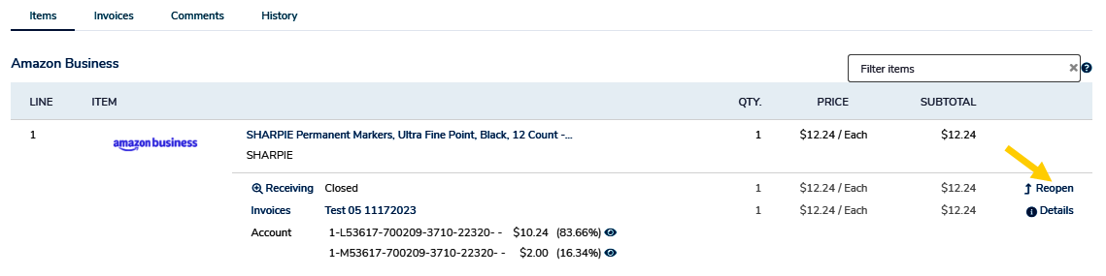
If you choose the reopen the receiving, you will be asked to provide a reason that will be recorded for auditing purposes.
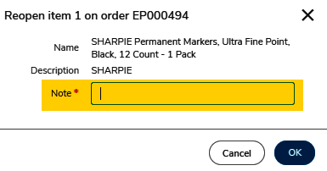
Once reopened you can choose to undo the receiving history by clicking the Receiving link in the line item.
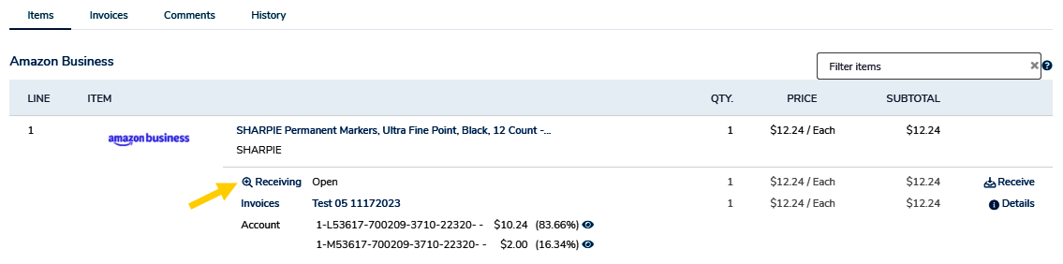
Once you open the receiving history on the reopened line item you will see the Undo button at the far right of the receiving action line.
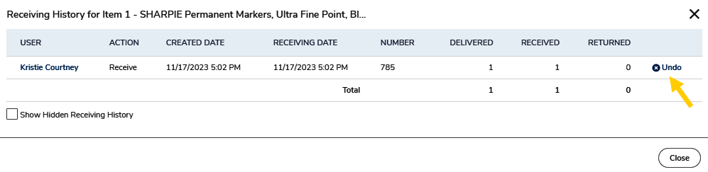
To undo the receiving action for the line item, you will be asked to provide a reason note then click OK.
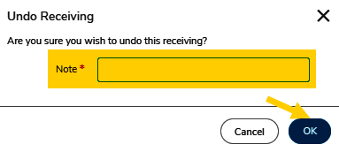
Once the receiving is reopened and undone you will be able to receive the correct amount as needed. You can also view the history of the receiving including the receiving, reopening and undo by clicking the Receiving button on the line item and check the box to Show Hidden Receiving History.
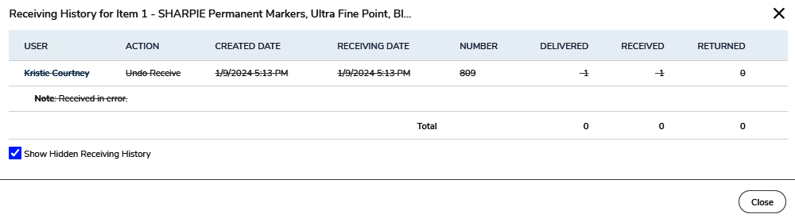

Viewing Receiving History
In the Receiving screen you can filter and search for orders that have been received, closed or are still pending receiving. The default search will show all open requisitions for the last 90 days. To find a past receiving records use the Supplier search field to search by individual suppliers, the date range to narrow the results, State to select All, Manually Closed, Open or Receipted orders.
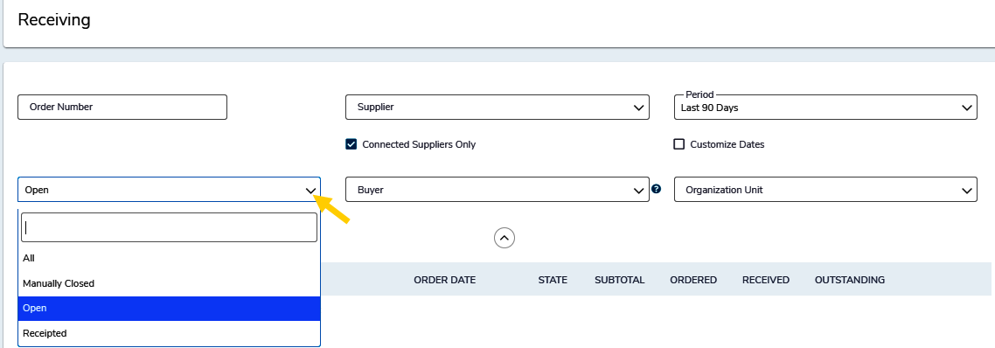
To look at the receiving history for a certain order, search and find the order then click on the order number to see the View Order page. The receiving history for each line is visible behind the Receiving link under each line. The Receiving History window will display the user that performed the receiving actions, as well as the date and time that the action was taken.
