Supplier Portal
The new supplier portal is an integral part of the Wu-Buy eProcurement system. The Supplier Portal provides self-service capabilities for companies and individuals to upload and maintain their supplier information including contacts, addresses, tax documentation, certificates of insurance, service offerings, diversity status and more. Additionally, the registration contains necessary confirmation and attestation statements to ensure the company or individual is certifying the accuracy of their own information.

WSU Supplier Request Process
University end users will now utilize the “Request a Supplier” functionality in Wu-Buy to initiate all supplier maintenance requests. Utilizing this process offers transparent workflow to make supplier management easier and provides a secure method for transmitting sensitive supplier data.

An invitation to your supplier contact is the simplest, most efficient way to get started in the Supplier Portal.

Wu-Buy Supplier Population
Suppliers (excluding employees) that have received at least 1 payment since July 2021 have been populated in the Wu-Buy marketplace. If you are unable to locate a specific supplier in the Wu-Buy system, you can request for the supplier to be added to the Wu-Buy marketplace.

Supplier Searching
From the Marketplace, you can search for suppliers by Name or Banner Supplier ID using either of the search fields show below.


You can also search for existing suppliers utilizing the WSU Reporting Services FCM00300 – Vendor Addresses report.
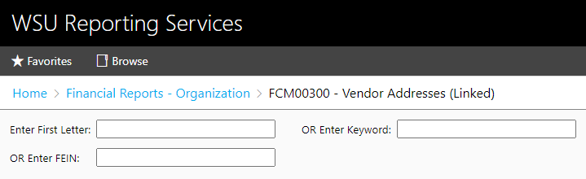
If you locate a supplier in this report that is not available in Wu-Buy, use the process detailed below to request the addition of the supplier.

End User Supplier Request Process
Users can request an invitation be sent to new suppliers from within Wu-Buy. Simply navigate to Marketplace --> Purchasing --> Request Supplier and fill out the form. Alternately, users can click the down arrow next to the blue Create button in the upper right corner and select Request Supplier.

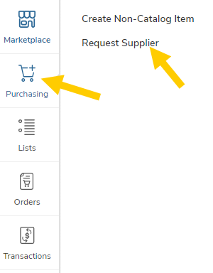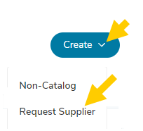

Request New Supplier
If you do not find the supplier, select the “Request New Supplier” button in the top-left corner of the form.

- The “Request New Supplier” form will open for you to enter the supplier information including
  - Supplier Name,
  - Supplier Contact Email,
  - Supplier Contact Phone Number,
  - Supplier Contact First Name,
  - Supplier Contact Last Name, and
  - Reason for requesting this supplier.
- Add any necessary attachments.
- Select the Supplier Administrator to send the request to by selecting the “Assign Request to” drop-down.
- Click Send Request to complete.

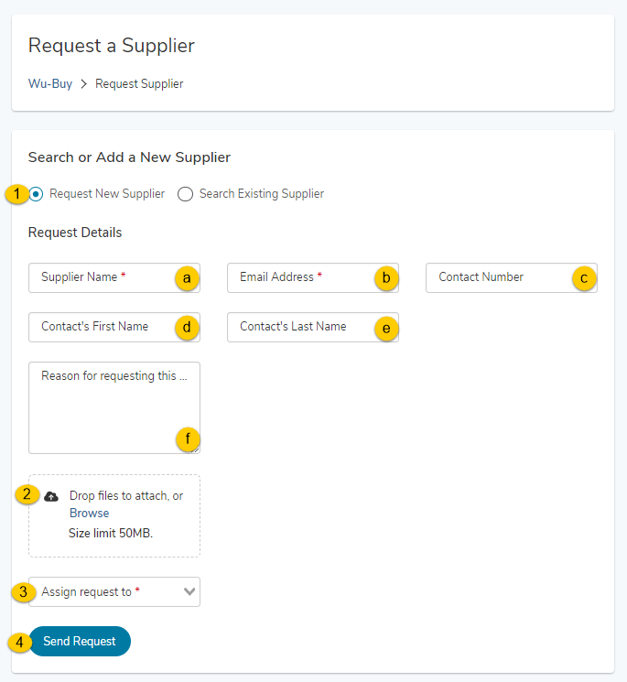

Once you send the request, the Supplier Administrator will receive an email notification to process the request. You will be notified by email once the request has been accepted or declined.

Search Existing Supplier
End users should not select this option.

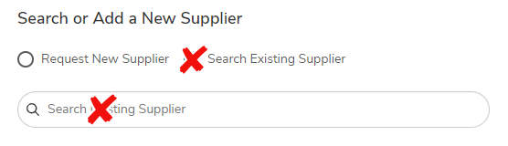

End Users Reviewing Their Requests
When a user requests a supplier, they may want to check on the status of that request. To do so, simply click the task icon in the upper right corner and select Supplier Requests.
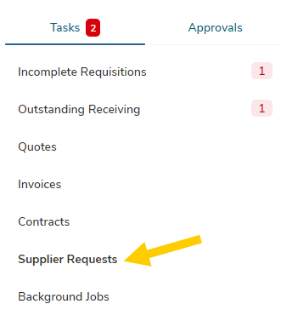
The Supplier Requests page provides a list and a status, as well as who is currently working on the request.

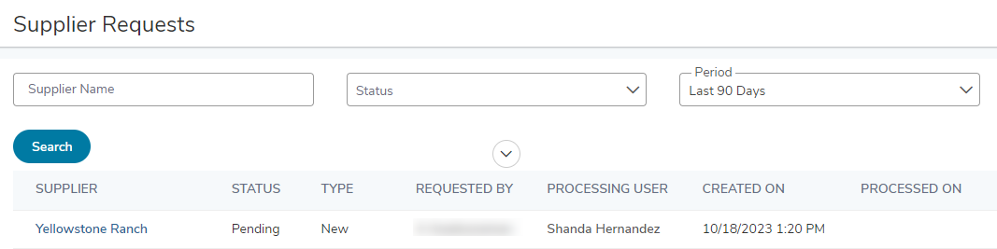
The different states that a request can be in are:
- Accepted – The request was approved, and an invitation will be sent to the supplier to register.
- Completed – The request was approved, and the supplier invite to register was completed and is in review or is available to use in the marketplace. An email would have been sent to the requestor when the status of the request is reached.
- Declined – The Supplier Administrator has declined and entered a reason why this supplier should not be invited to register. The requester will have received an email notifying them of the declined request. A request may also have this status if the Supplier Request was used to securely transmit supplier information for an existing supplier.
- Deleted – The requestor deleted this request after it was submitted.
- Pending – The request is still awaiting a review by the Supplier Administrator to approve or decline the request.

